Hnpg009 Course readings
Fall, 2008
“Learning, Leadership and Creativity”
v. 9-3-08, 15787 words

*W. Warren Wagar 1999 A Short History of the Future. (3nd Edition) Chicago:
University of Chicago Press. (available at Campus Store)

# 1 Thomas D. Hall and Christopher Chase-Dunn, 2006 “Global social change in the long run” Chapter 3 in C. Chase-Dunn and S. Babones (eds.) Global Social Change. Baltimore, MD: Johns Hopkins University Press. (Pp. 1-22 below).

#2 Christopher Chase-Dunn and Bruce Lerro, Social Change, Chapter 14 “The Modern World-System” (Pp. 22-37 below).

#3 Christopher Chase-Dunn and Bruce Lerro, Social Change, Chapter 19 “The World-System Since 1945” (Pp. 38-58 below).

#4 Christopher Chase-Dunn, A. K. Jorgenson, T.E. Reifer and S. Lio 2005 “The trajectory of the United States in the world-system” Social Forces 48,2:233-254 (Pp. 58-80 below).

# 5 Volker Bornschier 2008 “Income inequality in the world: looking back and ahead” Presented at the conference on “Inequality Beyond Globalization” organized by the World Society Foundation and the RC02 of the International Sociological Association, University of Neuchatel, June 28, 2008. (Pp. 80- 96 below).

“Global Social Change in the Long Run”
Thomas D. Hall and Chris Chase-Dunn, Chapter 3 in Global Social Change, C. Chase-Dunn and S. Babones (eds.) Baltimore: Johns Hopkins University Press 2006

The comparative world-systems perspective is a strategy for explaining human socio-cultural evolution that focuses on whole intersocietal systems rather than single societies. The main insight is that important interaction networks (trade, information flows, alliances, and fighting) have woven polities and cultures together since the beginning of human social evolution. Explanations of social change need to take intersocietal systems (world-systems) as the units that evolve. But intersocietal interaction networks were rather small when transportation was mainly a matter of hiking with a pack. Globalization, in the sense of the expansion and intensification of larger interaction networks, has been increasing for millennia, albeit unevenly and in waves.
World-systems are systems of societies. Systemness means that these societies are interacting with one another in important ways – interactions are two-way, necessary, structured, regularized and reproductive. Systemic interconnectedness exists when interactions importantly influence the lives of people within societies, and are consequential for social continuity or social change. World-systems may not cover the entire surface of the planet. Some extend over only parts of the Earth. The word “world” refers to the importantly connected interaction networks in which people live, whether these are spatially small or large.
Only the modern world-system has become a global (Earth-wide) system composed of national societies and their states. It is a single economy composed of international trade and capital flows, transnational corporations that produce products on several continents, as well as all the economic transactions that occur within countries and at local levels. The whole world-system is more than just international relations. It is the whole system of human interactions. The world economy is all the economic interactions of all the people on Earth, not just international trade and investment.
The modern world-system is structured politically as an interstate system – a system of competing and allying states. Political Scientists commonly call this the international system, and it is the main focus of the field of International Relations. Some of these states are much more powerful than others, but the main organizational feature of the world political system is that it is multicentric. There is no world state. Rather there is a system of states. This is a fundamentally important feature of the modern system and of many earlier regional world-systems as well.
When we discuss and compare different kinds of world-systems it is important to use concepts that are applicable to all of them. Polity is a more general term that means any organization with a single authority that claims sovereign control over a territory or a group of people. Polities include bands, tribes and chiefdoms as well as states. All world-systems are politically composed of multiple interacting polities. Thus we can fruitfully compare the modern interstate system with earlier systems in which there were tribes or chiefdoms, but no states.
In the modern world-system it is important to distinguish between nations and states. Nations are groups of people who share a common culture and a common language. Co-nationals identify with one another as members of a group with a shared history, similar food preferences and ideas of proper behavior. To a varying extent nations constitute a community of people who are willing to make sacrifices for one another. States are formal organizations such as bureaucracies that exercise and control legitimate violence within a specific territory. Some states in the modern world-system are nation-states in which a single nation has its own state. But others are multinational states in which more than one nation is controlled by the same state. Ethnic groups are sub-nations, usually minorities within states in which there is a larger national group. Ethnic groups and nations are sociologically similar in that they are both groups of people who identify with one another and share a common culture, but they often differ with regard to their relationship with states. Ethnic groups are minorities, whereas nations are majorities within a state.
The modern world-system is also importantly structured as a core/periphery hierarchy in which some regions contain economically and militarily powerful states while other regions contain polities that are much less powerful and less developed. The countries that are called “advanced ” (in the sense that they have high levels of economic development, skilled labor forces, high levels of income and powerful, well-financed states) are the core powers of the modern system. The modern core includes the United States, and the countries of Europe, Japan, Australia and Canada.
In the contemporary periphery we have relatively weak states that are not strongly supported by the populations within them, and have little power relative to other states in the system. The colonial empires of the European core states have dominated most of the modern periphery until recently. These colonial empires have undergone decolonization. The interstate system of formally sovereign states was extended to the periphery in a series of waves of decolonization that began in the last quarter of the eighteenth century with the American independence. This was follow in the early nineteenth century by the independence of the Spanish American colonies, and in the twentieth century by the decolonization of Asia and Africa. Peripheral regions are also economically less developed in the sense that the economy is composed of subsistence producers, as well as industries that have relatively low productivity and that employ unskilled labor. Agriculture in the periphery is typically performed using simple tools, whereas agriculture in the core is capital-intensive, employing machinery and non-human, non-animal forms of energy. Some industries in peripheral countries, such as oil extraction or mining, may be capital-intensive, but these sectors are often controlled by core capital.
In the past, peripheral countries have been primarily exporters of agricultural and mineral raw materials. But even when they have developed some industrial production, this has usually been less capital intensive and using less skilled labor than production processes in the core. The contemporary peripheral countries are most of the countries in Asia, Africa and Latin America – for example Bangla Desh, Senegal and Bolivia.
The core/periphery hierarchy in the modern world-system is a system of stratification in which socially structured inequalities are reproduced by the institutional features of the system (see Figure 1). The periphery is not “catching up” with the core. Rather both core and peripheral regions are developing, but most core states are staying well ahead of most peripheral states. There is also a stratum of countries that are in between the core and the periphery that we call the semiperiphery. The semiperiphery in the modern system includes countries that have intermediate levels of economic development or a balanced mix of developed and less developed regions. The semiperiphery includes large countries that have political/military power as a result of their large size, and smaller countries that are relatively more developed than those in the periphery.
Figure 1. Core/Periphery Hierarchy
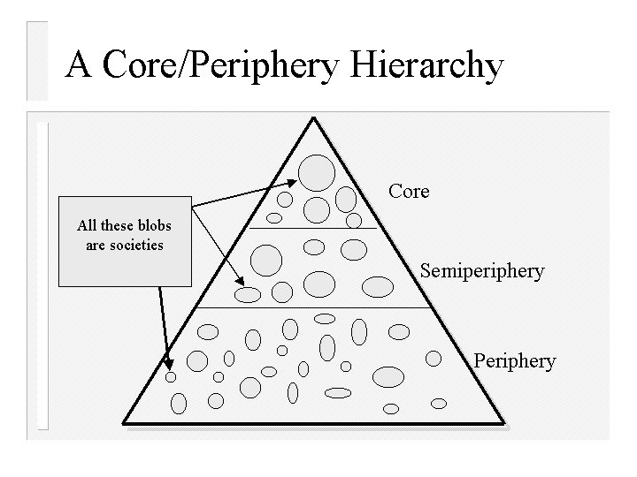
The exact boundaries between the core, semiperiphery and periphery are unimportant because the main point is that there is a continuum of economic and political/military power that constitutes the core-periphery hierarchy. It does not matter exactly where we draw lines across this continuum in order to categorize countries. Indeed we could as well make four or seven categories instead of three. The categories are only a convenient terminology for pointing to the fact of international inequality and for indicating that the middle of this hierarchy may be an important location for processes of social change.
There have been a few cases of upward and downward mobility in the core/periphery hierarchy, though most countries simply run hard to stay in the same relative positions that they have long had. A most spectacular case of upward mobility is the United States. Over the last 300 years the territory that became the U.S. has moved from outside the Europe-centered system (a separate continent containing several regional world-systems), to the periphery, to the semiperiphery, to the core, to the position of hegemonic core state (see below), and now its hegemony is slowly declining. An example of downward mobility is the United Kingdom of Great Britain, the hegemon of the nineteenth century and now just another core society.
The global stratification system is a continuum of economic and political-military power that is reproduced by the normal operations of the system. In such a hierarchy there are countries that are difficult to categorize. For example, most oil-exporting countries have very high levels of GNP per capita, but their economies do not produce high technology products that are typical of core countries. They have wealth but not development. The point here is that the categories (core, periphery and semiperiphery) are just a convenient set of terms for pointing to different locations on a continuous and multidimensional hierarchy of power. It is not necessary to have each case fit neatly into a box. The boxes are only conceptual tools for analyzing the unequal distribution of power among countries.
When we use the idea of core/periphery relations for comparing very different kinds of world-systems we need to broaden the concept a bit and to make an important distinction (see below). But the most important point is that we should not assume that all world-systems have core/periphery hierarchies just because the modern system does. It should be an empirical question in each case as to whether core/periphery relations exist. Not assuming that world-systems have core/periphery structures allows us to compare very different kinds of systems and to study how core/periphery hierarchies themselves emerged and evolved.
In order to do this it is helpful to distinguish between core/periphery differentiation and core/periphery hierarchy. Core/periphery differentiation means that societies with different degrees of population density, polity size and internal hierarchy are interacting with one another. As soon as we find village dwellers interacting with nomadic neighbors we have core/periphery differentiation. Core/periphery hierarchy refers to the nature of the relationship between societies. This kind of hierarchy exists when some societies are exploiting or dominating other societies. Examples of intersocietal domination and exploitation would be the British colonization and deindustrialization of India, or the conquest and subjugation of Mexico by the Spaniards. Core/periphery hierarchy is not unique to the modern Europe-centered world-system of recent centuries. Both the Roman and the Aztec empires conquered and exploited peripheral peoples as well as adjacent core states.
Distinguishing between core/periphery differentiation and core/periphery hierarchy allows us to deal with situations in which larger and more powerful societies are interacting with smaller ones, but are not exploiting them. It also allows us to examine cases in which smaller, less dense societies may be exploiting or dominating larger societies. This latter situation definitely occurred in the long and consequential interaction between the nomadic horse pastoralists of Central Asia and the agrarian states and empires of China and Western Asia. The most famous case was that of the Mongol Empire of Chingis Khan, but confederations of Central Asian steppe nomads managed to extract tribute from agrarian states long before the rise of Mongols.
So the modern world-system is now a global economy with a global political system (the interstate system). It also includes all the cultural aspects and interaction networks of the human population of the Earth. Culturally the modern system is composed of: several civilizational traditions, (e.g. Islam, Christendom, Hinduism, etc.), nationally-defined cultural entities -- nations (and these are composed of class and functional subcultures, e.g. lawyers, technocrats, bureaucrats, etc.), and the cultures of indigenous and minority ethnic groups within states. The modern system is multicultural in the sense that important political and economic interaction networks connect people who have rather different languages, religions and other cultural aspects. Most earlier world-systems have also been multicultural.
Interaction networks are regular and repeated interactions among individuals and groups. Interaction may involve trade, communication, threats, alliances, migration, marriage, gift giving or participation in information networks such as radio, television, telephone conversations, and email. Important interaction networks are those that affect peoples’ everyday lives, their access to food and necessary raw materials, their conceptions of who they are, and their security from or vulnerability to threats and violence. World-systems are fundamentally composed of interaction networks.
One of the important systemic features of the modern system is the rise and fall of hegemonic core powers – the so-called “hegemonic sequence.” A hegemon is a core state that has a significantly greater amount of economic power than any other state, and that takes on the political role of system leader. In the seventeenth century the Dutch Republic performed the role of hegemon in the Europe-centered system, while Great Britain was the hegemon of the nineteenth century, and the United States has been the hegemon in the twentieth century. Hegemons provide leadership and order for the interstate system and the world economy. But the normal operating processes of the modern system – uneven economic development and competition among states – make it difficult for hegemons to sustain their dominant positions, and so they tend to decline. Thus the structure of the core oscillates back and forth between hegemony and a situation in which several competing core states have a roughly similar amount of power and are contending for hegemony – i.e. hegemonic rivalry (see Figure 2).

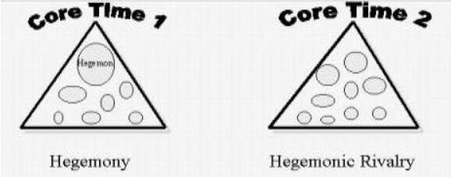Figure 2. Hegemony and Hegemonic Rivalry
So the modern world-system is composed of states that are linked to one another by the world economy and other interaction networks. Earlier world-systems were also composed of polities, but the interaction networks that linked these polities were not intercontinental in scale until the expansion of Europe in the fifteenth century. Before that world-systems were smaller regional affairs. But these had been growing in size with the expansion of trade networks and long-distance military campaigns for millennia.

SPATIAL BOUNDARIES OF WORLD SYSTEMS
One big difference between the modern world-system and earlier systems is the spatial scale of different types of interaction networks. In the modern global system most of the important interaction networks are themselves global in scale. But in earlier smaller systems there was a significant difference in spatial scale between networks in which food and basic raw materials were exchanged and much larger networks of the exchange of prestige goods or luxuries. Food and basic raw materials we call “bulk goods” because they have a low value per unit of weight. Indeed it is uneconomical to carry food very far under premodern conditions of transportation.
Imagine that the only type of transportation available is people carrying goods on their backs (or heads). This is a situation that actually existed everywhere until the domestication of beasts of burden. Under these conditions a person can carry, say, 30 kilograms of food. Imagine that this carrier is eating the food as s/he goes. So after a few days walking all the food will be consumed. This is the economic limit of food transportation under these conditions of transportation. This does not mean that food will never be transported farther than this distance, but there would have to be an important reason for moving it beyond its economic range.
A prestige good (e.g. a very valuable food such as spices, or jewels or bullion) has a much larger spatial range because a small amount of such a good may be exchanged for a great deal of food. This is why prestige goods networks are normally much larger than bulk goods networks. A network does not usually end as long as there are people with whom one might trade. Indeed most early trade was what is called down-the-line trade in which goods are passed from group to group. For any particular group the effective extent of its of a trade network is that point beyond which nothing that happens will affect the group of origin.
In order to bound interaction networks we need to pick a place from which to start – a so-called “place-centric approach.” If we go looking for actual breaks in interaction networks we will usually not find them, because almost all groups of people interact with their neighbors. But if we focus upon a single settlement, for example the precontact indigenous village of Onancock on the Eastern shore of the Chesapeake Bay (near the boundary between what are now the states of Virginia and Maryland), we can determine the spatial scale of the interaction network by finding out how far food moved to and from our focal village. Food came to Onancock from some maximum distance. A bit beyond that were groups that were trading food to groups that were directly sending food to Onancock. If we allow two indirect jumps we are probably far enough from Onancock so that no matter what happens (e.g. a food shortage or surplus), it would not have affected the supply of food in Onancock. This outer limit of Onancock’s indigenous bulk goods network probably included villages at the very southern and northern ends of the Chesapeake Bay.
Onancock’s prestige goods network was much larger because prestige goods move farther distances. Indeed, copper that was in use by the indigenous peoples of the Chesapeake may have come from as far away as Lake Superior. In between the size of bulk goods networks (BGNs) and prestige goods networks (PGNs) are the interaction networks in which polities make war and ally with one another. These are called political-military networks (PMNs). In the case of the Chesapeake world-system at the time of the arrival of the Europeans in the sixteenth century Onancock was part of a district chiefdom in a system of multi-village chiefdoms. Across the bay on the Western shore were at least two larger polities, the Powhatan and the Conoy paramount chiefdoms. These were core chiefdoms that were collecting tribute from a number of smaller district chiefdoms. Onancock was part of an interchiefdom system of allying and war-making polities. The boundaries of that network included some indirect links, just as the trade network boundaries did. Thus the political-military network (PMN) of which Onancock was the focal place extended to the Delaware Bay in the north and into what is now the state of North Carolina to the south.
Information, like a prestige good, is light relative to its value. Information may travel far along trade routes and beyond the range of goods. Thus information networks (INs) are usually as large or even larger than Prestige Goods nets (PGNs).
A general picture of the spatial relationships between different kinds of interaction networks is presented in Figure 3. The actual spatial scale of important interaction needs to be determined for each world-system we study, but Figure 4 shows what is generally the case – that BGNs (bulk goods nets) are smaller than PMNs (political-military nets), and these are in turn smaller than PGNs (prestige goods nets) and INs (information nets).
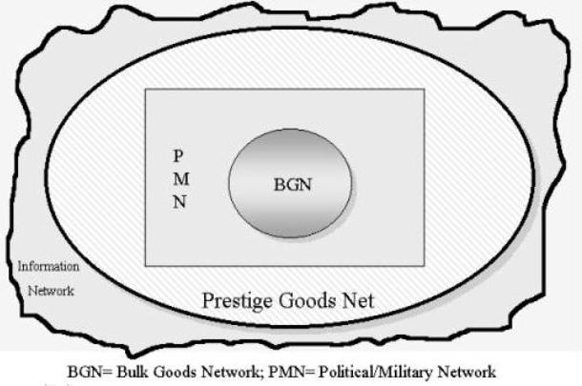Figure 3. The Spatial Boundaries of World Systems
Defined in the way that we have above, world-systems have grown from small to large over the past twelve millennia as societies and intersocietal systems have gotten larger, more complex and more hierarchical. This spatial growth of systems has involved the expansion of some and the incorporation of some into others. The processes of incorporation have occurred in several ways as systems distant from one another have linked their interaction networks. Because interaction nets are of different sizes, it is the largest ones that come into contact first. Thus information and prestige goods link distant groups long before they participate in the same political-military or bulk goods networks. The processes of expansion and incorporation brought different groups of people together and made the organization of larger and more hierarchical societies possible. It is in this sense that globalization has been going on for thousands of years.
Using the conceptual apparatus for spatially bounding world-systems outlined above we can construct spatio-temporal chronographs for how the interaction networks of the human population changed their spatial scales to eventuate in the single global political economy of today. Figure 4 (see next page) uses PMNs as the unit of analysis to show how a "Central" PMN, composed of the merging of the Mesopotamian and Egyptian PMNs in about 1500 BCE, eventually incorporated all the other PMNs into itself.

WORLD-SYSTEM CYCLES: RISE-AND-FALL AND PULSATIONS
Comparative research reveals that all world-systems exhibit cyclical processes of change. There are two major cyclical phenomena: the rise and fall of large polities, and pulsations in the spatial extent and intensity of trade networks. "Rise and fall" corresponds to changes in the centralization of political/military power in a set of polities – an “international” system. It is a question of the relative size of, and distribution of, power across a set of interacting polities. The term "cycling" has been used to describe this phenomenon as it operates among chiefdoms (Anderson 1994).
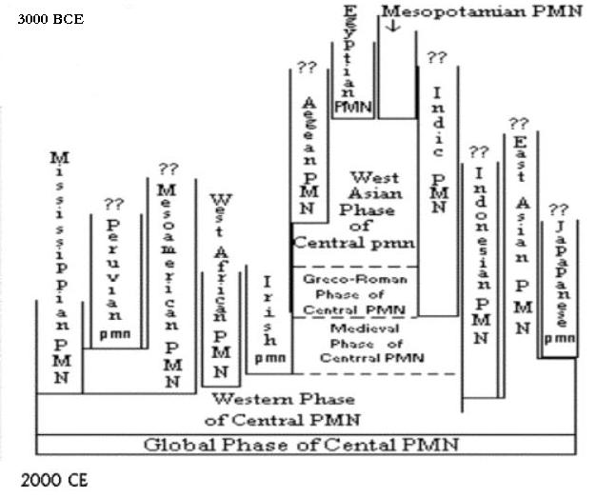Figure 4. Chronograph of PMNs [adapted from Wilkinson (1987)
All world-systems in which there are hierarchical polities experience a cycle in which relatively larger polities grow in power and size and then decline. This applies to interchiefdom systems as well as interstate systems, to systems composed of empires, and to the modern rise and fall of hegemonic core powers (e.g. Britain and the United
States). Though very egalitarian and small scale systems such as the sedentary foragers of Northern California (Chase-Dunn and Mann, 1998) do not display a cycle of rise and fall, they do experience pulsations.
All systems, including even very small and egalitarian ones, exhibit cyclical expansions and contractions in the spatial extent and intensity of exchange networks. We call this sequence of trade expansion and contraction pulsation. Different kinds of trade (especially bulk goods trade vs. prestige goods trade) usually have different spatial characteristics. It is also possible that different sorts of trade exhibit different temporal sequences of expansion and contraction. It should be an empirical question in each case as to whether or not changes in the volume of exchange correspond to changes in its spatial extent. In the modern global system large trade networks cannot get spatially larger because they are already global in extent. [1] But they can get denser and more intense relative to smaller networks of exchange. A good part of what has been called globalization is simply the intensification of larger interaction networks relative to the intensity of smaller ones. This kind of integration is often understood to be an upward trend that has attained its greatest peak in recent decades of so-called global capitalism. But research on trade and investment shows that there have been two recent waves of integration, one in the last half of the nineteenth century and the most recent since World War II (Chase-Dunn, Kawano and Brewer 2000).
The simplest hypothesis regarding the temporal relationships between rise-and-fall and pulsation is that they occur in tandem. Whether or not this is so, and how it might differ in distinct types of world-systems, is a set of problems that are amenable to empirical research.
Chase-Dunn and Hall (1997) have contended that the causal processes of rise and fall differ depending on the predominant mode of accumulation. One big difference between the rise and fall of empires and the rise and fall of modern hegemons is in the degree of centralization achieved within the core. Tributary systems alternate back and forth between a structure of multiple and competing core states on the one hand and core-wide (or nearly core-wide) empires on the other. The modern interstate system experiences the rise and fall of hegemons, but these never take over the other core states to form a core-wide empire. This is the case because modern hegemons are pursuing a capitalist, rather than a tributary form of accumulation.
Analogously, rise and fall works somewhat differently in interchiefdom systems because the institutions that facilitate the extraction of resources from distant groups are less fully developed in chiefdom systems. David G. Anderson's (1994) study of the rise and fall of Mississippian chiefdoms in the Savannah River valley provides an excellent and comprehensive review of the anthropological and sociological literature about what Anderson calls "cycling," the processes by which a chiefly polity extended control over adjacent chiefdoms and erected a two-tiered hierarchy of administration over the tops of local communities. At a later point these regionally centralized chiefly polities
disintegrated back toward a system of smaller and less hierarchical polities.
Chiefs relied more completely on hierarchical kinship relations, control of ritual hierarchies, and control of prestige goods imports than do the rulers of true states. These chiefly techniques of power are all highly dependent on normative integration and ideological consensus. States developed specialized organizations for extracting resources that chiefdoms lacked -- standing armies and bureaucracies. And states and empires in the tributary world-systems were more dependent on the projection of armed force over great distances than modern hegemonic core states have been. The development of commodity production and mechanisms of financial control, as well as further development of bureaucratic techniques of power, have allowed modern hegemons to extract resources from far-away places with much less overhead cost.
The development of techniques of power have made core/periphery relations ever more important for competition among core powers and have altered the way in which the rise-and-fall process works in other respects. Chase-Dunn and Hall (1997: Chapter 6) argued that population growth in interaction with the environment, and changes in productive technology and social structure produce social evolution that is marked by cycles and periodic jumps. This is because each world-system oscillates around a central tendency (mean) due both to internal instabilities and environmental fluctuations. Occasionally, on one of the upswings, people solve systemic problems in a new way that allows substantial expansion. We want to explain expansions, evolutionary changes in systemic logic, and collapses. That is the point of comparing world-systems.
The multiscalar regional method of bounding world-systems as nested interaction networks outlined above is complementary with a multiscalar temporal analysis of the kind suggested by Fernand Braudel’s work. Temporal depth, the longue duree, needs to be combined with analyses of short-run and middle-run processes to fully understand social change. The shallow presentism of most social science and contemporary culture needs to be denounced at every opportunity.
A strong case for the very longue duree is made by Jared Diamond’s (1997) study of original zoological and botanical wealth. The geographical distribution of those species that could be easily and profitably domesticated explains a huge portion of the variance regarding which world-systems expanded and incorporated other world-systems thousands of years hence. Diamond also contends that the diffusion of domesticated plant and animal species occurs much more quickly in the latitudinal dimension (East/West) than in the longitudinal dimension (North/South), and so this explains why domesticated species spread so quickly to Europe and East Asia from West Asia, while the spread south into Africa was much slower, and the North/South orientation of the American continents made diffusion much slower than in the Old World Island of Eurasia.
Figure 5 below depicts the coming together of the East Asian and the West Asian/Mediterranean systems. Both the PGNs and the PMNs are shown, as are the pulsations and rise and fall sequences. The PGNs linked intermittently and then joined. The Mongol conquerors linked the PMNs briefly in the thirteenth century, but the Eastern and Western PMNs were not permanently linked until the Europeans and Americans established Asian treaty ports in the nineteenth century.
Figure 5. East/West Pulsations and Merger (next page)
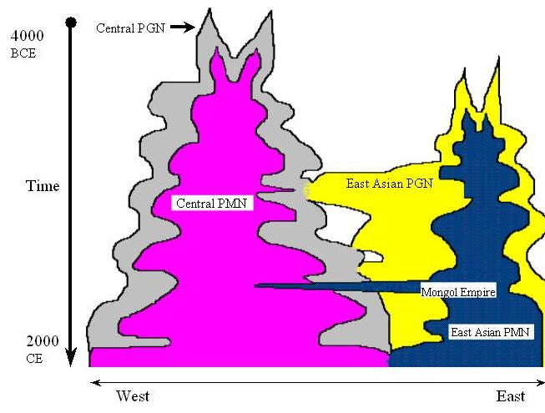MODES OF ACCUMULATION
In order to comprehend the qualitative changes that have occurred with the processes of social evolution we need to conceptualize different logics of development and the institutional modes by which socially created resources are produced and accumulated. All societies produce and distribute the goods that are necessary for everyday life. But the institutional means by which human labor is mobilized are very different in different kinds of societies. Small and egalitarian societies rely primarily on normative regulation organized as commonly shared understandings about the obligations that members of families have toward one another. When a hunter returns with his game there are definite rules and understandings about who should receive shares and how much. All hunters in foraging societies want to be thought of as generous, but they must also take care of some people (those for whom they are the most responsible) before they can give to others.
The normative order defines the roles and the obligations, and the norms and values are affirmed or modified by the continual symbolic and non-symbolic action of the people. This socially constructed consciousness is mainly about kinship, but it is also about the nature of the universe of which the human group is understood as a part. This kind of social economy is called a kin-based mode of production and accumulation. People work because they need food and they have obligations to provide food for others. Accumulation mainly involves the preservation and storage of food supplies for the season in which food will become scarce. Status is based on the reputation that one has as a good hunter, a good gatherer, a good family member, or a talented speaker. Group decisions are made by consensus, which means that the people keep talking until they have come to an understanding of what to do. The leaders have authority that is mainly based on their ability to convince others that they are right. These features are common (but not universal) among societies and world-systems in which the kin-based modes of accumulation are the main logic of development.
As societies become larger and more hierarchical, kinship itself becomes hierarchically defined. Clans and lineages become ranked so that members of some families are defined as senior or superior to members of other families. Classical cases of ranked societies were those of the Pacific Northwest, in which the totem pole represents a hierarchy of clans. This tendency toward hierarchical kinship resulted in the eventual emergence of class societies (complex chiefdoms) in which a noble class owned and controlled key resources and a class of commoners was separated from the control of important resources and had to rely on the nobles for access to these. Such a society existed in Hawaii before the arrival of the Europeans.
The tributary modes of accumulation emerged when institutional coercion became a central form of regulation for inducing people to work and for the accumulation of social resources. Hierarchical kinship functions in this way when commoners must provide labor or products to chiefs in exchange for access to resources that chiefs control by means of both normative and coercive power.
Normative power does not work well by itself as a basis for the appropriation of labor or goods by one group from another. Those who are exploited have a great motive to redefine the situation. The nobles may have elaborated a vision of the universe in which they were understood to control natural forces or to mediate interactions with the deities and so commoners were supposed to be obligated to support these sacred duties by turning over their produce to the nobles or contributing labor to sacred projects. But the commoners will have an incentive to disbelieve unless they have only worse alternatives. Thus the institutions of coercive power are invented to sustain the extraction of surplus labor and goods from direct producers. The hierarchical religions and kinship systems of complex chiefdoms became supplemented in early states by specialized organizations of regional control -- groups of armed men under the command of the king and bureaucratic systems of taxation and tribute backed up by the law and by institutionalized force. The tributary modes of accumulation develop techniques of power that allowed resources to be extracted over great distances and from large populations. These are the institutional bases of the states and the empires.
The third mode of accumulation is based on markets. Markets can be defined as any situation in which goods are bought and sold, but we will use the term to denote what are called price-setting markets in which the competitive trading by large numbers of buyers and sellers is an important determinant of the price. This is a situation in which supply and demand operate on the price because buyers and sellers are bidding against one another. In practice there are very few instances in history or in modern reality of purely price-setting markets, because political and normative considerations quite often influence prices. But the price mechanism and resulting market pressures have become more important. These institutions were completely absent before the invention of commodities and money.
A commodity is a good that is produced for sale in a price-setting market in order to make a profit. A pencil is an example of a modern commodity. It is a fairly standardized product in which the conditions of production, the cost of raw materials, labor, energy and pencil-making machines are important forces acting upon the price of the pencil. Pencils are also produced for a rather competitive market, and so the socially necessary costs given the current level of technology, plus a certain amount of profit, adds up to the cost.
The idea of the commodity is an important element of the definition of the capitalist mode of accumulation. Capitalism is the concentrated accumulation of profits by the owners of major means of the production of commodities in a context in which labor and the other main elements of production are commodified. Commodification means that things are treated as if they are commodities, even though they may have characteristics that make this somewhat difficult. So land can be commodified – treated as if it is a commodity – even though it is a limited good that has not originally been produced for profitable sale. There is only so much land on earth. We can divide it up into sections with straight boundaries and price it based on supply and demand. But it will never be a perfect commodity. This is also the case with human labor time.
The commodification of land is an historical process that began when “real property” was first legally defined and sold. The conceptualization of places as abstract, measurable, substitutable and salable space is an institutional redefinition that took thousands of years to develop and to spread to all regions of the Earth.
The capitalist modes of production also required the redefinition of wealth as money. The first storable and tradable valuables were probably prestige goods. These were used by local elites in trade with adjacent peoples, and eventually as symbols of superior status. Trade among simple societies is primarily organized as gift giving among elites in which allegiances are created and sustained. Originally prestige goods were used only in specific circumstances by certain elites. This “proto-money” was eventually redefined and institutionalized as the so-called “universal equivalent” that serves as a general measure of value for all sorts of goods and that can be used by almost anyone to buy almost anything. The institution of money has a long and complicated history, but suffice it to say here that it has been a prerequisite for the emergence of price-setting markets and capitalism as increasingly important forms of social regulation. Once markets and capital become the predominant form of accumulation we can speak of capitalist systems.

Patterns and Causes of Social Evolution
It is important to understand the similarities, but also the important differences between biological and social evolution. These are discussed in Chase-Dunn and Lerro 2005: Chapter 1). This section describes a general causal model that explains the emergence of larger hierarchies and the development of productive technologies. It also points to a pattern that is noticeable only when we study world-systems rather than individual societies. The pattern is called semiperipheral development. This means that those innovations that transform the logic of development and allow world-systems to get larger and more hierarchical come mainly from semiperipheral societies. Some semiperipheral societies are unusually fertile locations for the invention and implementation of new institutional structures. And semiperipheral societies are not constrained to the same degree as older core societies from having invested huge resources in doing things in the old way. So they are freer to implement new institutions.
There are several different important kinds of semiperipheries, and these not only transform systems but they also often take over and become new core societies. We have already mentioned semiperipheral marcher chiefdoms. The societies that conquered and unified a number of smaller chiefdoms into larger paramount chiefdoms were usually from semiperipheral locations. Peripheral peoples did not usually have the institutional and material resources that would allow them to make important inventions and to implement these or to take over older core regions. It was in the semiperiphery that core and peripheral social characteristics could be recombined in new ways. Sometimes this meant that new techniques of power or political legitimacy were invented and implemented in semiperipheral societies.
Much better known than semiperipheral marcher chiefdoms is the phenomenon of semiperipheral marcher states. The largest empires have been assembled by conquerors who come from semiperipheral societies. The following semiperipheral marchers are well known: the Achaemenid Persians, the Macedonians led by Alexander The Great, the Romans, the Ottomans, the Manchus and the Aztecs.
But some semiperipheries transform institutions, but do not take over. The semiperipheral capitalist city-states operated on the edges of the tributary empires where they bought and sold goods in widely separate locations, encouraging people to produce a surplus for trade. The Phoenician cities (e.g. Tyre, Carthage, etc.), as well as Malacca, Venice and Genoa, spread commodification by producing manufactured goods and trading them across great regions. In this way the semiperipheral capitalist city-states were agents of the development of markets and the expansion of trade networks, and so they helped to transform the world of the tributary empires without themselves becoming new core powers.
In the modern world-system we have already mentioned the process of the rise and fall of hegemonic core states. All of the cases we mentioned – the Dutch, the British and the U.S. – were countries that had formerly been in semiperipheral positions relative to the regional core/periphery hierarchies within which they existed. And indeed the rise of Europe within the larger Afroeurasian world-system was also a case of semiperipheral development, one in which a formerly peripheral and then semiperipheral region rose to become the new core of what had been a huge multi-core world-system.
The idea of semiperipheral development does not claim that all semiperipheral societies perform transformational roles, nor does it contend that every important innovation came from the semiperiphery. The point is rather that semiperipheries have been unusually prolific sites for the invention of those institutions that have expanded and transformed many small systems into the particular kind of global system that we have today. This observation would not be possible without the conceptual apparatus of the comparative world-systems perspective.
But what have been the proximate causes that led semiperipheral societies to invent new institutional solutions to problems? Some of the problems that needed to be solved were new unintended consequences of earlier inventions, but others were very old problems that kept emerging again and again as systems expanded – e.g. population pressure and ecological degradation. It is these basic problems that make it possible for us to specify a single underlying causal model of world-systems evolution. Figure 6 shows what is called the “iteration model” that links demographic, ecological and interactional processes with the emergence of new production technologies, bigger polities and greater degrees of hierarchy. In this model, arrows indicate effects, and signs indicate directions of effects.
Figure 6. Basic Iteration Model of World-System Evolution

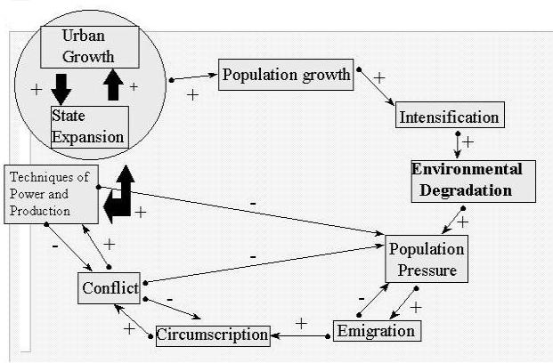
This is called an iteration model because it has an important positive feedback mechanism in which the original causes are themselves consequences of the things that they cause. Thus the process goes around and around, which is what has caused the world-systems to expand to the global level. Starting at the top we see population growth. The idea here is that all human societies contain a biological impetus to grow that is based on sexuality. This impetus is both controlled and encouraged by social institutions. Some societies try to regulate population growth by means of e.g. infanticide, abortion and taboos on sexual relations during nursing. These institutional means of regulation are costly, and when greater amounts of food are available these types of regulation tend to be eased. Other kinds of societies encourage population growth by means of channeling sexual energy toward reproduction, pro-natalist ideologies and support for large families. All societies experience periodic “baby booms” when social circumstances are somewhat more propitious for reproduction, and thus, over the long run, the population tends to grow despite institutional mechanisms that try to control it.
Intensification is caused by population growth. This means that when the number of mouths to feed increases greater efforts are needed to produce food and other necessities of life and so people exploit the resources they have been exploiting more intensively. This usually leads, in turn, to ecological degradation because all human production processes use up the natural environment. More production leads to greater environmental degradation. This occurs because more resources are extracted, and because of the polluting consequences of production and consumption activities. Nomadic hunter-gatherers depleted the herds of big game and Polynesian horticulturalists deforested many a Pacific island. Environmental degradation is not a new phenomenon. Only its global scale is new.
As Jared Diamond (1998) points out all continents around the world did not start with the same animal and plant resources. In West Asia both plants (barley and wheat) and animals (sheep, goats, cows, and oxen) were more easily domesticated than the plants and animals of Africa and the New World. Since domesticated plants and animals can more easily diffuse lattitudinally (East and West) than longitudinally (North and South) these inventions spread more quickly to Europe and East Asia than they did to Africa. These exogenous factors affect the timing and speed of hierarchy formation and technological development, as so climate change and geographical obstacles that affect transportation and communications. It is widely believed that the emergence of an early large state on the Nile was greatly facilitated by the ease of controlling transportation and communications in that linear environment, while the more complicated geography of Mesopotamia slowed stabilized the system of city-states and slowed the emergence of a core-wide empire. Patrick Kirch contends that it was the difficult geography of the Marquesas Island (short steep valleys separated by high mountains and treacherous coasts) that prevented the emergence of island-wide paramount chiefdoms, and kept the Marquesas in the “nasty bottom” of the iteration model.
The consequences of the above processes are that the economics of production change for the worse. According to Joseph Tainter (1988), after a certain point increased investment in complexity does not result in proportionate increasing returns. This occurs in the areas of agricultural production, information processing and communication, including education and maintenance of information channels. Sociopolitical control and specialization, such as military and the police, also develop diminishing returns. Tainter points out that marginal returns can occur in at least four instances: benefits constant, costs rising; benefits rising, costs rising faster; benefits falling, costs constant; benefits falling, costs rising.
When herds are depleted the hunters must go farther to find game. The combined sequence from population growth to intensification to environmental degradation leads to population pressure, the negative economic effects on production activities. The growing effort needed to produce enough food is a big incentive for people to migrate. And so humans populated the whole Earth. If the herds in this valley are depleted we may be able to find a new place where they are more abundant.
Migration eventually leads to circumscription. Circumscription is the condition that no new desirable locations are available for emigration. This can be because all the herds in all the adjacent valleys are depleted, or because all the alternative locations are deserts or high mountains, or because all adjacent desirable locations are already occupied by people who will effectively resist immigration.
The condition of social circumscription in which adjacent locations are already occupied is, under conditions of population pressure, likely to lead to a rise in the level of intergroup and intragroup conflict. This is because more people are competing for fewer resources. Warfare and other kinds of conflict are more prevalent under such conditions. All systems experience some warfare, but warfare becomes a focus of social endeavor that often has a life of its own. Boys are trained to be warriors and societies make decisions based on the presumption that they will be attacked or will be attacking other groups. Even in situations of seemingly endemic warfare the amount of conflict varies cyclically. Figure 7 shows an arrow with a negative sign going from conflict back to population pressure. This is because high levels of conflict reduce the size of the population as warriors are killed off and non-combatants die because their food supplies have been destroyed. Some systems get stuck in a vicious cycle of population pressure and warfare.
But situations such as this are also propitious for the emergence of new institutional structures. It is in these situations that semiperipheral development is likely to occur. People get tired of endemic conflict. One solution is the emergence of a new hierarchy or a larger polity that can regulate access to resources in a way that generates less conflict. The emergence of a new larger polity usually occurs as a result of successful conquest of a number of smaller polities by a semiperipheral marcher. The larger polity creates peace by means of an organized force that is greater than any force likely to be brought against it. The new polity reconstructs the institutions of control over territory and resources, often concentrating control and wealth for a new elite. And larger and more hierarchical polities often invest in new technologies of production that change the way in which resources are utilized. They produce more food and other necessaries by using new technologies or by intensifying the use of old technologies. New technologies can expand the number of people that can be supported in the territory. This makes population growth more likely, and so the iteration model is primed to go around again.
The iteration model has kept expanding the size of world-systems and developing new technologies and forms of regulation but, at least so far, it has not permanently solved the original problems of ecological degradation and population pressure. What has happened is the emergence of institutions such as states and markets that articulate changes in the economics of production more directly with changes in political organization and technology. This allows the institutional structures to readjust without having to go through short cycles at the messy bottom end of the model.
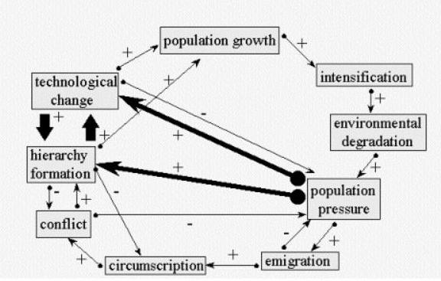Figure 7. Temporary Institutional Shortcuts in the Iteration Model
Another way to say this is that political and market institutions allow for some adjustments to occur without greatly increasing the level of systemic conflict. This said, the level of conflict has remained quite high, because the rate of expansion and technological change has increased. Even though institutional mechanisms of articulation have emerged, these have not permanently lowered the amount of systemic conflict because the rates of change in the other variables have increased.
It is also difficult to understand why and where innovative social change emerges without a conceptualization of the world-system as a whole. New organizational forms that transform institutions and that lead to upward mobility most often emerge from societies in semiperipheral locations. Thus all the countries that became hegemonic core states in the modern system had formerly been semiperipheral (the Dutch, the British, and the United States). This is a continuation of the long-term pattern of social evolution that Chase-Dunn Hall (1997) have called “semiperipheral development.” Semiperipheral marcher states and semiperipheral capitalist city-states had acted as the main agents of empire formation and commercialization for millennia. This phenomenon arguably also includes organizational innovations in contemporary semiperipheral countries (e.g. Mexico, India, South Korea, Brazil) that may transform the now-global system.
This approach requires that we think structurally. We must be able to abstract from the particularities of the game of musical chairs that constitutes uneven development in the system to see the structural continuities. The core/periphery hierarchy remains, though some countries have moved up or down. The interstate system remains, though the internationalization of capital has further constrained the abilities of states to structure national economies. States have always been subjected to larger geopolitical and economic forces in the world-system, and as is still the case, some have been more successful at exploiting opportunities and protecting themselves from liabilities than others.
In this perspective many of the phenomena that have been called “globalization” correspond to recently expanded international trade, financial flows and foreign investment by transnational corporations and banks. Much of the globalization discourse assumes that until recently there were separate national societies and economies, and that these have now been superseded by an expansion of international integration driven by information and transportation technologies. Rather than a wholly unique and new phenomenon, globalization is primarily international economic integration, and as such it is a feature of the world-system that has been oscillating as well as increasing for centuries. Recent research comparing the 19th and 20th centuries has shown that trade globalization is both a cycle and a trend.
The Great Chartered Companies of the seventeenth century were already playing an important role in shaping the development of world regions. Certainly the transnational corporations of the present are much more important players, but the point is that “foreign investment’ is not an institution that only became important since 1970 (nor since World War II). Giovanni Arrighi (1994) has shown that finance capital has been a central component of the commanding heights of the world-system since the fourteenth century. The current floods and ebbs of world money are typical of the late phase of very long “systemic cycles of accumulation.”
Most world-systems scholars contend that leaving out the core/periphery dimension or treating the periphery as inert are grave mistakes, not only for reasons of completeness, but also because the ability of core capitalists and their states to exploit peripheral resources and labor has been a major factor in deciding the winners of the competition among core contenders. And the resistance to exploitation and domination mounted by peripheral peoples has played a powerful role in shaping the historical development of world orders. Thus world history cannot be properly understood without attention to the core/periphery hierarchy.
Phillip McMichael (2000) has studied the “globalization project” – the abandoning of Keynesian models of national development and a new (or renewed) emphasis on deregulation and opening national commodity and financial markets to foreign trade and investment. This approach focuses on the political and ideological aspects of the recent wave of international integration. The term many prefer for this turn in global discourse is “neo-liberalism” but it has also been called “Reaganism/Thatcherism” and the “Washington Consensus.” The worldwide decline of the political left predated the revolutions of 1989 and the demise of the Soviet Union, but it was certainly also accelerated by these events. The structural basis of the rise of the globalization project is the new level of integration reached by the global capitalist class. The internationalization of capital has long been an important part of the trend toward economic globalization. And there have been many claims to represent the general interests of business before. Indeed every modern hegemon has made this claim. But the real integration of the interests of capitalists all over the world has very likely reached a level greater than at the peak of the nineteenth century wave of globalization.
This is the part of the theory of a global stage of capitalism that must be taken most seriously, though it can certainly be overdone. The world-system has now reached a point at which both the old interstate system based on separate national capitalist classes, and new institutions representing the global interests of capital exist, and are powerful simultaneously. In this light each country can be seen to have an important ruling class fraction that is allied with the transnational capitalist class. The big question is whether or not this new level of transnational integration will be strong enough to prevent competition among states for world hegemony from turning into warfare, as it has always done in the past, during a period in which a hegemon (now the United States) is declining.
The insight that capitalist globalization has occurred in waves, and that these waves of integration are followed by periods of globalization backlash has important implications for the future. Capitalist globalization increased both intranational and international inequalities in the nineteenth century and it has done the same thing in the late twentieth century (O’Rourke and Williamson 2000). Those countries and groups that are left out of the “beautiful époque” either mobilize to challenge the hegemony of the powerful or they retreat into self-reliance, or both.
Globalization protests emerged in the non-core with the anti-IMF riots of the 1980s. The several transnational social movements that participated in the 1999 protest in Seattle brought globalization protest to the attention of observers in the core, and this resistance to capitalist globalization has continued and grown despite the setback that occurred in response to the terrorist attacks on New York and Washington in 2001.
There is an apparent tension between those who advocate deglobalization and delinking from the global capitalist economy and the building of stronger, more cooperative and self-reliant social relations in the periphery and semiperiphery, on the one hand, and those who seek to mobilize support for new, or reformed institutions of democratic global governance. Self-reliance by itself, though an understandable reaction to exploitation, is not likely to solve the problems of humanity in the long run. The great challenge of the twenty-first century will be the building of a democratic and collectively rational global commonwealth. World-systems theory can be an important contributor to this effort.

REFERENCES
Amin, Samir.1997.Capitalism in the Age of Globalization. London: Zed Press.
Arrighi, Giovanni.1994. The Long Twentieth Century. London: Verso.
Bairoch, Paul. 1988. Cities and Economic Development: From the Dawn of History to
the Present. Chicago: University of Chicago Press.
Barfield, Thomas J. 1989. The Perilous Frontier: Nomadic Empires and China.
Cambridge, MA.: Blackwell
Chandler, Tertius 1987. Four Thousand Years of Urban Growth: An Historical Census.
Lewiston,N.Y.: Edwin Mellon Press
Chase-Dunn, Christopher. 1998. Global Formation. Lanham, MD: Rowman and
Littlefield
Chase-Dunn, C and Thomas D. Hall. 1997. Rise and Demise: Comparing World-Systems
Boulder, CO: Westview Press.
Chase-Dunn, C and Kelly M. Mann. 1998. The Wintu and Their Neighbors: A Very Small
World-System in Northern California Tucson: University of Arizona Press.
Chase-Dunn, C., Susan Manning and Thomas D. Hall. 2000. “Rise and Fall: East-West
Synchrony and Indic Exceptionalism Reexamined,” Social Science History
24,4:727-754.
Chase-Dunn, C. Daniel Pasciuti and Alexis Alvarez. 2005. “The Ancient Mesopotamian
and Egyptian World-Systems” forthcoming in Barry Gills and William R.
Thompson (eds.) The Evolution of Macrohistorical Systems. London: Routledge.
Chase-Dunn, C. and Alice Willard. 1993. "Systems of cities and world-systems:
settlement size hierarchies and cycles of political centralization, 2000 BC-
1988AD." Paper presented at the International Studies Association meeting,
March 24-27, Acapulco.
Chase-Dunn, Christopher and Bruce Lerro. 2005. Social Change: World Historical
Social Transformations. Boston: Allyn and Bacon.
Chase-Dunn, Christopher. 2004. “Modeling dynamic nested networks in pre-Columbian
North America” Presented at the workshop on “Analyzing Complex
Macrosystems as Dynamic Networks,” Santa Fe Institute, April 29-30.
Diamond, Jared. 1997. Guns, Germs and Steel: The Fates of Human Societies. New York: Norton
Hall, Thomas D. 2000. A World-Systems Reader: new perspectives on gender, urbanism,
cultures, indigenous peoples, and ecology. Lanham, MD: Rowman and Littlefield
Kirch, Patrick V. 1984. The Evolution of Polynesian Chiefdoms. Cambridge: Cambridge
University Press.
_____. 1991. "Chiefship and Competitive Involution: the Marquesas Islands of Eastern
Polynesia." Pp. 119-145 in Chiefdoms: Power, Economy and Ideology, edited by
Timothy Earle. Cambridge: Cambridge University Press.
Mann, Michael. 1986. The Sources of Social Power: A History of Power from the
Beginning to A.D. 1760. Cambridge: Cambridge University Press.
Marfoe, Leon. 1987. "Cedar Forest and Silver Mountain: Social Change and the
Development of Long-Distance Trade in Early Near Eastern Societies," Pp. 25-
35 in M. Rowlands et al Centre and Periphery in the Ancient World. Cambridge:
Cambridge University Press.
McMichael, Philip. 2000. Development and Social Change: A Global Perspective.
Thousand Oaks, CA: Pine Forge.
Modelski, George and William R. Thompson. 1995. Leading Sectors and World Powers:
The Coevolution of Global Politics and Economics. Columbia, SC: University
of South Carolina Press.
Modelski, George. 2003. World Cities, -3000 to 2000. Washington, DC: Faros 2000
O’Rourke, Kevin H. and Jeffrey G. Williamson. 2000. Globalization and History.
Cambridge, MA: MIT Press.
Pasciuti, Daniel 2003. “A Measurement Error Model for Estimating the Populations of
Cities,” http://irows.ucr.edu/research/citemp/estcit/modpop/modcitpop.htm
Shannon, Thomas R. 1996. An Introduction to the World-Systems Perspective. Boulder,
CO: Westview
Taagepera, Rein. 1978a. "Size and Duration of Empires: Systematics of Size" Social
Science Research 7:108-27.
______ 1978b. "Size and Duration of Empires: Growth-Decline Curves, 3000 to 600
B.C." Social Science Research 7:180-96.
______1979 "Size and Duration of Empires: Growth-Decline Curves, 600 B.C. to 600
A.D." Social Science History 3:115-38.
_______1997 “Expansion and Contraction Patterns of Large Polities: Context for
Russia.” International Studies Quarterly 41:475-504.
Tainter, Joseph A. 1988. The Collapse of Complex Societies. Cambridge: Cambridge
University Press.
Teggart, Frederick J. 1939. Rome and China: A Study of Correlations in Historical
Events Berkeley: University of California Press.
Thompson, William R. 1995. "Comparing World Systems: Systemic Leadership
Succession and the Peloponnesian War Case." Pp. 271-286 in The Historical
Evolution of the International Political Economy, Volume 1, edited by
Christopher Chase-Dunn. Aldershot, UK: Edward Elgar.
Turchin, Peter. 2003. Historical Dynamics. Princeton, NJ: Princeton University Press.
Wallerstein, Immanuel. 2000. The Essential Wallerstein. New York: New Press.
Wilkinson, David. 1987. "Central Civilization." Comparative Civilizations Review 17:31-
59.
______ 1992. "Cities, Civilizations and Oikumenes:I." Comparative Civilizations Review
27:51-87.
_______ 1993. “Cities, Civilizations and Oikumenes:II” Comparative Civilizations
Review 28.
Wright, Henry T. 1986. "The Evolution of Civilization." Pp. 323-365 in American
Archaeology, Past and Future: A Celebration of the Society for American
Archaeology, 1935-1985, edited by David J. Meltzer. Washington, D. C.:
Smithsonian Institutional Press.
EndNOTES
1. If we manage to get through several sticky wickets looming in the 21st century the human system will probably expand into the solar system, and so “globalization” will continue to be spatially expansive.

Chapter 14: The Modern World-System
From C. Chase-Dunn and B. Lerro, Social Change (forthcoming)

Three chapters that tell the story of the modern system chronologically since the fifteenth century will follow. But the unfolding story obscures certain general patterns that can only be see by looking at the whole system over the entire period of time since the 15th century. These patterns are the subject of this chapter. The modern system shares many similarities with earlier regional world-systems, but it is also qualitatively different from them in some important ways. Obviously it is larger, becoming global (Earth-wide) with the incorporation of all the remaining separate redoubts during the nineteenth century. The key defining feature of the modern world-system is capitalism. We have already seen the long emergence of those institutions that are crucial for capitalism (private property, commodity production, money, contract law, price-setting markets, commodified labor) over the previous millennia in Afroeurasia. But it was in Europe and its colonial empires that these institutions were able to take hold most strongly and to direct the fundamental dynamics of social change to so great an extent that we can speak of the first world-system in which capitalism was the predominant logic of development.
Capitalism has many definitions and its fundamental nature is still a matter of lively debate. We agree with those who define capitalism as an economic process of the accumulation of profits that interacts fundamentally with a geopolitical process of state-building, competition among states and increasingly large-scale political regulation involving institutions of coercion and governance. Capitalism is not solely an economic logic.
Some theorists contend that state power and “violence-producing enterprises” were only involved in setting up the basic underlying political conditions for capitalism during an age of “primitive accumulation” and once these institutions were in place capitalism began to operate as a purely economic logic of production, distribution and profit-making – so-called “expanded reproduction.” The world-systems perspective allows us to see that both economic and political institutions continue to evolve, and the central logic of capitalism is embedded in the dialectical dance of their co-evolution and expansion.
From a world-systems perspective the political body of capitalism is the interstate system rather than the single state. Single states all exist within a larger structure and set of processes that heavily influence the possibilities for social change. And the interstate system interacts with a core/periphery hierarchy in which powerful and more developed states and regions exploit and dominate less powerful and less developed regions.
States are just organizations that claim to exercise a monopoly of legitimate violence within a particular territory. They are not whole systems and they never have been. Much of contemporary social science treats national societies as if they are on the moon, with completely self-contained (endogenous) patterns of social change. That is even more a mistake for the modern world-system than it was for the more distant past.
Capitalism and capitalist states existed in earlier world-systems, but capitalism was only a sideshow within the commercializing tributary empires, while real capitalist states were confined to the semiperiphery. Capitalism became predominant in the modern system by becoming potent in the core. In the modern system the most successful states became those in which state power was used at the behest of groups who were engaged in commodity production, trade and financial services. State powers to tax and collect tributes did not disappear, but these became less important than, and largely subordinate to, more commercial forms of accumulation.
The very logic of capitalism produces economic, social and political crises in which elites jockey for position and less-favored groups try to protect themselves and/or to fundamentally change the system. Capitalism does not abolish imperialism but rather it produces new kinds of imperialism. Neither does it abolish warfare. It is not a pacific (warless) mode of accumulation as some have claimed (e.g. Schumpeter 1951). Rather the instruments of violence and the dynamics of interstate competition by means of warfare have been increasingly turned to serve the purposes of profitable commodity production and financial manipulations rather than the extraction of tribute. The growing “efficiency” of military technology produced in the capitalist world-system has made warfare much more destructive.
The core/periphery dimension is not abolished. On the contrary, the institutional mechanisms by which some societies can exploit and dominate others become more powerful and efficient and are increasingly justified by ideologies of civilization, development, foreign investment and foreign aid. “Backwardness” is reproduced and the world-system becomes even more divided between the included and the excluded than were earlier systems. The growing inequalities within and between national societies are justified by ideologies of productivity and efficiency, with underlying implications that some people are simply more fit for modernity than others. Nationalism, racism and gender hierarchies are both challenged and reproduced in a context in which the real material inequalities amongst the peoples of the world are increasing. This occurs within a context in which the values of human rights and equality have become more and more institutionalized, and so huge movements of protest and struggles over ideas and power occur. All this is characteristic, not only of the most recent period of globalization and globalization backlash, but of the whole history of the expansion of modern capitalism.
The similarities with earlier systems are important. There is a political-military system of allying and competing polities, now taking the form of the modern international system (studied mainly by political scientists who focus on international relations.) There are still different kinds of interaction networks with different spatial scales, though in the modern system many of the formerly smaller networks have caught up with the spatial size of the largest networks. Much of the bulk goods network is now global. One of the unusual features of the modern system in comparative perspective is that the differences in spatial scale among different kinds of networks has been greatly reduced, which makes its far easier for people to comprehend the complex networks in which they are involved.
The phenomenon of rise and fall remains an important pattern, albeit with some significant differences. As with earlier state-based systems, there is a structurally important interaction between core regions and less powerful peripheral regions. There remains an important component of multiculturalism in the system as a whole, a feature that is typical of most world-systems. Semiperipheral development continues. As discussed in Chapter 13, the rise of Europe was itself an instance of the emergence to global power of a region that was previously semiperipheral. And it is semiperipheral societies within the modern system that continue to be upwardly mobile and to restructure the institutions of the system. In these respects the modern system is quite similar to most of the earlier regional world-systems that contained states and hierarchies.
But the nature of the mode of accumulation is quite different and there are related other differences that are connected with the emergent predominance of capitalism. Both the pattern of rise and fall and the nature of core/periphery relations are significantly different. Since accumulation is predominantly capitalist and the most powerful core states are also the most important centers of capitalist accumulation, they do not use their military power to conquer other core states in order to extract revenues from them. In world-systems in which the tributary mode of accumulation is predominant, semiperipheral marcher states conquer adjacent core states in order to extract resources and erect “universal” empires. Similar versions of this strategy have been attempted in the modern system (e.g. the Hapburgs in the 16th century, Napoleon at the end of 18th century, Germany in the 20th century), but they have failed. The tributary mode of production is not gone, and indeed even modern capitalist hegemons employ “accumulation by dispossession” (Harvey 2003), especially when they are in decline, but a major difference between the modern capitalist world-system and earlier tributary systems is that the balance between coercion and consensus has shifted in favor of consensus. This is an important part of what Karl Marx meant when he claimed that capitalism, though not the best of all possible worlds, is indeed progressive relative to systems in which the tributary modes of accumulation were predominant.
Another sense in which capitalism may be thought of as progressive is its effects on technological change. Technological change has been a crucial aspect of human social evolution since the emergence of speech. The rate of innovation and implementation increased slowly as societies became more complex, but capitalism shoves the rate of technological change toward the sky. This is because economic rewards are more directly linked to technological innovation and improvements in production processes. There are, to be sure, countervailing forces within real capitalism, as when large companies sit on new technologies that would threaten their existing profitable operations. But because permanent world-wide monopolies do not exist (in the absence of a world state), the efforts of the powerful to protect their profits have repeatedly come under attack by a dynamic market system and competition among states. The institutionalization of scientific research and development has also added another strong element to the development and implementation of new technologies, so that in the most developed countries rapid technological change and accompanying social changes have become acceptable to people despite their disruptive aspects. This is a major way in which the modern world-system differs from earlier systems. Social change of all kinds has speeded up.
Another major difference between the modern system and earlier state-based systems is in the way in which the cycle of rise and fall occurs. The hegemonic sequence (the rise and fall of hegemonic core states) is the modern version of the ancient oscillation between more and less centralized interstate systems. As we have seen, all hierarchical systems experience a cycle of rise and fall, from “cycling” in interchiefdom systems to the rise and fall of empires, to the modern sequence of hegemonic rise and fall. In tributary world-systems this oscillation typically takes the form of semiperipheral marcher states conquering older core states to form a core-wide empire. (see Figure 1). Figure 1 contrasts the structure of a core-wide empire with that of a more multicentric system in which one state is the hegemon. 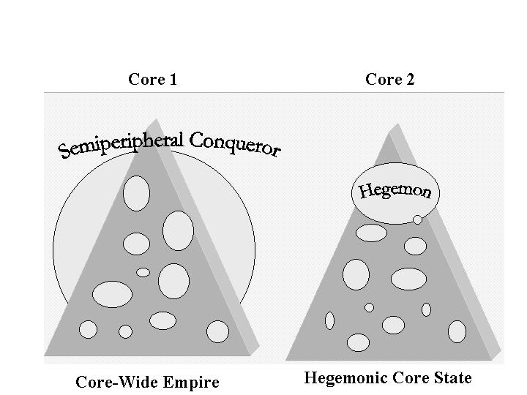
Figure 1: Core-Wide Empire vs. Hegemonic Core State
One important consequence of the coming to predominance of capitalist accumulation has been the conversion of the rise and fall process from semiperipheral marcher conquest to the rise and fall of capitalist hegemons that do not take over other core states. The hegemons rise to economic and political/military preeminence from the semiperiphery, but they do not construct a core-wide world state by means of conquest. Rather, the core of the modern system oscillates between unipolar hegemony and even more multicentric hegemonic rivalry.

Capitalist accumulation usually favors a multicentric interstate system because this provides greater opportunities for the maneuverability of capital than would exist in a world state. Big capitals can play states off against one another and can escape movements that try to regulate investment or redistribute profits by abandoning the states in which such movements attain political power.
Another difference produced by the rise of capitalism is the way in which imperialism is organized in a capitalist world-system. The predominant form of modern imperialism has taken the form of what has been called “colonial empires.” Rather than conquering ones immediate neighbors to make an empire, the most successful form of core/periphery exploitation in the modern system has involved European core states establishing political and economic controls over distant colonies in the Americas, Asia and Africa. To be sure, the old kind of imperialism continued to exist for centuries as the Ottoman, and Russian Empires expanded and the Manchus from semiperipheral northern Asia managed to conquer China in a classic example of the semiperipheral marcher state. Even in Europe the old strategy did not disappear. We have already mentioned the Hapsburg attempt to convert the nascent capitalist world economy into a tributary empire, and the French and German efforts of much more recent centuries also bear some of the marks of the older form of empire. But the most successful form was the colonial empire, and it evolved from the early efforts by Portugal and Spain into the later Dutch, French and British Empires, and then morphed into a less obvious kind of “neo-colonialism” in the relationship between the United States and Latin America after the 1880s.
There is another important difference between the modern core/periphery hierarchy and the earlier Afroeurasian system in the nature of core/periphery relations. The ability to extract resources from peripheral areas has long been an important component of successful accumulation in state-based world-systems and this is also true for the modern world-system. But there is an interesting and important difference -- the reversal of the location of relative intrasocietal inequalities. In state-based world-systems core societies had relatively greater internal inequalities than did peripheral societies. Typical core states were urbanized and class-stratified while peripheral societies were nomadic pastoralists or horticulturalists or less-densely concentrated peoples living in smaller towns or villages. These kinds of peripheral groups usually had less internal inequality than did the core states with which they were interacting.
In the modern world-system this situation has reversed. Core societies typically have less (relative) internal inequality than do peripheral societies. The kinds of jobs that are concentrated in the core, and the eventual development of welfare states in the core, have expanded the size of the middle classes within core societies to produce a more-or-less diamond-shaped distribution of income that bulges in the middle. Typical peripheral societies, on the other hand, have a more pyramid-shaped income distribution in which there is a small rich elite, a rather small middle class, and a very large mass of very poor people.
This reversal in the location of relative internal inequality between cores and peripheries was mainly a consequence of the development and concentration of complex economies needing skilled labor in the core and the politics of democracy and the welfare state that have accompanied capitalist industrialization.
These processes have occurred in tandem with, and dependent upon, the development of peripheral capitalism, colonialism, and neo-colonialism in the periphery, which have produced the greater relative inequalities within peripheral societies. Core capitalism is dependent upon peripheral capitalism in part because exploitation of the periphery provides some of the resources that core capital sometimes uses to pay higher incomes to core workers. Furthermore, the reproduction of an underdeveloped periphery legitimates the national capital/labor alliances that have provided a relative harmony of class relations in the core and undercut radical challenges to capitalist power (Chase-Dunn 1998:Chap. 11). We do not claim that all core workers compose a "labor aristocracy" in the modern world-system. Obviously groups within the core working class compete against each other and some are downsized and streamlined, etc. in the competition of core capitalists with one another. But the overall effect of core/periphery relations has been to undercut challenges to capitalism within core states by paying off some core workers and groups and convincing others that they should support and identify with the “winners.”
In premodern systems core/periphery relations were also important for sustaining the social order of the core (e.g., the bread and circuses of Rome), but not to the same extent, because the system did not produce relatively more equal distributions of income and political power in the core than in the periphery. Thus the core/periphery hierarchy has become an even more important structural feature of the modern world-system than it was in earlier tributrary systems. This change in structure corresponds to the relatively greater stability of power structures in the modern world-system because of the relatively greater harmony of class interests within the core. While bread and circus dynamics operated in Rome, they were far less developed than the welfare state apparati and entertainment industries of the modern system.
Another important difference is that the Central System before 1800 contained three non-adjacent core regions(Europe/West Asia; South Asia; and East Asia), each with its "own" core/periphery hierarchy, whereas the rise of the European core produced a global system with a single integrated set of core states and a global core/periphery hierarchy. This brought about the complete unification of the formerly somewhat separate regional world histories into a single global history.
Political ecologists have argued that capitalism is fundamentally different from earlier modes of accumulation with respect to its relationship to the natural environment (O’Conner 1989, Foster 2000). There is little doubt that the expansion and deepening of the modern system global capitalism has had much larger effects on the biogeosphere than any earlier system. There are many more people using hugely increased amounts of energy and raw materials, and the global nature of the human system has global impacts on the environment. Smaller systems were able to migrate when they depleted local supplies or polluted local natural resources and this relationship with the environment has been a driving force of human social change since the Paleolithic. But is all this due only to capitalism’s greater size and intensity, or is there also something else which encourages capitalists to “externalize” the natural costs of production and distribution and produces a destructive “metabolic rift” between capitalism and nature (Foster 2000)?
Capitalism, in addition to being about market exchange and commodification, is also fundamentally about a certain kind of property – private property in the major means of production. Within modern capitalism there has been an oscillating debate about the virtues of public and private property, with the shift since the 1980s toward the desirability of “privatization” being only the most recent round of a struggle that has gone on since the enclosures of the commons in Europe.
The ongoing debate about the idea of the “commons” –collective property-- is germane to understanding the relationship between capitalism and nature. The powerful claims about the commons being a “tragedy” because no one cares enough to take care of and invest in public property carries a powerful baggage that supports the notion that private ownership is superior. Private owners are supposed to have an interest in the future value of the property, and so they will keep it up, and possibly invest in it. But whether or not this is better than a more public or communal form of ownership depends entirely on how these more collective forms of property are themselves organized.
Capitalism seems to contain a powerful incentive to externalize the natural costs of production and other economic activities, and individual capitalists are loathe to pay for the actual environmental costs of their activities as long as their competitors are getting a free ride. This is a political issue in which core countries in the modern capitalist system have been far more successful at building institutions for protecting the national environment than non-core countries. And, indeed, there is convincing evidence that core countries export pollution and environmental degradation to the non-core (Jorgenson 2004).
Certainly modern capitalism has been more destructive of the natural environment than any earlier system. But it is important to know whether or not this is completely due to its effects on technology and the rapidity of economic growth, or whether or not there is an additional element that is connected to the specific institutions and contradictions of capitalism. Technological development, demographic expansion and economic growth cause problems for the environment. But are there better alternatives? And is capitalism more destructive of the environment than earlier modes of accumulation net of its demographic and technological effects?
Undoubtedly the human species can and must do better at inventing institutions that protect the geobiosphere. Regarding earlier modes of accumulation, certainly some cultures did better than others at protecting the environment. The institutions of law, the state and property evolved, in part, as a response to environmental degradation (recall our “iteration model” in Chapter 2). It is not obvious that contemporary capitalist institutions are worse than earlier ones in this regard. The main problem is that the scale and scope of environmental degradation has increased so greatly that very powerful institutions and social movements will be required to bring about a sustainable human civilization. Capitalism may not be capable of doing this, and so those theoretical perspectives that point to the need for a major overhaul may be closer to the point than those that contend that capitalism itself can be reformed to become sustainable.
The Schema of Constants, Cycles, Trends and Cyclical Trends
Most histories of the modern world tell a story, and we shall do the same in the following chapters. But here we will begin with a model, as if the modern world-system were a great machine or a superorganism. The systemic analogy will be stressed at this point so that we can see whether, and in what ways, the basic system has changed in the chapters that follow. One way to help us think about the modern world-system as a whole is to describe its structures and processes in terms of patterns that are more or less constant, those that are cyclical, and those that are upward (or downward) trends. And some important characteristics of the whole system, like globalization, are both cycles and trends. This means that there are waves of globalization in the sense of larger and more intense interactions, and that these waves also go up over time – an upward trend. Patterns of this kind are called trending cycles. Figure 2 illustrates what we mean by constants, cycles, trends and trending cycles.
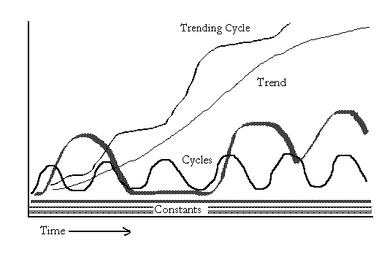
Figure 2: Constants, Cycles, Trends and Trending Cycles
The structural constants are:
1. Capitalism -- the accumulation of resources by means of the production and sale of commodities for profit under conditions in a which a significant proportion of the major means of production are privately held;
2. An interstate system -- a system of unequally powerful sovereign states that compete for resources by supporting profitable commodity production and by engaging in geopolitical and military competition;
3. A core/periphery hierarchy -- in which core regions have strong states and specialize in high-technology, high-wage production while peripheral regions have weak states and specialize in labor-intensive and low-wage production.
These structural features of the modern system are continuous and reproduced, and they also have evolved. They are interlinked and interdependent with one another such that any major change in one would necessarily alter the others in fundamental ways (Chase-Dunn, 1998).
In addition to these structural constants, there are several other structural features that are systemic continuities even though they involve patterned change. These are the systemic cycles, the systemic trends and the trending cycles. The basic systemic cycles are:
1.The Kondratieff Wave (K-wave) -- a worldwide economic cycle with a period of from forty to sixty years in which the relative rate of economic activity increases (during "A-phase" upswings) and then decreases (during "B-phase" periods of slower growth or stagnation).
2. The hegemonic sequence -- the rise and fall of hegemonic core powers in which military power and economic comparative advantage are concentrated into a single hegemonic core state during some periods and these are followed by periods in which wealth and power are more evenly distributed among core states. Examples of hegemons are the United Provinces of the Netherlands in the seventeenth century, the United Kingdom of Great Britain in the nineteenth century and the United States of America in the twentieth century.
3. The cycle of core war severity -- the severity (battle deaths per year) of wars among core states (world wars) displays a cyclical pattern that has closely tracked the K-wave since the sixteenth century (Goldstein, 1988).
The systemic trends that are normal operating procedure in the modern system are:
1. Expansion and deepening of commodity relations -- land, labor and wealth have been increasingly mediated by market-like institutions in both the core and the periphery.
2. State-formation -- the power of states over their populations has increased everywhere, though this trend is sometimes slowed down by efforts to deregulate. State regulation has grown secularly while political battles rage over the nature and objects of regulation.
3. Increased size of economic enterprises -- while a large competitive sector of small firms is reproduced, the largest firms (those occupying what is called the monopoly sector) have continuously grown in size. This remains true even in the most recent period despite its characterization by some analysts as a new "accumulation regime" of "flexible specialization" in which small firms compete for shares of the global market.
4. Increasing capital-intensity of production and mechanization -- several industrial revolutions since the sixteenth century have increased the productivity of labor in agriculture, industry and services.
5. Proletarianization -- the world work force has increasingly depended on labor markets for meeting its basic needs. This long-term trend may be temporarily slowed or even reversed in some areas during periods of economic stagnation, but the secular shift away from subsistence production has a long history that continues in the most recent period. The expansion of the informal sector is part of this trend despite its functional similarities with earlier rural subsistence redoubts.
6. The growing gap -- despite exceptional cases of successful upward mobility in the core/periphery hierarchy (e.g. the United States, Japan, Korea, Taiwan) the relative gap in incomes between core and peripheral regions has continued to increase, and this trend has existed since at least the nineteenth century, and probably before.
And there have been two trending cycles that oscillate up and down with intermittent peaks that are higher than all those before.
1. International economic integration (economic globalization) - the periodic and long-term growth of trade interconnectedness and the transnationalization of capital. Capital has crossed state boundaries since the sixteenth century but the proportion of all production that is due to the operation of transnational firms has increased in every epoch. Trending waves of trade and investment globalization have been quantitatively measured since the early 19th century (Chase-Dunn, Kawano and Brewer 2000).
2. International political integration (political globalization) - the emergence of stronger international institutions for regulating economic and political interactions. This is a trend since the rise of the Concert of Europe after the defeat of Napoleon. The League of Nations, the United Nations and such international financial institutions as the World Bank and the International Monetary Fund show an upward trend toward increasing global governance.
The above basic model of the modern system is not posited to deny that the system has evolved, but rather to make it possible to see clearly the new organizational features that have emerged over the past 600 years and to enable us to correctly compare new developments with the relevant features of the past. The schema above suggests a system that is experiencing expanding cycles of growth and confronting contradictions that require new organizational solutions, but this is not to suggest a purely functionalist process of adaptation and learning. Struggle over the very nature of social change has been present all along and remains entirely relevant for comprehending the emerging situation of the 21st century.
The trends in the shares of world population shown in Figure 3 (below) confirm observations that were discussed in Chapter 13. Figure 3 shows shares of the total global population since the beginning of the Common Era two thousand years ago according to Maddison’s (2001) estimates. The time scale on the horizontal axis of Figure 3 is misleading because the intervals are not equal. Keeping this in mind we can see that the countries that became hegemonic in recent centuries did not change much in terms of their shares of world population. The countries with the big shares, India and China, still have huge shares, though India declined quite a lot until 1950 and then began again to rise. China peaked in 1820 and has mainly been declining since then. The United States rose above 5% of world population in 1913 and dropped below that level in about 1985. East Asia and South Asia have long been the demographic centers of the Earth, but have become somewhat less so over the past two millennia.

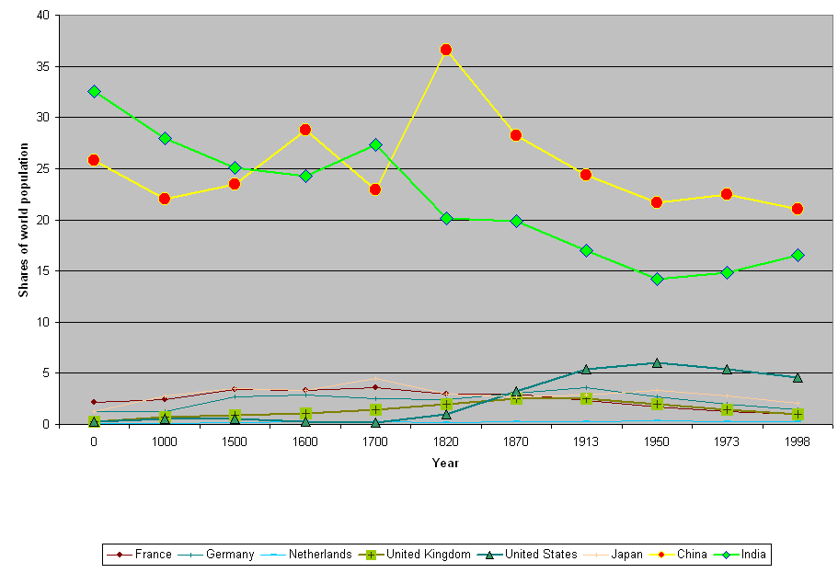
Figure 3: Shares of world population
Maddison’s (2001) estimates of GDP also allow us to examine the ratio between the GDP per capita in regions and countries to the world average GDP per capita. This is a useful indicator of economic hegemony, though it does not capture military, cultural or the finer points of even economic power. Figure 4 (below) traces this ratio for some of the European “great powers,” the United States and Japan since 1500. Again the time dimension is distorted, with earlier years receiving much less on the x axis than later years receive.
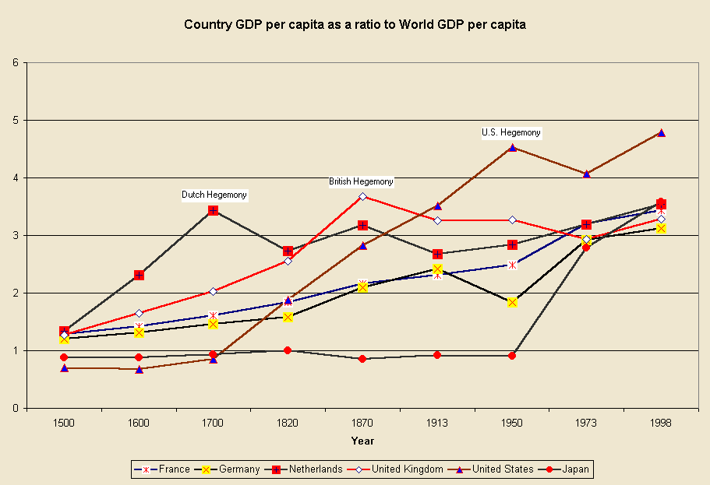
Figure 4: Country GDP per capita as a ratio to Average World GDP per capita, 1500-1998
Figure 4 shows the three hegemonies of the modern world-system (the Dutch in 17th century, the British in the 19th century, and the U.S. in 20th century, with quantitative data from Maddison (2001). It also shows that each of these successive hegemonies achieved a higher level of economic development relative to the general world level that its predecessor.
Waves of Colonial Expansion and Decolonization
The crusades against Moslem control of the old West Asian core and the reconquest of the Iberian Peninsula constitute the first wave of European expansion, as we have already discussed in Chapter 13. This was the effort of a reviving Europe to strike back against the expansion of Islam and to reopen the trade with Asia. It was followed by another wave of expansion that began slowly in the fifteenth century with Portugal’s establishment of colonial control of Ceuta (in Africa just across the strait of Gibralter from Gibralter) in 1415, and of Madeira, an island in the Atlantic that was important for sailing down the coast of Africa.
Under Prince Henry the Navigator the Portuguese were set on a course of rounding the African continent as a route to the East in order to break the Venetian monopoly on the spice trade. On the way they were able to gain access to important sources of West African gold and to develop an interest in the slave trade. This was the first burst of modern European colonial empire of the type described above. The Portuguese were encouraged and financed by the bankers of Genoa, who were competing with Venice for a better position in the Eastern trade. Thus did a semiperipheral capitalist city-state (Genoa) throw in with an ambitious nation-state (Portugal) on a global gamble that would have vast implications for the rise of the West. As Immanuel Wallerstein (1974b) has pointed out, there was no emperor of Europe to tell Prince Henry and the Genovese that they could not do this. At about the same time the Ming dynasty in China was recalling its fleets and battening down to concentrate its resources on expanding the Great Wall against Central Asian steppe nomads. The European interstate system was becoming institutionalized around the diplomatic protocols developed on the Italian peninsula among capitalist city-states in the southern sector of the “blue banana.”
The years between 1415 and 1420 saw the beginning of Portugal’s long circumcolonization of Africa. This was the first bump that one can see on the left side of Figure 5 (below). These were the settlement and establishment of sovereignty over Ceuta and Madeira. The Spanish grabbed the Canary Islands off the coast of Africa beginning in 1479, and then went for the New World.
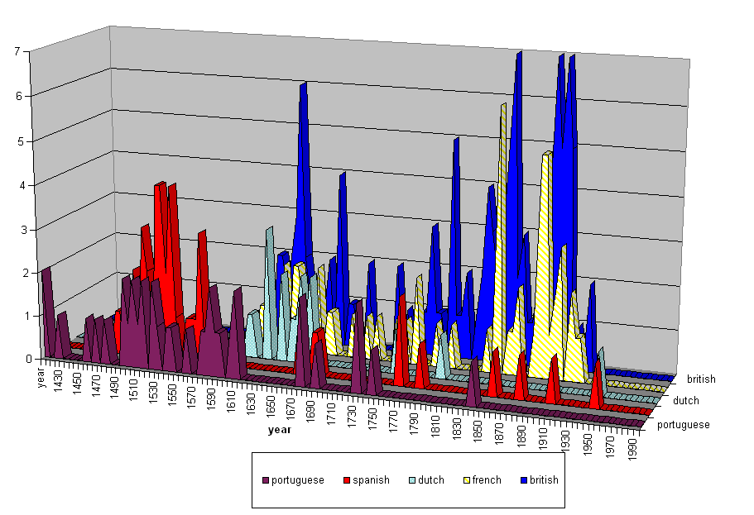
Figure 5: Colonies established by major European colonial powers
Portugal and Spain were the major players in the 16th century wave European colonial expansion. In the seventeenth century the Dutch, English and French moved out to produce another wave of expansion, in which the Spanish and the Portuguese also continued to expand their control of overseas territories. It is easier to see the successive waves of expansion in Figure 6 (below) in which all of the colonial “mother” countries shown in Figure 5 have been combined. But are there three more waves?, or just one long bumpy one that began in the 18th century and erratically reaches a crescendo in late 19th century with the Berlin Conference on Africa (in which the European powers divided the territory of the African continent amongst themselves)?

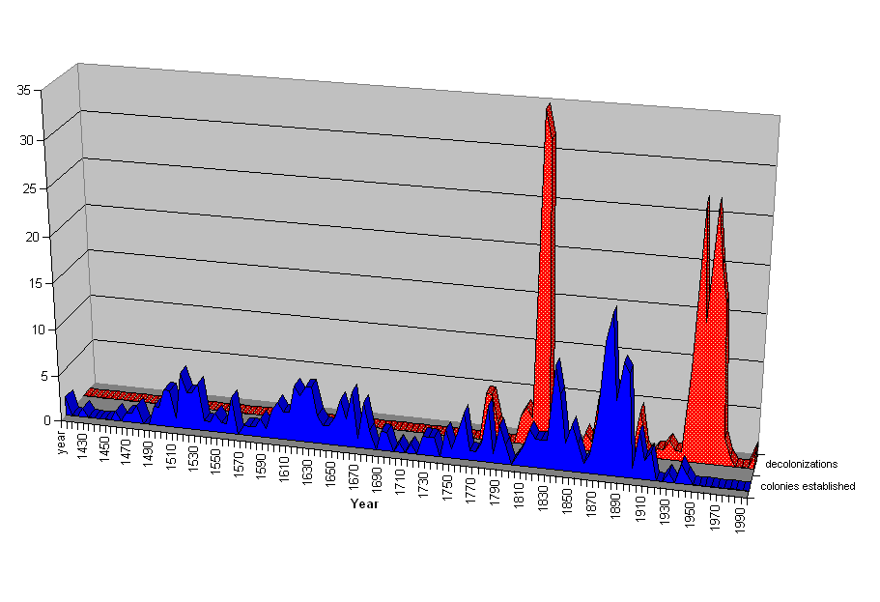
Figure 6: Waves of European Colonial Expansion and Waves of Decolonization
The waves of European colonial expansion were not only carried out by different countries in different time periods. The colonial empires had important cultural and structural differences as well, and the eras of colonialism were different because the needs and natures of both the colonizers and the colonized varied. Nevertheless, there is an important overarching reality to the whole process of European expansion that is shown in Figures 5 and 6.
Figure 6 also depicts waves of decolonization. The victims of colonialism were not inert or faceless peoples who simply were overwhelmed by the Europeans. They fought back, and eventually they succeeded at establishing, or reestablishing, at least formal sovereignty and political self-governance. The waves of decolonization started only in the late 18th century, the most famous example of which is the “American revolution.” Sometimes called “the first new nation,” the English colonies that became the United States were harbingers of rebellion against the colonial empires and modern imperialism, a story we shall retell from the perspective of the world in Chapter 17. While the British burned the capitol building in Washington to the ground in 1812 trying to recoup their losses, British covert policy, agents, money and “privateers” supported rebellions in Latin America against the Spanish, the Portuguese and the French. The early nineteenth century liberation of Spanish America was also supported by the fledgling United States, then still a semiperipheral state in the larger system.
The next big wave of decolonization began mainly after World War II and lasted well into the 1960s. This was the final establishment of formal sovereignty and the extension of membership in the interstate system to Asia, Africa and the Pacific. Like waves of colonial expansion, the waves of decolonization were somewhat different from one another. But as a singular phenomenon of the world-system as a whole, these constituted a major restructuring of the system from one of colonial empires to a globe-wide interstate system based on formalities of national sovereignty and the equality of nations.
The other side of this story is about neo-colonialism. In part because of its own history as former colonies, the United States spurned formal colonialism, but its rise to core status and eventual hegemony required the development of techniques for controlling and exploiting peripheral regions in the absence of the trappings of formal empire. The U.S. began practicing “gun boat diplomacy” in Latin America in order to get its way in local politics, and the institutional capabilities of informal control made possible what has been termed “neo-colonialism.” The power disparities between the core and the periphery continued to expand despite the abolition of the colonial empires, though the achievement of formal sovereignty has led to an increased level of autonomy in the non-core. Like the British in the early 19th century, the U.S. in the 20th century generally supported the decolonization of the empires of competing core powers, while at the same time it fought wars to prevent the emergence of regimes that were deemed to threaten the interests of the United States. So Cuba, the Phillipines, Puerto Rico, Guatemala, the Dominican Republic, and Vietnam saw U.S. military intervention as the raw face of neocolonialism. The colonial empires are gone, but not imperialism.

Endnotes

The definition we employ is explained and discussed in Chapter 2. “Capitalism is based on the accumulation of profits by the owners of major means of the production of commodities in a context in which labor and the other main elements of production are commodified.”
Karl Marx’s theory of expanded reproduction presented in Volume 1 of Capital proposes such an understanding. Marx defines capitalism as commodity production using wage labor, and so fully developed capitalism only emerges with the English industrial revolution. He sees modern colonialism as precapitalist because coercion is often directly used in the mobilization of labor power (e.g. slavery). World-system theorists have contended that what happened in the periphery was and continues to be essential for what occurs in the core, and peripheral capitalism must be understood as a constitutive and necessary institution that is part and parcel of the structural logic of capitalism. This said, Marx’s pithy portrayal (as translated from the German by Moore and Aveling) of the run-up to industrial capitalism remains one of the most powerful brief renditions of the roots of modernity. The discovery of gold and silver in America, the extirpation, enslavement and entombment in mines of the aboriginal population, the beginning of the conquest and looting of the East Indies, the turning of Africa into a warren for the commercial hunting of black skins, signalised the rosy dawn of the era of capitalist production. These idyllic proceedings are the chief momenta of primitive accumulation. On their heels treads the commercial war of the European nations, with the globe for a theatre. It begins with the revolt of the Netherlands from Spain, assumes giant dimensions in England’s Anti-Jacobin War, and is still going on in the opium wars against China, &c. (Marx 1967: 751). Karl Marx, Capital, Vol. 1, Chapter 21, “Genesis of Industrial Capital” [1887 (1967:751)] Frederic Engels (ed.), translated from the 3rd German edition by Samuel Moore and Edward Aveling. New York: International Publishers
This is likely to be true of future world-system as well, though the form of the power cycle may change.
A core-wide empire has sometimes been called a "universal empire" by world historians such as Arnold Toynbee (1947). Immanuel Wallerstein’s (1974b) distinction between a “world-empire” and a “world-economy” points to this same difference in the degree of centralization of a state system. The term world-empire has sometimes been used to refer to single tributary states such as Sassanid Iran (e.g., Foran 1993), but this is a mistaken usage because all tributary states are involved in trade of basic goods with other regions. Thus they are not whole world-systems but are rather parts of systems.
Earlier examples of colonial empires were the sea-borne imperial enterprises of those maritime semiperipheral capitalist city-states who captured distant political and economic vantage points in order to carry out long distance trade.
. The increased inequality of wealth and income in the United States since the 1980s are in the direction of a Third World-like stratification system, but the remaining differences are still very large.
The contemporary focus on transnational corporate sourcing and the single interdependent global economy is the heightened awareness produced by a trending cycle long in operation.
Coded from Henige (1970). Ottoman and Manchu conquests were not included because they were not included in Henige and are not understood to have been products of modern colonialism. Also not included were new colonies created from old colonies, redivisions of existing colonies, and colonial transfers (colonies taken from other powers). The criteria we used to determine when a colony should be included were: it had to be both claimed and settled and it could not have been settled and claimed by another country previously. Territorial expansions were also documented in the data sets. Double counting was avoided. So territories taken from other modern colonial powers were not counted. Temporary settlements of short duration (e.g. Roanoke) were not counted. The idea was to capture the territorial expansion of European colonial sovereignty. Chapter 19: The World-System Since 1945: Another Wave of Globalization, Hegemony and Revolutions 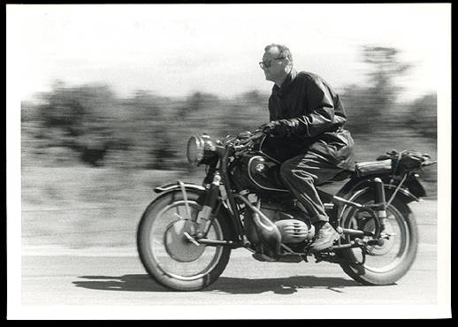 Radical sociologist C. Wright Mills The second half of the twentieth century was a relatively peaceful era of economic development and the golden age of U.S. hegemony. The Cold War between the U.S. and the Soviet Union provided a justification for the U.S. to extend credits to other societies for national development and for the Soviet Union to sponsor urbanization, education and industrialization in its Eastern European satellites. Another wave of national liberation movements in the remaining colonies brought independence and the trappings of national sovereignty to Africa and Asia. The demographic transition to lower birth rates continued to spread, but so did the transition to greater longevity and lower mortality rates, so the world population continued to rapidly increase, becoming more than 6 million by the end of the century. Cities continued to grow and in some areas this produced city-regions – dense concentrations of large cities with suburbs in between them. Country-folk in non-core countries increasingly moved to dwell in large urban areas and so by the end of the century over half of the human population of the Earth lived in large cities. Another great wave of globalization and the falling costs of communication and transportation brought the peoples of the world into much greater contact with one another, and two more world revolutions (1968 and 1989) once again challenged and restructured the institutions of global and national governance. America’s Half Century Those enlightened conservatives who wanted to take the rough edges off of capitalism in order to preserve it invented the New Deal and a global development project based on Keynesian economic policies. The intent was to overcome the perceived dangers of speculative capitalism and state communism that ran wild in the 1920s and the beggar-thy-neighbor economic nationalism that took hold during the deglobalization of the 1930s. The New Deal addressed the problems of overproduction and underconsumption by supporting the rights of workers to organize unions to collectively bargain with employers over wages and working conditions. In the U.S. the Wagner Act of 1935 provided legal protections to union organizers. Henry J. Kaiser, a progressive industrialist based in California, encouraged the workers at his steel and shipbuilding plants to organize their own independent labor unions. Corporate businessmen and wealthy families in the older Eastern industries and politicians from the U.S. south opposed this enlightened conservatism. In order to get New Deal legislation passed President Franklin Delano Roosevelt had to make compromises. Southern Dixiecrats (conservative Democrats) demanded that agriculture not be included in the New Deal labor legislation. The rising potential military challenge from Japan in the Pacific was a powerful argument for industrializing the U.S. West. Eastern steel companies acquiesced in allowing new steel production in the West, but only under certain conditions. The Fontana steel mill in Southern California, built by Kaiser, had to be located far enough from water transportation to make its products too expensive to survive during peacetime (Davis 1994). Thus did the New Deal contain important aspects of the old deal. The Congress of Industrial Organizations (C.I.O), with strong leadership provided by the American Communist Party, organized less skilled workers and the unemployed, and tried to overcome white racism in the labor movement by encouraging cooperation between black and white workers. In 1934 the American Communist Party had over a million members. That was the year of the San Francisco general strike, in which longshoremen and sailors led a successful organizing effort that resulted in radical unions taking control of hiring at all the west coast ports of the United States. This victory and other important struggles signaled the growing power of the C.I.O. World War II was a replay of World War I. But now the Japanese challenge and the German challenge came together in time, and on the same side. This required the U.S. to fight wars in Europe and in the Pacific at the same time. Only a supersized superpower could bring this off. The war also ushered in the nuclear age. The “Manhattan Project” succeeded at detonating a plutonium implosion bomb near Alamagordo, New Mexico in 1945, that physicist J. Robert Oppenheimer described as “brighter than a thousand suns.” In August of the same year the U.S. dropped two bombs that obliterated the Japanese cities of Hiroshima and Nagasaki, ostensibly to save lives by ending the fighting more quickly. But the U.S. monopoly on nuclear weapons of mass destruction was short-lived. The U.S. and the Soviet Union had become allies in the fight against Nazi Germany in the war, but this evolved rapidly into the Cold War and a “balance of terror” arms race after the Soviet Union acquired nuclear weapons. After World War II the United States actively took up the mantle of global multilateral hegemony. The establishment of the United Nations and the Bretton Woods institutions – the International Monetary Fund and the World Bank -- was a further move toward political globalization. The Marshall Plan facilitated the rebuilding of the Western European national economies by means of massive U.S. lending. A similar approach was employed in East Asia, where developmental states were supported in Japan and later in Korea, and U.S. corporations were prevented from buying up key domestic sectors of the Japanese and Korean economies. Getting support from conservatives in the U.S. for all these far-reaching global initiatives was not easy. And President Roosevelt, the great architect of the New Deal, died in April of 1945. His Vice President was Harry Truman, and Truman was elected President in a very close race with Henry Wallace, the candidate of the Progressive Party, in 1948. Truman was able to get the acquiescence of the heartland conservatives for the Marshal Plan and other international programs because he painted these as part of the effort to contain Communism and to protect and develop “the Free World.” Thus did the Cold War, a global confrontion between different visions of the human future, serve as a powerful political justification for U.S. hegemony and an important contributor to the further expansion of capitalist globalization. The C.I.O. and the Communist Party (CP) emerged as powerful in certain unions and sectors in the U.S. after World War II. Many sympathizers with the radical labor movement had been badly put off by the U.S. Communist Party’s support for the Hitler-Stalin pact before World War II. But the CP played an important role in organizing workers in the steel and auto industries before and during World War II. Julius and Ethel Rosenberg were accused of passing the secret of the atomic bomb to the Soviet Union and were tried and executed for treason. Senator Joseph McCarthy from Wisconsin led a crusade to expose Communists and “fellow-travelers” in the federal government and higher education. And a battle took place within the labor movement between those radicals who wanted to fundamentally challenge the rule of capital and those other labor leaders who only wanted the workers that they represented to get a larger share of the pie. Joe McCarthy’s methods were unscrupulous and many innocents suffered until those who supported civil rights were able to prevail over the witch-hunt.? But the “business unionists” prevailed over the reds in most of the struggles within the labor movement in the U.S. The prospect of an expanding U.S-led hegemonic project with a growing economy and an expanding middle class tilted in favor of class harmony rather than class struggle, at least within the core of the world-system. The business unionists won out in most of the labor movement because capitalism was able to incorporate a broad sector of the core working class into its developmental project as national citizens and consumers. The wave of decolonization after World War II produced another spate of “new nations” in Asia and Africa. American leadership needed a development ideology that could compete with Soviet and Chinese Communism. The experiences of the Age of Extremes and the demands of the Cold War produced a consensus on Keynesian national development as the main project of the American hegemony and the reformist alternative to communism. All these factors reduced the salience of world parties and transnational social movements, and further increased the legitimacy of national societies as the totemic unit of world political and social organization. By constituting the world order as a set of separate national societies, each with its own allegedly unique history and culture, nationalism became an even stronger dimension of the institutional structure of the world-system than it had been in the nineteenth century. Transnational political organizations and non-national forms of solidarity based on class, religion and ethnicity, continued to operate, but they were upstaged by national states and international organizations such as the United Nations and the Bretton Woods international financial institutions (the World Bank and the International Monetary Fund) in which national states were the main constituent members. The “new nations” of the periphery had a strong motive to support this institutional structure because they had only recently gained at least formal national sovereignty, and they had high hopes of using this new autonomy to modernize and develop their societies without the obstacles posed by colonialism. The Bandung Conference (Asian-African Conference) of 1955 was organized by non-core (so-called Third World) states, mainly former colonies, that wished to pursue policies that were non-aligned with either the Soviet Union or the West.? This non-aligned movement was an important development in the political representation of the non-core, and recent efforts to organize solidarity among peoples of the global south owe a great debt to the legacy of the Bandung Conference. But even the non-aligned states did not encourage their citizens to directly participate in transnational political decision-making. Global governance became increasingly defined as the representation of national societies. Figure 19.1 (below) shows changes in the distribution of shares of world Gross Domestic Product (GDP)? among countries from 1820 to 2000 based on the estimates of national GDP produced by Angus Maddison (1995, 2001). Shares of world GDP are not an ideal indicator of hegemony because they include simple economic size, which is an important but insufficient aspect of relative power among states. A large country with a lot of people will have a large GDP. But if we look at changes in the world shares over time we can see the trajectories of hegemony that we have been discussing. In Chapter 14, Figure 14.4 we showed the Dutch, British and U.S. hegemonies in a graph of the last 500 years. Geopolitical hegemony is a relative, not an absolute, concept. The Dutch are no longer the fore-reachers of the capitalist world economy, but the Queen of the Netherlands still owns many of the stately mansions on embassy row (Massachusetts Avenue) in Washington, DC, renting them to the countries that can afford this prestigious location. And Amsterdam is still an important center of world financial services nearly four centuries after the peak of Dutch hegemony in 1630. Figure 19.1 shows the trajectories of individual European countries, the U.S., Japan, and lumps together those European Countries who had joined the European Union by 1992. 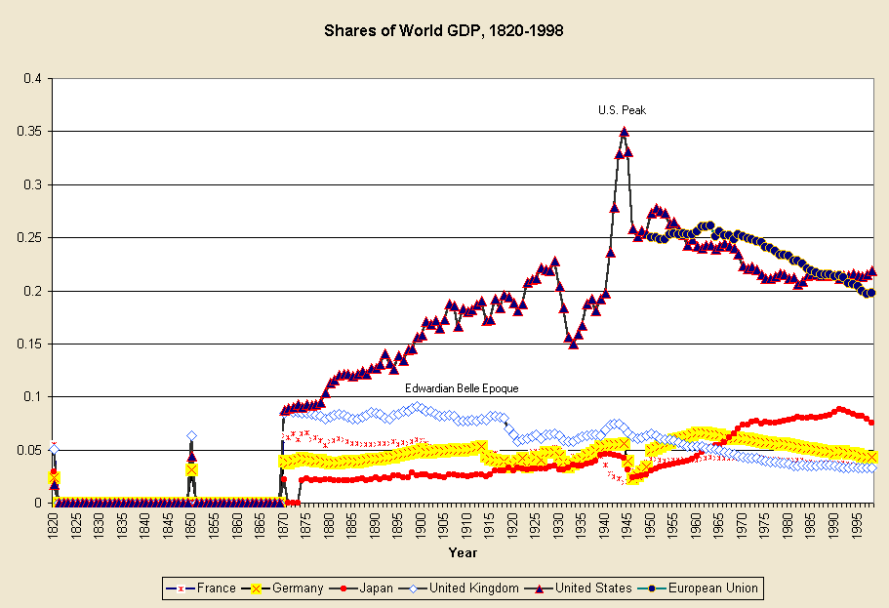 Figure 19.1: Shares of World GDP, 1820-1998 Sources: Maddison 1995, 2001. The most striking feature of Figure 19.1 is the rapid ascent of the U.S. economy in its size relationship with the world economy as a whole – from less than 2% in 1820 to a peak of 35% in 1944. The U.S. share slumped precipitously from 1929 to 1933, and then rapidly ascended again to its highest point in 1944. A rapid post-World War II decline was followed by a slight recovery that began in 1949 and then, beginning in 1951, a decline until 1958, then a plateau until 1968, then another decline until 1982, followed by another plateau until 1998 at between 21 and 22%. The U.S. GDP trajectory shown in Figure 18.3 strongly supports the contention that U.S. economic hegemony rose and then declined in the twentieth century.? But some of the details of the timing contradict certain accounts of the U.S. trajectory. By the measure of shares of world GDP the U.S. decline began in 1944, not in the late 1960s as some world-systems analysts have claimed. There were three steps of U.S. decline, the first beginning in 1944, the second in 1951 and the third in 1968. As mentioned above, the U.S. share of world GDP had become larger than that of Britain by 1880. The stair-step nature of both hegemonic rise and hegemonic decline can be seen in the U.S. trajectory in Figure 19.1. Economic hegemony is a matter of staying ahead of the game relative to competitors. New lead industries are the key, and each modern hegemon has tended to move from consumer goods to capital goods and then to financial services (Wallerstein 1984). As discussed in Chapter 16, Britain’s first wave of industrial leadership was in the production of cotton textiles, which then spread to other countries. Then Britain became the leading producer of machines, steam engines, railroads and steam ships, both for its own home market and for markets across the globe. As competition in these sectors increased, and profits declined, British capital shifted into financial services and making money on money. This, and a continuing predominance in global telecommunications, were the economic bases of the belle epoque. For the U.S. the sequence was similar, though the particular industries were different, and the whole trajectory was somewhat modified because of the much greater size of the U.S economy relative to the sizes of other core powers and to the world economy as a whole. While Britain’s home market was that of an island nation, the U.S. came to encompass a continent-sized home market, which was a big advantage in international competition. U.S. industrial hegemony emerged with the development of the oil industry and the production of automobiles. These were the new lead industries and generative sectors (Bunker and Ciccantell 2205) that further transformed the built environment of the North American continent and then the world. As cotton textile manufacturing had in the British hegemonic rise, the automobile industry spread abroad and profits went down because of increased competition. The U.S. managed to stay ahead of the curve by developing electronic technology (the telephone, vacuum tubes, the transistor and the computer chip) and information technology (Hugill 1999). But these also moved abroad and became more competitive, and new possible high tech industries (e.g. biotechnology and nanotechnology) have been slow to move out of the research and development phase. So U.S. investors, like the British in the belle époque, have increasingly moved into financial services with the huge advantage that the U.S. economy is such a large portion of the whole world economy that making money on the U.S. dollar and financial services is much less of a challenge than making money on the pound Sterling had been. After World War II U.S. military expenditures had returned to peacetime levels, but they went back up during the Korean War, and after that military spending remained a very large proportion (nearly half) of the U.S. federal expenditures. Thus the economic boom of the 1950s was stimulated in part by government spending – so-called “military Keynesianism.” U.S. federal expenditures in the name of “defense” were used to subsidize key industries in the United States and to stimulate the development of new lead technologies, especially the transistor. And the government also acted to prevent the phone company, American Telegraph and Telephone (AT&T), whose Bell Labs had invented the transistor with federal grant support, from monopolizing and sitting on the new technology. As the world’s biggest owner of traditional switching devices and vacuum tube amplifiers, AT&T had a lot of investment in the old technologies that solid-state electronics made obsolete. Despite the vaunted fecundity of private entrepreneurs, many of the techno-miracles of advanced capitalism were first developed with heavy financial support and organizational intervention from the U.S. federal government -- e.g. nuclear energy, the transistor, and the Internet. The most recent phase of financialization of the world economy has expanded the realm of virtual capital (based on securities that ostensibly represent future income streams) to a far greater extent than earlier financial expansions did. New instruments of financial property have multiplied and information technology has facilitated the expansion of trading of securities in new venues located in the older financial cities and in the so-called “emerging markets” of the less developed countries (Arrighi 1994; Henwood 1997). The post-World War II expansionary boom was based on new lead manufacturing industries in the United States, some of which spread to Japan and to Europe, especially Germany. In the 1970s Japan and Germany caught up with the United States in manufacturing and the profit rate declined (Brenner 2002). This profit squeeze in core manufacturing encouraged an expansion of investment in financial services that was the beginning of the huge wave of financialization that has ballooned since the 1970s. Lending to non-core countries expanded rapidly and there was a large debt crisis in the 1980s in which many non-core countries in Asia, Africa and Latin America were unable to make the payments on external debt that they had committed to make (Suter 1992). This development was not unusual. The capitalist world economy has experienced waves of debt crises since at least the 1830s when many states within the United States, as well as countries in Latin America, defaulted on foreign loans. Usually the house of cards collapses. The symbolic claims on future income are devalued, and the real economy of goods production, trade and services starts up again with a reduced set of property claims and symbols of value. But this did not happen in the 1980s debt crisis. There was no collapse. Rather the bankers of the core cooperated with one another and engineered a renegotiation of the terms of indebtedness of the non-core countries. This an important indicator of the relatively high degree of cooperation achieved by the world’s bankers by the time of the 1980s and it supports the contentions of those who see the emergence of an increasingly integrated transnational capitalist class (Sklair 2001; Robinson 2004). But one result of this new level of cooperation is that the huge mountain of “securities” -- claims on future income streams -- has continued to grow larger and larger such that it now dwarfs the real world economy of production, trade and services. In the past financial collapses periodically brought the domains of purely symbolic and material values back into balance with one another. The continuous rapid expansion of what some call “fictitious capital” since the 1970s appears to have altered some of the basic rules of the capitalist economy and has led many observers to claim that the old rules have been transcended by the new information economy. Whether that turns out to be the case in the long run remains to be seen. The economy of the United States regained some of its lost share of world GDP in the 1990s. This was mainly due to financialization and a real estate investment boom based on a large inflow of capital investment from abroad. Though other national currencies have not been pegged to the U.S. dollar since the 1970s, the United States continues to enjoy what historical sociologist Michael Mann (2006) calls “dollar seignoriage.” The only use for surplus U.S. dollars held abroad was now to invest them in the US. Since most were held by central banks, they bought U.S. Treasury notes in bulk, which lowered their interest rate. U.S. adventures abroad could now be financed by foreigners, despite American current account deficits, and at a very low interest rate. The alternative, the foreigners felt, was worse: disruption of the world’s monetary system, weakening U.S. resolve to defend them, and a fall in the value of the dollar, making U.S. exports cheaper than their own. Hudson (2003: 20) concludes “This unique ability of the U.S. government to borrow from foreign central banks rather than from its own citizens is one of the economic miracles of modern times.” This miracle of economic imperialism meant that U.S. governments were now free of the balance of payments constraints faced by other states (Mann 2006). The European Union is shown in Figure 19.1 as if it already existed in 1950, though in reality it was not formally constituted until 1992. This is so we can see that those twelve European core countries that joined together in 1992 had a downward trajectory in terms of shares of world GDP that was similar to that of the United States. What was happening in this period was the rise of Japan (see Figure 19.1) and the rise of the newly industrializing countries in the semiperiphery (e.g. China, India, Korea, Taiwan, Brazil, etc.). These rises partly account for the relative downward trend in shares of both the U.S. and the E.U. The Global Settlement System The ancient volcano form of the city that had emerged with the first cities in Mesopotamia 5000 years ago, had survived the industrial revolution and railroads, but it succumbed to the car-based multicentric suburban and edge-city settlement structure when residences and work became organized around mass individual motorcar transportation (see Figures 19.2 and 19.3). 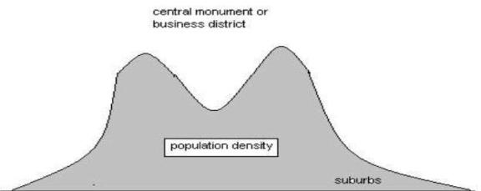 Figure 19.2: The volcano model of urban structure 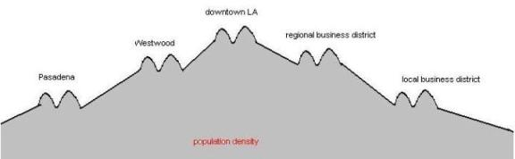 Figure 19.3: The multicentric pattern of automobile-based urban structure As mentioned in Chapter 18, the global population continued to move into cities in the twentieth century, so that the proportion of the total population living in rural areas continued to fall and the sizes of cities continued to rise. But the world city size distribution flattened out after 1950. New York had been both the largest city and the biggest center of business in the world since it grew larger than London in 1925, but after World War II other cities began to catch up with New York in terms of population size. Tokyo-Yokohama became as large as greater metropolitan New York City by 19xx, and then other cities such as Sao Paolo, Mexico City and Shanghai began to catch up (Chase-Dunn and Willard 199x). It seems that there is a contemporary growth ceiling on the population size of the largest cities that is around 20 million, and that cities in both the core and the semiperiphery are catching up to this ceiling. Some of the megacities of the non-core have become among the largest settlements on Earth. ? The other thing that is happening to the global settlement system is the formation of large city-regions. The whole eastern half of the United States is an urbanized region in which nearly contiguous suburbs connect formerly cities with one another. Europe is another city region of this kind. The structure of the world settlement system can be seen in Figure 19.4, which shows city lights at night as recorded from satellites and in photographs taken by shuttle astronauts. 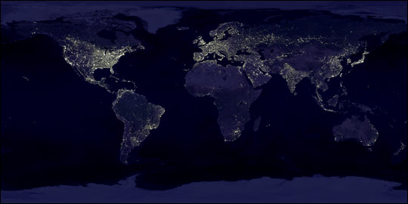 Figure 19.4: City lights from satellite and shuttle images The Final Wave of Decolonization Core countries mobilized soldiers from their colonies to fight in World War II, and when these soldiers returned home they demanded citizenship rights and sovereignty for their homelands. Movements for decolonization and sovereignty had been emerging since the earlier wave of late eighteenth century and early nineteenth century decolonizations (See Figure 16.4 in Chapter 16). After World War II the U.S. was able to quickly build a global network of military bases by providing political and financial support to European powers to help them continue to control their colonial empires. Thus did the U. S. accomplish in a few years what it had taken the British Empire centuries to achieve – an intercontinental system of military power. This was made possible because the U.S. utilized the colonial structures that had been erected by the other European powers (Go 2007). In return for financial support the U.S. gained locations for military bases as well as agreements to allow trade and investment. But the post-war decolonization movements became increasingly militant and in many cases they received encouragement from the Soviet Union. The principle of national self-determination had long been an important pillar of European civilization, and now the colonized peoples asserted that they too were citizens, not subjects. And in this they found support from the Soviet Union, but also from the UN. Declaration of Human Rights. Eventually the U.S. also became a supporter of decolonization. Just as Britain had claimed the moral high ground by stopping the slave trade and supporting Latin American independence in the early 19th century, the United States proclaimed itself the leader of “Free World” and began to support (or did not oppose) most non-communist independence movements in the colonies of the other core powers. The U.S. intervened covertly or overtly in countries in Latin America, Asia and Africa where emerging nationalist or leftist movements appeared to be likely to align with the Soviet Union or to threaten the property rights of U.S. companies (e.g. Nicaragua, Guatemala, the Dominican Republic, the Congo, and eventually Vietnam, etc.). But the wave of decolonization that began in the years after World War II was eventually successful in extending at least the formal trappings of national sovereignty to nearly the entire periphery, creating a global system of national states for the first time. 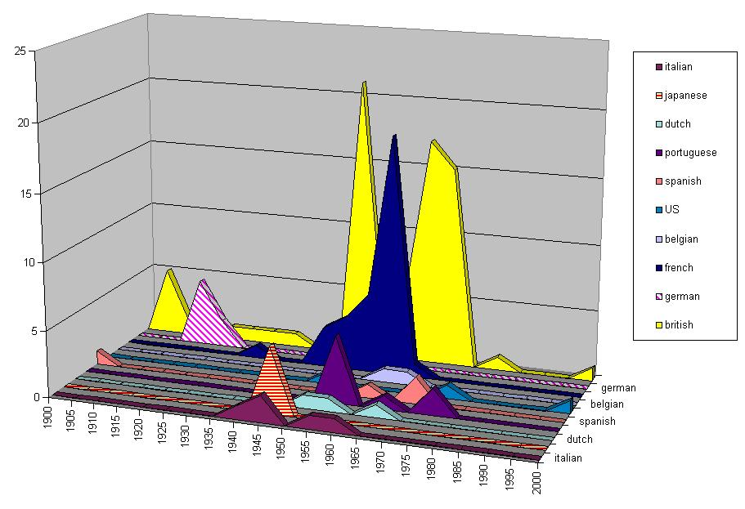 Figure 19.5:Twentieth Century Decolonization- Last Year of Colonial Governors (Source: Henige 1970) Figure 19.5 shows the last year in which a territory had a colonial governor. The main reason why colonial governors were sent home in this period was the great wave of decolonization after World War II in which former colonies became sovereign states. Exceptions were the African colonies taken from Germany at the end of World War I (note the diagonally-lined pyramid in Figure 18.7 in 1915. These became French and British “protectorates” that eventually gained formal sovereignty only after World War II. By the time Japan’s colonies were taken from it at the end of World War II it had become acceptable to go quickly to formal sovereignty, as did Korea and Taiwan, rather than having to pass through a long period in the status of protectorate. The horizontally-lined triangle in Figure 19.5 represents Japan’s former colonies – Korea, Manchuria and Taiwan. Another thing that Figure 19.5 shows is that the timing of the dismantling of the French and British Empires was somewhat different. The British experienced two big waves, while the French had a single wave. But from a world-historical point of view these were minor variations, parts of an overall global phenomenon in which formal colonialism had ceased to be an acceptable practice of global governance. The enshrinement of the Universal Declaration of Human Rights as a foundational document of the United Nations, and the virtual abolition of formal colonialism was as big a step toward global democracy as the abolition of large-scale slavery and serfdom had been in the nineteenth century. The very idea of empire in the formal sense was thrown into the dustbin of history, but huge global inequalities yet remained, and they were socially structured by the legacies of colonialism and by the continuing operation of the political and economic institutions of global governance. Rise and Demise of the Welfare State Political incorporation generally meant gaining the right to vote in the election of representatives in governments that increasingly became legitimated from below rather than from above. Monarchies are usually based on the idea that the king represents a divinely sanctioned moral order – the so-called divine right of kings. This was an extension of the notion of the sacred chiefs, that some people – the elites-- are closer to god or the ancestors or have great influence or control over the powers of the universe. Democracy is the idea that governance is legitimated from below. Polities have increasingly tended to be legitimated as existing to serve the people. It has become commonly asserted that government is based on a social contract in which the purpose of law is to serve the needs of the whole population of citizens, and in some states policies have increasingly been shaped by the will of average citizens (Tilly 2007). Core states incorporated workers, and eventually women and students, by extending political, civil and welfare rights. The capitalist welfare state emerged in somewhat different ways in each country and with different political configurations that depended on the nature of the economy and the kind of class structures that existed. The shift from divine to demographic legitimacy enhanced the claims of “men of no property” to be allowed to participate as equals in political decision-making. Democratic participation had formerly been constituted as the political rights of aristocrats, and this had usually restricted voting rights to those who owned significant amounts of property. In the nineteenth century many states extended the franchise to most adult males regardless of property qualifications, and eventually to adult females as well. In the twentieth century the capitalist welfare state expanded further to take responsibility for the provision of mass public education, public health regulations (clean water, etc.), publicly provided health care and retirement security. These expansions of the welfare state became strongly institutionalized in most of the European core states, especially after World War II, and a somewhat narrower version emerged in the United States as well. The differences have to do with the ways in which welfare rights were constructed. In some states, especially those with ethnically homogenous populations, rights became construed as applying to all citizens. In other states the legal institutionalization of welfare rights was tied to the status of soldier or was connected with particular types of employment rather than being universal citizen rights. In the U.S. the development of citizenship and welfare rights was complicated by the federal system and the way in which the party system was related to regional differences. The Democratic Party claimed to represent workers and urban populations in the north, but in the south it was the creature of conservative whites (Dixiecrats) who had opposed the extension of citizenship to blacks and who managed to get agriculture excluded from the protections of the New Deal labor and welfare legislation. The rights of citizenship and federal welfare programs in the U.S. had been tied to service in the armed forces since the Civil War (Skocpol 1992). Even the post-World War II expansion of the welfare state in the U.S. was importantly tied to the soldier status – the GI Bill of Rights that extended housing and education credits to veterans. Thus was national patriotism again linked to global order as the expansion of the U.S. welfare state became an important source of support for the world-wide military network that was charged with protecting the “free world.” This was the form that social imperialism took in the last half of the twentieth century. The militarized welfare state in the U.S. was also linked to race relations. White racism stood in the way of universal welfare programs that would benefit all citizens equally because white working class people could be mobilized against programs that would benefit the non-white poor. Racism was also an important factor when welfare programs were attacked and dismantled in the 1980s and 1990s (Reese 2005). Before and during World War II the armed services were racially segregated, and platoons of black soldiers and sailors were used to do unusually dangerous and dirty jobs. In 1948 President Truman ordered the desegregation of the armed forces. The actual desegregation of the U.S armed forces took quite awhile to accomplish beyond the formal declaration but its eventual success shows that racial inequalities can indeed be eliminated by strongly supported policies. Racial segregation was a huge embarrassment to the U.S. federal government as it took up the mantle of leadership of the free world. Critics of the U.S. hegemony and foreign policy both at home and abroad pointed to the public racism that was especially visible in the U.S. South. And so federal policies began to turn against the most visible and formal aspects of institutional racism, adding a new twist to the racialized and militarized shape of the welfare state in the United States (Winant 19xx). Bretton Woods and Keynesian National Development In 1944 representatives of the 45 countries that had been Allies against the Axis powers in World War II met in Bretton Woods, New Hampshire to found a new set of international economic institutions that were designed to try to prevent the kinds of dysfunctional economic problems that had emerged in the 1920s and the 1930s. The International Monetary Fund was set up to help countries maintain stable currencies by creating a fund to make short-term loans. International currency speculation was curtailed by pegging currencies to the U.S. dollar. The World Bank was set up as the International Bank for Reconstruction and Development to help countries recover from the disruption and destruction of the war and to help less developed countries industrialize. These institutions, and the policies they were designed to support, were greatly shaped by the writings of the British economist John Maynard Keynes (1936). Keynes’s studies of what had happened in the international economy in the 1920s and 1930s had strong implications for the ways in which national government policies should intervene in the economy in order to take the rough edges off of the boom and bust cycles of capitalist development and to encourage full employment. Keynesian economics enjoins governments to use monetary adjustments in interest rates to even out the boom and bust cycles of capitalist development. In order to do this states need to be able to control their money supplies by printing more money to keep interest rates low or to tighten the money supply to increase interest rates in order to slow inflation. The Bretton Woods institutions were originally designed to help each country to develop industrial production that was owned by businessmen within the country. International investments were not discouraged, but global accounting systems were put in place in the International Monetary Fund’s Balance of Payments Yearbook that allowed international investments and profit repatriations to be tracked. Keynes also proposed the creation of an international clearing union that would help to even out international inequalities by creating incentives for countries with trade surpluses to invest in countries with trade deficits. This proposal was opposed by the leader of the U.S. delegation at the Bretton Woods conference, Harry Dexter White, and the clearing union did not come to pass (Monbiot 2003:159-169). This was the international face of the New Deal. It was a global order that was designed to produce national development by expanding mass education and raising labor productivity in the non-core countries. The Roosevelt administration strongly supported both the founding of the Bretton Woods institutions and the United Nations. The main purpose of the United Nations was to implement “collective security” by creating a mechanism that would allow countries to resolve their conflicts without resort to warfare. This was also a reaction to the Age of Extremes, in which two devastating world wars had occurred. The founding conference of the United Nations was held in San Francisco in 1945. Franklin Delano Roosevelt seriously considered proposing that the headquarters of the U.N. should be located on Niihau, a small island off the coast of Kauai in the Hawaiian archipelago. Roosevelt wanted the new proto world government to strongly symbolize the incorporation of Asia into the new institutions of global governance. China, one of the Allied Powers in World War II, became a founding member of the U.N. Security Council. Roosevelt’s global New Deal also involved a massive funding of reconstruction in Europe that became known as the Marshall Plan. And Roosevelt acted to prevent U.S. corporations from gaining control of the conquered Japanese economy after World War II. Both Japan and Korea were protected from “Latin Americanization” by the U.S. federal government’s policies, thereby laying the foundation for the developmental states that emerged in these two countries (Arrighi 1994). The complicated deal allowed Japanese zaibatsu (family-based business conglomerates) to control the major industries of the Japanese economy, but proscribed them from competing in the aircraft industry. The purposes of these policies were to stimulate trade partners for American businesses, but also to produce strong developmental states friendly to the United States that could help contain Communism within the borders of China and the Soviet Union. Thus did semiperipheral state communism help to induce the expansion of core capitalism (Boswell and Chase-Dunn 2000). This incorporation of Asia, and especially Japan, into the circle of core countries required confronting racism toward Asians within the United States. In California, where fears of the “yellow peril” had been inculcated since the Gold Rush, the requirement that the locals should be polite to the Japanese was a hard sell, but a group of internationalists among the regional elites stepped forward to insist on equal treatment for Asians. This did not eliminate racism, but it did set a standard in which tolerance was expected and overt racist behavior was disapproved. The Boom and the Bubble The post-war boom was a further expansion of core capitalism that incorporated formal-sector workers in the core and expanded the size of the middle class in some of the non-core countries as well. In the U.S. it was a period of interstate highway construction, suburbanization and the expansion of higher education. More families could afford to own their own homes, and this was supported by government-sponsored housing credits. Increasing sales buoyed the automobile industry and automobile workers, now members of the United Auto Workers union, were earning good wages and working full-time. The lunch buckets were full. Mass production of standardized goods that were affordable to the working class became known as Fordism because this model was touted and implemented by Henry Ford in the early decades of the twentieth century. Ford opposed labor unions, but the Fordist model of industrial organization came to incorporate a more positive attitude toward unions that sought better wages and working conditions for their members in the period after World War II. This was part of the Keynesian effort to encourage full employment and to pay workers enough so that they could purchase the products produced by large capitalist firms. Manufacturing was also growing in Europe and Japan, and the U.S. naval forces protected the seas so that oil from distant ports could be globally delivered in larger and larger tanker ships mentioned above. Developmental states under the sponsorship of the United States emerged in Japan and in Korea (Evans 19xx). Japan’s reemergence as a strong and competitive economic power after World War II is shown in Figure 19.1 above. The Japanese developmental state combined a highly professional planning bureaucracy with strong links to large family-owned business conglomerates called Zaibatsu and nationally coordinated higher education and research and development capabilities. The Japanese model developed business practices that were later adopted all over the world with the shift from Fordism to flexible specialization. Japan built the biggest ports, the biggest ships, and gained access to cheap energy and raw materials imported from distant continents. Korea, a Japanese colony from 1913[check] to the end of World War II, emulated the Japanese model with the help of both the U.S. and Japan. And Taiwan, another former Japanese colony, also joined the club of newly industrializing societies. The Chinese diaspora of the 19th century had spread migrants from China to Thailand, Singapore, and Indonesia as well as to the United States and the Caribbean. Giovanni Arrighi (2008) has contended that the East Asian regional system after World War II retained aspects of the earlier trade-tribute system that had existed before the Western states surrounded China in the 19th century. The U.S. took over the role that China had played in the earlier system, a somewhat paternalistic power that acted to facilitate development by sustaining developmental states in Japan, Korea and Taiwan. This stance by the U.S. was justified to the American public and European as containing Russian and Chinese communism (Cumings 19xx). It also provided a context which allowed Japan to become an important economic center in East Asia despite having been defeated in World War II and which subsequently allowed China to re-emerge as large and strong economy and a regional power after the Maoist era. The World Revolution of 1968 But all was not happy, even during the great post-war boom. The middle class expanded, more people went further in school and had decent jobs, more owned their own homes and had cars, and the homes had labor-saving appliances, making housework less onerous. The Frankfurt school had come to the conclusion that Marx had made a mistake in not analyzing more deeply the cultural processes of capitalism. Political scientists and sociologists wrote about the emergence of mass society in which middle-class consumers came under the sway of mass media that promoted social consensus and depolarized class struggle. The middle class did expand. But not everyone was pleased. In the U.S. South black people were still kept from voting and were insulted every day by public segregation practices. The Civil Rights movement emerged to challenge racist institutions, and college students, now an expanded group that had not yet been fully incorporated into political life as citizens, brought the Civil Rights movement to the north. Radical sociologist C.Wright Mills wrote about the power elite, a governing class that manipulated the political process in order to have its way (Mills 19xx; Hayden 2006). Mills and an important group of other U.S. intellectuals, especially those associated with the independent Marxist journal, Monthly Review, were inspired by the Cuban Revolution that overthrew the rule of General Fulgencia Batista in 1959, and hoped that serious challenges to the rule of capital would re-emerge within the U.S. The Vietnam War was a failed attempt by the U.S. to prevent the emergence of a Communist regime in Southeast Asia. Perceived by radical students and some black leaders as a return to imperialism, the anti-war and civil rights movements brought forth the World Revolution of 1968. In 1962 students who had been involved in the civil rights movement in the South returned to campuses in the north and came together to form the Students for a Democratic Society (SDS). Tom Hayden wrote “the Port Huron Statement” for a founding conference of SDS in 1962 (Hayden 2006). In 1964 students at the University of California in Berkeley found their political activities on campus restricted by a policy of “in loco parentis” that treated them as if they were children despite that they had the right to vote and were seasoned political activists some of whom had been on the front lines of the civil rights movement in the south. The Free Speech Movement at Berkeley mobilized students around their own interests and radicalized large numbers. In 1966 Mao Zedong launched the Great Proletarian Cultural Revolution in China by mobilizing young “Red Guards” for the purpose of revitalizing the Chinese revolution. The news from China and Mao’s philosophy spread widely across the globe as radicalized young people looked for critical alternatives to the mainstream mass media pablum. The People’s Republic of China flooded the world with inexpensive translations of Mao’s “Little Red Book” and other essays by Mao and classical Marxist texts. Radical students joined with militant workers in France and Italy in huge demonstrations. There were also important manifestations and violent government crackdowns in Argentina and Mexico and the populist “liberation theology” of radical Catholic priests spread to both the core and the non-core. In the U.S. “the New Left” attacked electoral politics and the welfare state as counter-revolutionary and undemocratic fig leaves hiding the power of capital. As had happened in the past, radical social movements spun out of one another. Feminists criticized the macho Marxists leading the student movement and went on to form their own groups, thus revitalizing the movement for the equality of women that had emerged out of the abolitionist movement in the 19th century. The environmental movement was reborn as more people became aware of the massive ecological degradation produced by industrial capitalism. The youth movement produced a critique of the sexual mores of middle class society, and proponents of alternative forms of sexual expression mobilized to assert their rights. Hallucinogenic drugs became popular as a way of protesting middle class norms, and added to the stew of resistance and revolution in the years around 1968. The Neoliberalism Counter-revolution In the 1970s the Organization of Petroleum Exporting Countries (OPEC) organized a cartel and raised the price of crude oil. At the same time Japanese and European manufacturing caught up with the United States and the increasing competition caused a profit squeeze. The international monetary system erected at Bretton Woods had pegged national currencies to the U.S. dollar and the dollar was denominated at a low “official” gold price that became more and more deviant from the market price of gold as time passed. In the 1970s the rise of other currencies in value relative to the dollar put financial pressures on the U.S., and the Nixon administration unilaterally rescinded the Bretton Woods monetary agreement, allowing national currencies to trade against one another in a global market for money. The profit squeeze and other pressures led to reneging on the New Deal social contract that had been established after World War II. In California a state referendum called Proposition 14 greatly constrained the use of property taxes for public education. Wealthier homeowners, most of whom no longer had children in school, were not willing to pay the educational costs of the children of renters, a group that was increasingly made up of non-white immigrants. The New Deal institutions were attacked as inefficient government interference in the market economy. Welfare programs were discredited as unfair taxation of workers to pay for “welfare queens” who were portrayed as fat and promiscuous black women (Reese 2005). Labor unions were attacked as “special interest groups” that obtained undeserved rents for their members by means of political muscle. Politicians arose in the U.S. and Great Britain who championed the ability of markets to provide optimal production and distribution and vilified state interference. This set of political ideas has become known as “neoliberalism.” It championed the operation of free markets, justified attacks on organized labor, advocated the privatization of publically-owned or controlled resources, and supported “streamlining” business operations by replacing workers with technology. Governmental regulations were portrayed as inefficient relative to the private sector, which was alleged to be much more entrepreneurial, productive and efficient. In the United States California Governor Ronald Reagan, who was later elected President of the U.S, promulgated this neoliberal political ideology. In Britain Prime Minister Margaret Thatcher championed a very similar approach. The ideas were not new. They are basically some of the same moral and philosophical concepts that can be found in Adam Smith’s The Wealth of Nations, published in 1776.? What was new was the vigorous promulgation of these concepts and policies by certain think-tanks and politicians as replacements for the Keynesian policies that had been predominant in the West since World War II. The neoliberal political notions spread widely. Politicians in nearly all countries adapted neoliberalism to their local situations. Communist Parties in Europe, Social Democrats in New Zealand and the Chinese Communist Party all moved in the direction of market-based justifications for policy. Neoliberalism was also adopted by international agencies, especially the International Monetary Fund, under the banner of what came to be known as “the Washington Consensus.” The International Monetary Fund (IMF) took it upon itself to try to enforce neoliberal policies by making them the condition for further loans – so-called Structural Adjustment Programs that required governments to reduce or abolish subsidies for food, transportation, etc. These policies were not popular, especially in poor Third World countries, and a large number of “anti-IMF” demonstrations and riots occurred in the 1980s (Walton and Seddon 1994). These and the Zapatista rebellion in 1994 in Southern Mexico were precursors of the so-called antiglobalization protests that gained greater attention in the late 1990s (Podobnik 2003). In 1971 the World Economic Forum was founded by Swiss business professor Klaus Schwab. Annual invitation-only January meetings in Davos, Switzerland are attended by leading global corporate executives, politicians, entertainers and other celebrities. This institution is perhaps the most visible face of what Leslie Sklair (19xx) and Bill Robinson (2004) have called the transnational capitalist class. 1989: Another World Revolution The rise of information technology facilitated a shift in the organization of business away from mass production of standardized goods toward more flexible production of smaller customized batches. Businesses throughout the world adopted techniques that had been developed in Japan such as “just in time” inventory deliveries from subcontracted firms. These changes in the organization of business practices also undermined the power of labor unions that had developed during the Fordist regime of mass production. And these changes were also incompatible with the “command economies” that had emerged in the Soviet Union and its satellites and in the Peoples Republic of China. Nationalist rebellion against Soviet dominance in Eastern Europe had been occurring since the Hungarian revolt of 1956. The clunky state-owned economy in the Soviet Union was also under great pressure because it was trying to keep up with the U.S. in a new arms race. Ronald Reagan had undertaken another wave of huge military expenditures – the so-called “Star Wars” program -- that was to provide a shield against intercontinental ballistic missiles. These pressures led to a political crisis in the Soviet Union in which Mikhail Gorbachev proposed to dismantle party controls over communications and to open up political life. The resulting political upheaval led to the fall of the Soviet State, and a series of major regime changes in Eastern Europe as well. This was the world revolution of 1989. Gorbachev and the Solidarity Movement that emerged in Poland wanted individual political rights such as the freedom of speech, freedom of the press, and more democratic political institutions, but they also wanted to preserve some of the progressive features of social life that had been achieved under state communism, such as protections for the rights of women, socialized health care and public education. The transitions that ensued often did provide more political rights and individual freedoms, but the arrival of neoliberal consultants from the West advocating market-based “shock therapy,” deregulation and privatization dismantled most of the kinds of social equality that had been the legacy of the Soviet era. The Great U-Turn of Inequality in the Core In most premodern state-based world-systems urbanized core societies in which a small elite ruled over a mass of urban poor and rural peasants had more internal inequality than non-core societies, where less social stratification was the norm. In the modern world-system this pattern became reversed. In the modern system non-core societies have a pyramid-shaped distribution of income and wealth with a small elite and a much larger number of poor urban and rural residents, e.g. ∆. Core societies, on the other hand, tend to have diamond-shaped distributions of income and wealth in which a large proportion of middle-class people compose a bulge in the middle of the distribution, with elites above and a smaller proportion of poorer people below, e.g. ♦. This simple fact about the modern world-system both reflects and causes other features of the system. Core countries have larger middle classes because their economies are more developed and they require larger numbers of educated and skilled workers (Lenski, 1966). Representative democracy is more prevalent in the core because it is easier to establish and maintain the institutional prerequisites of electoral democracy when there is less inequality. This situation has changed somewhat since the emergence of neoliberalism and the globalization project in the 1970s and 1980s. As we have described above, a number of things came together to produce the rise of neoliberalism. The profit squeeze produced by Japanese and German manufacturing catching up with U.S. manufacturing combined with availability of new mass transportation technologies, communications technologies and information processing. There was also a conservative reaction to the world revolution of 1968 especially in the U.S. where evangelical Christians adopted some of the music of the 60s to support a renewal of family values. This development allowed neoliberal politicians to gain popular support while attacking the welfare state protections of the working class. And neoliberal businessmen also perceived threats to profit-making from the emergent solidarities in the global south such as the Organization of Petroleum Exporting Countries (OPEC) and the initiative for the New International Economic Order (NIEO) that was pushed by non-core countries at the U.N. The shift to flexible specialization, the deindustrialization of the core produced by manufacturing businesses investing in the non-core, the attack on labor unions and the welfare state, deregulation and privatzation led to the phenomenon in some core countries that has been called “the shrinking middle class” (Rose 19xx). Rose’s research has shown that the size of the bulging middle of the U.S. income distribution shrank as some households move up while a much larger number moved down. A similar trend toward greater income inequality has also been demonstrated in many of the other core nations since the 1980s (Bornschier 2008). Some analysts have overstated the significance of this trend by using terms such as “the peripheralization of the core” and others have declared that the world is flat, meaning that the earlier core/periphery hierarchy based on colonialism is a thing of the past. But these breathless celebrations (or condemnations) of the new global age are undoubtedly overstated. The U.S., while its hegemony is obviously in decline, remains the most powerful national society on Earth. Inequalities at the global level have not diminished (Bornschier 2008). The core/periphery hierarchy is alive and well. It has always been a complicated and messy nested affair and that situation continues, but it has certainly not evaporated to produce a level playing field in the context of the latest wave of globalization. This said, the shrinking middle class in core societies is an important structural fact that has had huge consequences for social, political and economic change in recent world history. In the U.S. a new generation of extremely wealthy people seem to be replaying the conspicuous consumption of the “robber barons” of the late 19th century, while the large majority of citizens work harder for less income and hope to hit the Lotto so that they too can live the life of the rich and famous. Neoliberals and Neoconservatives Neoliberalism was made possible in part by new transportation, communications and information-processing technologies, but it was also spurred by a profit squeeze in core manufacturing and by conservative reactions to the world revolution of 1968. Another important motivating force was reaction to perceived threats to core profits posed by organized non-core resistance. The Organization of Petroleum Exporting Countries (OPEC) formed in the 1970s was a cartel of non-core fossil fuel producers that demonstrated that states in the global south could form powerful coalitions that could be major players in the global political economy. Research on the negative economic and inequality effects of dependence on foreign capital investment (Bornschier and Chase-Dunn 1985) and organized efforts to produce a New International Economic Order (NIEO) that would reduce core/periphery inequalties also created a climate that provoked the neoliberal counter-revolution. The neoliberal ideologues seized upon the fall of the Soviet Union and the world revolution of 1989 to proclaim the “end of history” and the final triumph of capitalism and parliamentary democracy (e.g. Fukayama 1992). These developments helped to spread and support the emerging ideological hegemony of neoliberal policies. British Prime Minister Margaret Thatcher declared that there was no alternative to capitalist globalization. But by the 1990s some of the neoliberals seemed to have lost their nerve. Some swung away from the radical notions of dismantling states and privatizing everything. Jeffrey Sachs, one of the most militant proponents of “shock therapy” – rapid marketization, deregulation and privatization—in Eastern Europe and the Soviet Union, has joined with Mary Robinson, former Irish Prime Minister and U.N. Secretary of Human Rights in a campaign to ameliorate the suffering of the poorest people in the periphery that have been left out of the wonders of capitalist globalization (Sachs 20xx). Others have embraced a different approach that sought to prop up the declining U.S. economic hegemony by means of the unilateral use of U.S. military supremacy in a bid to obtain greater control over the global supply of fossil fuels. These “neoconservatives” proposed a plan for “A New American Century” in which strong military interventions by the U.S. would confront the growing disorder of the world-system. This proposed approach made little headway until the terrorist attacks of September 11, 2001 propelled the administration of President George W. Bush to mount a “war on terrorism” by invading Afghanistan and Iraq. Samir Amin (1997) suggested that the neoliberal policies were “crisis management” in the sense that they were motivated by the perception that the previous Keynsian policies were unlikely to be able to succeed in sustaining the hegemony of the U.S. and the stability of the global political economy. Crisis management is also an apt characterization of the rise of the neoconservatives who saw that neoliberalism could not succeed for long. The recent neoconservative project is similar in important ways to the policies developed and pursued by an important element within the British ruling class during the decline of British hegemony at the end of the 19th century. The Boer Wars, discussed in Chapter 18, were the most obvious example. Unilateral military power was employed in an effort to sustain a world order under the sway of English-speaking peoples. This phenomenon has been called “imperial over-reach” by Paul Kennedy (1988) and “the imperial turn” by George Modelski (2005). Declining hegemonic core powers tend to try to shore up their global position by employing unilateral military coercion, playing the last card in which they still have a comparative advantage. These actions usually only exacerbate the problems of global disorder and help to usher in a period of hegemonic rivalry, resource wars and rebellions. The twentieth century ended and the new millennium began with a situation among humans that was similar in many ways to the end of the nineteenth century, except that the declining hegemon was far larger and even more tightly wound with the whole global political economy than had been the case. The institutions of global governances beyond the interstate system and governance by hegemony were far more developed, but perhaps still not sufficiently evolved to be able to effectively deal with the new problems that our species had created for itself. Notably the hugely enlarged human population, globalized industrial production and the massive burning of fossil fuels had begun to degrade the biosphere on a global scale. Global warming would pose a huge problem, especially to the large numbers of very poor people living in areas that are particularly susceptible to disruption by rising sea levels, droughts and violent storms. To this we can add the inevitable arrival of important resources shortages as non-renewable fossil fuels bring about the end of cheap energy, and even renewable resources such as sources of fresh water become short because of the massive scale of human usage. Peak oil and peak water posed large challenges to the increasingly integrated single world society of humans, and these combine with the older challenges of huge inequalities and violent conflict to create the potential for a perfect storm of Malthusian corrections. But this is not the only possibility. The next chapter discusses several possible human futures for the 21st century. “The Trajectory of the United States in the World-System: A Quantitative Reflection” Christopher Chase-Dunn Department of Sociology and Institute for Research on World-Systems University of California, Riverside Andrew K. Jorgenson Department of Sociology, Washington State University Thomas E. Reifer Department of Sociology, University of San Diego Shoon Lio Department of Sociology, University of California, Riverside Abstract Using improved estimates of world and country GDPs, population and GDP per capita published by Angus Maddison (2001) we report findings of a quantitative study of the trajectory of the United States in world historical perspective. We compare the U.S. economic hegemony of the twentieth century with the seventeenth century Dutch hegemony and the British hegemony of the nineteenth century. We also track the trajectories of challengers and discuss the future of hegemonic rivalry and global governance. Our findings support the existence of a sequence of hegemonic rises and declines. Despite a recent plateau in the decline of U.S. economic hegemony, we contend that the U.S. will continue to decline. Key Words: Economic Hegemony, Geopolitics, Hegemonic Decline, Empire, New Lead Industries, Product Cycle Concerns about empire, hegemony and the changing distribution of power and wealth among the peoples of the world are both au courant and deeply historical. Recent U.S. unilateralism in the war on terrorism, especially the conquest of Iraq, has stimulated interest in what is being called “the new imperialism” (e.g. Harvey 2003). An institutionalized global culture of human rights and equality shines an embarrassing floodlight on the rise of within-nation and between-nation inequalities generated by state-corporate globalization since the 1980s. This is producing a renewed reaction against the wave of marketization and commodification of human social relations that is likely to be similar in some respects to the globalization backlash that occurred during the late nineteenth and early twentieth centuries. This Polanyian (Polanyi 2001) “double-movement” of commodification and the reassertion of political regulation over market forces is an old phenomenon that reinvents itself in unique ways every time it comes around, depending on the exact nature of the problems that need to be solved and the actions of the agents who mobilize to solve them. An important component of this elaborate dance is the recurrent phenomenon of “rise and fall,” the centralization and decentralization of political/military and economic power that is a characteristic of all hierarchical world-systems (Chase-Dunn and Hall 1997; Friedman and Chase-Dunn 2004). Complex interchiefdom systems experienced a cycle in which a single paramount chiefdom became hegemonic within a system of competing polities (e.g. Anderson 1994). Once states had emerged within a regional system they went through an analogous cycle of rise and fall in which a single state became hegemonic and then declined. Eventually these systems of states (interstate systems), experienced the phenomenon of semiperipheral marcher conquest in which a new state from out on the edge of the circle of older states conquered all (or most) of the states in the old core region to form a “universal empire”. This pattern repeated itself for thousands of years, with occasional leaps in which a semiperipheral marcher state conquered larger regions than had ever before been subjected to a single power (e.g. the Assyrian Empire, Achaemenid Persia, the Alexandrian Empires, the Han and Roman Empires, the Islamic Caliphates, the Aztec and Inca Empires, and the dynasties of China). These were the classic tributary empires. With the rise of Europe and intensified capitalism a modification of this old pattern appeared. In the European interstate system the semiperipheral marcher states bent on the conquest of adjacent core states (e.g. the Hapsburgs, Napoleonic France, and Germany in the 20th century) were effectively opposed by a new breed of capitalist nation-states (The Dutch Republic, Britain and the United States). These capitalist hegemons established primacy in the larger system without conquering adjacent core states, and so the core remained a multicentric state system despite the continued rise and fall of hegemonic core powers. Imperialism was reorganized as colonial empires in which each European core state had its own set of colonies in distant peripheral regions in the Americas, Asia and Africa. The efforts by some modern core powers to conquer their neighbors and create a world empire were defeated by coalitions that successfully defended the multistate structure within the core. Thus the ancient oscillation between “universal state” and “interstate system” came to an end and was replaced by the rise and fall of hegemonic core powers within a system that remained multicentric in the core. The hegemonic sequence of the modern interstate system alternates between two structural situations as hegemonic core powers rise and fall: hegemony and hegemonic rivalry. Some analysts now contend that the “globalization project” that emerged out of Reaganism-Thatcherism in the 1980s and the “new imperialism” of the Bush administration and the Committee for a New American Century constitute a new pattern of capitalist world empire. The research reported here on long-term patterns of economic change reported here sheds new light on the trajectory of U.S. hegemony.? The Westphalian interstate system, in which the sovereignty of separate and competing states is institutionalized by the right of states to make war to protect their independence, has become a taken for granted global institution in the modern world-system. Historians of international relations (e.g. Kennedy 1987) and theorists of international relations (e.g. Waltz 1979) have come to define the existence of an interstate system rather than a system-wide state as a natural condition. Authors with greater temporal depth (e.g. Wilkinson 1988, 1999) have argued that the peculiar resistance of the modern interstate system to the emergence of a “universal state” (core-wide empire) by means of conquest has been the result of an evolutionary learning process unique to modern Europe in which states realized that in order to protect their own sovereignty they should band together and engage in “general war” whenever a “rogue state” threatens to conquer another state. A rather different explanation of the modern transition from the pattern of semiperipheral marcher state conquest to the rise and fall of hegemonic core powers points to the emergent predominance of capitalist accumulation in the European-centered interstate system. Once capitalism had become the predominant strategy for the accumulation of wealth and power it partially supplanted the geopolitical logic of institutionalized political coercion as a means to accumulation. Powerful capitalist core states emerged that could effectively prevent semiperipheral marcher states from conquering whole core regions to erect a “universal state.” The first capitalist-nation state to successfully do this was the Dutch republic of the seventeenth century. Theoretical Perspectives on Rise and Fall There has been a vociferous debate over terminology that reflects underlying theoretical and disciplinary differences among those who have sought to compare power processes over recent centuries. Some historians and historical sociologists, while making the requisite comparisons between Dutch, British and U.S. histories, reject the idea that these histories should be considered instances of a single phenomenon (e.g. Mann 1993; O’Brien 2002). In other words, they stress the differences to the extent of trivializing the similarities, though the particular differences they stress are themselves different. Both Mann and O’Brien refuse to characterize the role of Britain during the Pax Britannica as hegemonic, especially as compared with the superpower status of the United States in the post-World War II period. Britain is seen as leading the world in the ways of industrialization and democracy, but not as a controller or exploiter of other countries. The question of the relative size of the British economy in the larger world economy during the nineteenth century compared with relative size of the U.S. economy during the twentieth century is a matter that we shall investigate below. Among those who are more willing to perceive structural similarities across different historical periods, the ways in which these similarities are defined vary greatly. Several dimensions are at play in these differences. One important distinction among theorists is between functionalists (who see emergent global hierarchies as serving a need for global order), and conflict theorists (who dwell more intently on the ways in which hierarchies serve the privileged, the powerful, and the wealthy). The term “hegemony” usually corresponds with the conflict approach, while functionalists tend to employ the idea of “leadership,” though several analysts occasionally use both of these terms (Arrighi and Silver et al 1999; Gill 2004) and acknowledge that global governance has been an evolving dialectic between forms of coercion and elements of consensus. Another difference is between those who stress the importance of political/military power vs. what we shall call “economic power.” This issue is confused by disciplinary traditions (e.g. differences between economics, political science and sociology). Most economists entirely reject the notion of economic power, assuming that market exchanges occur among equals. Most political scientists and sociologists would agree that economic power has become more important than it formerly was. Some of the literature on recent globalization goes so far as to argue that states and military organizations have been largely subsumed by the power of transnational corporations and global market dynamics (Ross 1995; Hardt and Negri 2000). Rather than reviewing the entire theoretical literature, we will describe five key contrasting and overlapping approaches in some detail – those of Wallerstein (1984, 2002), Modelski and Thompson (1994); Arrighi (1994); Rennstich (2001, 2004) and Robinson (2004). Wallerstein defines hegemony as comparative advantages in profitable types of production. This economic advantage is what serves as the basis of the hegemon’s political and cultural influence and military power. Hegemonic production is the most profitable kind of core production, and hegemony is just the top end of the global hierarchy that constitutes the modern core/periphery division of labor. Hegemonies are unstable and tend to devolve into hegemonic rivalry. Wallerstein sees a Dutch seventeenth century hegemony, a British hegemony in the nineteenth century and U.S. hegemony in the twentieth century. He perceives three stages within each hegemony. The first is based on success in the production of consumer goods; the second is a matter of success in the production of capital goods; and the third is rooted in success in financial services and foreign investment stemming from the institutionalized centrality of the hegemon in the larger world-system. George Modelski and William R. Thompson (1994) are political scientists whose theoretical perspective contains a strong dose of Parsonsian structural functionalism as applied to international systems. It is alleged that the world needs order and so world powers rise to fill this need. They rise on the basis of economic comparative advantage in new lead industries that allow them to acquire the resources needed to win wars among the great powers and to mobilize coalitions that keep the peace. World wars are the arbiters that function as selection mechanisms for global leadership. But the comparative advantages of the leaders diffuse to competitors and new challengers emerge. Successful challengers are those that ally with the declining world leader against another challenger (e.g. the U.S. and Britain against Germany). Modelski and Thompson (1994) measured the rise of certain key trades and industries, so-called “new lead industries,” that are seen as important components of the rise of world powers. New lead industries are important as the bases of hegemonic rises because they have huge spin-offs for the national economies in which they first emerge, spurring growth far beyond the original sectors in which they appear, and because they generate “technological rents.” Technological rents are the large profits that return to innovators because they enjoy a monopoly over their inventions. The first firm to market a calculator that calculated a square root at the press of a key was able to sell that calculator for several hundreds of dollars. Now one can buy one of these for $4 in the checkout line at the supermarket. Patents, legal protections of monopolies justified by the idea that technological innovation needs to be rewarded, may extend the period in which technological rents may be garnered. But all products eventually follow the “product cycle” in which technological rents are reduced because competing producers enter the market, and profits are reduced to a small percentage of the immediate cost of production. Inputs such as labor costs, raw materials, and transport costs become the major determinants of profitability as a production becomes more standardized and routine (Vernon 1966, 1971). Modelski and Thompson (1988) also have measured the degree of concentration of naval power in the European interstate system since the fifteenth century. Their “twin peaks” model posits that each “power cycle” includes two Kondratieff waves.? Their list of world powers begins with Portugal in the fifteenth century. Then they include the Dutch period of world leadership in the seventeenth century. And they see the British as having successfully performed the role of world leader twice, once in the eighteenth century and again in the nineteenth century. Thus Modelski and Thompson introduce the possibility that a world leader can succeed itself, and they designate the United States as the world leader of the twentieth century. Giovanni Arrighi’s (1994) The Long Twentieth Century employs a Marxist and Braudelian approach to the analysis of what Arrighi terms “systemic cycles of accumulation.” Arrighi rejects any consideration of K-waves as being unrelated to theories of capitalist accumulation.? He sees hegemonies as successful collaborations between capitalists and wielders of state power. His tour of the hegemonies begins with Genoese financiers who allied with Spanish and Portuguese statesmen to perform the role of hegemon in the fifteenth century. In Arrighi’s approach the role of hegemon itself evolves, becoming more deeply entwined with the organizational and economic institutional spheres that allow for successful capitalist accumulation. He sees a Dutch hegemony of the seventeenth century, then a period of contention between Britain and France in the eighteenth century, and a British hegemony in the nineteenth century, followed by U.S. hegemony in the twentieth century. A distinctive element of Arrighi’s approach is his contention that profit making from trade and production becomes more difficult toward the end of a ‘systemic cycle of accumulation” and so big capital becomes increasingly focused on making profits through financial manipulations. Arrighi’s approach is compatible with the idea that new lead industries are important in the rise of a hegemony, but he sees the economic activities of big capital during the declining years in terms of speculative financial activities. Overaccumulation leads to a surplus of capital, which lowers the overall rate of profit in trade and production and so those who are central in global monetary networks increasingly turn to making money with money. This period of financialization produces a “reflation” of the economy of the declining hegemon in which incomes rise during a latter-day belle époque of the systemic cycle of accumulation. Securities are exported rather than real goods. But this period of reflation is based on the economic power of haute finance and the centering of world markets in the global cities of the hegemons rather than on their ability to produce real products that people will buy, and so these belle époques are unsustainable and are soon followed by decline. Joachim Rennstich (2001, 2004) combines aspects of Arrighi’s (1994) formulation with that of Modelski and Thompson. Modelski and Thompson (1996) had argued that the British successfully managed to enjoy two “power cycles,”? one in the eighteenth and another in the nineteenth century. With this precedent in mind, Rennstich considers the possibility that the U.S. might succeed itself in the twenty-first century. Rennstich contends that that the United States has a large comparative advantage over its competitors because of the nice fit between its organization, cultural and political features with the contemporary new lead industries – information technology, digital processing and biotechnology. He argues that a hegemon can succeed itself if the rising industrial sectors within the hegemon are able to separate themselves sufficiently from the old declining industrial sectors and avoid being held back by them. Rennstich focuses on the regional and institutional differences between the old and new sectors of the U.S. economy.? Bill Robinson’s (2004) A Theory of Global Capitalism posits the present and future emergence of a transnational capitalist state that is the instrument of an increasingly integrated global capitalist class. His approach is quite different from most of the other theorists of a global stage of capitalism (e.g. Ross, 1995; Hardt and Negri, 2000) in that, rather than contending that states no longer matter, Robinson argues that states have been reconfigured to serve as the instruments of an emerging transnational state and global capitalist class. In this view the U.S. federal government has become (or is becoming) a tool of the transnational capitalist class. Robinson’s portrayal of the emergence of a global stage of capitalism in the 1970s tends to presume that the world-system was primarily organized as a set of national economies before then, a view that is strongly contested by those who study the world-system over longer periods of time. But the two approaches can be somewhat reconciled by the observation that waves of globalization produce periods of global elite integration, including at the end of the nineteenth century and in the most recent decades. Robinson’s notion of a transnational state, which includes both national states and international organizations (the United Nations, the International Monetary Fund, etc.), may also be seen to have been emerging in waves since the British effort to prevent further French Revolutions by promoting the Concert of Europe in the early nineteenth century. The notion that global state formation and political globalization have been emerging for a long while, and that these developments have occurred while the old interstate system also continues to function allow us to understand the current situation more adequately. Previous Research Earlier studies have most often proceeded by designating a country as hegemonic during a certain period and dividing this period up into qualitatively different subperiods supported by a narrative of events.? Only a few studies have quantitatively compared the hypothesized hegemons with other core powers or examined the subperiodizations quantitatively. One important exception is Modelski and Thompson’s (1988) quantitative study of changes in the distribution of naval power among the “great powers” of the European interstate system since the fifteenth century. This is the most thorough and comprehensive quantitative study that actually measures hegemony by comparing contending countries over a long period. Modelski and Thompson’s more recent (1996) quantitative study of new lead industries is helpful, but the industries are not studied country by country, so it is not possible to see how the relative distributions of industrial activities changed over time. Another quantitative study is that by Jeffrey Kentor (2000). Using economic (total GDP and per capita GDP) and military indicators (military expenditures) to create composite measures of power in the world-economy, Kentor (2000) explored the changes in core power and hegemony by providing snapshots profiles for core countries in 1820, 1900, 1930, 1950, 1970, and 1990. His results indicate that in 1820, Britain was the dominant core power with an overall standardized composite score twice that of its nearest rival, France (Kentor 2000). Britain’s relative strength came primarily from its level of capital intensity (as indicated by GDP per capita), and military strength. By 1900, relationships between core powers had changed dramatically. Britain still possessed the highest overall score, but its strength was based primarily upon its military power. The U.S. and China had surpassed Britain in output, and the U.S. was approaching Britain’s level of capital intensity (Kentor 2000). The shift in hegemony was quite evident by 1930 where the U.S. achieved dominance through its advantage in national output. In 1950, national output for the U.S. had grown to more than three times that of its nearest rival (USSR), its relative level of capital intensity was twice that of Britain, and its relative level of military power increased to an almost identical level with the USSR (Kentor 2000). By 1970 U.S. relative military strength had increased while its advantages in output and capital intensity had declined. By 1990 the USSR lost its military dominance, Japan had continued its rise in the world-economy with increases in all areas, China had grown to the second largest producer in the world-economy, and the U.S. had increased its global dominance with relative growth in all three power dimensions (Kentor 2000). New Quantitative Data on Economic Hegemony Angus Maddison (2001) has published a revision and extension of his long-range estimates of populations, gross domestic products and levels of economic development of countries and world regions. His most recent endeavor presents quantitative snap-shots of economic and demographic change over the past 2000 years. For the research reported here we combined the more detailed estimates from Maddison’s (1995) earlier publication with the more recent and revised estimates he published in 2001 to paint a quantitative picture of the trajectories of economic hegemony in the modern world-system. Hegemony is undoubtedly multidimensional (e.g. economic, political, military, cultural). But Maddison’s (1995, 2001) estimates allow for better temporal resolution of certain aspects of the economic dimension of hegemony. Maddison’s estimates make it possible to examine the relative economic sizes and levels of economic development of the national states and how these have changed over time. The critical methodological operation for these improved estimates is the transformation of statistical evidence from all over the world and from earlier centuries into a single comparable metric – 1990 “international dollars.” Maddison (2001:171-175) carefully explains and justifies his use of PPP (purchasing power parity) estimates rather than currency exchange rates to convert country currency data into constant dollars. Purchasing power parity estimates convert GDPs denominated in country currencies into one another by estimating comparable purchasing power for consumer goods and the other elements that compose the Gross Domestic Product. Maddison has worked for years to produce comparable estimates for very different kinds of accounting systems (e.g. the Net Material Product of centrally planned economies) and for different kinds of economies (e.g. highly monetized vs. the partially monetized economies in the periphery of the world-system). Maddison applies all this experience to the most difficult task he has yet undertaken – the valuing of the economic activity of premodern world regions. These new quantitative estimates allow us to quantitatively compare the economic and demographic sizes of countries and their levels of economic development over very long periods of time. Shares of World GDP Total GDP reflects the economic size of a country by estimating the value of all goods, services and monetary transactions that occur in a single year. GDP combines both economic development and demographic size. It is large when there are a large number of producers, and when the productivity per person is high. India and China contained most of the world’s GDP until 1800 because they contained most of the world’s population. But after 1800 this began to change because of the rapid increase in GDP per capita in certain European countries and the United States. Figure 1 shows the shares of world GDP held by the core countries of the European interstate system since 1820. Maddison (1995) provides estimates for 1820 and 1850, and then yearly estimates for many countries from 1870 on. We have interpolated his estimates of total world GDP in order to calculate the yearly shares of countries after 1870, and we have added data from Maddison (2001) for the years after 1994. Figure 1: Shares of World GDP, 1820-1998 The first question is whether or not shares of world GDP are really a good indicator of hegemony. Obviously GDP does not capture the military, political or cultural aspects of hegemony. And it is perhaps not even the best indicator for economic hegemony because, as we have pointed out above, a strong component of GDP is merely demographic. And, as we shall discuss below, the GDP of a country does not directly include that part of its economic power that is due to foreign investments or colonial enterprises abroad. Nevertheless, the economic size of a national economy is an important and basic aspect of relative power in the world-system. That part of it that is due to demographic size (as opposed to greater economic productivity) is also an important element in the relative power of states because a country with a larger population can mobilize a larger military force. The most striking feature of Figure 1 is the rapid ascent of the U.S. economy in its size relationship with the world economy as a whole from less than 2% in 1820 to a peak of 35% in 1944. The U.S. share slumped precipitously from 1929 to 1933, and then rapidly ascended again to its highest point in 1944. A rapid post-World War II decline was followed by a slight recovery that began in 1949 and then, beginning in 1951, a decline until 1958, then a plateau until 1968, then another decline until 1982, followed by another plateau until 1998 at between 21 and 22%. The U.S. GDP share trajectory supports discussions of U.S. hegemonic rise and decline in the world economy, but the details contradict some versions of this trajectory. By the measure of share of world GDP the U.S. decline began in 1944, not in 1970 as some world-systems analysts have claimed. There were three steps of U.S. decline, the first beginning in 1944, the second in 1951 and the third in 1968. The peak in 1944 was produced mainly by the fact that the U.S. had the only modern industrial economy that was not decimated in World War II. So the first wave of decline was produced simply by the recovery of the other core economies from the destruction of the war. The other waves were produced by the increasing ability of Japanese and European economies to efficiently manufacture and export products that had formerly been the basis of U.S. preeminence. What are the implications of Figure 1 for our understanding of the British hegemony? Figure 1 shows the British ascent from 5% in 1820 to a peak of almost 9% in 1870, a little wobbling, and then back up to a full 9% in 1899, followed by a slow decline to 3.3% in 1998. Those scholars who have emphasized the difference in scale between the huge U.S. primacy and the much smaller British component of the world economy (Mann 1992; O’Brien 2002) are supported by this result. At its highest peak in 1899, during the Edwardian belle époque, the British economy only constituted 9% of the world economy. Recall that the U.S. peak in 1944 was 35%. Also, the British decline was slow, not precipitous. And the U.S. passed Britain in 1870 with respect to shares of the world GDP. Of course the British GDP does not include the great economic mass of the British Empire that was in India and many other colonies during most of the period portrayed in Figure 1. But neither does the U.S. GDP include its “neo-colonial” dependencies -- those countries that have been economically and politically dominated by the United States since its rise to core status in the 1880s. If both formal and informal imperialism were taken into account we surmise that the British hegemony would be more prominent than it appears in Figure 4, but it would still not be such a huge portion of the world economy as the U.S. hegemony has been. The French economy peaked in 1872 and then entered a slow decline. The German economy fluctuated between 3 and 5½%, with its most recent peak in 1962. The Japanese economy rose from 1820 to a peak of 4.6% in 1941, then fell after World War II and rose again to a peak of 8.8% in 1991, from whence it fell back somewhat to 7.5% in 1998. Of interest for the question of hegemony is the size of the European Union, ? an emergent core polity that has transformed the terrain of global geopolitics (Boswell 2004). The emergence of the EU is changing the world economy from a unicentric structure dominated by the United States into a bipolar structure with two very large states at the center, albeit with one of these in only a partially institutionalized stage of state formation. The countries that were to become the European Union contained 26% of the world’s GDP in 1963, but have declined since then to slightly less than 20% in 1998. The recent trajectories, since 1992, of Japan and the European Union have been down, while the U.S. has remained on a plateau since 1974. These differences may have implications for future trajectories and for the question of possible future hegemonic rivalry among core states. We will return to these issues after considering another measure of economic hegemony, the ratio of national GDP per capita to the average world GDP per capita. Ratio of National Level of Economic Development to the World Average As we have mentioned above, shares of world GDP indicate a combination of demographic size and economic power. Large and populous countries such as China and India are high on this measure, and this is one important reason why we classify them in the semiperiphery despite their relative low average levels of economic development. But power status in the modern world-system is more than just a matter of demographic size. Military technology is also important as well as economic power based on the ability to produce capital-intensive products and to specialize in types of production that employ highly skilled labor. A better indicator of economic power is GDP per capita.? Figure 2 shows the scores of countries based on the ratio between their national GDP per capita and the average world GDP per capita calculated from Maddison’s new estimates. Figure 2 begins in 1500 CE, but beware that the horizontal axis does not have equal temporal intervals. The earlier time intervals are allotted less space on the horizontal axis than are the later intervals. Figure 2: Country GDP per Capita as a ratio to Average World GDP per capita, 1500-1998 The first thing we can notice about Figure 2 is that all the core countries show a general upward trend in the ratio of their national GDP per capita to the world average GDP per capita. This is an indication that the trend toward greater inequality between the core and the periphery that has been noted in recent decades is in fact of long standing. But this is not our main concern in this paper. Rather we are investigating changes in relative differences among countries within the core and upwardly mobile semiperipheral challengers.? The seventeenth century economic hegemony of the Netherlands is indicated by its peak ratio of 3.4 in 1700. Interestingly, the Netherlands has returned to this same high point in 1998. The difference is that in 1700 the Netherlands was far ahead of its closest competitor, the United Kingdom, while in 1998 it was bunched together with all the other core countries, save the United States, which was much higher. The British hegemony of the nineteenth century is much more evident in Figure 2 and its high point appears to have been in 1870. Maddison’s books do not contain estimates of British GDP per capita between 1700 and 1820 and so we are not able to see if Modelski’s and Thompson’s contention that there was a British “power cycle” in the eighteenth century would be borne out by GDP data. Figure 2 indicates the long ascent of the United States to an apparent peak in 1950 (ratio = 4.52), then a decline to 4.06 in 1973, and rise back to 4.78 in 1998 (but see Figure 5 below). The U.S. ratio in 1998 is significantly larger than that of the second country as gauged by the GDP per capita ratio, Japan (ratio = 3.57). The story of Germany and France is a similar long rise, except for Germany’s dip in 1950. In Figure 2 Japan shows no rise in the GDP per capita ratio until after 1950, contradicting all the literature about Japanese development after the Meiji restoration (but see Figure 3 below). Japan’s ascent after 1950 is quite rapid, and in 1998 it is higher than any of the other core countries, save the United States. In order to more closely examine the temporality of the changes indicated in Figure 2 we have combined estimates from Maddison’s (1995) earlier presentation with his updated estimates (2001) to produce Figure 3.? 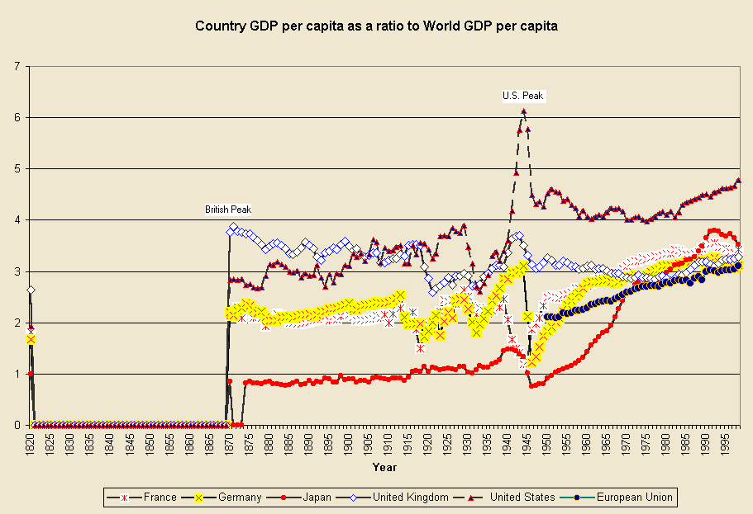 Figure 3: Country GDP per capita as a ratio to Average World GDP per capita, 1820-1998 Figure 3 can be compared with Figure 1 above to see the differences between shares of world GDP and the ratios of country GDP per capita to world GDP per capita. Figure 3 shows that British capital intensity was already significantly higher than French capital intensity in 1820, whereas their shares of world GDP were nearly the same (see Figure 1). The French economy was demographically and territorially larger that the British economy, and this accounts for their similar size and share of world GDP. But the British GDP per capita ratio to average world GDP per capita was 2.6, whereas the French ratio was 1.8. This indicates a significant advantage in average capital intensity for the British. Figure 3 shows that the British economic hegemony as indicated by relative capital intensity peaked in 1871, when the British ratio was nearly 3.9. The British ratio then declined slowly until 1918, when it took a dive to a low point of 2.6 in 1921, from whence it wobbled around below 3 until 1932 and then experienced a revival to 3.7 in 1943 and then another slow decline to 2.8 in 1977 followed by a slow rise to 3.3 in 1998. The trajectory of U.S. relative capital intensity is similar in many respects to U.S. GDP share as shown in Figure 1, but there are also some interesting differences. The U.S. rise during the nineteenth century was steeper by the GDP share measure than by the relative capital intensity ratio. This is because the U.S. population and territory were growing as fast as was its relative capital intensity during the nineteenth century. The capital intensity ratio shows the same peak in 1944 as was revealed in the GDP shares in Figure 1. But after that the U.S. trajectory is a bit different. The post-war plummet is followed by a recovery, as was the GDP share indicator, but the successive plateaus and declines after that are less evident, and there is a new upward movement that begins in 1982 and reaches a rather high level of 4.8 in 1998. This last might be interpreted as indicating a renewal of U.S. economic hegemony as hypothesized by Rennstich (2001,2004), but another aspect of Figure 3 needs to be noted. Since the middle of the 1970s all the core powers have been increasing their relative capital intensities. This is because global inequality has been increasing for the last three decades, with the core countries experiencing greater growth in GDP per capita than most of peripheral and semiperipheral countries (with the notable exception of China). The rise in relative capital intensivity for the core countries shown in Figure 3 is probably due to increasing global inequality of development (Jorgenson 2003). The EU capital intensity ratio also rises since 1950.? Relative Proportions in the Core The results above study the trajectories of core countries relative to the world-system as a whole. But what difference does it make if we examine trajectories of the core countries relative to only the core? This will allow us to see if the trends noted above may have been the result of changes in the distribution of economic power and levels of development in the non-core (e.g. the rapid growth of China). We want to examine the relationships among core powers themselves in order to see the implications of our study for the question of future hegemonic rivalry. Figure 4 shows the trajectories of the GDP shares of the United States, Japan and the European Union as a proportion of the sum of their GDPs (the core countries plus those in the EU that are on the edge of the core). The results are quite similar to what were shown in Figure 1 above, but the exclusion of the period before 1950 makes it easier to see the temporal details since then. Both Japan and the EU rise a bit and then they slowly decline, while the U.S. declines until the 1970s and displays a mild rise in the 80s and a somewhat stronger rise in the 90s. 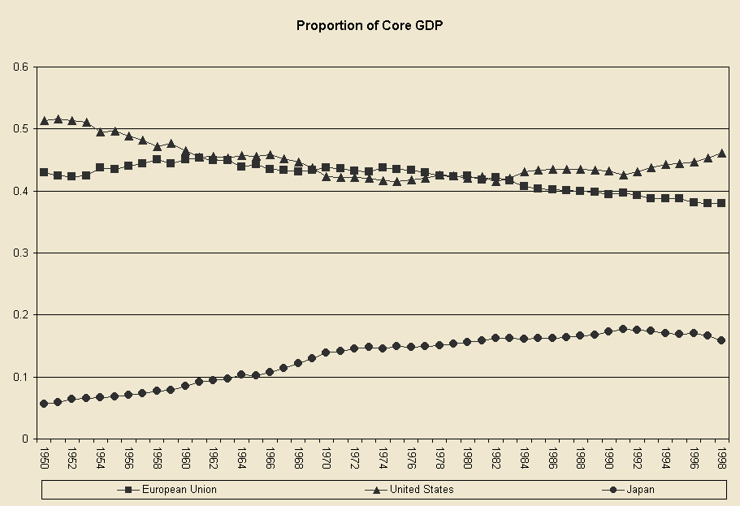 Figure 4: U.S., E.U. and Japanese GDPs as proportion of total Core GDP, 1950-1998 Figure 5 also uses the core as the denominator to calculate the recent trajectories of ratios of GDP per capita, and it shows the results for more countries. 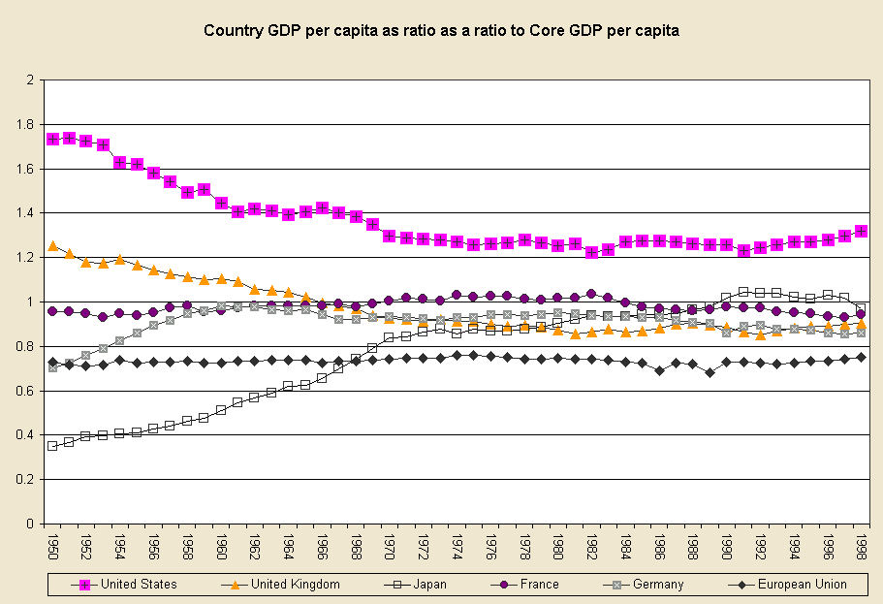 Figure 5: Country GDP per capita as a ratio to average Core GDP per capita, 1950-1998 The results in Figure 5 can be compared to those in Figure 3 above to see the differences that stem from comparing core societies to only the core rather than to the whole world-system. As suggested above, the general tendency for the core countries to rise since World War II seen in Figure 3 must be due to increasing inequalities between the core and the periphery. When we compare each core country to the core as a whole we see a lot of stability (e.g. the flat trajectory of the E.U). Japan rises from 1950 to 1972 and then a bit more from 1978 to 1990 and then declines back to its 1990 level in 1998. Germany rises from 1950 to 1962 and then declines very slightly thereafter. Britain declines slowly over the whole period. The U.S. declines until the early 1970s (balance by the rise of Germany and Japan), then stabilizes and rises somewhat in the 1990s. This is a crude but generally accurate picture of relative economic development within the core of the capitalist world-system. Discussion and Conclusion Maddison’s (1995, 2001) improved estimates are not the best possible measures of the relative economic power of core countries. But they do allow us to make long run and large-scale quantitative comparisons, and the results have implications for future research concerning economic hegemony. The hegemonic rises of the Dutch, British and United States constitute a continuation of the phenomena of rise and fall and semiperipheral development in which formerly semiperipheral societies transform the institutional structures of world order and ascend to the top of a world-system and then later decline (Chase-Dunn and Hall 1997). All of the modern hegemons were former semiperipheral countries before they rose to hegemony. The United States became the “800-pound gorilla” of the world-economy in a rapid ascent after 1850. Figure 1 supports those who emphasize the important difference in scale between the Pax Britannica and the Pax Americana (Mann 1993; O’Brien 2002). And this difference may have significant implications for the future of hegemony. Home market size is clearly a valuable advantage that might facilitate the possibility of another round of U.S. hegemony. Also Figure 3 shows a significant difference between the British and U.S. hegemonies in terms of relative capital intensivity. The British peak in 1871 was 3.9, while the U.S. peak in 1944 was 6.1. This is a sizeable difference, but the U.S. peak was an unusual spike due to the extremities of World War II. The U.S. plateau varied between 4 and 4.8, a level that was higher than the British level in the 19th century, but not massively higher. Figure 2, based on the ratios of country GDP per capita to the world average GDP per capita, shows the seventeenth century Dutch hegemony, the nineteenth century British hegemony and the twentieth century U.S. hegemony in relative levels of economic development. Figure 3, the same indicator but with finer temporal resolution, shows a slow Japanese ascent from 1820 to 1942, a collapse, and then a rapid Japanese ascent after 1949. Since 1992 the Japanese capital intensity ratio has declined from 3.8 to 3.5, reflecting the East Asian economic crisis. Figures 1, 3 and 4 show that the rise of the European Union adds another gorilla of similar size to the global geopolitical landscape. The recent GDP share trajectory of the E.U. is down, while that of the United States is flat (see Figures 1 and 4). But when we examine capital intensity relative to the whole world economy both the E.U. and the U.S. are rising. The U.S. ratio in 1998 is 4.8 while the E.U. average is 3.1 (Figure 3). When we examine these trajectories relative to the core rather than the whole system as the base of comparison it is shown that some of the above is due to increasing inequalities between the core and the non-core. Figure 5, which uses the average GDP per capita of the core countries for the denominator (instead of the average GDP per capita of all the countries) shows that the E.U. has been stable throughout the post-World War II period, while the U.S. fell from 1950 to the early 1970s (balanced by the rise of Germany and Japan), then stabilized and rose slightly in the 1990s. A big question raised by the literature on modern hegemony is the future trajectory of the United States. The Maddison GDP data indicate that the U.S. decline after World War II reached a plateau and turned up a bit in the 1990s. The question is whether or not this is a hiatus in the U.S. decline that might turn out to be the beginning of a renewed round of U.S. hegemony, or is only a temporary phenomenon similar to the Edwardian belle époque of British hegemony in the last decade of the nineteenth century. Ultimately, only the future will tell. But in the meantime a close examination of other indicators of the U.S. position in the world-economy can shed more light on this question. Trends in the U.S. balance of trade and balance of payments are germane. It is well known that the United States economy has increasingly imported more goods than it has exported. And there has been a huge increase in the amount of foreign direct and portfolio investment coming into the U.S. economy from abroad since the early 1990’s. Proponents of the belle époque thesis contend that the slowing of decline and/or the small upturn seen in general indicators of U.S. position such as those shown by the Maddison data may be the result of stock bubbles and over-investment in housing and commercial real estate created by the influx of foreign capital investment (Brenner 2002). Much of the recent foreign investment flowing into the U.S. has come from East Asian investors seeking greater returns than the ailing East Asian economies have been able to generate in the last decade. Other social scientists stress the advantages that the U.S. has been able to develop in new lead industries such as information technology and biotechnology. Rennstich (2001, 2004) argues that the huge size of the U.S. economy has made it possible for these new lead technologies to become relatively autonomous from the older declining industries within the United States, and that these new industries can be the basis for a new round of U.S. economic leadership and another power cycle in which the U.S. will renew its predominance in the global economy. Some earlier investment bubbles have served as incubators of new lead industries and, while most of the start-ups fail, the few that survive can become the basis for a spreading round of economic growth. The information technology industry may have already run through most of the standard course of the product cycle. Technological rents are few and globalized competition over the costs of production and services, with IT jobs being outsourced to the semiperiphery, may indicate that this sector will no longer serve as an engine of U.S. economic hegemony. Biotechnology has been heralded as the new engine of growth, but so far most of the money that has been made is in the selling of stocks. Governments and venture capitalists have put up great sums with the hope of grand paychecks down the road, and huge amounts have been spent on attorney’s fees obtaining patents on processes and genomes. But significant competition has emerged from Singapore and the Peoples’ Republic of China, challenging the notion that the United States is the only serious contender. A rapid expansion of real profits could occur, but more likely the development of real-world economic applications will continue to be slow. If this is the case biotechnology will not serve, in the next few decades, as an engine of renewed U.S. economic hegemony. ? We contend that another round of U.S. economic hegemony based on new lead industries is unlikely. The U.S. hegemonic decline that began in the 1970s is likely to continue. There are several institutional and contextual differences between the U.S. and British hegemonies that are important for understanding how new lead industries are related to geopolitics. The United States's reliance on multilateral institutions, which have persisted and supported U.S. leadership despite a decline of U.S. industrial exports since the mid-1970s, is one example. This and the high concentration of global military power under U.S. control may be important factors in the future of economic concentration (Gilpin 2001). It is plausible that the greater institutionalization of multilateral institutions, the greater degree of concentration of military power among core powers, and the greater extent of financial globalization will allow the U.S. to avoid the need for exporting more than “securities and security” for longer than Britain was able to do. But neither does the U.S. have a formal colonial empire of the kind that Britain had. Giovanni Arrighi (2003) points out that Britain was able to counterbalance some of its economic losses by turning the screws on India and using Indian conscripts in the imperial wars that were intended to prop up the hegemony. The U.S. has to rely mainly on its own population for cannon fodder. Thus do the differences as well as the similarities between hegemonies need to be taken into account. The greater concentration of military power in the contemporary international system relative to the late nineteenth century is another important difference. Wars among great powers cannot start as long as there is only one superpower. Arguably, the unilateralism demonstrated by the conquest of Iraq and the advocacy by the New American Century group of the more active use of U.S. military advantage to gain control of global oil supplies, is more likely to spur opposition than it is to sustain a successful “new imperialism” (Mann 2002). This kind of military adventurism may be interpreted as a desperate attempt to sustain the power of wealthy elites by substituting coercion for consent. The British also engaged in what has been called “imperial overstretch” (Kennedy 1987) during the waning years of their period of hegemony. It is the playing of one of the last cards in the hand of the declining hegemon. ? Robinson’s model of transnational state formation would seem to be contradicted by the rise of the “new imperialism” and U. S. unilateralism, but there may still be some truth to it. Arguably the global capitalist class is itself having a disagreement about strategies for ameliorating the crisis – whether to support the neo-conservatives and their advocacy of intervention or, alternatively, to try to organize a global Keynsianism that would redistribute enough income to the poor to help resolve the overaccumulation crisis. Jeffrey Sachs, the former advocate of neoliberal “shock therapy,” is now trying to embarrass core states into contributing more money to a development fund for the poorest countries. Despite the significant differences between the current period and the late nineteenth century, the structural similarities are more important. The cycle of rise and fall is manifesting itself, except there is one difference that is hugely important for the future of our species. The development of weapons of mass destruction has reached the point that we no longer can afford to decide upon the leadership of the global system in a military contest among the great powers without sending ourselves back to subsistence. So the great challenge is how to reconcile changes in the contours of economic power with the contours of political-military power by peaceful means. This observation shines new light on the importance of multilateral global institutions and their prospects for becoming legitimate arbiters of conflicts and promoters of cooperation. We need to get through the next few decades of hegemonic decline and incipient hegemonic rivalry without resorting to the time-honored institution of trial by fire. References Anderson, David G. 1994. The Savannah River Chiefdoms: Political Change in the Late Prehistoric Southeast. Tuscaloosa, AL: University of Alabama Press. Arrighi, Giovanni. 1994. The Long Twentieth Century. New York, NY: Verso. _______ 2003 “The social and political economy of global turbulence,” New Left Review 20:5-71 (March-April). _________ 2004 “Spatial and other ‘fixes’ of historical capitalism” Journal of World-Systems Research 10,2. Arrighi, Giovanni and Beverly Silver, et al. 1999. Chaos and Governance. Minneapolis, MN: University of Minnesota Press. Berry, Brian. 1991. Long-Wave Rhythms in Economic Development and Political Behavior. Baltimore, MD: Johns Hopkins University Press. Bornschier, Volker and Christopher Chase-Dunn. 1998. The Future of Global Conflict. London: Sage. Boswell, Terry. 2004. "Hegemonic decline and World Revolution: When the world is up for grabs." Pp. 149-161 in Thomas E. Reifer (ed.) Hegemony, Globalization and Anti-systemic Movements. Boulder, CO: Paradigm Press. Boswell, Terry and Albert Bergesen (eds.). 1987. America’s Changing Role in the World-System. New York, NY: Praeger. Boswell, Terry and Mike Sweat. 1991. "Hegemony, Long Waves and Major Wars: A Time Series Analysis of Systemic Dynamics, 1496-1967." International Studies Quarterly. 35(2):123-150. Brenner, Robert 2002 The boom and the bubble : the U.S. in the world economy New York : VERSO. Chase-Dunn, Christopher. 1998. Global Formation: Structures of the World-Economy. Lanham, MD: Rowman and Littlefield. __________. 2001. “Globalization: a world-systems perspective.” Protosociology 15:26-50. __________ and Thomas D. Hall. 1997. Rise and Demise: Comparing World-Systems. Boulder, CO: Westview. ___________ and Bruce Podobnik. 1995. “The Next World War: World-System Cycles and Trends.” Journal of World-Systems Research 1(6), http://csf.colorado.edu/jwsr/archive/vol1/v1_n6.htm. Chase-Dunn, Christopher, Richard Niemeyer and Armando Lara-Millan. 2004. “U.S. hegemony and biotechnology.” http://irows.ucr.edu/research/biotech/isa04biotech.htm Friedman, Jonathan and Christopher Chase-Dunn 2004 Hegemonic Declines: Present and Past. Boulder, CO: Paradigm Press. Gill, Stephen 2003 Power and Resistance in the New World Order London: Palgrave Gilpin, Robert. 1981. War and Change in World Politics. Cambridge: Cambridge University Press. __________ 2001 Global political economy: understanding the international economic order. Princeton: Princeton University Press. Goldfrank, Walter L. 1983. “The limits of an analogy: hegemonic decline in Great Britain and the United States.” Pp. 143-54 in Albert Bergesen (ed.) Crises and the World-System. Beverly Hills, CA: Sage. Goldstein, Joshua. 1988. Long Cycles: Prosperity and War in the Modern Age. New Haven, CT: Yale University Press. Gowan, Peter 1999 The Global Gamble: Washington’s Faustian Bid for World Dominance. New York: Verso. Hardt, Michael and Antonio Negri 2000 Empire. Cambridge, MA: Harvard University Press. Harvey, David 2003 The New Imperialism. New York: Oxford University Press. Hopkins, Terence K. and Immanuel Wallerstein. 1979. “Cyclical rhythms and secular trends of the capitalism world-economy.” Review 2(4):483-500. Jorgenson, Andrew. 2003. “International Inequality in the Capitalist World-Economy 1500-2000: A Quantitative Cross-National Analysis.” Paper presented at the Annual Meetings of the American Sociological Association, Atlanta, Georgia. Kennedy, Paul. 1987. The Rise and Fall of the Great Powers. New York, NY: Vintage Books. Kentor, Jeffrey. 2000. Capital and Coercion: The Economic and Military Processes That Have Shaped the World Economy 1800-1990. New York, NY: Garland Publishing. Maddison, Angus. 1995. Monitoring the World Economy, 1820-1992. Paris: Organization for Economic Cooperation and Development. _________. 2001. The World Economy: A Millennial Perspective. Paris: Organization of Economic Cooperation and Development. Mann, Michael. 1993. The Sources of Social Power, Vol. 2. Cambridge: Cambridge University Press. __________ 2002 Incoherent empire New York: Verso, 2003 McNeill, William H. 1982. The Pursuit of Power: Technology, Armed Force, and Society Since A.D. 1000. Chicago, IL: University of Chicago Press. Modelski, George and William R. Thompson. 1996. Leading Sectors and World Powers: the Coevolution of Global Economics and Politics. Columbia, SC: University of South Carolina Press. O’Brien, Patrick K. 2002. “The Pax Britannica, American hegemony and the international economic order, 1846-1914 and 1941-2001.” Paper presented at the annual spring Political Economy of World-Systems conference, University of California, Riverside, May 3-4. Polanyi, Karl. 2001 [1944]. The Great Transformation. Boston, MA: Beacon Press. Robinson, William I. 2004 A Theory of Global Capitalism. Baltimore, MD: Johns Hopkins University Press. Rennstich, Joachim K. 2001. “The Future of Great Power Rivalries.” In Wilma Dunaway (ed.) New Theoretical Directions for the 21st Century World-System New York, NY: Greenwood Press. _____. 2004 “The phoenix cycle: global leadership transition in a long-wave perspective.” Pp. 35-53 in Thomas E. Reifer (ed.), Hegemony, Globalization and Antisystemic Movements. Boulder, CO.: Paradigm Press. Reifer, Thomas E. 2002 “Globalization & the National Security State Corporate Complex (NSSCC) in the Long Twentieth Century.” In The Modern/Colonial Capitalist World-System in the 20th Century, Ramon Grosfoguel and Margarita Rodriguez, eds., Westport, CT: Greenwood Press. Robinson, William I. 2004 A Theory of Global Capitalism. Baltimore: Johns Hopkins University Press. __________1998. "Beyond Nation-State Paradigms: Globalization, Sociology and the Challenge of Transnational Studies.” Sociological Forum 13:561-594. Ross, Robert J.S. 1995. “The theory of global capitalism: state theory and variants of capitalism on a world scale.” Pp. 19-36 in David Smith and Jozsef Borocz (eds.) A New World Order?: Global Transformations in the Late Twentieth Century. Westport, CT: Praeger. Sassen, Saskia. 2001. The Global City: New York, London, Tokyo. Princeton: Princeton University Press. Thompson, William R. 1992. "Dehio, long cycles, and the geohistorical context of structural transition." World Politics 45(1):127-152. __________. 2000a. The Emergence of the Global Political Economy. London, Routledge. __________. 2000b. “K-waves, leadership cycles and global war: a nonhyphenated approach to world systems analysis.” Pp. 83-104 in Thomas D. Hall (ed.) A World-Systems Reader. Lanham, MD: Rowman and Littlefield. Vernon, Raymond 1966 “International investment and international trade in the product cycle.” Quarterly Journal of Economics 80: 190-207. _____. 1971 Sovereignty at Bay: The Multinational Spread of U.S. Enterprises. New York: Basic Books. Wallerstein, Immanuel. 1984. ‘The three instances of hegemony in the history of the capitalist world-economy.” Pp. 100-108 in Gerhard Lenski (ed.) Current Issues and Research in Macrosociology, International Studies in Sociology and Social Anthropology, Vol. 37. Leiden: E.J. Brill. __________ 2004 World-Systems Analysis. Durham, N.C.: Duke University Press. Wilkinson, David. 1988. “Universal empires: pathos and engineering.” Comparative Civilizations Review 18:22-44. Appendix A: Other non-quantitative studies of hegemonic rise and fall In a related study, Terry Boswell and Mike Sweat (1991) employ time series analysis to study the relationships between different conceptions of hegemony and the intensity of world wars among the great core powers. The conceptions of hegemony addressed in Boswell and Sweat’s (1991) analysis include economic efficiency in the world economy and global reach via sea power. A series of dummy variables are created that quantify phases of hegemonic cycles: ascent, victory, maturity, and decline. An additional variable is dummy coded from Wallerstein’s (1984) dating of unicentric hegemony. Global reach made possible by sea power is measured by Modelski and Thompson’s (1988) sea power concentration index. Boswell and Sweat (1991) construct a dummy-coded variable to reflect Gilpin’s (1981) set of unicentric hegemons determined by their total relative power. Boswell and Sweat (1991) admit that the dummy variables are crude measures of economic hegemony that lack precision. However, these crude measures are treated as factors impacting war intensity among core nations, and the fine-grained temporal trajectory of economic hegemony is not the focus of their analysis. Goldstein (1988) argues for a hegemony cycle that links the military and economic aspects of hegemony. He uses a phase method analysis that employs a paired t-test to test for differences in growth between adjacent upswing and downswing phases of hegemonic cycles. In his analyses, he looks at the rise and decline of Netherlands, Great Britain, and United States hegemony with special attention paid to the major corresponding wars. Goldstein (1988) finds that sustained rise in production supports an upturn in the severity of wars among the core powers as indicated by the number of battle deaths per year. At the end of each hegemony cycle, and the beginning of the next, is a major great power war out of which a new hegemonic power emerges with a predominant share of world capabilities. Other powers rebuild from the war and the new technologies that form the basis for the hegemonic power’s economic advantage are imitated by other countries thus giving rise to competition. Goldstein posits that recurring wars, on several long wave upswings, eventually culminate in a new hegemonic war that brings about the restructuring of the core and a new period of hegemony in the world-system. Brian Berry (1991) disagrees with Goldstein’s Kondratiev-phased war-production hypothesis. Berry (1991) argues that production oscillates with Kuznets periodicity. He analyzes GNP data only for the United States for each decade from 1790 to the present to chart the annual growth rates of both nominal and real GNP and finds approximately half-century long patterns of acceleration and deceleration in U.S. economic growth. Thus, Berry (1991) argues that there are two Kuznets cycles in infrastructural investment embedded within each Kondratiev wave. The first Kuznets cycle is characterized by beginning of a long-wave depression moving towards a period of inflationary growth, followed by a period of stagflation and a period of deflationary growth in the second Kuznets cycle. “Income Inequality in the World – Looking Back and Ahead” Volker Bornschier University of Zurich and World Society Foundation “Inequality Beyond Globalization: Economic Changes and the Dynamics of Inequality.” Joint conference of the World Society Foundation and the RC02 of the International Sociological Association. Neuchâtel, Switzerland, June 26–28. “Forecasting is a hard venture especially if it pertains to the Future” – a wise saying attributed to Keynes. Looking back Before I shall make six forecasts about the future let me briefly recapitulate the past until now, acknowledging that the data are far from perfect. For thousands of years during the evolution of human societies material inequality has been on the rise. A turning point in this history occured only recently – two centuries ago – when average income levels between societies started to diverge, see Figure 1. Still between 1750 and 1800 the inequality comparing broad regions like Europe and China was mainly due to class differences in income and regional difference in fertility of the soil. From then onward diverging average income levels between societies increasingly became the main source of differences in income. Will this continue in the future? First back to past trends. Figure 1: Polarization of average income levels from 1750 to 1980. Logged income per capita in different goups: core advanced (Vorhut), total core, total periphery, poor periphery (Nachhut) Source: Bornschier, Weltgesellschaft, 2002: 330, 2008: 417. Figures from Paul Bairoch. It would be tempting to relate the emerging divergence in income levels to the industrial revolution which started in Britain around 1750 and spread to the continent and European settler colonies during the early 1800s. This is the story which conventional modernization theory is telling us. Yet the size and pattern of this uneven development was not a consequence of industrialization as such. Instead, it was the consequence of two linked social processes – industrialization at the core and colonial rule at the periphery. This double peripherization was followed by a de-industrialization of the periphery, see Figure 2. This specific economic and political power relation functioned at the advantage of the core and at the disadvantage of the periphery. For quite a while core countries enjoyed a monopoly in industrialization, with long lasting consequences. Figure 2: Industrialization and colonial rule: de-industrialization at the periphery. Logged percapita levels of industrial output 1750 to 1980. Standardized: United Kingdom (VereinigtesKönigreich) 1900 = 100. United Kingdom, total core, world, periphery Source: Bornschier, Weltgesellschaft, 2002: 322 f., 2008: 408. Figures from Paul Bairoch. Since the mentioned historic divide material inequality in the world continued to grow as it did before but at a faster pace. Between 1820 and 1992 total inequality doubled, see Figure 3 (mean Logarithmic deviation). Furthermore it changed its structure. In 1820 almost 90% of total inequality was due to the “within societies” component and this dropped to 40% at the end of the period, telling us that at the beginning of the 1990s almost two thirds of total inequality was due to the “between societies” component. Figure 3: Increase of total income inequality (upper line) and its components: between societies(line below, going up) and within societies (middle line going down and up again), 1820 to 1992 Source: Bornschier, Institutionelle Ordnungen und soziale Ungleichheit, 2005: 102, Weltgesellschaft 2008: 70. Figures from François Bourguignon and Christian Morrison 2002. Processes in the 20th century – an overview Within country inequality Inequality within societies which was increasing throughout the 19th century experienced marked drops after World War I and II. During the 1950s and 1960s income inequality achieved a historical trough – especially among rich democracies in the heyday of the Keynesian welfare state era. The newly increasing inequality within countries which was setting in during the 1970sreceived great attention among scholars in social sciences. Figure 4 demonstrates this newly emerging trend towards higher inequality within countries which holds for the majority of countries – although not for all. The trend did not stop in recent times but continues until 2000. The admittedly approximate data suggest that the trend was even more pronounced from 1990 to 2000. While it holds for the core, semiperiphery and periphery it seems to be even more pronounced for core countries. Figure 4: Increase of “within” inequality, 1967–1992 Source: Bornschier, Weltgesellschaft, 2002, 2008: chapters 2 and 9. Increase of “within” inequality 1990–2000 Source: Bornschier, Weltgesellschaft, new edition 2008: chapter 9. Computed in collaboration with Hanno Scholtz. Between country inequality Also average income differences between countries – a sample of 103 cases from 1980 to 1997 – continued to increase, see Figure 5. This finding has produced some unnecessary controversy and the following figures are shedding some light to the apparent differences in finding. Firstly, it demonstrates that the divergence also holds when purchasing power parities of income are used (which was contested). Secondly, it shows the effect of weighing the cases by population size. Figure 5: The change of “between” income inequality (ppp) for a world sample of 103 societies, unweighted and weighted for population, controlling for the PR of China. Upper rising line unweighted, middle slightly rising line weighed, but without China, lower declining line weighed and including China Legend: The mean logartithmic deviation is the measure of inequality which is set equal to 1 in 1980. The figure 1.20for 1997 indicates that the mean logarithmic deviation has increased 20% over 1980. When the same weigh to each country observation is given (what is the normal procedure in cross-national research) average income differences between the 103 cases have diverged during the 1980 to 1997 period. When we weigh cases by population (what is the necessary procedure in order to compute a between component of inequality for total income distribution), then the weighed income differences have been shrunken between 1980 and 1997. Figure 5 clearly demonstrates that the different trends are due to a single influential case, i.e., the PR of China. Let me dwell a bit more on this point since it will be important for the forecast. Countries like China and India have enormous populations – representing together about 37% of the world population. To the extent that the economic growth rates of such influential cases deviate from the general pattern, this will have a considerable impact on the evolution of the world stratification of incomes. Figure 6 gives details for growth rates over 30 years, 1975–2004, which are relevant for his issue. The figures for the different income layers are population weighed but do not include China and India, which are listed separately. Over a quarter of a century the growth patterns over different income layers of the world income stratification in five-year periods (Figure 6) tell the following story: from 1975–79 stability can be observed, neither convergence nor divergence, from 1980–99 divergence or polarization is observed, and from 2000–2004 middle income layers were gowing faster than the rich and poor income layers. This recent growth pattern – if it continues – will make the difference between the middle and the rich layers shrink and the difference between the poor layer and the rest grow. Last but not least, the separately computed growth figures for China and India over the six five-year periods always exceed the growth of any of the income layers, becoming very distinct after 1980. Figure 6: Economic per capita growth in different income layers, 1975 to 2004, controlling for thePR of China and India by displaying their figures separately. Income layers according to WorldBank definition Source: Bornschier, Weltgesellschaft, new edition of 2008: 102. Computed in collaboration with Hanno Scholtz, datafrom World Development Indicators, World Bank, CD-Rom 2006. Two findings from Figure 6 are relevant for the forecasts: (i) the much faster economic growth of India and China and (ii) the fact that for the first time in history, the high income layer has recently lost its lead in growth rates. These facts may indicate a beginning turning point in world inequality history. In finishing my look backward I like to point to the most recent figures from Branko Milanovic for world income inequality and its components which cover also the 1990s, see Figure 7. The “within” component of world inequality is increasing also in the 1990s which is in line with the mentioned other findings, the “between” component is stabilizing at a high level indicating the beginning influences of the rapid growth of China and India, and as a consequence total inequality is stabilizing, too, yet at a very high level. Figure 7: Most recent estimates for total, for “within” and for “between” inequality in world income distribution Source: Branko Milanovic 2005: 112 (Worlds Apart: Measuring International and Global Inequality. Princeton: Princeton University Press). Forecasts 1. Forecast. Both “within” as well as “between” country inequalities (unweiged) are likely to increase in the next two decades. (See second forecast for weighed effects.) Two main reasons for this first forecast can be brought forward: – The transition to the knowledge-based new technological style (overview Fig. 8, details follow in Fig. 9) – The impact of increasing marginalization (overview in Fig. 8 with details in Fig. 10) Figure 8 graphically presents the jointly working effects: the sectoral change towards the knowledge-based new technological style and the increasing marginalization. The schematic presentation keeps the relative population size of the three income layers (symbolized by the size of the circles) constant. Both processes make for more income inequality within countries and at the same time polarize income between the three groups. Figure 8: Graphical demonstration that the two effects together make for more within inequalities and for a polarization of income levels across core, semiperiphery and periphery. The transition to the knowledge-based new technological style (left part) has a greater impact for the core, whereas increasing marginalization (right part) has a greater impact outside the core. Figure 9: The theoretical impact of the transition to the knowledge-based new technological style. Kuznets-curves with more than two sectors. Change in total inequality is dependent on the transition of the economically active population between sectors with different average income. Marginalization A telling visual representation of urban marginalization is given before we start with the argument. Marginalization has an obvious impact on within inequalities. Less recognized is its role for enduring inequality at later stages of the rural-urban transition. The argument is as follows: At later stages of the rural-urban transition – when more than 50% having left the rural sector – total inequality will not decrease with further increasing size of the non-rural sector as the classical Kuznets argument would suggest. This is because such a decline would be dependent on the average productivity differences between the traditional sector and the rest. Marginalization in the urban sector, however, sharply reduces the mentioned differences which are necessary for such a decline. Figure 10: The effect of marginalization The classical Kuznets argument would suggest that total inequality starts to decline as soon as more than 50% are outside the traditional sector. But his will only happen if there are considerable differences in overall productivity between the two sectors. See below: the weight of the quadratic term (c) which would make for a decline at later stages of the transition is only dependent on such a difference in productivity which is, however, unlikely due to increasing marginalization. The curvilinear model can be written as: s2 = a + bx – cx2 The coefficient of the quadratic term (c) is a function of the average income differences between the two sectors. Given considerable marginalization, the less developed countries at later stages of the rural-urban transition will thus not benefit from decreasing inequality. Instead they become increasingly affected by the new dualism, the transition to the knowledge-based new technological style as modeled in Figure 9. 2. Forecast. Although polarization “within” as well “between” countries will be the prevalent trend for the coming two decades, total world income inequality may not increase but remain rather stable, albeit at a historically very high level. This is because world stratification of income will considerably change its shape. The expected changing shape of world stratification of incomes is driven in large part by rapid economic growth in the two population rich countries China and India. Although this rapid growth is unlikely to last forever (as the historical growth trajectory of Japan suggests) it will be likely to continue for many years to come. The changing shape of income stratification. For two centuries world income stratification had increasingly become a pyramidal shape with a privileged hydrocephaly (Wasserkopf) on top, i.e., the population in the rich countries at the core. The change already going on is into the direction of an onion-shaped distribution of populations over income layers, see Figure 11. As emphasized, this historically remarkable shift is, however, to an overwhelming extent due to the shifts of only two cases, PR of China and India. Of course, there are several other cases with rapid economic growth adding to the trend, but in terms of population they are even together comparatively small as compared to the China and India's share in world population (PR of China's share in world population is 21.4% in 1980 and India's 15,2%, together they account for 36.6% of world population). Thus talking about the future of world income distribution over income layers one can – without making a too big mistake – concentrate on the predictions of the further growth trajectories of China and India. (Other population rich countries, like Brazil, Russia, Mexico and Indonesia, account together for only about half of only China's population.) Comment to the next figure. In 1980 both China and India were still in the low income layer, i.e.at the bottom of world income stratification. In 1999 and 2005 China has switched to the lower middle income layer, whereas India still remained in the lower income layer. The likely soon shiftof India to the lower middle layer will – other things being equal – reduce the population share in the low income group from 36.5% to about 21.5% while the population share of the lower middle layer will increase by India's upward move. At the same time China will then have moved into the upper middle layer which will increase its share in world population from 9.3 to well over 30%. Therefore, the picture for 2005 given in Figure 11 is but a transitory one. In the years to come a population structure of about the following kind will emerge: 16% in the top income layer, 64% in the two middle income layers, and about 20% in the bottom layer – clearly an onion-like distribution. Figure 11: The beginning shift in the shape of the world income stratification. Source: Bornschier, Weltgesellschaft, new edition 2008: 85. Income layers according to World Bank classification. 1999 and 2005 GNP per capita ppp in USD. 3. Forecast Changing income differentials between the different income layers. The mentioned comparatively lower growth of the upper income layer is novel and until now observed only for the short period 2000–2004 (see Figure 6). If this continues – and there are good arguments for it (see so-called beta-convergence) – then the middle and upper income layers will come closer together. This might have quite surprising different effects: the average citizen in rich countries will fall back in relative terms. For sure, only the lower classes in rich countries will be the relative losers while the upper class can gain from global accumulation opportunities. The shrinking relative income privileges of lower classes in rich countries contrast with the relative income gains of the population in middle income countries. This seems relevant for people's perceptions even if the relative shares of lower classes in the middle income layers are shrinking. It may mitigate or even overcompensate their shrinking relative share as long as economic growth remains rapid. For quite a while this suggests a novel support for world capitalism since the world middle income layer will soon – if the second forecast is correct – represent a relative majority of world population. While the upper und middle income layers come closer together, the bottom income layer falls back in relative terms. This might represent less a grave legitimacy problem for the whole distribution since the relative population size of the bottom layer will shrink (see forecast 2). And upward mobility into the middle income layers which will have taken place may well foster an ideology of the kind “one can do it if one really works hard”. Talking about interest that may stem from the changing world stratification of incomes leads us to the next forecast which is, however, rather cautious in terms of politically relevant consequences of inequality. 4. Forecast Will collective action as a reaction to inequality have a feed-back impact on inequality? There exists a long history of thought in social philosophy and science to look at conflict and rebellion as likely reactions to inequality. The popular nexus which is also prominent in the Marxian model is: inequality —> conflict —> change in inequality. Our detailed cross-national results, based on a sample of 28 countries, suggest several noteworthy points of doubt, see Figure 12. – First of all, objective inequality (as it is usually measured) has little effect on collective conflict articulation aimed at changing the structure of power and rewards. This is also supported by arecent meta-analysis of the research literature on that correlation (Mario Bazzani 2008). – Secondly, subjective evaluation of income distribution as unjust is hardly related to objectiveincome inequality, probably because considerable absolute income gains due to rapid growth maycompensate. – Thirdly, subjective evaluation of income distribution as unjust is by far the most importantpredictor of subjective awareness of conflict. The latter, however, does not necessarily translate into collective action since political opportunity structures and considerable absolute gains in income intervene. For the time being, collective reactions towards inequality will thus hardly have a significant feed-back effect on inequality. Conditions under which the latent conflict potential might turn into action will be mentioned in the last forecast. The results displaced in Figure 12 are also in line with observations in the aggregate: Whereas inequality mostly increased in recent time, all available conflict data are on decline sincethe 1990s (figures available from the author, see also Bornschier 2007, 2008). Figure 12: Objective income inequality, subjective evaluation of income distribution as unjust,-subjective awareness of conflict and objective, collective conflict manifestations Source: Bornschier, Konflikt, Gewalt, Kriminalität und abweichendes Verhalten 2007: 515ff, Weltgesellschaft 2008: 110ff. Results in collaboration with Thomas Volken. 5. Forecast Reactions to absolute deprivation – like food riots, for example, in Egypt – are likely to have a more immediate political impact. But hunger relief measures are hardly changing overall relative deprivation, i.e. the unequal distribution of incomes. Absolute deprivation – hunger – has been a topic not touched so far in this paper. Theavailable figures suggest that absolute deprivation has become less salient over the last decades. World poverty headcounts at USD 1 per day declined in absolute and even more so in relative terms(see Chen and Ravallion 2004, Hillebrand 2008). Yet, the sudden recent surge in agriculturalcommodities prices (after twenty years of constant or even slightly decreasing real prices) will bring the issue of world hunger again to the fore. The attention of the public and politicians is quiteconsiderable. For sure a moral issue is involved in the fact that a world of affluence is unable to fight the hunger of considerable populations. Last but not least it is obscene to see widespreadhunger coexisting with starting obesity problems among the middle class youth, like, for example, in India. To feed the needed is an obligation, not only a moral one but also a question of politicalstability. Yet, even after having solved this problem this will not change the relative deprivation that is the topic of this paper. 6. Forecast and concluding remarks: the politics of inequality Class politics across national borders, will it become more likely? Given the mentioned trends greater parts of lower classes in the world will – after long time – come closer together in terms ofobjective life conditions. In principle, this would work into the direction of world classes as such – much more than in the past. It seems, however, unlikely that such a “class in itself” will result in politics of a “class for themselves“ to use Marx' terms. The necessary solidarity is too hard to achieve. The emerging class in itself is heavily split into fractions: (i) into parts of the lower class which are downwardly mobile in relative terms and into parts of the lower class which are upwardly mobile in relative terms; (ii) into an integrated and legal part of the lower class vs a marginalized and illegal part. How difficult it is to achieve solidarity even among the for long time during the Apartheid regime that heavily discriminated against blacks shows present-day South African where the poor violently fight against the poorer. More likely than class politics is therefore an increasing focus on alternative movements that absorb latent class conflict resulting from inequality, i.e., reactionary populist nationalism. It detracts the attention from “within” inequalities by focusing on “us” against “others”. During the times of increasing inequality in the past decades this option has already quite frequently seen manifestations – in rich democracies and poorer societies alike. In poorer societies this reactionary branch of movements may go together with a contradictory anti-systemic thrust (anti-imperialistic, anti-capitalistic, anti-globalization), like, for example, in Malaysia (see annex, see also Malay reservation act/bangsa Malaysia program), in Venezuela, Iran and Russia. (Nazi Germany serves as an historical example.) For the years to come this will be the likely way in absorbing much of the latent class conflict. Yet, as long as world economic growth remains high, this is hardly causing severe international disturbancies. But the world economic boom associated with the diffusion of the new technological style will reach its peak in about a dozen years. After the ending boom such diverted conflict potentials may cause severe troubles for world peace. To prevent such a scenario means to fight inequality now. Annex. Let me add brief excerpts from a longer speech by the Prime Minister of Malaysia, Mahathir Mohammad (1996): "What does globalization hold in store for the developing countries? (...) (...) A globalized world is not going to be a very democratic world. A globalized world is going tobelong to the powerful dominant countries. They will impose their will on the rest. And the rest willbe no better off than when they were colonies of the rich. History would have turned a full circlewithin just two generations. Fifty years ago the process of decolonization began and in a space ofabout twenty years was virtually completed. But even before all colonies of the West have beenliberated, indeed before any had become truly and fully independent, recolonization has begun. And it is recolonization by the same people. (...) This is what globalization may be about. This is a gloomy prediction. It is pessimistic. It does notcontain much hope for the weak and the poor. But unfortunately it is entirely possible. And it will be unless the weak and the poor appreciate now this possibility and fight tooth and nail against it. There are ways of fighting the powerful. It will be a kind of guerilla war. But it can succeed. And that war can only begin if there is understanding of what globalization can mean. Of course globalization may bring about Utopia, a paradise on earth, a world of plenty in which everyone can have everything. But nothing that has happened so far seems to justify this utopian dream." Source: Mahathir, Mohamad, Prime Minister of Malaysia. 1996. "Globalization – What it Means to Small Nations." Inaugural Lecture of the Prime Ministers of Malaysia Fellowship Exchange Programme at Dewan Merdeka, PutraWorld Trade Centre, Kuala Lumpur, on 24 July 1996. Extracts in South Letter (published by the South Centre), 3 (26), October 1996: 10–11. References Bairoch, Paul. 1982. "International Industrialization Levels from 1750 to 1980." The Journal of European Economic History 11 (2): 269–333. Bairoch. Paul. 1986. "Historical Roots of Economic Underdevelopment: Myths and Realities." Pp. 191–216 in Wolfgang J. Mommsen and Jürgen Osterhammel. Hg. Imperialism and After. Continuities and Discontinuities. London: Allen & Unwin. Bornschier, Volker. 2007. Konflikt, Gewalt, Kriminalität und abweichendes Verhalten. Ursachen, Zeit-und Gesellschaftsvergleiche. Zurich: Loreto. Order directly from the author (bornschier@soziologie.uzh.ch). Bornschier, Volker. 2008. Weltgesellschaft. Grundlegende soziale Wandlungen. New and enlarged edition of 2008. Zurich: Loreto. Order directly from the author (bornschier@soziologie.uzh.ch). Bourguignon, François und Christian Morrisson. 2002. "Inequality Among World Citizens: 1820–1992." The American Economic Review 92 (4): 727–744. Chen, S. and M. Ravallion. 2004. "How Have the World's Poorest Fared Since the Early 1980s?" The World Bank Research Observer 19 (2): 141–169. Hillebrand, Evan. 2008. "The Global Distribution of Income in 2050." World Development 36 (5): 727–740. Milanovic, Branko. 2005. Worlds Apart: Measuring International and Global Inequality. Princeton: Princeton University Press.

