C. Chase-Dunn and B. Lerro, Social Change. Forthcoming, Allyn and Bacon
Chaps 14, 16,18,19 and 20
v. 4-2-09

Chapter 14: The Modern World-System
v. 8-3-05, xxxx words
put stuff about world orders and world revolutions in schema as trending cycles.
Causes of glob from research proposal on glob.

Three chapters that tell the story of the modern system chronologically since the fifteenth century will follow. But the unfolding story obscures certain general patterns that can only be see by looking at the whole system over the entire period of time since the 15th century. These patterns are the subject of this chapter. The modern system shares many similarities with earlier regional world-systems, but it is also qualitatively different from them in some important ways. Obviously it is larger, becoming global (Earth-wide) with the incorporation of all the remaining separate redoubts during the nineteenth century. The key defining feature of the modern world-system is capitalism. We have already seen the long emergence of those institutions that are crucial for capitalism (private property, commodity production, money, contract law, price-setting markets, commodified labor) over the previous millennia in Afroeurasia. But it was in Europe and its colonial empires that these institutions were able to take hold most strongly and to direct the fundamental dynamics of social change to so great an extent that we can speak of the first world-system in which capitalism was the predominant logic of development.
Capitalism has many definitions and its fundamental nature is still a matter of lively debate. We agree with those who define capitalism as an economic process of the accumulation of profits that interacts fundamentally with a geopolitical process of state-building, competition among states and increasingly large-scale political regulation involving institutions of coercion and governance. Capitalism is not solely an economic logic.
Some theorists contend that state power and “violence-producing enterprises” were only involved in setting up the basic underlying political conditions for capitalism during an age of “primitive accumulation” and once these institutions were in place capitalism began to operate as a purely economic logic of production, distribution and profit-making – so-called “expanded reproduction.” The world-systems perspective allows us to see that both economic and political institutions continue to evolve, and the central logic of capitalism is embedded in the dialectical dance of their co-evolution and expansion.
From a world-systems perspective the political body of capitalism is the interstate system rather than the single state. Single states all exist within a larger structure and set of processes that heavily influence the possibilities for social change. And the interstate system interacts with a core/periphery hierarchy in which powerful and more developed states and regions exploit and dominate less powerful and less developed regions.
States are just organizations that claim to exercise a monopoly of legitimate violence within a particular territory. They are not whole systems and they never have been. Much of contemporary social science treats national societies as if they are on the moon, with completely self-contained (endogenous) patterns of social change. That is even more a mistake for the modern world-system than it was for the more distant past.
Capitalism and capitalist states existed in earlier world-systems, but capitalism was only a sideshow within the commercializing tributary empires, while real capitalist states were confined to the semiperiphery. Capitalism became predominant in the modern system by becoming potent in the core. In the modern system the most successful states became those in which state power was used at the behest of groups who were engaged in commodity production, trade and financial services. State powers to tax and collect tributes did not disappear, but these became less important than, and largely subordinate to, more commercial forms of accumulation.
The very logic of capitalism produces economic, social and political crises in which elites jockey for position and less-favored groups try to protect themselves and/or to fundamentally change the system. Capitalism does not abolish imperialism but rather it produces new kinds of imperialism. Neither does it abolish warfare. It is not a pacific (warless) mode of accumulation as some have claimed (e.g. Schumpeter 1951). Rather the instruments of violence and the dynamics of interstate competition by means of warfare have been increasingly turned to serve the purposes of profitable commodity production and financial manipulations rather than the extraction of tribute. The growing “efficiency” of military technology produced in the capitalist world-system has made warfare much more destructive.
The core/periphery dimension is not abolished. On the contrary, the institutional mechanisms by which some societies can exploit and dominate others become more powerful and efficient and are increasingly justified by ideologies of civilization, development, foreign investment and foreign aid. “Backwardness” is reproduced and the world-system becomes even more divided between the included and the excluded than were earlier systems. The growing inequalities within and between national societies are justified by ideologies of productivity and efficiency, with underlying implications that some people are simply more fit for modernity than others. Nationalism, racism and gender hierarchies are both challenged and reproduced in a context in which the real material inequalities amongst the peoples of the world are increasing. This occurs within a context in which the values of human rights and equality have become more and more institutionalized, and so huge movements of protest and struggles over ideas and power occur. All this is characteristic, not only of the most recent period of globalization and globalization backlash, but of the whole history of the expansion of modern capitalism.
The similarities with earlier systems are important. There is a political-military system of allying and competing polities, now taking the form of the modern international system (studied mainly by political scientists who focus on international relations.) There are still different kinds of interaction networks with different spatial scales, though in the modern system many of the formerly smaller networks have caught up with the spatial size of the largest networks. Much of the bulk goods network is now global. One of the unusual features of the modern system in comparative perspective is that the differences in spatial scale among different kinds of networks has been greatly reduced, which makes its far easier for people to comprehend the complex networks in which they are involved.
The phenomenon of rise and fall remains an important pattern, albeit with some significant differences. As with earlier state-based systems, there is a structurally important interaction between core regions and less powerful peripheral regions. There remains an important component of multiculturalism in the system as a whole, a feature that is typical of most world-systems. Semiperipheral development continues. As discussed in Chapter 13, the rise of Europe was itself an instance of the emergence to global power of a region that was previously semiperipheral. And it is semiperipheral societies within the modern system that continue to be upwardly mobile and to restructure the institutions of the system. In these respects the modern system is quite similar to most of earlier regional world-systems that contained states and hierarchies.
But the nature of the mode of accumulation is quite different and there are related other differences that are connected with the emergent predominance of capitalism. Both the pattern of rise and fall and the nature of core/periphery relations are significantly different. Since accumulation is predominantly capitalist and the most powerful core states are also the most important centers of capitalist accumulation, they do not use their military power to conquer other core states in order to extract revenues from them. In world-systems in which the tributary mode of accumulation is predominant, semiperipheral marcher states conquer adjacent core states in order to extract resources and erect “universal” empires. Similar versions of this strategy have been attempted in the modern system (e.g. the Hapsburgs in the 16th century, Napoleon at the end of 18th century, Germany in the 20th century), but they have failed. The tributary mode of production is not gone, and indeed even modern capitalist hegemons employ “accumulation by dispossession” (Harvey 2003), especially when they are in decline, but a major difference between the modern capitalist world-system and earlier tributary systems is that the balance between coercion and consensus has shifted in favor of consensus. This is an important part of what Karl Marx meant when he claimed that capitalism, though not the best of all possible worlds, is indeed progressive relative to systems in which the tributary modes of accumulation were predominant.
Another sense in which capitalism may be thought of as progressive is its effects on technological change. Technological change has been a crucial aspect of human social evolution since the emergence of speech. The rate of innovation and implementation increased slowly as societies became more complex, but capitalism shoves the rate of technological change toward the sky. This is because economic rewards are more directly linked to technological innovation and improvements in production processes. There are, to be sure, countervailing forces within real capitalism, as when large companies sit on new technologies that would threaten their existing profitable operations. But because permanent worldwide monopolies do not exist (in the absence of a world state), the efforts of the powerful to protect their profits have repeatedly come under attack by a dynamic market system and competition among states. The institutionalization of scientific research and development has also added another strong element to the development and implementation of new technologies, so that in the most developed countries rapid technological change and accompanying social changes have become acceptable to people despite their disruptive aspects. This is a major way in which the modern world-system differs from earlier systems. Social change of all kinds has speeded up.
Another major difference between the modern system and earlier state-based systems is in the way in which the cycle of rise and fall occurs. The hegemonic sequence (the rise and fall of hegemonic core states) is the modern version of the ancient oscillation between more and less centralized interstate systems. As we have seen, all hierarchical systems experience a cycle of rise and fall, from “cycling” in interchiefdom systems to the rise and fall of empires, to the modern sequence of hegemonic rise and fall. In tributary world-systems this oscillation typically takes the form of semiperipheral marcher states conquering older core states to form a core-wide empire. (see Figure 1). Figure 1 contrasts the structure of a core-wide empire with that of a more multicentric system in which one state is the hegemon. 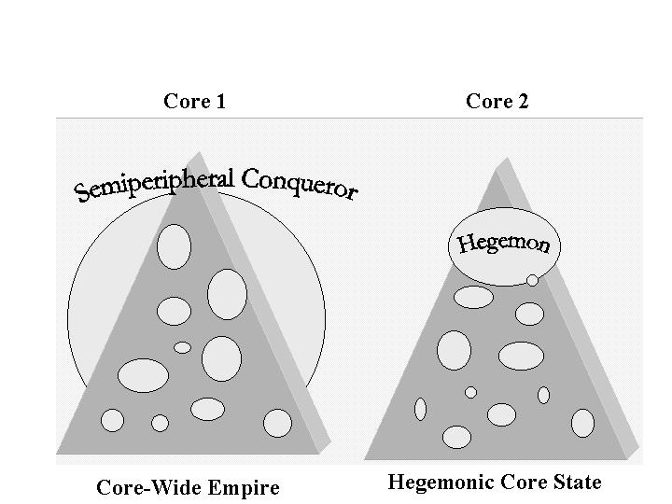
Figure 1: Core-Wide Empire vs. Hegemonic Core State
One important consequence of the coming to predominance of capitalist accumulation has been the conversion of the rise and fall process from semiperipheral marcher conquest to the rise and fall of capitalist hegemons that do not take over other core states. The hegemons rise to economic and political/military preeminence from the semiperiphery, but they do not construct a core-wide world state by means of conquest. Rather, the core of the modern system oscillates between unipolar hegemony and even more multicentric hegemonic rivalry.

Capitalist accumulation usually favors a multicentric interstate system because this provides greater opportunities for the maneuverability of capital than would exist in a world state. Big capitals can play states off against one another and can escape movements that try to regulate investment or redistribute profits by abandoning the states in which such movements attain political power.
Another difference produced by the rise of capitalism is the way in which imperialism is organized in a capitalist world-system. The predominant form of modern imperialism has taken the form of what has been called “colonial empires.” Rather than conquering ones immediate neighbors to make an empire, the most successful form of core/periphery exploitation in the modern system has involved European core states establishing political and economic controls over distant colonies in the Americas, Asia and Africa. To be sure, the old kind of imperialism continued to exist for centuries as the Ottoman, and Russian Empires expanded and the Manchus from semiperipheral northern Asia managed to conquer China in a classic example of the semiperipheral marcher state. Even in Europe the old strategy did not disappear. We have already mentioned the Hapsburg attempt to convert the nascent capitalist world economy into a tributary empire, and the French and German efforts of much more recent centuries also bear some of the marks of the older form of empire. But the most successful form was the colonial empire, and it evolved from the early efforts by Portugal and Spain into the later Dutch, French and British Empires, and then morphed into a less obvious kind of “neo-colonialism” in the relationship between the United States and Latin America after the 1880s.
There is another important difference between the modern core/periphery hierarchy and the earlier Afroeurasian system in the nature of core/periphery relations. The ability to extract resources from peripheral areas has long been an important component of successful accumulation in state-based world-systems and this is also true for the modern world-system. But there is an interesting and important difference -- the reversal of the location of relative intrasocietal inequalities. In state-based world-systems core societies had relatively greater internal inequalities than did peripheral societies. Typical core states were urbanized and class-stratified while peripheral societies were nomadic pastoralists or horticulturalists or less-densely concentrated peoples living in smaller towns or villages. These kinds of peripheral groups usually had less internal inequality than did the core states with which they were interacting.
In the modern world-system this situation has reversed. Core societies typically have less (relative) internal inequality than do peripheral societies. The kinds of jobs that are concentrated in the core, and the eventual development of welfare states in the core, have expanded the size of the middle classes within core societies to produce a more-or-less diamond-shaped distribution of income that bulges in the middle. Typical peripheral societies, on the other hand, have a more pyramid-shaped income distribution in which there is a small rich elite, a rather small middle class, and a very large mass of very poor people.
This reversal in the location of relative internal inequality between cores and peripheries was mainly a consequence of the development and concentration of complex economies needing skilled labor in the core and the politics of democracy and the welfare state that have accompanied capitalist industrialization.
These processes have occurred in tandem with, and dependent upon, the development of peripheral capitalism, colonialism, and neo-colonialism in the periphery, which have produced the greater relative inequalities within peripheral societies. Core capitalism is dependent upon peripheral capitalism in part because exploitation of the periphery provides some of the resources that core capital sometimes uses to pay higher incomes to core workers. Furthermore, the reproduction of an underdeveloped periphery legitimates the national capital/labor alliances that have provided a relative harmony of class relations in the core and undercut radical challenges to capitalist power (Chase-Dunn 1998:Chap. 11). We do not claim that all core workers compose a "labor aristocracy" in the modern world-system. Obviously groups within the core working class compete against each other and some are downsized and streamlined, etc. in the competition of core capitalists with one another. But the overall effect of core/periphery relations has been to undercut challenges to capitalism within core states by paying off some core workers and groups and convincing others that they should support and identify with the “winners.”
In premodern systems core/periphery relations were also important for sustaining the social order of the core (e.g., the bread and circuses of Rome), but not to the same extent, because the system did not produce relatively more equal distributions of income and political power in the core than in the periphery. Thus the core/periphery hierarchy has become an even more important structural feature of the modern world-system than it was in earlier tributrary systems. This change in structure corresponds to the relatively greater stability of power structures in the modern world-system because of the relatively greater harmony of class interests within the core. While bread and circus dynamics operated in Rome, they were far less developed than the welfare state apparati and entertainment industries of the modern system.
Another important difference is that the Central System before 1800 contained three non-adjacent core regions (Europe/West Asia; South Asia; and East Asia), each with its "own" core/periphery hierarchy, whereas the rise of the European core produced a global system with a single integrated set of core states and a global core/periphery hierarchy. This brought about the complete unification of the formerly somewhat separate regional world histories into a single global history.
Political ecologists have argued that capitalism is fundamentally different from earlier modes of accumulation with respect to its relationship to the natural environment (O’Conner 1989, Foster 2000). There is little doubt that the expansion and deepening of the modern system global capitalism has had much larger effects on the biogeosphere than any earlier system. There are many more people using hugely increased amounts of energy and raw materials, and the global nature of the human system has global impacts on the environment. Smaller systems were able to migrate when they depleted local supplies or polluted local natural resources and this relationship with the environment has been a driving force of human social change since the Paleolithic. But is all this due only to capitalism’s greater size and intensity, or is there also something else which encourages capitalists to “externalize” the natural costs of production and distribution and produces a destructive “metabolic rift” between capitalism and nature (Foster 2000)?
Capitalism, in addition to being about market exchange and commodification, is also fundamentally about a certain kind of property – private property in the major means of production. Within modern capitalism there has been an oscillating debate about the virtues of public and private property, with the shift since the 1980s toward the desirability of “privatization” being only the most recent round of a struggle that has gone on since the enclosures of the commons in Europe.
The ongoing debate about the idea of the “commons” –collective property-- is germane to understanding the relationship between capitalism and nature. The powerful claims about the commons being a “tragedy” because no one cares enough to take care of and invest in public property carries a powerful baggage that supports the notion that private ownership is superior. Private owners are supposed to have an interest in the future value of the property, and so they will keep it up, and possibly invest in it. But whether or not this is better than a more public or communal form of ownership depends entirely on how these more collective forms of property are themselves organized.
Capitalism seems to contain a powerful incentive to externalize the natural costs of production and other economic activities, and individual capitalists are loathe to pay for the actual environmental costs of their activities as long as their competitors are getting a free ride. This is a political issue in which core countries in the modern capitalist system have been far more successful at building institutions for protecting the national environment than non-core countries. And, indeed, there is convincing evidence that core countries export pollution and environmental degradation to the non-core (Jorgenson 2004).
Certainly modern capitalism has been more destructive of the natural environment than any earlier system. But it is important to know whether or not this is completely due to its effects on technology and the rapidity of economic growth, or whether or not there is an additional element that is connected to the specific institutions and contradictions of capitalism. Technological development, demographic expansion and economic growth cause problems for the environment. But are there better alternatives? And is capitalism more destructive of the environment than earlier modes of accumulation net of its demographic and technological effects?
Undoubtedly the human species can and must do better at inventing institutions that protect the biogeosphere. Regarding earlier modes of accumulation, certainly some cultures did better than others at protecting the environment. The institutions of law, the state and property evolved, in part, as a response to environmental degradation (recall our “iteration model” in Chapter 2). It is not obvious that contemporary capitalist institutions are worse than earlier ones in this regard. The main problem is that the scale and scope of environmental degradation has increased so greatly that very powerful institutions and social movements will be required to bring about a sustainable human civilization. Capitalism may not be capable of doing this, and so those theoretical perspectives that point to the need for a major overhaul may be closer to the point than those that contend that capitalism itself can be reformed to become sustainable.
The Schema of Constants, Cycles, Trends and Cyclical Trends
Most histories of the modern world tell a story, and we shall do the same in the following chapters. But here we will begin with a model, as if the modern world-system were a great machine or a superorganism. The systemic analogy will be stressed at this point so that we can see whether, and in what ways, the basic system has changed in the chapters that follow. One way to help us think about the modern world-system as a whole is to describe its structures and processes in terms of patterns that are more or less constant, those that are cyclical, and those that are upward (or downward) trends. And some important characteristics of the whole system, like globalization, are both cycles and trends. This means that there are waves of globalization in the sense of larger and more intense interactions, and that these waves also go up over time – an upward trend. Patterns of this kind are called trending cycles. Figure 2 illustrates what we mean by constants, cycles, trends and trending cycles.
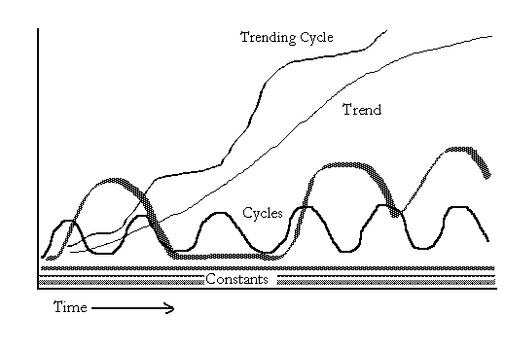
Figure 2: Constants, Cycles, Trends and Trending Cycles
The structural constants are:
1. Capitalism -- the accumulation of resources by means of the production and sale of commodities for profit under conditions in a which a significant proportion of the major means of production are privately held;
2. An interstate system -- a system of unequally powerful sovereign states that compete for resources by supporting profitable commodity production and by engaging in geopolitical and military competition;
3. A core/periphery hierarchy -- in which core regions have strong states and specialize in high-technology, high-wage production while peripheral regions have weak states and specialize in labor-intensive and low-wage production.
These structural features of the modern system are continuous and reproduced, and they also have evolved. They are interlinked and interdependent with one another such that any major change in one would necessarily alter the others in fundamental ways (Chase-Dunn, 1998).
In addition to these structural constants, there are several other structural features that are systemic continuities even though they involve patterned change. These are the systemic cycles, the systemic trends and the trending cycles. The basic systemic cycles are:
1.The Kondratieff Wave (K-wave) -- a worldwide economic cycle with a period of from forty to sixty years in which the relative rate of economic activity increases (during "A-phase" upswings) and then decreases (during "B-phase" periods of slower growth or stagnation).
2. The hegemonic sequence -- the rise and fall of hegemonic core powers in which military power and economic comparative advantage are concentrated into a single hegemonic core state during some periods and these are followed by periods in which wealth and power are more evenly distributed among core states. Examples of hegemons are the United Provinces of the Netherlands in the seventeenth century, the United Kingdom of Great Britain in the nineteenth century and the United States of America in the twentieth century.
3. The cycle of core war severity -- the severity (battle deaths per year) of wars among core states (world wars) displays a cyclical pattern that has closely tracked the K-wave since the sixteenth century (Goldstein, 1988).
The systemic trends that are normal operating procedure in the modern system are:
1. Expansion and deepening of commodity relations -- land, labor and wealth have been increasingly mediated by market-like institutions in both the core and the periphery.
2. State-formation -- the power of states over their populations has increased everywhere, though this trend is sometimes slowed down by efforts to deregulate. State regulation has grown secularly while political battles rage over the nature and objects of regulation.
3. Increased size of economic enterprises -- while a large competitive sector of small firms is reproduced, the largest firms (those occupying what is called the monopoly sector) have continuously grown in size. This remains true even in the most recent period despite its characterization by some analysts as a new "accumulation regime" of "flexible specialization" in which small firms compete for shares of the global market.
4. Increasing capital-intensity of production and mechanization -- several industrial revolutions since the sixteenth century have increased the productivity of labor in agriculture, industry and services.
5. Proletarianization -- the world work force has increasingly depended on labor markets for meeting its basic needs. This long-term trend may be temporarily slowed or even reversed in some areas during periods of economic stagnation, but the secular shift away from subsistence production has a long history that continues in the most recent period. The expansion of the informal sector is part of this trend despite its functional similarities with earlier rural subsistence redoubts.
6. The growing gap -- despite exceptional cases of successful upward mobility in the core/periphery hierarchy (e.g. the United States, Japan, Korea, Taiwan) the relative gap in incomes between core and peripheral regions has continued to increase, and this trend has existed since at least the nineteenth century, and probably before.
And there have been three trending cycles that oscillate up and down with intermittent peaks that are higher than all those before.
- International economic integration (economic globalization) - the periodic and long-term growth of trade interconnectedness and the transnationalization of capital. Capital has crossed state boundaries since the sixteenth century but the proportion of all production that is due to the operation of transnational firms has increased in every epoch. Trending waves of trade and investment globalization have been quantitatively measured since the early 19th century (Chase-Dunn, Kawano and Brewer 2000).
- International political integration (political globalization) - the emergence of stronger international institutions for regulating economic and political interactions. This is a trend since the rise of the Concert of Europe after the defeat of Napoleon. The League of Nations, the United Nations and such international financial institutions as the World Bank and the International Monetary Fund show an upward trend toward increasing global governance.
- Global culture formation (cultural globalization or geoculture) – the emergence over the tops of the civilizational and national cultures of a global culture-in-formation in which assumptions about what exists (ontology) and what is good (ethics and values) are coming to be shared across the whole Earth. This process procedes as the constitution of a series of world orders and their contestation by world revolutions that challenge the old hegemonic assumptions and produce new versions. The Protestant Reformation was the first of these world revolutions and the waves of decolonization discussed below were parts of later world revolutions.
The above basic model of the modern system is not posited to deny that the system has evolved, but rather to make it possible to see clearly the new organizational features that have emerged over the past 600 years and to enable us to correctly compare new developments with the relevant features of the past. The schema above suggests a system that is experiencing expanding cycles of growth and confronting contradictions that require new organizational solutions, but this is not to suggest a purely functionalist process of adaptation and learning. Struggle over the very nature of social change has been present all along and remains entirely relevant for comprehending the emerging situation of the 21st century.
The trends in the shares of world population shown in Figure 3 (below) confirm observations that were discussed in Chapter 13. Figure 3 shows shares of the total global population since the beginning of the Common Era two thousand years ago according to Maddison’s (2001) estimates. The time scale on the horizontal axis of Figure 3 is misleading because the intervals are not equal. Keeping this in mind we can see that the countries that became hegemonic in recent centuries did not change much in terms of their shares of world population. The countries with the big shares, India and China, still have huge shares, though India declined quite a lot until 1950 and then began again to rise. China peaked in 1820 and has mainly been declining since then. The United States rose above 5% of world population in 1913 and dropped below that level in about 1985. East Asia and South Asia have long been the demographic centers of the Earth, but have become somewhat less so over the past two millennia.

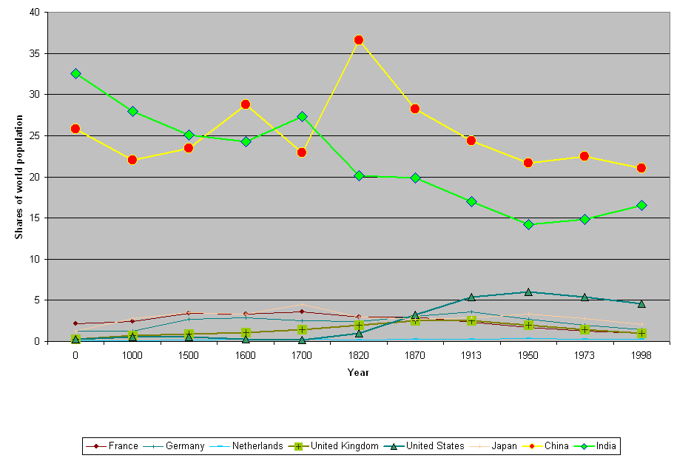
Figure 3: Shares of world population (Source: Maddison, 2001)
Maddison’s (2001) estimates of GDP also allow us to examine the ratio between the GDP per capita in regions and countries to the world average GDP per capita. This is a useful indicator of economic hegemony, though it does not capture military, cultural or the finer points of even economic power. Figure 4 (below) traces this ratio for some of the European “great powers,” the United States and Japan since 1500. Again the time dimension is distorted, with earlier years receiving much less on the x axis than later years receive.
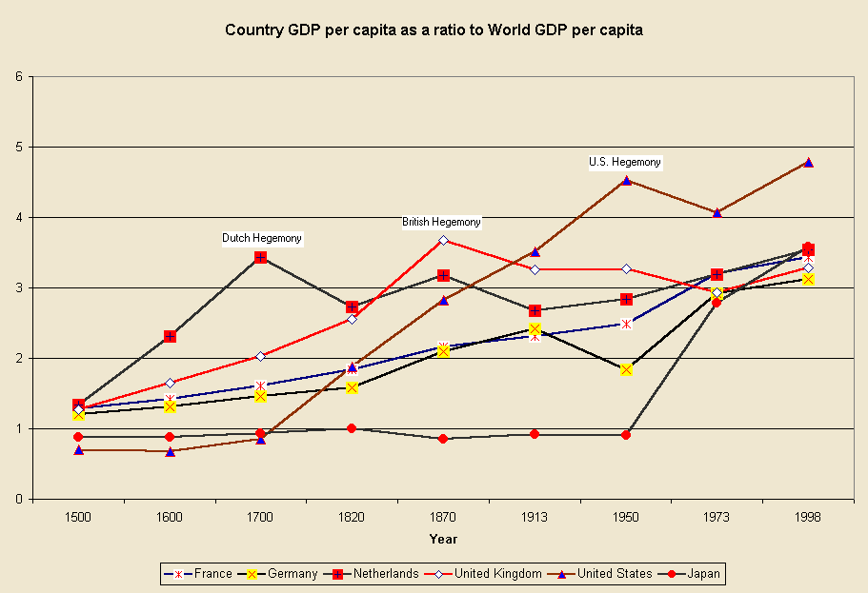
Figure 4: Country GDP per capita as a ratio to Average World GDP per capita, 1500-1998
Figure 4 shows the three hegemonies of the modern world-system (the Dutch in 17th century, the British in the 19th century, and the U.S. in 20th century, with quantitative data from Maddison (2001). It also shows that each of these successive hegemonies achieved a higher level of economic development relative to the general world level that its predecessor.
Waves of Colonial Expansion and Decolonization
The crusades against Moslem control of the old West Asian core and the reconquest of the Iberian Peninsula constitute the first wave of European expansion, as we have already discussed in Chapter 13. This was the effort of a reviving Europe to strike back against the expansion of Islam and to reopen the trade with Asia. It was followed by another wave of expansion that began slowly in the fifteenth century with Portugal’s establishment of colonial control of Ceuta (in Africa just across the strait of Gibralter from Gibralter) in 1415, and of Madeira, an island in the Atlantic that was important for sailing down the coast of Africa.
Under Prince Henry the Navigator the Portuguese were set on a course of rounding the African continent as a route to the East in order to break the Venetian monopoly on the spice trade. On the way they were able to gain access to important sources of West African gold and to develop an interest in the slave trade. This was the first burst of modern European colonial empire of the type described above. The Portuguese were encouraged and financed by the bankers of Genoa, who were competing with Venice for a better position in the Eastern trade. Thus did a semiperipheral capitalist city-state (Genoa) throw in with an ambitious nation-state (Portugal) on a global gamble that would have vast implications for the rise of the West. As Immanuel Wallerstein (1974b) has pointed out, there was no emperor of Europe to tell Prince Henry and the Genovese that they could not do this. At about the same time the Ming dynasty in China was recalling its fleets and battening down to concentrate its resources on expanding the Great Wall against Central Asian steppe nomads. The European interstate system was becoming institutionalized around the diplomatic protocols developed on the Italian peninsula among capitalist city-states in the southern sector of the “blue banana.”
The years between 1415 and 1420 saw the beginning of Portugal’s long circumcolonization of Africa. This was the first bump that one can see on the left side of Figure 5 (below). These were the settlement and establishment of sovereignty over Ceuta and Madeira. The Spanish grabbed the Canary Islands off the coast of Africa beginning in 1479, and then went for the New World.
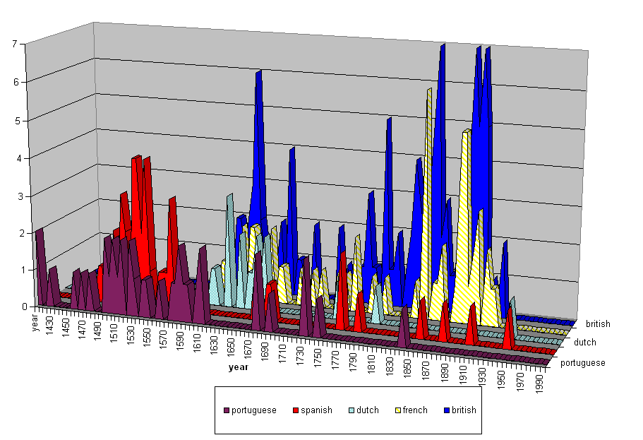
Figure 5: Colonies established by major European colonial powers
Portugal and Spain were the major players in the 16th century wave European colonial expansion. In the seventeenth century the Dutch, English and French moved out to produce another wave of expansion, in which the Spanish and the Portuguese also continued to expand their control of overseas territories. It is easier to see the successive waves of expansion in Figure 6 (below) in which all of the colonial “mother” countries shown in Figure 5 have been combined. But are there three more waves?, or just one long bumpy one that began in the 18th century and erratically reaches a crescendo in late 19th century with the Berlin Conference on Africa (in which the European powers divided the territory of the African continent amongst themselves)?

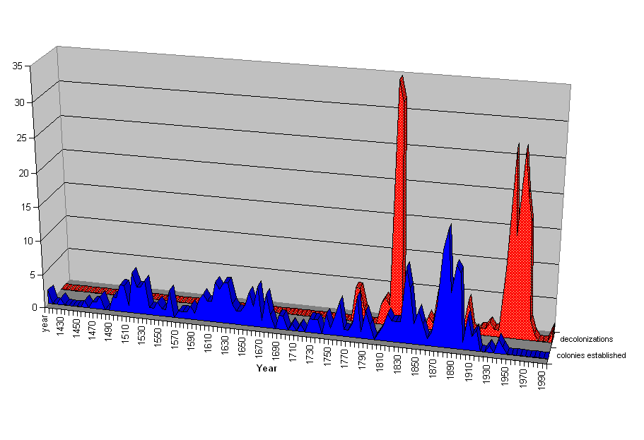
Figure 6: Waves of European Colonial Expansion and Waves of Decolonization
The waves of European colonial expansion were not only carried out by different countries in different time periods. The colonial empires had important cultural and structural differences as well, and the eras of colonialism were different because the needs and natures of both the colonizers and the colonized varied. Nevertheless, there is an important overarching reality to the whole process of European expansion that is shown in Figures 5 and 6.
Figure 6 also depicts waves of decolonization. The victims of colonialism were not inert or faceless peoples who simply were overwhelmed by the Europeans. They fought back, and eventually they succeeded at establishing, or reestablishing, at least formal sovereignty and political self-governance. The waves of decolonization started only in the late 18th century, the most famous example of which is the “American revolution.” Sometimes called “the first new nation,” the English colonies that became the United States were harbingers of rebellion against the colonial empires and modern imperialism, a story we shall retell from the perspective of the world in Chapter 17. While the British burned the capitol building in Washington to the ground in 1812 trying to recoup their losses, British covert policy, agents, money and “privateers” supported rebellions in Latin America against the Spanish, the Portuguese and the French. The early nineteenth century liberation of Spanish America was also supported by the fledgling United States, then still a semiperipheral state in the larger system.
The next big wave of decolonization began mainly after World War II and lasted well into the 1960s. This was the final establishment of formal sovereignty and the extension of membership in the interstate system to Asia, Africa and the Pacific. Like waves of colonial expansion, the waves of decolonization were somewhat different from one another. But as a singular phenomenon of the world-system as a whole, these constituted a major restructuring of the system from one of colonial empires to a globe-wide interstate system based on formalities of national sovereignty and the equality of nations.
The other side of this story is about neo-colonialism. In part because of its own history as former colonies, the United States spurned formal colonialism, but its rise to core status and eventual hegemony required the development of techniques for controlling and exploiting peripheral regions in the absence of the trappings of formal empire. The U.S. began practicing “gun boat diplomacy” in Latin America in order to get its way in local politics, and the institutional capabilities of informal control made possible what has been termed “neo-colonialism.” The power disparities between the core and the periphery continued to expand despite the abolition of the colonial empires, though the achievement of formal sovereignty has led to an increased level of autonomy in the non-core. Like the British in the early 19th century, the U.S. in the 20th century generally supported the decolonization of the empires of competing core powers, while at the same time it fought wars to prevent the emergence of regimes that were deemed to threaten the interests of the United States. So Cuba, the Phillipines, Puerto Rico, Guatemala, the Dominican Republic, and Vietnam saw U.S. military intervention as the raw face of neocolonialism. The colonial empires are gone, but not imperialism.

Chapter 16: The Nineteenth Century Wave of Globalization
v. 9-21-07 14809 words
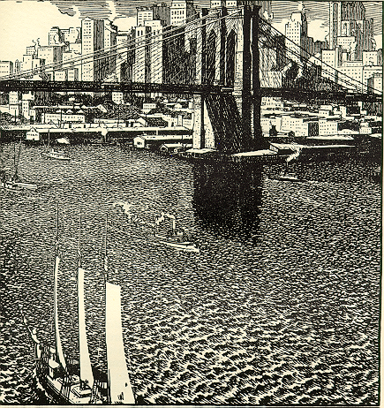
The Brooklyn Bridge
Semip devel. England, US, Japan. Meiji. Suez Canal 1869
Demog transition, end of slavery and serfdom, fossil fuel
More on exceptionalism. Relative class harmony is US was still contentious. Don’t make it sound too democratic. Pyramid- vs. diamond-shaped distribution of income. The Homestead strike. More on Labor’s untold story in the 19th century. The pinkertons. Mick Mann’s thing about the strict interpretation of private property. The pinkertons/ and the hard come down on labor. Tom on law and the courts. Cite him.
Incorporation of the workers as soldiers. Reifer. Skocpol – soldiers and mothers.
The emergence of the national security state. The business roundtable. Businessmen and lawyers become the military leaders. The destruction of the plantocracy meant No aristocracy with military traditions. Implications for masculinity. Businessmen as war leaders.
Add rise of japan, meiji restoration, adaptation of technology and org to jap conditions.
do Chinese treaty ports, opium wars, etc.
Fix stuff from mike davis book[p 8 Davis]
Fix what I say about great depression, 1873-1896.
edit rise of germany, add shugihara and pomeranz to discussion of east asia. Maybe put one of the discussions of this in chap18 into this chap.
add graphic showing new colonies and decolonization in the 19th century.
Put in stuff from global party formation paper

This chapter tells the story of the great wave of globalization in the nineteenth century. The rise and fall of British hegemony, the world revolution of 1848, the merger of the East Asian system into the Central System, and the rise of the United States are important parts of this story. The British hegemony was based on a second industrial revolution that began in England in the middle of the eighteenth century and spread to the other core and upwardly mobile semiperipheral areas. European interlopers surrounded China, and Japan leapt on to the global stage. The United States rose from the periphery to the core in the nineteenth century. And another world revolution emerged in the middle of the century. International trade and investment rose to a high peak in 1880 and the spread of the industrial revolution and the intensification of global markets allowed other core and semiperipheral states to challenge the economic and political hegemony of the United Kingdom. The British resisted the changing structure of economic power, and a new period of hegemonic rivalry emerged at the end of the nineteenth century.
The eighteenth century struggle between Britain and France for global hegemony ended in 1815 with Napoleon’s defeat. British forces tried to reconquer their lost colonies in North America in 1812. The new capitol building in Washington DC was burned to the ground, but U.S. forces held in New Orleans and at Fort McHenry in Baltimore Harbor. Frances Scott Key wrote the poem that would become the U.S. national anthem while watching British ships bombard Fort McHenry to no avail. The flag was still there. The story of the long rise of the United States is below, but first let us look at the British hegemony.
Modern hegemony is based upon a complicated combination of economic comparative advantage, military superiority and political consensus. It is both leadership and domination. British resolve had vanquished Napoleon and saved Europe from another marcher state conquest, but this did not completely resolve the issues that had been posed in the world revolution of 1789. Demands for democracy did not end with the defeat of Napoleon. The decolonized U.S. republic survived and the Haitian revolution created a new state run by former slaves in the Caribbean. The ideals of the French and American Revolutions had spread widely in Europe, the European colonies and the uncolonized regions.
British industrialization was going great guns and the industrial revolution was spreading to the European continent and to North America. The nature of business organization was evolving from the more corporate, centralized and formally regulated structures typified by the English East India Company to the more decentralized, informally regulated and flexibly organized networks of firms that emerged in the late eighteenth and earlier nineteenth centuries in Britain (Barr 1999). In the English Midlands the new industrial cities of Manchester and Birmingham were using steam engines to power huge spinning and weaving machines to produce cotton cloth in large factories. The demand for labor to supply, tend and maintain the machines created and expanded a new class of urban industrial workers. Vast amounts of raw cotton were imported to feed the machines, and vast amounts of cloth for sails and apparel were produced. This product could be profitably sold both in the home market and abroad for a low price, and so the English manufacturers had a substantial comparative advantage with which to penetrate the home markets of other countries.
In this first phase of British hegemony economic comparative advantage was combined with both political conservatism and some selected progressive international policies that were substantially congruent with the economic interests of the British elites. Conservatism was revealed in the repression of Chartism, an early trade union movement, at home, and Britain’s strong support of the organization of the Concert of Europe in the international arena. The suppression of the Chartists was accomplished by outlawing unions (so-called “combinations”). The Concert of Europe was a formally organized supernational alliance of European governments the purpose of which was to prevent future French Revolutions and Napoleonic escapades by sustaining traditional elites and resisting demands for popular sovereignty. The Concert of Europe was also intended to reproduce the interstate system, and yet it was itself a supernational political organization. In this respect it was a precursor to the League of Nations and the United Nations of the twentieth century.
Two other British international policies that emerged in the wake of the Napoleonic Wars were suppression of the international slave trade and covert support for the decolonization of Spanish colonies in the Americas. Both of these policies were progressive efforts to occupy the moral high ground with respect to the European Enlightenment ideas of equality and national self-determination. Support for Latin American decolonization was an easy option because decolonized states were much more likely to become trade partners with the British and to be open to diplomatic influence. This had to be done covertly because Spain had been an important ally of the British in the struggle against Napoleon. The suppression of the international slave trade was more politically complicated. The British Navy went about intercepting slave ships traveling from Africa to the New World, effectively suppressing this booming business in coerced labor.
This unilateral British intervention into the international slave trade was opposed in Parliament by West Indian plantation owners, but their opposition was overcome, and the effective implementation of the policy of preventing further depredations on the peoples of Africa allowed the British government to regard itself as a leader in humane global governance and an upholder of Christian civilization. As a consequence the price of slaves in the New World went up to the benefit of those regions within countries that could grow slave children for sale (e.g. Virginia). The suppression of the slave trade and abolition of slaver in the British colonies in 1834 provided validation for Haiti and for the abolition movements in other colonies and states.
One of the most important consequences of industrialization was urbanization, a large increase in the percentage of the total population living in big cities. The nineteenth century saw an upward sweep in the growth of cities. Britain led this trend, which then spread across Europe and to the other industrializing regions of the world. Another consequence of the British hegemony was that London became the most populous city in the world, surpassing Constantinople (the capitol of Ottoman Empire) and Beijing (the capitol of Qing Dynasty) by 1825.
In the 1840s there arose in Britain a movement for international free trade that focused first on British tariffs (taxes on imports) on grain. The “Anti-Corn Law League” sought to abolish the Corn Law – a high tariff on imported grain (“corn”). This tariff protected British growers of wheat and barley against foreign competition and kept the price of bread artificially high. Thus the slogan of the Anti-Corn Law League was, “Down with infamous bread tax.” (see Figure 16.1).
This was a successful use of the economic theory Adam Smith, the father of modern economics, who published his famous book defending free trade, The Wealth of Nations, in 1776. Not only was the British Corn Law repealed, but the British government went on to campaign for international free trade in Europe and the Americas and this campaign was rather successful in convincing other governments to reduce tariffs and to adopt the Gold Standard in which their national currencies were valued in gold. The world economy was increasingly organized by world markets for money and commodities in the second half of the nineteenth century, and international trade as a proportion of all exchange peaked around 1880. This was the nineteenth century wave of economic globalization (O’Rourke and Williamson 2000).
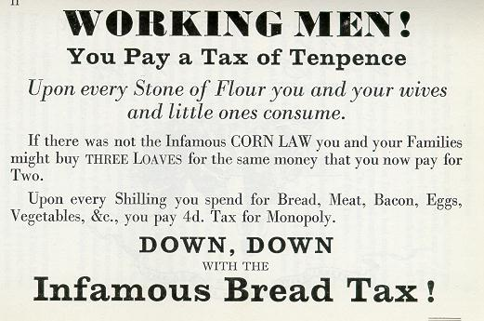
Figure 16.7: Anti-Corn Law League Handbill
At the middle of the nineteenth century London was the host of the Crystal Palace Exhibition, a huge ‘world’s fair” at which the high tech gizmos of all the countries who were seeking a place in the arena of technical competition displayed their products and inventions.
But already by the 1840s Britain was losing its comparative advantage in textile manufactures to competitors abroad. British capitalists had begun making money by exporting textile machinery rather than cloth. They also began building railroads abroad and sold the steel tracks, and the “rolling stock” (engines and cars). And soon would come the boom in the production of steam ships and their sale to buyers all over the world. This was the capital goods phase of British hegemony described by Eric Hobsbawm (1969) in his Industry and Empire. Railroads and steamships were lowering transportation costs across the world economy, and this expanded and intensified the markets for long-distance trade.
In the 1860s both England and France had to decide what to do about the “war for Southern Independence” in the United States. The war disrupted the export of cotton from the U.S. south, which created a “cotton famine” in the English Midlands. Despite entreaties from the Southern Confederacy for support based on the principle of self-determination, both the English and the French governments decided not to support the secession of the U.S. South. The English cotton textile manufacturers sought new sources of supply, and so cotton growing in Egypt was stimulated.
In the Crimean War (1854-1856), in which Russia tried to seize territory from the declining Ottoman Empire, the British allied with the Ottoman Empire to prevent the Russian advance. This is usually depicted as a crucial defeat for the Russian effort to keep its place among the “Great Powers” of Europe. But in Victorian England, despite the eventual defeat of Russia, it revealed that the British Navy had become moribund during the long period of relative peace since the Napoleonic Wars (Briggs 1964).
The Rise of Germany
The rising power of Prussia and the economic and political integration of Germany accelerated the emergence of German industrial prowess. Friedrich List, a German economist, had argued in favor of the “developmental state,” in which government would ally with industrial business interests in order to promote national industrialization. This model was executed successfully in Germany, and many other states tried to emulate it.
The story of the rise of Germany needs to be told in order to understand how the Great War (World War I) could have happened. The lands in which the German language was spoken were divided into the Austro-Hungarian Empire, the remnant of the Hapsburg Empire discussed in Chapter 15, and a large number of small independent states. The age of the Hanseatic capitalist city states had passed, though the long history of successful German merchant capitalism demonstrated a strong cultural capability for successful business entrepreneurship and craftsmanship. The question after the Napoleonic Wars was whether Hapsburg Austria would lead an emergent German nation, or whether some other center would lead. The notion of the sovereignty of nations that was part of the political heritage of the French revolution challenged the basic premise of the Austro-Hungarian Empire as well as the Ottoman Empire, because these were multicultural states held together by a small elite. A strong nationalist movement has emerged in Hungary during the World Revolution of 1848, but it had been suppressed by the Hapsburgs. Though they would have preferred to lead the new Germany, their main energies were spent trying to hold together the Empire. Prince Metternich of Austria had along with the British Lord Castlereigh, been the main architects of the Concert of Europe. But the British were enlightened conservative who saw that the nationalist movements would need to be accommodated, while the Austrians could not afford to compromise. This difference of approach became visible in the different policies toward the emerging national movement of integration in Italy. The British supported Italian unification, while Austria-Hungary opposed it.
A German customs union, the Zollverein, was organized to allow for free trade among the 38 independent principalities of the German Confederation in 1834 and a common external tariff border, and then the Prussians emerged victorious in the Franco-Prussian war with France. The Franco-Prussian war demonstrated that the Germans were a serious military power. It was the Prussian Junker elite of landed aristocrats with a strong military tradition that provided the core of the new German governing class that would lead the emergent nation. The idea of Germany as a nation of people who were related by blood and culture emerged in the nineteenth century and became the basis of the political unification of the principalities with Prussian leadership.
The Prussians supported the policy ideas of Frederick List and accommodated the emerging industrial capitalists. It was the success of German industrialization and railroad building that provided the economic power that was the mainstay of German military capability, but the aristocratic military culture of the Prussians was also a big advantage in crafting the geopolitical policies of a world player and social policies of enlightened conservatism. The German state responded to a strong and organized labor movement by developing nationalism and by extending public education to the working class. Some find it ironic that capitalist industrialization and modern nation-building was led by an elite with deep roots in the tributary mode of production, landed aristocrats. But from another point of view the German challenge to declining British hegemony had the look of an old strategy, the semiperipheral marcher state, and in that light the Prussians fit the bill perfectly. They were able to be nationalists without having to give up an existing empire while their co-nationals in Vienna tried in vain to maintain an empire.
German successes in industrialization created international “lateral pressure,” --the growing need for access to foreign markets and raw materials in a world that was already structured around British hegemony (Choucri and North 1975). In an attempt to accommodate this, the British participated in the Berlin Conference on Africa in 1884-1885, in which the European nations agreed on a division of Africa amongst themselves. The Germans were allocated Tanganyika, Southwest Africa (now Namibia) and the Kamerouns. This constituted an extension of the European system of colonial empires to Africa. Thus was Africa converted from a region of pure predation to a region of exploitation in which the imperial powers came to have an interest in the reproduction of the labor force and the development of the colonial economy. This was the further incorporation of the African land and the people into the Europe-centered world economy, and a transition from an external source of the “reserve army of labor” to an internal source of peripheral production (Wallerstein 1976; Rodney 1974).
As mentioned above, the Berlin Conference was partly an effort by the British to incorporate Germany into the club of European core states. But this effort was not enough. After agreeing to hold the conference in Berlin and granting Germany three colonies in Africa, the British attitude toward accommodating German expansionism hardened.
The victory of the north in the U.S. Civil War firmly set the U.S. on a path toward core status. While some in Britain continued to resent the upstart colonials, others saw opportunities for profitable investments and geopolitical partnership. The financial houses of New York and London became increasingly linked and upper class English gentlemen began increasingly to marry wealthy American wives, tightening the links between the English and American elites.
The process of economic development in England was anything but a smooth upward trend. Ten-year business cycles of boom and bust were a prominent a noted feature of the British economy, and larger forty to sixty year business cycles, later called Kondratieff Waves after the Russian economist who observed and theorized them, were noticeable in prices series that began in the 1790s (Goldstein 1988). The success of the Anti-Corn Law League at home encouraged free trade proselytizers to carry their message of economic liberalization abroad, and these ideas were also promoted by British legations in countries all over the world. In 1846 the U.S. federal government lowered tariffs and the governments of most European powers followed suit in the next two decades (Krasner 1976). Widespread adoption of the Gold Standard made national currencies tradable and encouraged international trade and foreign investment because an investor could be assured that holdings in a foreign currency could be converted into gold at a predictable rate. The British pound sterling (£) become the de facto currency of global trade. The great nineteenth century wave of economic globalization can be seen in Figure 16.2, which shows the ratio of international trade to the size of the whole world economy.
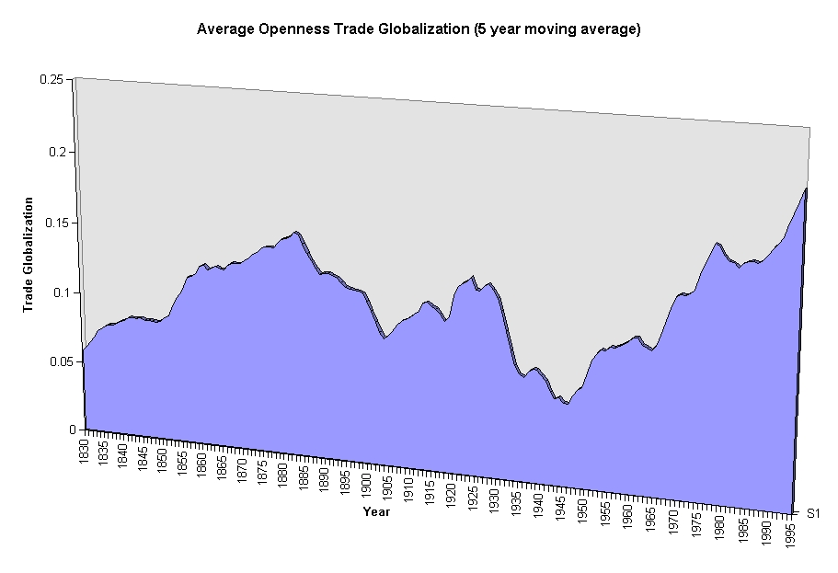
Figure 16.8: Waves of trade globalization
There was an unusually large economic depression in 1873 and another big one in 1896. British hegemony in the world market for capital goods was in relative decline already by the 1870s as serious competition emerged abroad, especially in Germany and the United States. British capital was increasingly invested overseas and the last phase of British hegemony was based on centrality in the world of finance capital. The City of London (the financial district of London) was truly the global center of high finance. Banking, currency exchange, stock and bond markets and insurance were concentrated in London. This was quite similar to the global economic role that had been played by Amsterdam in the declining years of the Dutch hegemony. But, though London was the most important center, there was also a network of other world cities that included Paris, New York, Berlin and others. These competed with each other, but they also complemented one another with regard to regional specialization.
As British hegemony in manufacturing declined, jobs were exported. Many urban and rural workers in England could no longer find jobs, and so they emigrated to the Americas and to Australia and New Zealand. Irish victims of the potato famine crowded into the East End of London, adding to the casualization of labor and the expansion of the “informal sector” in construction and petty services (Jones 1971). This “peripheralization of the core” and growing inequalities in the urban economy was similar in many ways to that studied by Saskia Sassen (2001) during the more recent rise of global cities such as New York during the most recent wave of globalization in the last decades of the twentieth century. As with contemporary globalization, the nineteenth century wave saw growing inequalities within many of the countries that were involved in expanded international trade and investment (O’Rourke and Williamson 2000; Davis 2003).
One reason why trade globalization declined after 1880 (see Figure 16.2 above), is that many of the countries that had lowered tariffs and adopted the Gold Standard in the middle decades of the nineteenth century reversed these policies in later decades. The United States reasserted its policy of tariff protectionism during the Civil War and did not return to Free Trade until after World War II. In Germany Freidrich List advocated that the national state should support national industrialization by using monetary and tariff policies to helf found new industries. List advocated a strong national bank that would make credit available to strategically chosen industries. List’s ideas were taken up the by newly integrated German state under the Kaiser Wilhelm and were influential in many other countries that wanted to catch up with the British.
The Edwardian reign has been called the “Indian summer” of British hegemony, the last warm days before the winter of hegemonic rivalry and deglobalization. It has also been called the belle époque, the beautiful epoch, because life was good for those who could benefit from investments abroad. But the working class was again on the move in the union movement and in national politics. The English were the first to adopt free trade, and the last to abandon this policy. Joseph Chamberlain, the political leader from Manchester, increasingly focused attention on the Empire in the name of improving social conditions at home – so-called “social imperialism.” Cecil Rhodes expanded the British Empire in South Africa, but the Dutch colonists (Afrikaners) were not happy with the expansion of British control. The Afrikaners rebelled in the Boer Wars, and the British Army carried on a long and bloody struggle that finally succeeded in saving South Africa for the British Empire. For many students of modern hegemony the second Boer War represents an instance of “imperial overstretch” in which a hegemon that is losing it economic comparative advantages tries to maintain its global supremacy by using its remaining military superiority (e.g. Modelski 2005).

1848: Another World Revolution
Toward the middle of the nineteenth century another world revolution was brewing. This time the volatile mixture was composed of reactions to capitalist exploitation of workers (slaves, serfs and wage workers) resistance to rapidly expanding global markets and demands for national sovereignty, especially in the remaining multicultural tributary empires – Austria-Hungary and the Ottoman Empire. Steamships and railroads brought distant regions into the sway of world market forces. Food was now exported to lands that had the ability to pay, and this often caused local shortages and made prices rise. The workers movement in Europe recovered from its earlier repression, and states that sought to mobilize citizens for war increasingly extended citizenship rights that enabled workers to play a greater role in national politics. From the 1830s new religious sects emerged in regions that were exposed to rapid social changes (in technology, migration, and marketization). Migration and economic reorganization disrupted older forms of community, and many new movements emerged to reestablish or to build new collective identities. Identity politics is another feature of globalization that is not unique to the twentieth century.
It is called the world revolution of 1848 because that is when worker’s movements and demands for popular sovereignty came to a head in several European countries. But the mobilizations included both secular humanist demands for equality (following the tradition of the French Revolution and the Leftist branch of the European Enlightenment) and radical religious sects that produced new forms of community with creative new interpretations of older religious ideologies. In the United States several new Christian sects emerged during the middle decades of the nineteenth century. Both the prophets and the recruits were people whose lives had been disrupted by the powerful forces of rapid technological and economic change. These newly emergent forms of cooperation and community challenged traditional moral orders, established religions, and political structures. Not everyone had fared well in the rapid economic changes that occurred during the nineteenth century expansion of capitalism and people were needy for a reassertion of moral values and revitalized bases for generalized trust.
The new religious sects adopted many of the radical ideals and reforms of the European secular movements. Joseph Smith, the prophet of the Latter Day Saints (Mormons), embraced communal ownership of property, obviously inspired by utopian socialist ideas emanating from Europe (Stegner 2003). The Mormons, who eventually established a large colony in Utah with pretensions to becoming an independently sovereign state, devised, taught and published newspapers in a radically simplified script for representing the English language. Linguistic reforms of this kind were intended to facilitate mass literacy and they had been another prominent feature of the radical social movements in Europe.
Population pressures encouraged migration, and some of the lands to which people moved were environmentally marginal. In Northeastern Brazil a huge area [NAME] receives enough rainfall in unusually wet years to support rain-watered agriculture. Thousands of immigrants and landless people from other areas of Brazil moved out to this region during a series of years [when?] of unusually greater rainfall associated with the El Nino/La Nina climate oscillation (Davis 2003). When the more usual low precipitation returned, the new crops failed and the pioneers faced starvation. Some left, but the others banded together under a religious leader who told them of the imminent return of a good king who would save the Earth.
In China the cycle of peasant rebellions discussed in Chapter 15 continued, but the rebellions came to be influenced ideologically and economically by strengthening interactions with Europe and the Americas. The Taiping Rebellion (1851-1864) was a huge movement that was joined by millions of landless peasants and unemployed workers. As with the earlier White Lotus peasant rebellions, the Taiping started off as a peaceful religious cult that stressed class and gender equality and vegetarianism. The leader was Hong Xiuquan, a member of an ethnic minority from South China called the Hakka. Hong had tried four times to pass the literary exams that were required to become an official in the Qing state. He came to be influenced by Issachar Roberts, an American Baptist missionary from Tennessee, who held to a very millenarian interpretation of Christianity. Hong came to think of himself as Jesus’s younger brother. The Taipings turned to military action in order to expel the Manchus from China and to redistribute land to the poor. The Taipings recruited women as soldiers and proclaimed gender equality. They rejected private property and promoted a simplified language and mass literacy in order to overthrow the literary hierarchy of the Mandarins. The Taiping guerilla armies were formidable foes and it took decades and thirty million deaths for the Qing dynasty to crush the rebellion.
Was this connected to the world revolution of 1848? The Taiping Rebellion was certainly a continuation of the pattern of East Asian development described in Chapter 15 in which Chinese population growth enlarged the underclass, which then rebelled against that paternalistic neo-Confucianist political order using egalitarian and apocalyptic ideas. But the influence of Western millenarian ideas and the increasingly synchronous economic cycles linking China with the Central system in the nineteenth century constitute both ideological and structural links that justify considering the Taiping rebellion to have been part of the world revolution of 1848.

Coordinated global party formation from below began in the world revolution of 1848. The movement to abolish slavery in the U.S. was inspired by the example of the Haitian revolution and led by an ex-slave from the Caribbean named Denmark Vesey, a large group of slaves in Charleston, South Carolina plotted an uprising in 1822 that was discovered and crushed before the rebellion could emerge. Slaves that were able to escape to the free states played an important role, along with protestant ministers, in the development of the abolitionist movement in the U.S. In England and France abolitionist groups were emboldened by the suppression of the slave trade by the British Navy. The radical abolitionist John Brown moved from Massachusetts to Kansas in order to try to prevent that state from adopting slavery. Frederick Douglass, a slave shipwright from Maryland’s Eastern Shore, worked in a shipyard at Fell’s Point in Baltimore before he moved to Boston, where he was a leading publicist in the rapidly growing abolitionist movement. The New England publisher and campaigner William Lloyd Garrison was a synergist who saw the potential for fruitful alliances among the several movements that were challenging the powers that be in the world revolution of 1848. The trade union movement was growing and feminists were beginning to demand that women should be able to vote. Garrison traveled to the World Antislavery Conference in London in 1840 with an American delegation that included women from New England and from the South. When the English majority refused to seat the women as American delegates Garrison and several other male members of the American delegation sat with the women in the balcony as spectators (Keck and Sikkink 1998: 46).
The American Civil War was a battle between the peripheral capitalists of the South and the free farmers of the West over the extension of slavery (see below). In the midst of the war, under pressure from both England and France, the Union leadership embraced the abolition of slavery. This was an important moment in the global struggle to make slavery illegal.
In 1863 the Czar Alexander II of Russia abolished serfdom in order modernize Russia’s economy and to improve its position in the international system. The abolition of serfdom failed to undermine the power of the Russian landed aristocracy and neither did it measurably improve the situation of the Russian peasants. But it did provide fuel for the next world revolution, which is usually called the world revolution of 1917 because of the world historical importance of the October Revolution in Russia.
One outcome of the world revolution of 1848 was the increasing popularity of the idea that the urban working class was going to be the main agent of the transformation of capitalism into a more collectively rational and egalitarian social order. Karl Marx, a German Jewish expatriate living in London in the middle years of the nineteenth century, wrote a brilliant analysis of industrial capitalism that assumed that the British path of development was the path that the whole world would take. Marx’s analysis, mainly contained in Volume 1 of Capital, underestimated the continuing importance of the core/periphery hierarchy in the development of capitalism. Marx knew that European colonialism had been crucial for the emergence of capitalism in Europe, but he saw this as an early stage of “primitive accumulation” that would later be transcended. For Marx capitalism was based mainly on wage labor, as it had come to be within the United Kingdom. Its spread to the rest of the world would create a global proletariat of wageworkers, which would then make socialist revolutions everywhere. Marx had no notion of peripheral capitalism, in which coerced labor would continue to be an important source of labor exploitation for producing commodities. And he only vaguely understood that the capitalist world-economy is importantly and continuously stratified into a global hierarchy of core and peripheral regions, with an important group of semiperipheral regions in between.
Marx was not entirely wrong, however. He saw that capitalism had internal contradictions that would eventually cause it to evolve into a qualitatively different kind of social system. His focus on class relations and the urban wage workers as important players in the world historical movements that are restructuring capitalism was a fundamental insight, but his failure to see the continuing significance of the core/periphery hierarchy was an unfortunate error because it blinded him to the phenomenon of semiperipheral development.
The First New Nation
Before the Europeans discovered the Americas, regional indigenous world-systems were in the process of developing complexity and hierarchy, as we saw in Chapters 7 and 8. The arrival of the Europeans incorporated these indigenous systems into the expanding Central system over a period of centuries. By the arrival of the nineteenth century there were only a few pocket regions that had not been incorporated. These were in the Western part of that portion of North America that became the United States and during the nineteenth century these too were brought within the Central web.
Though the Europeans had great technological and institutional advantages, the indigenous peoples were still capable of mounting significant resistance to peripheralization (Dunaway 1996). But the fact that local indigenous elites had long been able to reinforce their power by means of goods obtained by trade -- the prestige goods systems of the Mississippian culture -- set the stage for the trade dependencies that formed the main basis for integration and peripheralization of the indigenous peoples. Once local societies grew dependent on the importation of European tools and weapons, they soon lost the craft skills necessary to produce traditional tools. And the old elites lost power when they could not protect the people from diseases. This led to their replacement by new leaders, many of whom were allies of the Europeans. A new political order emerged promoted by the Europeans as a means of controlling the indigenous peoples.
The very decentralized and localized political structure that the Europeans encountered among the Cherokees in the Southeast was the outcome of the devolution of former Mississippian complex chiefdoms. The decentralized polity was very difficult for the British colonists to deal with because treaties and trade agreements had to be made with each Cherokee town. Thus the British colonists successfully imposed a more centralized form of governance on the Cherokees (Dunaway 1996). It is interesting to wonder how the centralized political structure that emerged as a result of peripheralization was similar to, or different from, the earlier centralized Mississippian complex chiefdoms. Historically known Cherokee leadership was divided between two different organizational structures -- the Red organization led by a war chief (the Raven) and a White organization of elders led by the peacetime White chief. The White chief was in charge during periods of peace, while the Red chief took over during war (Dunaway 1996). The British succeeded in consolidating the centralized Cherokee polity mainly around the warrior leaders. The White chiefs lost their power. This shift was partly due to the increased importance of warfare and slave raiding that accompanied incorporation in the Central System (Ferguson and Whitehead 1992). Trade was important in both the old and the new hierarchies, but in the old hierarchy trade fed into a theocratic system in which the sacred chiefs used imported prestige goods to reward subalterns. Trade with the Europeans was not a matter of symbolic goods used in religious rituals to glorify the sacredness of elites. Rather the goods received were guns, ammunition, metal tools and alcohol. While these sorts of goods have had (and do have) ritual importance in some societies, their effects on the Native Americans shifted power to the war chiefs, and centralized that power.
The competing European states allied with different Indian groups and used these alliances to provide buffer zones of protection for colonies and to keep trade routes open. The Cherokee alliance with the British transformed the Cherokees from an autonomous and decentralized set of societies to a more centralized group that became a dependent and exploited periphery of the Central system. Their culture was corrupted and transformed, their lands were despoiled and appropriated, and their labor was exploited (Dunaway 1996). On the other hand, at least in the long run, the Cherokees picked the right bunch of invaders with which to ally. The Creeks and Choctaws had it much worse when their Spanish and French allies withdrew.
The Native Americans were thus peripheralized and exploited by the traders and colonists from Britain. The colonial economy was based at first upon extracting valuables from the natives. But soon colonists began to produce agricultural cash crops (mainly rice and indigo) for export to the European core. This required massive amounts of labor. The Native Americans did not make good plantation slaves. But Africans, far from their homelands and able to survive lowland climes and hard labor, served the purpose well. On their backs the colonial economy took shape as a classical peripheral structure using coerced labor to produce agricultural goods for export to the core. Some have called the plantation economy non-capitalist because its use of coerced labor is similar to serfdom and slavery in tributary modes of accumulation. But the tight interdependence of manufacturing and industrial capitalism in the core with production based on labor coercion in the periphery of the modern world-system warrants the use of the term "peripheral capitalism" to designate the expansion of labor coercion that occurred in conjunction with the development of European capitalism.
In the emerging global capitalist world-system "national development" is best understood as upward mobility in the hierarchical division of labor between the core and the periphery. Most areas that were incorporated into the expanding Central system became organized as peripheries and were unable to escape this position. The process of peripheralization, or as Andre Gunder Frank (1966) called it, the "development of underdevelopment," reproduced the institutional structures that perpetuated peripheral capitalism and blocked the emergence of core capitalism. A few countries were able to overcome the forces of peripheralization and to develop core activities and to move upward in the core/periphery hierarchy. By far the most successful was the United States of America.
The developmental history of the United States, rather than being a replicable model of modern development for all countries, is an extremely unusual case of a region that went from being a colonial periphery to the hegemonic core power while the larger system remained a quite stable core/periphery hierarchy in which most countries did not change their positions. The American Revolution was an important first step in this trajectory. One interesting question that involves core/periphery relations is why the planter aristocrats of the South joined with the embryonic core merchants and producers of New England to drive the British out. Structurally, the Northerners had a shot at becoming another England and some of them knew it (e.g. Alexander Hamilton's Report On Manufactures) so they had a powerful reason to increase their autonomy from the mother country. But the Southerners were completely dependent on the British as customers and suppliers. The South was taking a big risk in joining up. Why did this happen? Several arguments have been suggested including resentment at the reimposition of British taxes after a lax period of “benign neglect,” and the indebtedness of Southern planters to English lenders. It has also been argued that the Southerners joined because they resented Crown efforts to keep them from expanding westward. Perhaps it is not such a mystery after all. Dominated peoples often rebel if they see a reasonable chance of success. After the threat of French dominion was settled in the Seven Years War, the French became a valuable but unthreatening ally of the North American colonists. Thus success was perceived to be possible enough for both Southerners and Northerners to take the risk.
Tariff politics in the nineteenth century provides a clear and wide window on how political power in the United States was in contention between the core and peripheral capitalists in the ante-bellum period (before the Civil War) (Chase-Dunn 1985). After the Revolutionary War the different world-system positions of the North and the South engendered contrary attitudes toward tariff protectionism. As exporters of raw materials to the European core, and importers of manufactured goods, the Southerners were devoted to free trade. The manufacturers of New England and the Middle States came to embrace tariff protection of their “infant industries.” The U.S. trajectory over the nineteenth and twentieth centuries is reflected in its tariff history. The United States was a classical semiperiphery containing both core and peripheral regions -- the North and the South. As have most peripheral countries, the South favored free trade because it depended on core markets. The North came to favor protectionism because it aspired to develop core industries and to rise in the value-added hierarchy that is the core/periphery division of labor.
Nascent core producers are likely to be driven out of business if they have to face the competition of existing core producers, and so they need tariff protection to survive. Before the Civil War the North and the South struggled over the question of tariffs. After the Civil War the rising United States was firmly protectionist until after World War II when, as a hegemonic power with a strong comparative advantage in core production, it shifted to free trade and went about the world trying to convince others to do the same. The English had followed the same trajectory. First they were dependent exporters of wool to the textile producers of the Low Countries. Then they engaged in protectionism to support their own domestic textile producers. When they had developed a global comparative advantage in the production of core commodities they became champions of free trade. And when they lost their comparative advantage they rediscovered the promise of protectionism. This was also the trajectory of the Dutch Republic in the seventeenth century.
The economy of the U.S. South grew rapidly in concert with the English Midlands as the invention of the cotton gin made upland short-fiber cotton commercially viable. King Cotton also exhausted the land quickly and fresh western lands became an important need for the expanding South. The fight over tariffs began with the South Carolina nullification movement in the 1830s. Whereas the North was intellectually fortified with the protectionist economics of Henry Carey, the South had a pro-free trade economist in Dr. Thomas D. Cooper of the College of South Carolina. Though the South was a classical example of peripheral capitalism (producing cash crops with coerced labor), it was a dynamic peripheral economy. Indeed, by the time of the Civil War the South was the ninth largest economy in the Western world.
The Federal Congress adopted protectionist legislation in fits between1816 to 1846. The farmers of the West supported free trade when the world market price of grain was high. But when the external demand was glutted they supported the “American System” of Kentucky’s Henry Clay -- a program of tariff protection of domestic industry and the building of transportation infrastructure to connect agricultural and industrial regions. The North/South struggle over tariffs was largely over by the time of the Civil War, because by then the core capitalists of the North no longer needed tariff protection to prosper in the world market. The Civil War was primarily a fight between the plantocracy and Northern and Western workers and farmers. The Southerners main reason for insisting on extending slavery to the West was that they needed to control the Federal government in order to protect their “peculiar institution”. The Republican Free Soilers brought the Eastern manufacturers into their coalition by committing to the ultra-protectionist Morrill Tariff of 1861 and the United States remained protectionist until after World War II. The plantocracy was brought to heel and henceforth core capital ruled the Federal state with substantial support from workers and farmers. In this light the political histories of most of the Latin American countries can be seen as anticolonial struggles that were followed by Civil Wars in which the local "Souths" won.
The first new nation was formed when thirteen of the English colonies in North America rebelled against King George of the United Kingdom and established their own sovereign government, a federation of former colonies that had become states. It is fairly easy to understand why the colonies of New England rebelled. A large scale fishing industry, a boat-building industry and a class of merchants who carried goods all around the Atlantic world had emerged by the middle of the eighteenth century. Shipbuilders and merchants of New England and the middle colonies in the eighteenth century were able to begin the process of capital accumulation in types of production that allowed them to compete with producers of core products in England. The later rise of the United States to core status and world hegemony stems from these developments. The defeat of the French in the Seven Years War meant that the New Englanders no longer needed the British Army and Navy to protect them from France. But why did the plantation-owners of the southern colonies join the rebellion? They were exporters of agricultural raw materials mainly to British markets, and so they were quite dependent on the good will of the British. Yet they joined the rebellion, and indeed the great general who led the rebel army was a plantation-owner from Virginia, George Washington.
No doubt part of the explanation for the rebellion in the south was the popularity of republican ideas and the notion of national self-determination. The plantation class of Virginia is well known for the enthusiasm it had for Montesquieu and the ideals of liberty, as least insofar as these applied to land-owning gentlemen. Another factor may have been the desire to expand toward the west. George Washington, in addition to inheriting a prodigious great plantation on the Potomac, was a surveyor who spent much of his young manhood establishing the official boundaries of properties in the relatively as yet undeveloped regions to the west. The Virginians wanted to expand their plantations into the west, but the British government was standing by treaties that it had made with those Indian tribes that had supported the British against the French in the Seven Years War. This was an immediate and material reason to be free of the crown.
It was a long and difficult war, with the rebels resorting to tactics that would be labeled as terrorism or butchery if they had been carried out by other than the totemic fathers of the nation. General Washington crossed the Delaware River at midnite on Christmas Eve to slaughter the holiday-inebriated Redcoats in their bunks. Then, as now, the distinction between terrorists and freedom fighters is not so simple.
At the crucial battle that turned the tide against King George there were no Americans present. It was a naval encounter at the mouth of Chesapeake Bay in which the French Navy succeeded in repelling a British Fleet that was headed to reinforce Lord Cornwallis at Yorktown. The French won and the American Revolution was saved. As mentioned in Chapter 15, the expense of supporting the American rebels weakened the French monarchies ability to deal with the challenges that emerged in the French Revolution of 1789. But French support had been crucial to the birth of the first new nation.
New England was a classical case of semiperipheral development. The involvement of its merchants in the “triangle trades” linking the Caribbean with Africa, the Mediterranean and the ports of Northwestern Europe was tolerated by the benign neglect of the British authorities. But the rebellion was spurred by new efforts to enforce the Regulation Acts (mercantile laws that gave preferences to British merchants and shippers) and to collect taxes from the American colonies. The alliance between New England and the South was fitful because the two regions had rather different interests vis a vis the larger Atlantic economy. And Alexander Hamilton’s 1791 " A Report on the Subject of Manufactures" was an original and innovative statement of the strategy of the developmental state. Hamilton’s writings were an important inspiration for German economist Freidrich List, who resided in the United States from 1825 to 1832. Hamilton advocated the establishment of a strong national bank that could use monetary policy and the allocation of credit to help establish and support industrial manufacturing. Hamilton also recommended a strong federal role in the development of transportation infrastructure that would link the new agricultural regions of the hinterland with the industrial ports of the coast. The Southerners opposed these policies, which envisioned a strong and active central government. They wanted local autonomy and low taxes so that they could continue to export their agricultural commodities to the core areas of Europe. This regional conflict of interest was not fully resolved until the Civil War.
The anticolonial victory did not, in itself, guarantee the upward mobility of the United States in the world-system. After all, the Latin American republics successfully established formal political independence in the early nineteenth century, but economic "neo-colonialism" continued to produce the development of underdevelopment and they remained in a peripheral position in the core/periphery hierarchy (Stein and Stein, 1970). So how were the forces supporting the development of domestic core production in the United States able to win out over the interests that supported the maintenance of peripheral production for export to the established core in Europe?
The Americans did not declare war on Britain in alliance with Napoleon. Rather they attempted to maintain neutrality so that their commerce could continue. It was British attacks on American shipping and the impressments of American sailors into the British Navy by force that led to war. In the first encounters fast and large American ships-of-the-line roundly defeated the British Navy to the great consternation of all who supported Britain and opposed Napoleon. But the long war with Napoleonic France was decided elsewhere, and during a lull the British decided that it was time to reconquer the upstart colonials, as recounted above. This time the colonials were able to hold their own without the help of the French in the War of 1812, though the new capitol building in Washington was burned to the ground. The few anglophiles left in the former thirteen colonies kept their feelings to themselves.
The politics of import duties reflects the struggle between classes that have different interests in the larger world economy. Thus the outlines of the struggle between core capitalists, peripheral capitalists, and the other classes that ally with or oppose them, can be discerned in the tariff history of the United States.
During the Napoleonic Wars imports to the United States from Britain and from other developed regions were severely curtailed because the war interfered with international trade. The resulting pent-up demand and rise in prices was a big incentive for “import substitution” of manufactured goods. Entreprenuers from Providence, Rhode Island traveled to Manchester and Birmingham to survey the latest technologies in cotton textile manufacturing. When these clever spies returned to Providence they designed a new power loom that was a big improvement over the British technology. The cotton textile industry in Rhode Island was well under way when the war came to an end.
Lord Brougham gave a speech in Parliament recommending the export of vast quantities of British goods to be sold in New York at below their cost of production, thereby to drive out of business those industries that had emerged in the United States during the war so that the British manufacturers might retake the American market. In 1816 the U.S. Congress passed its first protective tariff in order to counteract the British dumping and to allow the new industries to survive.
Henry Clay of Kentucky proposed his "American System" to promote the alliance between agriculture and industry based on the protected development of a diversified national market. In Clay's scheme the Federal government would stimulate manufacturing by applying a protective (but not prohibitive) tariff. The revenues resulting from the tariff would enable the government to sell Western land cheaply and to finance internal improvements in transportation between the agricultural West (and, presumably, the South) and the industrial East. Clay's program created a political alliance among core capitalists, farmers, and labor, that supported increasing protectionism until Southern opposition reversed this trend in 1833. The program of internal improvements began in 1818 with the completion of the National Road, a Federally built highway that connected Baltimore with the Ohio Valley. The General Survey bill of 1824 proposed an elaborate national transportation system of roads and canals, most of which were later built under the auspices of the separate states, but with Federal encouragement. The Erie Canal, connecting the Hudson River with the Great Lakes, was completed in 1825.
The shifts in United States tariff policy between 1815 and World War II can be generally described as follows: The war duties during the Napoleonic Wars (which were intended to raise revenues for the Federal government) were replaced in 1816 with a tariff that, although not high, was intended to be protective. The average rate in 1816 was 25% ad valorum, meaning that the import tax on an item was equal to one quarter of the price of the item. This was increased in 1824 to 33%, and again in 1828 to 50% (Freehling, 1967). In 1833, Southern planter and Northern merchant opposition forced the adoption of the Compromise Tariff that lowered rates slowly until 1842. In 1842 protection was renewed until 1846 when the Walker Tariff, a victory for the free traders, was adopted. In 1857 tariffs were lowered even further. The Republicans, who gained much power with the election of Lincoln, passed the ultra-protectionist Morrill Tariff of 1861 and protectionism reigned from then until after World War II.
This tariff history from 1816 to 1860 reflects the process of class formation in the antebellum period (before the Civil War). Core manufacturers expanded after the War of 1812 and, in alliance with farmers, succeeded in passing protectionist legislation. The peripheral capitalism of King Cotton in the South expanded even more rapidly and the core and peripheral interests contended for power in the Federal state by making alliances with other classes: merchants, workers, and yeoman farmers.
Peripheral capitalism in the South was by no means moribund. Indeed it was a dynamic and differentiated economy based on commodity production with slave labor. By the 1840s the upper South had become a slave-breeding and semi-industrial region. But the main-stay of this slave-based peripheral economy remained the production of cotton for the English Midlands. The plantocracy of the South was able to dominate the Federal state during most of the antebellum period by allying with Western farmers and Northern workers in the Democratic Party. This alliance, which ushered in the period of low tariffs in the 1840s and 1850s, eventually foundered on the issue of the legal status of slavery in the new territories of the West.
The shippers and merchants of New England had opposed protectionism because they feared that it would interfere with their business, but New England eventually came over to protectionism. “In 1825, the great firm of W. and S. Lawrence of Boston turned its interest and capital from importing to domestic manufacturing, and the rest of State Street fell in behind it. So did Daniel Webster, who was now to become Congress's most eloquent supporter of protection” (Forsythe 1977: page #).
The advances made by the core industries in the 1820s and 1830s enabled them to survive and prosper in the period during the 1840s and 1850s when peripheral producers reestablished their control of the Federal state. Zevin (1971) reports that between 1820 and 1830 American consumption of cotton cloth increased from 50 to 175 million yards, while the share of that consumption supplied by New England increased from about 30% to about 80%. By 1825 even Hezekiah Niles, the ardent Baltimore protectionist, admitted that American coarse cotton textiles no longer needed protection. By 1832 these coarse cottons were competing with British products in the markets of the Far East. Thus further protection of cotton textiles was redundant.
There was considerable United States support for the Latin American independence wars against Spain, especially from the Catholic enclave in Baltimore (Maryland) where Latin American colonial elites often sent their children to be educated in Jesuit colleges (Bornholdt 1949).14 In 1823 President Monroe refused a British proposal for a joint British-United States declaration in support of Latin American independence and issued the precocious Monroe Doctrine forbidding European interference in Pan-American affairs. The United States, itself still a non-core power, staked out the moral high ground on which its later hegemony would claim legitimation as “leader of the free world” and defender of national self-determination.
The Rise of Opposition to Protection
The peripheralized colonial Southern economy based on tobacco, rice, and indigo seemed to have reached its zenith at the end of the eighteenth century. Contemporaries such as Jefferson predicted that slavery would wither away. Others thought that the South would turn toward maritime and industrial activities. But the invention of the cotton gin and the demand for cotton to feed the mills of the English Midlands gave plantation slavery a new lease on life. The cotton gin made cultivation of the short fiber, upland cotton commercially profitable with the application of slave labor.
The reorganization of the core/periphery division of labor between the South and England also had effects on the maritime and commercial interests of the North, particularly New York City. New York merchant shippers bought most of the cotton from the planters, at first transporting the cotton to New York for inspection before shipment to Liverpool. Later the New York merchants established factors in the port cities of the South that enabled them to ship directly. But they maintained financial control of most of the trade between the south and England. Specialized merchant-banker firms such as Baring Brothers and George Peabody and Company established credit facilities by which American merchants could purchase English goods with drafts on London banks. Peabody, a Baltimore dry goods merchant, established a firm in London for this purpose and hired another dry goods importer, Junius Spencer Morgan of Boston. Through this connection the Morgan family entered the calling of high finance.
Both Northern merchants and Southern planters came to fear that their British customers would retaliate against U.S. protection by obtaining their raw materials from other than U.S. producers. Also Southern exporters were made aware that, as international economists have demonstrated, a tariff on imports is not only a tax on consumers of imports but is also effectively a tax on exporters. Dr. Thomas Cooper, a disciple of Adam Smith and President of the College of South Carolina, suggested that the marriage between the states had become somewhat less than a transcendent relationship.
The Tariff of 1828 raised rates and extended protection to a large number of commodities not protected before, including a number that angered New England. Antiprotectionist sentiment was growing and free traders hoped that the election of Andrew Jackson would bring relief. But Jackson did not act to lower the duties. Southern planters organized an unsuccessful boycott of Northern products and leading politicians appeared in public in homespun (clothing made from thread and cloth that had been produced at home) to dramatize their cause. The most rabid of the South Carolinians were talking of secession when their Senator John C. Calhoun devised what he thought to be a compromise that would preserve the Union. Antitariff politicians had argued that tariff protection was unconstitutional. Calhoun (anonymously at first) proposed the doctrine that states have the right to nullify Federal laws that they deem unconstitutional. Nullification received enthusiastic support in South Carolina, but not in the other Southern states. In 1832 the South Carolina legislature called a convention and adopted nullification unilaterally, but President Jackson stood firm against this challenge to the sovereignty of the Federal state and, after some sabre-rattling, the South Carolinians backed down.
The controversy over the tariff is often portrayed as being based on sectionalism, and indeed the Congressional voting record on the tariff acts from 1820 on shows that it was increasingly the Southern states that opposed protection. But the sectional aspect was due mainly to the conflict between core capitalists interested in creating a diversified and integrated national economy and peripheral capitalists specializing in the exchange of raw materials for European core products. These two groups contended throughout the antebellum period for the support of other politically important classes: merchants, farmers, and increasingly, workers.
In the 1830s both farmers and plantation-owners were increasingly dissatisfied with the tight money policies of Eastern bankers. And labor organizations emerged to oppose municipal monopolies and restrictive land sales policies that were associated with Eastern financial and manufacturing interests. The Democratic Party chose Andrew Jackson, an Indian fighter from Tennessee, to symbolize the new coalition of farmers, laborers, and planters.15 Jackson was not sympathetic to free trade, nor did he yield to nullification, but his election was the beginning of the coalition between the South and the West, which was to increasingly delimit the power of the domestic core capitalists in the Federal state in the 1840s and 1850s.
Free Trade
In 1845 the potato famine in Ireland caused prices of American agricultural commodities to rise due to increased foreign demand. The recovery of the West from the crash of 1839 had been slow, but the new demand caused a renewal of expansion and brought the West back into the free trade coalition with the South.
Many industries in the U.S. no longer needed protection from imports. Cotton textiles were cheaper in New York than in Manchester. By 1839 the domestic market for many manufactures did not need tariff protection. Schumpeter (1939) points out that this period saw a long-term upswing in the pace of economic growth throughout the world. As we have mentioned above, tariffs were reduce all across Europe and the Atlantic economy as the benefits of trade came to outweigh the injuries done to domestic producers and the British engaged in a globalization project that promoted free trade and the gold standard. The British economy shifted from the production of mass consumption goods toward the production of capital goods (Hobsbawm 1968), and the capitalists of other core states developed their own mass consumption industries by importing British machinery and railroad equipment.
The Crystal Palace Exhibition of 1851 was a great promotional effort to expand the export of British technology, a reversal of the earlier attempt to monopolize production techniques (Landes 1969). The international division of labor between core producers became less autarkical and protectionist as a result (Krasner 1976). Cobden and Bright traveled widely, lecturing on the beneficial effects of a world free market. Their arguments were acted upon because the actual gains from free trade to consumers came to outweigh the costs to producers. And the producers, including core capitalists in the United States, had less to lose because the pace of growth was expanding and they wanted to import capital goods from England.
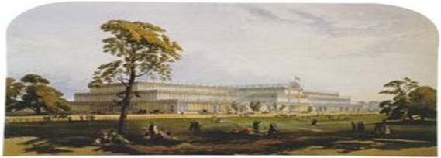
Crystal Palace, London
Protection Again: The Irrepressible Conflict
The Panic of 1857 came a few months after the passage of the tariff bill. It was similar to the depression of 1839 in that it followed a period of rapid inflation, economic expansion, foreign investment, importation, and Westward movement. But the expansionary phase was based on the growth of manufactures and Western free agriculture rather than slave-grown cotton as the growth of the 1830s had been. And, as before, the fall of grain prices (partly resulting from the end of the Crimean War which allowed Russian wheat back on to the world market) and the fall of wages and employment renewed the spirit of protectionism.
The new growth of the labor movement (especially among immigrant German workers), the opposition to the extension of slavery to the Western states, and the renewed enthusiasm for cheap land led to the birth of the Republican Party .The greatest issue of the new party was "free soil" and the passage of the Homestead Act (E. Foner 1970). The Republicans attracted Democratic voters with the slogan "vote yourself a farm" and they supported pro-labor legislation. Lincoln avowed the principle that labor is the source of all wealth and won the support of immigrant workers by his opposition to an alliance between the Republicans and the Know-Nothings (P. Foner 1975). The Republicans were antagonistic to the "money power" of the East, but they eventually adopted protectionism in order to appeal to the manufacturers.
The success of the Republicans and the split between the Northern and Southern Democrats broke the alliance between the farmers of the West and the planters of the South, that had allowed the Southerners to control the Federal state through the Democratic party. The crumbling of this alliance provoked the Civil War17 even though the Republicans never advocated the abolition of slavery but only prevention of its extension to the West. Southern peripheral capitalism was expansionist because of its extensive nature and the quick exhaustion of the soil, but this was not the main reason why the South desired the extension of slavery to the West. The main issue for the South was control over the Federal state. Planters opposed the creation of free states because the alliance with free farmers was tenuous and they felt they would have less and less power in the Federal state. The result would be a direct attack on their "peculiar institution" and their subjugation to the North as an internal colony. Therefore, when the South- West coalition crumbled and Lincoln won the election in 1860, South Carolina did not even wait for him to take office. South Carolina seceded immediately, and most of the other slave states followed when it became clear that the North would make war in order to preserve the Union.
The argument that the conflict between the North and the South was due to the economic inefficiency of slavery has been sufficiently demolished. Let me only add that plantation slavery remained highly profitable and the Southerners were well aware that emancipation in the British West Indies in 1834 had increased the cost of sugar production considerably. Slavery was not simply the basis of an aristocratic civilization, it was a profitable business. The plantocracy of King Cotton was probably the most successful peripheral capitalism in the whole history of the world-system because it was less encumbered by precapitalist institutions than the Hispanics, Germanics, Slavs, or even the British, and French colonies had been. This was truly successful capitalist agriculture and its very success led to dreams of Slave Empire and the challenge to the Northern and Western interests (Genovese 1965). After all, the slaveholders started the Civil War. The core capitalists, workers, and farmers of the North only grudgingly made war to keep the Union intact.
The contention that capitalism and slavery were incompatible for political or cultural reasons simply does not fit with the historical facts. Barrington Moore's (1966) observation that the legal and political legitimation of slavery contradicted the more opaque form of exploitation that existed in the North is true, but insufficient to explain the violent conflict that developed. Similarly Eugene Genovese's (1969) characterization of the divergence between the political culture of the aristocratic and precapitalist South from that of the fully developed capitalist mode of production based on wage labor in the North does not explain the Civil War. Regardless of cultural differences, both the North and the South were capitalist, only the North had become an area of core capitalism employing relatively high wage labor, while the South had remained an area of peripheral capitalism utilizing coerced low cost slave labor (Wallerstein, 1979).
The evidence that supports the foregoing contention is to be seen in the political history that led to the Civil War. Northern manufacturers were not against slavery. In fact, in the face of increasing labor struggles they may have been envious of it. Their biggest conflict with the South had been over the tariff issue, and that was no longer crucial to them by 1860. A main cause of the Civil War was the opposition of the free workers and farmers to the extension of slavery to the West. These core workers and farmers were not abolitionists. The main issue for them was the threat of competition with slave labor and plantation owners for the lands of the West. Their unhappiness with the Compromise of 1850 was seen most vividly in the battle for Kansas and in the fight against Southern opposition to the Homestead Act.
The Lincoln Administration did not contemplate emancipation until well after the Civil War had begun, and then mainly to head off English and French support for the South (Case and Spencer, 1970). Queen Victoria adopted a formally neutralist stance. The cotton famine caused by the blockade of Southern ports resulted in massive unemployment in the English Midlands. English support for Southern naval raiders allowed them to sink a large portion of the Northern merchant marine.18 The Emancipation Proclamation generated enough support for the Northern cause in England and France to prevent further aid to the South.
It was not slavery that was the main issue, but the question of who would control the Federal state. Free farmers and wageworkers found themselves at odds with the interests of the peripheral capitalists of the South on the issue of the frontier, and so they cast their lot with core capital. Thus was the plantocracy destroyed and a strong federal state was created that was firmly in the hands of core capital and supported by a key sectors of core labor. This was the form that semiperipheral develop took in the 19th century. The upward mobility of the United States was hereafter assured. The regime crises of antebellum period were over. Core capital had the state and was willing to innovate the institutions needed to move on to the global stage as a core state. The alliance between the core capitalists, labor and farmers would be tested at several point in the future, but the core capitalist would never again be challenged by domestic peripheral capitalists.
The history of the tariff issue is significant as a reflection of contradictory class interests as perceived by the actors and the changing political alliances of classes and interest groups. As mediators of the core/periphery trade the merchants often sided with the peripheral capitalists, but when the imperial core state (Britain) became unusually hostile, or when manufacturing became more profitable than the maritime trade, the merchants and finance capitalists supported the politics of the domestic manufacturers.
The class alliances of the free farmers were a function of their changing position in the larger world-economy. When the world market price of wheat was high they went with the free-trading South. When the price was low they supported protectionism and the American System.
A world historical perspective sheds new light on the class position and alliances of American wageworkers, and implies a new interpretation of the problem of "American exceptionalism." In comparative perspective the United States is held to be unusual (compared with European societies) because a labor party did not become an institutional part of the political system and the welfare state was only weakly institutionalized. The classic question of American exceptionalism is “why no socialism in the United States.” As Aglietta (1978) has argued, the original reliance of the propertied classes on farmers and mechanics for support against the British in the War of Independence created a political constitution that allowed the early extension of citizenship and political rights to men of no property. The control that elites maintained over the law and the court system protected the concentration of private property and allowed for the incorporation of non-elite groups into the political process in a way that did not seriously threaten the propertied class. The competition and conflict between core and peripheral capitalists of the North and South caused both to try to mobilize the farmers and mechanics (workers) behind them. Both free traders and protectionists argued that adoption of their tariff policy would raise wages.
It was not the cultural incompatibility of slave society and wage-labor capitalism that led to the irrepressible conflict, but rather the diminishing amount of new territory in which to expand that exacerbated the confrontation between core capitalism and peripheral capitalism. And this was less a struggle between core capitalists and peripheral capitalists (as the earlier controversy over the tariff had been) than a fight between peripheral capital and core labor and farmers. The victory redounded to the favor of the manufacturers, but it was not primarily their interests that led to the conflict.
The conflict between core labor and peripheral capital over the "internal" policies of the state is not inconsistent with a sophisticated version of the world-systems perspective. The examination of class conflict as it occurs in the context of the world political economy seeks to eliminate the internal-external distinction, which has confused much previous analysis. The confrontation was caused by "internal" scarcities only because the policy of annexation had come upon natural and political limits. The emergent relative harmony between core capital and an important sector of core labor can be seen in formation in the Civil War. This class coalition made possible the creation of a strong core state that could rise to hegemony in the world-system.
In addition, the dynamism of American economic growth was both a cause and consequence of the interaction between capital and labor. The open frontier allowed expansion and, even with massive immigration, kept wages higher than they were in Europe. This encouraged capitalists to utilize laborsaving machinery, and also provided demand from relatively well-paid workers for an expanding home market for manufactures and agricultural commodities. Thus the political constitution, the legal system, the class structure, and the rate of economic growth made possible a relative harmony between capital and labor in the first new nation, and the outcome of political struggles between core and peripheral capitalists favored the trajectory of upward mobility in the larger core/periphery hierarchy. The expanding frontier was an important factor in this success story. When later militant challenges emerged from the working class the playing field was tilted in favor of compromise by the ability of the economy to incorporate and reward an expanding middle class and a large sector of labor.
By 1880 the United States of America had recovered from the Civil War. Industry was booming and the U.S. was beginning to play the role of a core power in the newly global world-system. The intertwining of the finance capitalists of New York and London was getting very cozy and was spilling over into other sectors. The wounds of 1812 were healing over. The U.S. economy was becoming more tightly linked by trade and investment with the great powers of Europe, and the West Coast was further developing its ties with the Pacific Rim. In 1898 the former champion of national sovereignty began to dabble in the “new imperialism” of the late nineteenth century by challenging Spain in Cuba and the Philippines. This was a new twist in the Monroe Doctrine in which the former first new nation was becoming the “colossus of the North” in the eyes of the Latin Americans. The British supported the U.S. against Spain, and the Anglo-American alliance was firmly on.
The indigenes of the American West whose cultures and life-ways had been over-run by the miners, farmers, rails, markets and Buffalo slaughterers developed millennial revitalization movements based on the idea that the White Man would disappear and all the dead Indians would come back to life. Some of the enthusiasts of the Ghost Dance Religion thought that their ghost shirts would repel bullets, and this belief contributed to some of the massacres of the 1870s and 1890s (Thornton 1986).
New York became the second largest city on Earth in 1900, though London was still considerable larger (see Figure 16.3). New York did not surpass London in population size until 1925.
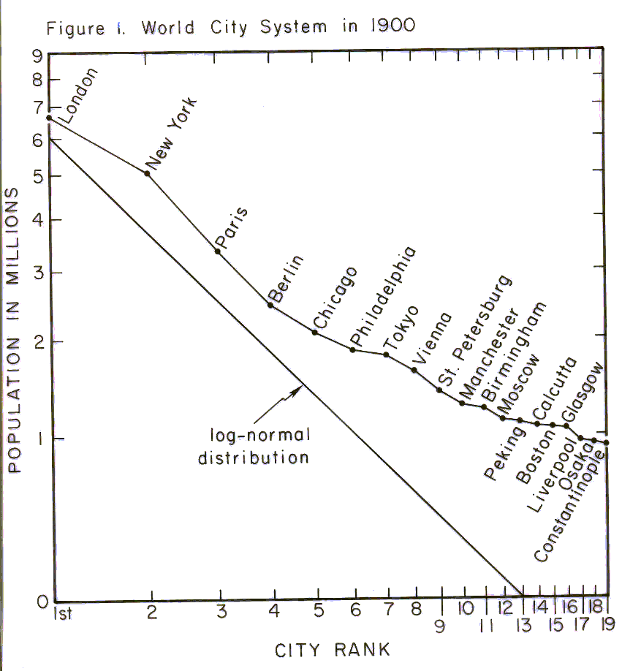
Figure 16.9: The population sizes of world cities in 1900
There was a strong and militant labor movement in the United States that produced important political institutions. Agrarian socialism emerged in the granger movement that opposed the power of big banks and railroads. Unions and parties carried on important struggles and won electoral political power in several Midwestern states. The Socialist Party nearly won the presidency and the Communist Party had three million members in the 1930s. So it is not true that there was no socialism in the United States. But the defeat of the radical left and the incorporation of the labor movement into the Democratic Party does need explaining. The incredible 200-year upward mobility of the United States in the world-system made it possible for the rewards of economic growth to be shared by a sizeable group of middle class people and skilled workers. Waves of immigration undermined the power of labor organizations by pitting new arrivals against older working class communities, as did the migration of sharecroppers from the South to the industrial cities of the North. “Labor’s Untold Story” (Boyer and Morais 1975) needs to be told in order to understand how the relative harmony between capital and labor in the United States developed and what the implications U.S. hegemonic decline in the twenty-first century are for the future of class relations in the United States. The form of incorporation of the working class in the United States was constructed around nationalism and military service. The first formal welfare institutions created at the time of the Civil War were for war veterans (Skocpol 1992). The citizen-soldier axis was the major institution for building Federal welfare institutions in the U.S., and this served to undercut the class-consciousness of workers by strengthening nationalism. These elements will be traced in the next Chapters.
The New Imperialism
Until the 19th century the processes of contestation were substantially separate and autonomous in East Asia, where a trade-tribute system organized by China had long been the central institutional structure of an East Asian world order (Arrighi et al 2003). East Asia had been indirectly linked with the Central (Western) state system by means of long-distance prestige goods trade since before the Roman and Han empires, and though this connection and interaction with intervening Central Asia steppe nomads had some effects on both Eastern and Western state systems, their world orders remained substantially independent until the nineteenth century. In the nineteenth century the rising European preeminence incorporated the East Asian state system into a single global system of states with a strongly and directly connected set of core states. The increasingly Europe-centered Central system had become organized within its core as a system of spatially bounded and formally sovereign states, most of which claimed control over distant peripheral colonies.
Increasing inter-imperial rivalry in the late nineteenth century combined with nation building and pressures from emergent classes to produce another wave of European expansion. This can be seen in Figure 1, which shows the number of new colonies established from 1870 to 2000. There was a wave of new colonies established from 1870 to 1905. This was called the “new imperialism,” and the signal event was the Berlin Conference on Africa in 1884 in which the European powers gathered to divide Africa up amongst themselves.

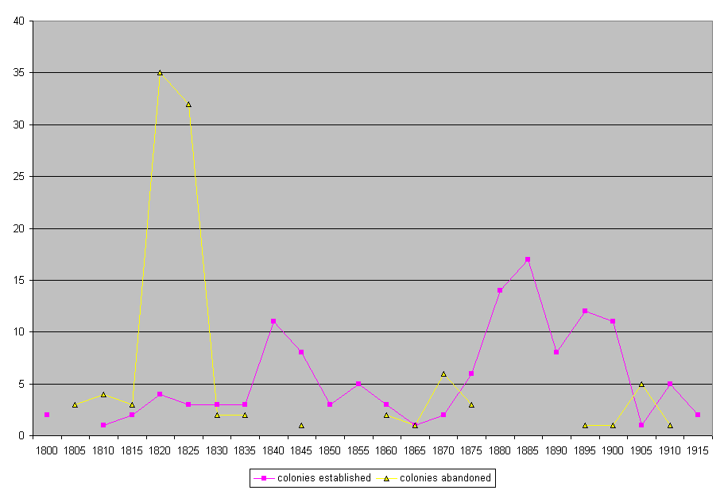
Figure 16.4 Colonial Expansion and Decolonization, 1800-1900. (Source: Henige 1970)
Figure 16.4 also shows the last year in which a colonial governor served, which can indicate that a country has gained sovereignty or that a colony has been taken over by another core power. The vast majority of cases, especially in the first great wave of decolonization that occurred in the first decades of the 19th century, were instances of gaining sovereignty and joining the system of sovereign states. The world of sovereign European core states, each with its own colonial empire, was becoming a global interstate system because the former colonies demanded and gained entrance into the system of sovereign states.
These waves of colonization and decolonization had been going on for centuries, but the relations between core and periphery had also been evolving. The big pattern involved first an uneven and long-term transition from old-style tributary imperialism in which a state would conquer its neighbors and extract tribute, to a new system of colonial empires in which core states that were competing with one another economically would establish control over distant colonies as sources of raw materials or to help control shipping. The European colonial empires had somewhat different styles and much of the comparative literature on colonialism focuses on these differences. E.g. the British often preferred so-called indirect rule, in which they found a local leader to be their ally and to help them get access to raw materials and markets, while the French often tried to turn all their colonial subjects into French citizens. But in practice all the colonial empires used different mechanisms under different circumstances, and the long-run evolutionary processes can only be seen by more or less ignoring the complications of each case and period.
The last transformation, which is still under way, is from colonial empire to neo-colonial dependency. Some have argued that the attaining of formal political sovereignty by former colonies abolishes the core/periphery hierarchy and creates a world of equal states. Indeed the General Assembly of the United Nations gives each national member one vote, so the votes of Honduras and of the United States have equal weight. But others point out that institutionalized international inequalities have continued to be structurally important despite the elimination of formal colonialism. What has happened is a shift from formal political mechanisms of control backed up by military power to a system based more on economic power. This shift has been occurring for centuries. Indeed, the prior transformation from tributary imperialism to colonial empires was also based on the rising importance of economic competition among core powers for shares of the world market in new lead industries. Semiperipheral capitalist city-states had had colonial empires for millennia before a whole regional system emerged in Europe in which all the core states adopted this type of imperialism. Both of the transitions were due to the increasing importance of capitalist accumulation in the processes of intersocietal competition.
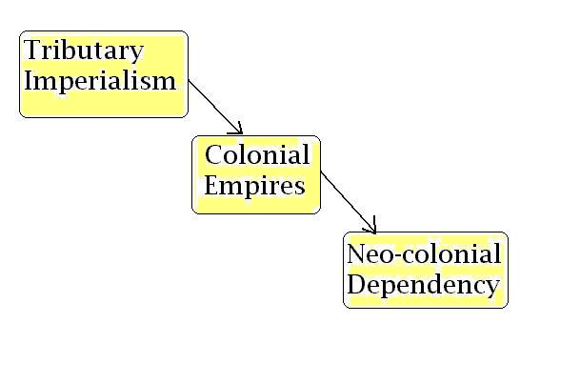
Figure 16.x Evolutionary Typology of Forms of Imperialism
Neo-colonialism was one of the main structural innovations that became the basis of U.S. global hegemony after World War II. The United States had perfected the mechanisms of controlling peripheral and semiperipheral countries in Latin America through policies that involved alliances with local elites and military forces, with occasional episodes of “gun boat diplomacy” when other methods failed to achieve the desired result. Control of access to international credit, direct foreign investment and control over international financial institutions such as the International Monetary Fund and the World Bank have resulted in de facto U.S. hegemony over Latin American since the United States became a core power in the 1880s. But this does not mean that the United States has always had its way in Latin America. The Mexican Revolution produced a regime that was rather antagonistic toward the “colossus of the North.” In the 1930’s Mexican President Lazaro Cardenas nationalized the properties of the U.S.-owned Standard Oil Company in Mexico. Other regimes have occasionally come to power that pursued an independent course, and Latin American countries have a long history of episodic resistance to U.S. control.
But it should be recalled that Britain also employed neo-colonial forms of control in those parts of the periphery that were not incorporated into the formal British Empire. Just as the U.S. supported decolonization movements in the British and French Empires after World War II, Britain lent covert support to Simon Bolivar and the anti-imperial decolonization movements in Latin America in the early decades of the 19th century. This was the first wave of decolonization, and the British were quite happy to see the colonies of Spain and Portugal establish their freedom to trade with Britain. And their relations with these “new nations” employed the same mechanisms of financial manipulation, direct investment and covert operations that would later be called neo-colonial when they became the mainstays of U.S. policy toward Latin America.
Though it is in the main correct to say that the United States, itself a former colonized region, never had a formal colonial empire, this is not entirely true. U.S. expansion toward the Pacific Coast was a kind of internal colonialism that involved both buying territorial claims from other core states (France and Russia) and conquering territories claimed by other states. The Mexican-American War and the Treaty of Guadalupe-Hidalgo of 1848 gained a great expanse of western North America from Mexico. The treatment of indigenous peoples and of the Mexican residents of California was as brutal as anything that the other European core powers had even done in their colonies, with perhaps a few exceptions.
In the wave of colonialism that was the “new imperialism” in the last quarter of the 19th century, the U.S. belatedly jumped on the bandwagon. Politicians from the U.S. South had long had their eyes on choice pieces of Central America and the Caribbean. In 1898 the U.S. took Cuba and the Philippines from Spain by force, thus participating in the “new imperialism” wave of expansion.
The new imperialism was also a response to pressure from working classes in the core who were agitating to either overthrow capitalism or to be included in the capitalist development project. As nation-building led to the incorporation of workers into political coalitions as citizens politicians began to see the advantages of imperial expansions as a way of incorporating workers into their projects. This took different forms in different countries, but the overall pattern came to be known as “social imperialism.”
The nineteenth century wave of globalization was winding down and the winds of world war were blowing. Successful German development was pushing up against the glass ceiling of the world order structured around British hegemony. Hegemonic rivalry, new class struggles, ethnic conflicts and challenges to the rule of capital were brewing. Anarchist terrorists were using dynamite in their “propaganda of the deed.” Socialist parties and labor unions were proclaiming international solidarity of the world working class. Arms races were getting under way. The world revolution of 1917 and the Age of Extremes were peeking through the flowers in the garden of the beautiful epoch.

Further Reading:
Eric Hobsbawm, Industry and Empire
Kevin O’Rourke and Jeffrey Williamson, Globalization and History
Karl Polanyi, The Great Transformation
Mike Davis, Late Victorian Holocausts
Giovanni Arrighi, The Long Twentieth Century
Roger Ransome. His book.
Wallace Stegner. Mormon Country
“Labor’s Untold Story” (Boyer and Morais 1975)
Howard Zinn, A People’s History of the United States.
Mann, Michael 1993 The Sources of Social Power: the Rise of Classes and nation-states, 1760-1914. Vol. 2.
Cambridge: Cambridge University Press.
Thornton, Russell 1986 We Shall Live Again: The 1870 and 1890 Ghost Dance Movements as
Demographic Revitalization. Cambridge: Cambridge University Press.

Chapter 18: The Twentieth Century Age of Extremes v. 9-21-07, 8612 words
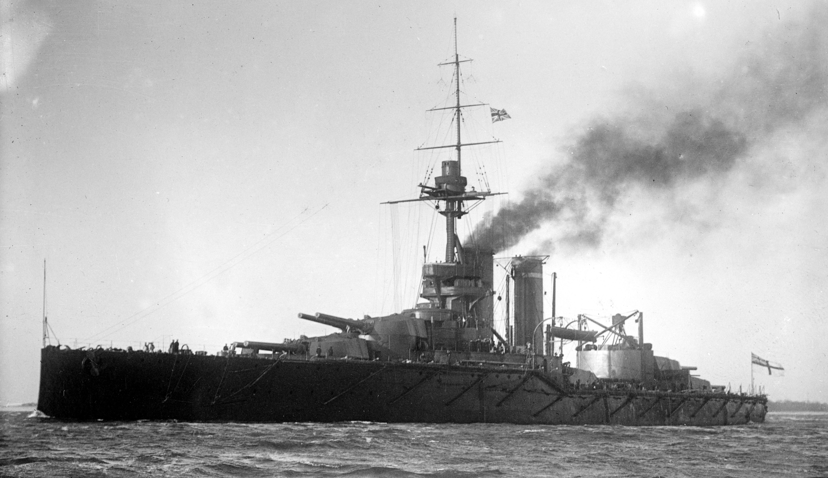
HMS Audacious, 1912

The world history of the Twentieth Century includes three more world revolutions, two linked world wars, two more waves of globalization that were separated by a period of deglobalization. All this was intertwined with the rise and decline of the hegemony of the United States. The human population of the Earth increased from 1.65 billion in 1900 to over six billion people in 2000. More people were killed in twentieth century interstate wars (about 32 million) than the total population of the Earth had been in 1500 BCE. The first half of the Twentieth Century was the “Age of Extremes” and the second half was a relatively peaceful and prosperous round of globalization and the emergence of a world civilization based on continued contention over the values of the European Enlightenment. These stories are told in Chapters 18 and 19.
The nineteenth century saw the emergence of geometrical growth in the number of people and the sizes of settlements. These trends continued in the twentieth century. The demographic transition also continued apace – the transition from large to small families spread from the core to the non-core. In core countries natural population increase (not due to immigration) ceased as the birth rate came into balance with the declined mortality rate. People lived longer and older people became a large proportion of the total population. But the total number of people in the world continued to increase rapidly because the non-core countries combine an industrial death rate, due mainly to the spread of public health practices, with an agricultural birth rate that declined only slowly. Where women gained political rights, increasing autonomy and more education, the fertility rate came down, but these trends have been slow in much of the non-core. The education and increasing autonomy of women gave them important work outside the family and the movement of the majority of households from rural to urban settings also decreased the labor utility of having large numbers of children. By the end of the twentieth century over half of the world’s population lived in very large cities.
The chaotic first half of the 20th century has been aptly characterized as “the Age of Extremes” by the eminent historian Eric Hobsbawm (1994). The British hegemony was in decline. The world of high finance remained centered on the City of London, but England had lost its comparative advantage in most of the new lead industries to Germany and the United States. The great 19th century wave of global economic integration bottomed out in 1900 and was then followed by a weak upturn which was followed in turn by a massive deglobalization after 1929. World War I was a classic global struggle for hegemony, but after the war the United States, already an economic hegemon, refused to take up the mantle of political hegemony, and so the world remained without a stable leadership structure until after World War II.

The Belle Epoque
The Edwardian “Indian summer” in the years after the end of the Boer War (1901) was like those days at the end of fall when the weather is still pleasant. Trade globalization had begun an upturn around 1900 after its decline since 1880 (see Figure 16.2 in Chapter 16). British foreign investment was flooding out from the City of London, and those able to get in on the returning profits were living well. The technological miracles of steam ships, the Suez Canal, transoceanic telegraph communications and railroads had brought the people of the world closer together (Hugill 1999). The network of international trade was becoming denser, but also less hierarchical, as England’s centrality in world trade and industrial production had been in decline since the 1870s (Hobsbawm 1969). The British-centered world economy was being replaced by a system of contending centers of industry and trade. But the financial district in the City of London managed to stay on as the center of world banking, currency trading, stock trading and insurance, and there was plenty of tea and jam for most of the residents of the British Isles so that they could feel that they too were sharing in the glories of the Empire (Mintz 1985). Nationalism and the “new imperialism” evolved as a politics of reform and inclusion within core states that was coupled with expansion of colonial and neo-colonial adventures abroad – so-called “social imperialism.”
Nazli Choucri and Robert North’s (1975) careful and elaborate study of the great powers in the run-up to World War I is organized around the idea of “lateral pressure” – increasing competition for natural resources and markets as industrialization spread from Britain to other countries, especially the United States and Germany. This notion is related to the more general concepts of circumscription and population pressure that we have employed in our iteration model of world-systems evolution (see Chapter 2). Circumscription refers to a situation in which an expanding system comes up against geographical and social limits to growth because all the adjacent low hanging fruit has already been picked. The problems that had been solved by expansion had to increasingly find other solutions.
The rise of European hegemony was running up against global spatial limits. The U.S. had expanded to the Pacific Coast of North America and had integrated the natural resources of the West into the American development project. The European powers had conquered the Americas, the East Indies, South Asia, Southeast Asia, and had finally colonized Africa. Only China remained uncolonized, but it was surrounded and subjected to the competitive incursions of the European core powers, the United States and Japan. The incorporation of the East Asian PMN into the Europe-centered PMN meant that the whole globe was now integrated into a single closely wound system of states and colonies with a single interconnected set of core and semiperipheral statesa. No longer was there a Eurasian-wide PGN containing geographically separated and geopolitically independent PMNs in the West and the East. The now-global interstate system (with colonies) and the older global prestige goods network had completely merged. Of course, the European powers had long been competing with one another over choice parts of the periphery, but now colonial imperialism was becoming an increasingly zero sum game. This meant that one core power could only expand at the expense of another. This was global circumscription and lateral pressure.
The core of the Europe-centered system was also expanding with the rise of Germany and the United States. This also increased the overall demand for natural raw materials and for opportunities to sell goods and to make profits, thus increasing the general level of competition in the system.
Imperial Over-reach
By the end of the nineteenth century Britain had lost its supremacy in trade and industrial production, but it still held first place in military power, financial centrality and telecommunications. The British Empire was being challenged by nationalism in some of its colonies, and the labor movement was challenging elite rule at home. Economic nationalism among the contending core states had restored protective tariffs in the international economy, though Britain held out as the last bastion of free trade. British naval supremacy came into question during the Crimean War (1854-56) as it became obvious that decrepit ships and corruption had taken their toll on a Royal Navy that had seen little serious action since dispatching Napoleon. A significant investment in new naval technology was made to remedy this situation (Briggs 1964).
The British elite had long been divided between the staunch conservatives who sought to perpetuate the role of the landed aristocracies and the crowned heads of Europe (e.g. Queen Victoria), and a group of enlightened conservatives who realized that flexibility and creative reorganization were often more productive policies for dealing with the huge social changes that industrial capitalism and globalization had brought about. The enlightened conservatives had decided that a new emphasis on imperial expansion could be used to mollify challenges from an increasingly organized and vocal labor movement at home. This policy has been called “social imperialism” because it combines an awareness of the need for social reform and welfare at home with an expansive policy toward control and access to resources abroad, especially from the periphery. One of its main political protagonists at the end of the nineteenth century was Joseph Chamberlain, a Manchester industrialist who was appointed to the position of Colonial Secretary and later became the British Prime Minister The British had long championed free trade in the world economy and they held to this position after most of the other core countries had gone back to tariff protectionism. Chamberlain favored a tariff reform that would give preference to products from British colonies or to members of the emerging British Commonwealth of English-speaking countries.
A group of British elite politicians, intellectuals and journalists came together to form a set of intersecting networks of intermarried families and old school ties--mainly from Balliol and All Souls colleges at Oxford (Quigley 1981). These men were originally inspired by Professor John Ruskin, a poet and historian of architecture who developed a philosophy of Christian Socialism that was sympathetic to the labor movement and the poor without posing a challenge to the rule of capital. Ruskin and other Oxford dons also favored the notion that the British way of life and the English language were the highest attainment of human civilization and that these features were the best possible bearers of true freedom for the rest of humanity. This high moral ground, rather than simply the desire for wealth and power, was used by certain members of the British upper class as a justification for a new wave of imperialism, especially directed toward Africa, which was to bring the gifts of civilization to the less developed world. Some of these visionaries also favored the establishment of a strong federation of English-speaking countries that was to include the United States and British Empire. This federation of English-speaking states was especially the vision of Cecil Rhodes, the organizer of the Royal African Company and of Alfred Milner, a journalist who took up the leadership of this cause after Rhodes died. Rhodes was linked with a group of intermarried nobles that included Lord Salisbury that Quigley calls the Cecil bloc. The confidants and agents of Alfred Milner included many important journalists. These groups were linked by a secret society organized by Rhodes and this evolving network eventually became know as the “Round Table.” This group pursued its goals by controlling newspapers, including the Times of London, engaging in what it itself termed “propaganda” and by speaking into the ears of the powerful, especially Queen Victoria and King Edward. They planned the Jameson raid, brought about the war against the Boers, and eventually were central players in the formation of the Union of South Africa and the League of Nations after World War I.
Rhodes and Milner envisioned a reorganization of the British Empire that was designed to sustain Britain’s global preeminence and to help resolve class issues at home in favor of a national harmony that would preserve the rule of the propertied elites. The British Commonwealth was to be a strong federation of English-speaking countries that could jointly supply leadership to the world. This federation was to be mainly composed of former British colonies in which English-speaking settlers were a majority – e.g. Canada, Australia, New Zealand, and the United States. The Round Table group also desired that British control might hold sway over nearly the entire continent of Africa, and the key to this notion was control of South Africa.
The English had wrested control of the Cape Colony from the Dutch in 1806 and had taken over Natal by 1843. But the Dutch farmers (Boers) of the Cape had migrated to the interior to escape British authority. This was not a big issue until gold and diamonds were discovered in the Transvaal. British mining investors sunk their money into the Transvaal and English-speaking miners migrated to the interior. Cecil Rhodes was the Minister of the Cape Colony and head of the Royal Africa Company that had large investments in railroads and mines in the Transvaal. The British mining and rail investors increasingly came to resent the taxes and restrictions placed upon them by the Boer Republics and sought to bring them down. The increasingly wealthy Boer Republics were also seen as a potential threat to British control of the Cape.
The Boer governments were accused of discriminating against the English-speaking “uitlander” miners by not extending them the franchise. Rhodes, with initial support from Joseph Chamberlain, organized the “Jameson raid,” a failed effort to bring about a coup d’etat in the Transvaal. After this debacle the Boers were convinced that a war with Britain was inevitable and they began to purchase the best modern armaments that the world market could supply (Evans 1999). In 1899 the Boers attacked and besieged some towns in Natal, initially defeating some of the small British forces that were present. The British mobilized a huge force to defeat the Boers in a war that went on and on because the Boers made effective use of guerilla tactics against the British army. The war was brutal on both sides, inviting comparison with more recent First World/Third World guerilla struggles.
The eventual defeat of the Boers was sealed because none of the other powerful core states were willing to challenge Britain by supporting the Boers, despite that there was great public sympathy for the Boer cause in most of the countries of Europe and in the United States. In the Netherlands and in Germany the old Boer leader, “Uncle” Paul Kruger was very popular, and there was much sympathy for the pioneer farmers of the Boer Republics. But the German and Dutch governments prudently avoided a confrontation with the powerful British Empire over the issue of Boer independence. The German Kaiser Wilhelm was quite sympathetic to the Boers and considered supporting them militarily, but he was convinced to abandon the Boers by Count Bernhard Von Bulow, the German foreign secretary, who had made a secret pact with Britain to divide up the Portuguese colonies in Africa (Mommsen 2001:4). The German government used the popular sympathy for the Boers to mobilize support for the expansion of the German Navy and a prominent officer in the German Army wrote about the inevitability of future wars among industrial states (explicitly Britain and Germany) over control of global resources (Yasamee 2001). The Russian Czar also had great sympathy for the Boers, but was dissuaded from actively opposing the British campaign by the Russian finance minister, Sergei Witte (Spring 2001).
The Boers were well armed with the best rifles and light artillery. They had been able to use the gold and diamond mines of the Transvaal to purchase large stocks of the latest armaments and munitions on the international market. So the war was a true test of both British resolve and of the military capabilities of the British Army. The “plight of the uitlanders” and the early Boer successes against the British Army were successfully used by the Round Table politicians and journalists to garner significant public support in England for the war against the Boers. Many still know the campaign song, “Marching to Pretoria,” the capital of the Boer Transvaal.
Playing the military card was successful in bringing about the conquest of South Africa, and British armed force proved that it could prevail over a serious challenge. But this unilateral policy of might-makes-right has been characterized as “imperial over-reach” by Paul Kennedy (1988) and as the “imperial detour” by George Modelski (2005). These scholars of hegemony and geopolitics see a repeated pattern in which a formerly powerful hegemon that has lost its economic preeminence tries to substitute unilaterally exercised military supremacy in place of its former ability to gain compliance based on economic comparative advantage and political legitimacy. The result is to mobilize significant resistance and counter-hegemony on the part of those who feel that power is being exercised illegitimately. The Round Table group failed to attain most of its most cherished goals. It did not create “so great a power as to hereafter render wars impossible and promote the best interests of humanity,” though it did eventually play a key role in emergence of the League of Nations, and its remnants were involved in the organization of the United Nations. It did not prevent the decline of British hegemony nor the dismemberment of the British Empire. The Commonwealth of Nations did not become the strong federal government that Rhodes and Milner envisioned. Rather it became a trading block and a group of largely sovereign nations joined together by common ideals, culture and language.

The so-called “Great War” (World War I)
The Berlin Conference on Africa (1884) was a negotiation in which those European powers that were interested in obtaining colonies in Africa came to an agreement on the boundaries by which that continent would be partitioned. Britain had made an effort to incorporate Germany into the club of industrial core powers by agreeing to hold the conference in Berlin, and by seeing that Germany got some of the pieces. But this did not do the trick. The Germans felt that Britain was going to continue to obstruct them, especially after the Boer War. And the British, for their part, had lost patience with the Germans, who were perceived as ungrateful and pushy challengers. The power vacuum created by the collapsing Ottoman Empire drew the powers in as it had in the Crimean War, but this time the Germans and their allies thought that they might win a quick victory while Britain’s naval power was stretched across the globe.
During the Boer War there were public scares in both France and England that a Franco-British war might erupt at any moment over disagreements regarding control of Egypt and other issues. The fault line that was to develop into a chasm of conflict in the coming Great War (World War I) was as yet undefined. Britain still saw France and Russia as its main challengers. The contours of the world trade network in the decades before the war did not reveal the coming chasm that would emerge in the great conflict (Table 18.1). Germany and Austria-Hungary were deeply involved in commerce with Britain and the United States. There were old and strong dynastic ties between the royal elites of Germany and Britain, i.e. the House of Hanover. And the waves of migration in the 19th century had resulted in a large presence of Germans in the United States. German, English, Belgian, U.S. and French trade unionists and socialists had joined together in the Second International and had pledged not to go to war against one another (Haupt 1972)

Entente Allies | Central Powers | Neutral
Belgium | Austria-Hungary | Brazil
France | Bulgaria | China
Greece | Germany | Denmark
Italy | Turkey | Mexico
Japan |  | Netherlands
Portugal |  | Norway
Romania |  | Spain
Russia |  | Sweden
United Kingdom |  | Switzerland
USA
Balkans
Table 18.1: Factions In the Great War
Despite all the theories that have predicted that trade amongst nations and other friendly ties should reduce the chances of conflict, and despite all the integration amongst elites and pacts of international solidarity among trade unions and socialist parties, the core split asunder and an estimated 20 million military and civilian deaths were brought about by the awesome power of industrialized warfare in World War I (Singer and Small 1972; Barbieri 2002).
The great mystery about World War I is why the Germans chose to fight on two fronts despite a long tradition of Germen statesmen who cautioned against such a risky move. Attacking both to the east and to the west, and making war against the British, and eventually the Americans, while at the same time fighting Russia in the east seems in retrospect to have been suicidal. Peter Hugill (1999) has argued that there were really two Germanies – the aspiring industrialists centered in Hamburg, and the military aristocrats of Prussia – the so-called coalition of Iron and Rye. The war was a compromise between these two groups, which explains the attack on two fronts. The western front was an effort to gain the upper hand in the world economy, while the eastern front was an effort to gain agricultural land by annexing adjacent territory. These are the two different strategies that have contended with one another within and between states for millennia. The Germans resolved an internal struggle by displacing it to foreign policy, and this is what led them to bite off far more than they could chew. The German leaders who led the charge also mistakenly adduced from their quick victory in the Franco-Prussian War of 1870 that they might be able to consolidate control before the conquered states and navies could mobilize their whole potential forces. The long stale-mate in the trenches in France melted this fantasy.
The Anglo-American Alliance
A strong and important Anglo-American alliance emerged at the end of the nineteenth century. This development had to overcome large obstacles. The British had long felt that the Americans were colonial upstarts and hill-billies. On the U.S. side, a strong Anglophobia and anger had been produced by the struggle for sovereignty from colonialism. The British had burned the new capitol building in Washington DC to the ground during the War of 1812. Overcoming these bad memories required new conditions and concerted action by those who sought to promote the new alliance.
The main structural changes in the relationship between Britain and the United States were:
- the United States had risen from being a peripheralized region at the time of the American Revolution to a core power by the 1880s; and
- Britain had lost its industrial hegemony and needed a strong ally to help it maintain its power and wealth in a world in which these were being challenged by other emergent national societies.
Strong and symmetrical financial ties had emerged between London and New York. Recall from Chapter 16 that Junius Spencer Morgan of Boston got his start in high finance working in George Peabody’s financial office in London. The house of Morgan became one the world’s largest banking concerns during the belle époque. By the end of the century British aristocrats whose fortunes had dwindled were increasingly marrying the daughters of rich Americans. Another factor was the intention of the British Round Table group to form a strong federation of English-speaking countries to help shore up and sustain the Pax Britannica. The key move here was British support for the U.S. in its war with Spain in 1898. This welcome support was a key factor in convincing American politicians to ignore broad popular sympathy in the U.S. for the Boer farmers.

Developmental States and Also-Rans
The pattern of semiperipheral development that we have seen in earlier eras continued in the 20th century. The United States, Germany and Japan emerged from the semiperiphery to the core in the late nineteenth century. In the 20th century China and Russia were semiperipheral challengers to the hegemony of capitalism and the United States. The evolution of the world order continued to be a spiral of challenge and response
Japan’s developmental state success was strongly signaled to the rest of the world by its victory in the Russo-Japanese war of 1904-5. Russia’s defeat by Japan also trumpeted the failure of the Russian modernization effort and triggered an abortive but auspicious radical rebellion within Russia (1905) that was a prelude to the October Revolution of 1917. Japan had begun its modern colonial expansion in 1879 with the occupation of the Ryuku Islands (formerly ruled by China), and it took Formosa (Taiwan) from China in the Sino-Japanese war of 1894-5. With the Russo-Japanese war (1905) Japan formalized its rule over Korea and added Kwantung Leased Territory on Southern Sakhalin Island to its empire (Henige 1970:203-6)
The Chinese modernization effort had also failed. Several major factors conspired against the Chinese efforts to adapt Western technology to Asian conditions. China was a huge country with internal regions that had somewhat contradictory needs and interests vis a vis the larger world economy. The massive peasant rebellions of the 19th century discussed in Chapter 16 took a huge toll on the energies of the Qing (Manchu) regime, which was also compromised by the fact that many of the Han Chinese continued to see Manchu rule as the illegitimate fruit of conquest by barbarians. To these factors was added the embarrassment of “treaty port” incursions by Western powers. All these factors, and the conviction held by many Chinese that China was still the center of the universe and that all the foreigners were barbarians, undermined the efforts of some farsighted individuals to try to effectively respond to the external challenges posed by industrial technology and the aggressive actions of Europeans and the Japanese.
The Qing Empress Dowager was so frustrated by European meddling that she vacillated when a new peasant and landless movement, the Boxer Rebellion, emerged in North China. The Boxers believed that martial arts could overcome the weapons of the Westerners and they sought to expel the “foreign devils.” This rebellion was strongest in those regions that had been penetrated by foreign-built railroads. The rail lines provided cheap transportation for the export of food grains, and this had the effect of creating local shortages and high prices. This is one of the cases analyzed by Mike Davis (2003) in his careful comparative study of famines. Davis contends that globalization, in the sense of international market integration, exacerbated famines and related disease epidemics, producing “late Victorian holocausts.” The Qing Empress shared the Boxer’s anger, if not their hunger. But this did little to help organize the kind of effective response to modernity of the kind that had emerged in Japan.

Globalization Without A Hegemon
Karl Polanyi’s (1944) analysis of waves of globalization as the “great transformation” points to the emergence of markets and high finance that become disembedded from politics and the moral order, which then produces a reactive “double movement” in which people resist commodification and try to reestablish communities and protect morality from commercialization. Some have interpreted the long-term world historical interaction between expanding capitalism and socialist movements in these terms (e.g. Boswell and Chase-Dunn 2000), but the double movement also includes traditionalist, nationalist and fundamentalist movements that are not considered to be progressive by the activists of the Left.
The Age of Extremes carried on in the post-war Roaring Twenties, when the spasmodic wave of globalization resumed and hot money flowed freely. But, though it was widely recognized that Britain was no longer hegemonic after the Great War, despite winning, the United States, now the economic hegemon, refused to take up the political role of global leadership. U.S. President Woodrow Wilson and the Round Table network strongly supported the formation of a global confederation that was eventually to include all the countries of the world – the League of Nations. But the senators from the American mid-western heartland were still heeding George Washington’s warning about entangling alliances, and so the U.S. Senate declined to ratify the membership of the United States in the League of Nations. Thus the world had no hegemon but money in the decades after World War I. Economic globalization rebounded, but without effective political globalization.
The Age of Extremes was composed of another world revolution, two linked world wars and a nearly worldwide economic depression. People who had been left out, displaced by, or immiserated by the great wave of capitalist globalization rebelled against authorities in all the zones of the now fully global world-system. The first Great Depression that began in 1873 had ended in 1896 and trade globalization (the ratio of international trade to the size of the whole world economy) bottomed out in 1900 (See Figure 16.2 in Chapter 16). Another short, shallow and spasmodic wave of trade globalization started up in 1900, peaked in 1929, and then collapsed into a trough of deglobalization.
The World Revolution of 1917
The Chinese, Mexican and Russian revolutions and World War I were linked and conjoint events in world history. Peasants and workers made revolution and the great powers attacked one another in a violent spasm of industrial warfare. The strong economic ties that had been created by the nineteenth century and early twentieth century waves of globalization did not prevent World War I. The British hegemonic decline was produced by the success of the spreading industrial revolution. Britain had managed to stay ahead of the curve through several phase changes by shifting its comparative advantage from mass produced consumer goods to capital goods and then to financial services. But the spread of industrial success to Germany, the United States, Japan and other European core powers increased competition for raw materials and for access to markets, driving profit rates down and creating conditions in which the use of military power by the German challenger appeared to a be an attractive strategy.
Recall that world revolutions are based on popular movements that contest the existing institutions of governance. World revolutions have been assigned symbolic years. Thus we speak of the world revolutions of 1789, 1848, 1917, 1968 and 1989 as representational years in which especially dramatic events took place, but the world revolutions that clustered around these symbolic years often went on for several decades (Arrighi et al 1989, Boswell and Chase-Dunn 2000). Transnational social movements are those in which individuals and groups come together across national boundaries for political purposes, but are not organized solely as representing their nations, whereas international organizations are mainly composed of nationally organized groups.
In 1864 Karl Marx and activists from labor unions and socialist, anarchist and communist groups from all over Europe and the United States organized the International Workingmen’s Association (the First International). Samir Amin’s recent discussion of the possibility of a “Fifth International” points out that the First International was very diverse in terms of the groups that participated, but that it nevertheless managed to achieve a high degree of democratic representation (Amin 2006). This said, the First International eventually fell apart because of the intense disagreements between the Marxists and the anarchists over both the goals and tactics of radical progressivism.
The Second International, formed in 1889, was an alliance of labor unions and socialist parties. It was explicitly an international federation of national parties representing unions and socialist parties, mainly from core states. The anarchists were left out and the participants were representing nationally organized units of the labor movement. The Second International declared that the workers of the world should not go to war against one another at the behest of capitalists. That sworn alliance fell apart, and most of the workers of Germany, France, England and the United States chose nationalism over international class solidarity by fighting each other in World War I. A large part of this failure was due to the rise of “social imperialism” in which politicians in core states symbolically incorporated workers and the labor movement into nationalist imperial ventures in the Third World. Despite the famous slogan “Workers of the world unite!,”core unions and socialist parties did not see that they had common interests with workers in the non-core countries. In practice, labor internationalism in the Second International meant solidarity among workers from different European countries or settler colonies with majorities of European descent. White racism played an important role in undermining the potential for global north/south worker solidarity and worked in favor of nationalism in both the core and the periphery.
A massive revolt by Russian workers, soldiers and peasants made the Bolshevik Revolution after the Czar’s army had suffered large defeats in World War I. The revolutionary situation in Russia had been building for a long time. We have already mentioned the revolution of 1905 that occurred after the defeat in the Russo-Japanese war. The Czarist government lost respect abroad and legitimacy at home when it was defeated by those developmental states (Germany and Japan) that had succeeded at the game of catch-up with Britain, a game that the Czarist regime had failed at despite valiant efforts. But Russian industrialization had created only a small industrial working class, mainly in Moscow and St. Petersburg. The vast majority of people in Russia were peasants. The Bolshevik Party held that the industrial working class was the protagonist of history – the agent of the transformation from capitalism to socialism. The Bolsheviks acted out Marx’s tendency to identify peasants as a reactionary class, and so a party who saw a majority of the Russian people as reactionaries led the Russian Revolution. The Bolsheviks fully expected that there would be a Communist-led revolutionary victory in Germany, the most advanced country with a strong labor movement. The Russian Communists saw Russia as a backward and underdeveloped country, and they were greatly dismayed when their successful conquest of state power left them standing alone in a larger world in which the other powerful states were still under the control of capital.
But the Russian Revolution nevertheless gave heart to workers on every continent who believed that the labor movement could overthrow capitalism and create a more humane form of human society. The American journalist John Reed (1919) told the story of the heady days of October 1917 in his famous book, Ten Days That Shook the World.
As mentioned above, the Mexican and Chinese revolutions were part of the world revolution of 1917. The Chinese situation has already been described above. The nationalist revolution of 1911, the collapse of the Qing regime and regional differences led to a long period of strife in China from 1912 to 1949. The Chinese Communist Party was founded during a secret night meeting in a mattress factory in Shanghai in 1921. Marx’s analysis of modern social change was based mainly on observations about the development of capitalism in Great Britain and the other industrializing countries in the middle of the 19th century. Marx saw the urban industrial proletariat as the leading group that would transform capitalism into a more humane socialist form of society. Like the Bolsheviks in Russia, the Chinese Communist Party was Marxist and held to the notion of the urban industrial proletariat as the revolutionary class. But, as in Russia, the urban proletariat in China was a minority of the population.
In 1934 the Communist Party, led by Mao Zedong, was forced to undertake the “long march” to rural Yenan Province because the Communists were driven out of the cities by the nationalist (Kuomintang) army. Thus was Mao thrown into the arms of the peasantry, and the subsequent policies of the Chinese Communist Party were far less injurious to the agrarian sector of society than the policies of the Bolshevik Party had been in the Soviet Union. When the United States defeated Japan in World War II Japan had to give up its colonies in Taiwan, Korea and Manchuria. After further battles with the Kuomintang the Communist Peoples Army forced the nationalists to retreat to Taiwan and the Communists formed a new state on the mainland in 1949.
Nineteenth century Mexico gained independence from Spain, had a war with the United States (1848) in which California, Arizona, New Mexico and Texas were lost, and endured a failed military campaign by France (during the U.S. civil war) to make Mexico part of the French Empire under the Habsburg Emperor Maximilian. U.S. support in driving out the French helped to mend the badly broken fences left by the Mexican-American war of 1848, and explains why the Cinco de Mayo holiday celebrating a Mexican victory in 1862 is celebrated on both sides of the border. These momentous developments were followed by the regime of President Porfirio Diaz – the “Porfiriata.” The Diaz government tried to modernize Mexico by privatizing and commodifying communal land titles and by inviting foreign investment in railroads, mining and other natural resources. The radical ideas of the world revolution of 1848 and the emerging world revolution of 1917 encouraged popular resistance to appropriations of communally held land, especially in southern Mexico where indigenous cultures and communities had not been completely erased by Spanish colonialism. The revolution of 1910 was led by Emiliano Zapata in the south and by Pancho Villa in the north. When they met in the Zocalo, the great square in Mexico City, they rode their horses into the cathedral that the Spaniards had built over the ruins of the Aztec pyramid of Tenochtitlan. The Catholic Church was seen as implicated in the exploitation and domination that had occurred under Spanish colonialism and during the Porfiriata and so the Mexican Revolution invoked the values of secular humanism against the powers and properties of the church and restored a dose of respect for the prehispanic indigenous heritage of Mexico.
The Communist International: A World Party in the 1920s
Counter-hegemonic world party formation reached an apogee in the world revolution of 1917. The Communist International (Comintern or the Third International) was a vast and complex network of red labor unions, peasant associations, womens’ associations, youth organizations, organizations of the unemployed, and etc. that was constructed on an intercontinental scale. Called a “world party” and a “red network” by both its supporters and by those who opposed it, the Comintern demonstrated that a popular alliance of workers, peasants and other relatively powerless groups could exercise important political influence in core, peripheral and semiperipheral countries, and could have a serious and sustained impact on world politics. The Comintern networks competed not only with capitalist elites and hegemonic contenders, but also with anarcho-syndicalists who also successfully organized large numbers of peasants and workers in the late 19th and early 20th centuries. The Comintern was organized explicitly to confront the issues of social imperialism and racism that were made evident by the failures of the Second International (Amin 2006). But rather than recognizing and trying to embrace diversity as the First International had tried to do, the Comintern tried to construct a single global workers’ culture and political line, and this effort came increasingly to be dominated by the Communist Party of the Soviet Union.
The Comintern adopted V.I. Lenin’s critique of the Second International and then tried to overcome the problems that Lenin had highlighted. Lenin thought that social democracy and the electoral road to socialist state power (reformism) was not a sufficiently strong challenge to capitalism. He blamed the success of this reformist tendency in the core labor movement on the emergence of a “labor aristocracy” in the core countries that was willing to form cooperative alliances with capital. This resulted in social imperialism based on capital-labor nationalist alliances and contributed to the interimperial rivalry that led to World War I. Though Lenin was critical of nationalism, he saw it as problematic mainly for the working class movement in the core. Third World nationalism could be a progressive force. And so the Comintern was formed as a network of national organizations of reds with attention to strong representation from the non-core countries.
The Comintern is often characterized as having been a puppet of the Soviet Union and as having had a hierarchical form of organization based on the principles and directions set forth in Lenin’s book on revolutionary organization, What Is to Be Done (1973). But the Communist International was a very complicated creature and it changed in important ways over its period of existence from March 1919 to June 1943 (Sworakowski 1965; McDermott and Agnew 1997).
The Comintern adopted its own statutes at its second congress in 1920. It was led by an Executive Committee and a Presidium. These statutes mandated that congresses with representatives from all over the world were to meet “not less than once a year.” The Comintern also organized and sponsored a number of other “front organizations” – the Red International of Labor Unions, the Communist Youth International, International Red Aid, the International Peasants’ Council, the Workers’ International Relief and the Communist Women’s Organization (Sworakowski 1965).
The Comintern was founded in the Soviet Union, the so-called “fatherland of the proletariat,” and so it is often depicted as having been mainly a tool of Soviet foreign policy. There is little doubt that this became true after the rise of Stalin. In perhaps the most blatant example, Stalin tried to use the Comintern to get Communist Parties all over the world to support the Hitler-Stalin pact of 1939. But during Lenin’s time the Comintern held large multinational congresses at which over forty languages were spoken. The largest of these congresses had as many as 1600 delegates attending. Sworakowski (1965:9) says,
After some attempts at restrictions in the beginning, delegates were permitted to use at the meetings any language they chose. Their speeches were translated into Russian, German, French and English, or digests in these languages were read to the congresses immediately following the speech in another language. Whether a speech was translated verbatim or digested to longer or shorter versions depended upon the importance of the speaker. Only by realizing these time-consuming translation and digesting procedures does it become understandable why some congresses last as long as forty-five days.
The Comintern was abolished in 1943, though the Soviet Union continued to pose as the protagonist of the world working class until its demise in 1989. In 1938 Trotskyists organized the Fourth International to replace the Comintern, which they saw as having been captured by Stalinism. The Fourth International suffered from a series of sectarian splits and the huge communist-led rebellions that emerged during and after World War II were led by either pro-Soviet or Maoist organizations that held the Fourth International to be illegitimate.
Wobblies and Reds in the United States
By the time of the Age of Extremes the labor movement in the United States had already had a long and militant history. The great nineteenth century waves of migration from Europe brought workers who had had experience in the anarchist and Marxist revolutionary traditions in the old world to the U.S. But most of the labor leadership in the U.S. continued to represent the skilled craft workers in the American Federation of Labor (AF of L) who had been able to improve their wages and working conditions in local struggles with employers. The new waves of immigrants, the growth of railroads and large-scale industrial production in cities, produced a situation in which less skilled workers could also be organized. In the U.S the World Revolution of 1848 had mainly taken the form of the creation of new Christian sects and community revitalization movements (see Chapter 16). But later in the nineteenth century the Socialist Party had mounted strong electoral challenges. The Granger movement had mobilized farmers to challenge the economic monopolies of the Eastern banks and railroads. And the anarcho-syndicalists, who believed that industrial workers could dispense with capitalists and could themselves operate large-scale industries, emerged to challenge the rule of capital, especially in the West.
The railroad and the telegraph were used by capital to expand and reorganize production and trade, and by politicians and military leaders to exercise power across the North American continent, but these new transportation and communications technologies also served as useful tools in the hands of those who challenged the rule of capital. Organizers could travel cheaply and communicate inexpensively across great distances. The strongest anarcho-syndicalist organization in the U.S. was the Industrial Workers of the World (I.W.W), also known as the wobblies. Their slogan was “One big union of all the workers.” The wobblies sent organizers armed with pamphlets, songs and dynamite into the mining camps and lumber towns of the West. If the pot was ready to boil, two wobs could do the job, one at a late-night meeting with the workers, the other beneath the closest rail-bridge to town. The I.W.W. songbook contained popular ballads with lyrics that had been written by Joseph Hilstrom, a Swedish immigrant wordsmith, whose movement name was Joe Hill. In 1915 Joe Hill was executed in Salt Lake City for allegedly killing a grocery store owner in a robbery.
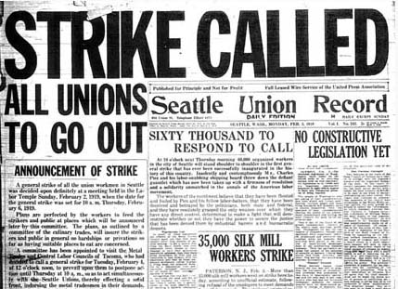
Figure 18.2: Front Page of the Seattle Union Record February 8, 1919
The Seattle general strike in February of 1919 was part of the world revolution of 1917. A wage dispute that began with the dockworkers became a general strike of 65,000 workers when it appeared that the federal government was siding with the employers (See Figure 18.2). For several days workers took control of the city of Seattle, organizing their own police force and an emergency food distribution system. Pamphlets were circulated that approved of the Russian Revolution with its organization of workers’ councils (Soviets). Later, Seattle longshoremen refused to load arms destined to resupply the anti-Bolshevik White Army in Russia. The Seattle longshoremen attacked strikebreakers who were brought in to load the munitions. The AF of L union leadership helped bring the general strike to an early end, and 39 members of the Industrial Workers of the World (Wobblies) were arrested despite that they had not played a very central role in the general strike. This “first Soviet on American soil” was an important stimulus to the “Big Red Scare” and the crack-down on radicals and immigrants that emerged later in 1919.
The Big Red Scare was not the only reaction to the radical labor movement in the U.S. The U.S. ruling class was particularly incensed at the challenges that radicals posed to their control of big private property in the means of production (Mann 1993). When they felt that state and federal police agencies were not doing a good enough job they hired private Pinkerton armed guards to attack strikers and defend property. It was in this period that the Federal Bureau of Investigation was created. And there was a major crackdown and expulsion of immigrants who were believed to be radical “outside agitators.” The famous anarchist Emma Goldman was deported and the U.S. began an effort to regulate immigration. In Southern California the Los Angeles Diocese of the Catholic Church sent money to support the Cristeros, a conservative peasant movement in Mexico that opposed the anti-clericalism of the Mexican Revolution (Davis 1990). Some labor leaders also promulgrated racist and zenophobic attitudes toward non-white workers.
The U.S. had been a crucial ally of Britain in the Great War, and was victorious in that effort despite the huge human costs of the war. The economy boomed again in the roaring twenties, and the radicals were both repressed and ignored, though the American Communists got their act together for the next round of counter-hegemonic struggles in the 1930s.
Germany and the other countries that had been defeated in World War II were made to pay indemnities. Germany colonies in Africa were taken over by Britain and France after the war. Resentment and the failure of a new legitimate form of global governance to emerge, as well as strong challenges by labor, socialist and communist parties, created fertile ground for the emergence of a new and virulent form of reactive super-nationalism called fascism. Fascism glorified the state as the agent of the national community and it stressed the duties of individuals to serve the national state. This was clearly a reaction to the radically individualized form of capitalism that had emerged in Europe, and to the disruptions that had been produced by marketization and international flows of volatile capital. Fascist movements took state power or were important in influencing politics in Germany, Italy, Japan, Spain, Portugal, China, Romania, Hungary, Austria, Slovakia and Ukraine, and to a lesser extent in Brazil and Argentina as well (Goldfrank 1978).
It was in the context of the “Age of Extremes” that a transnational network of Communist intellectuals claimed to lead the global proletariat in a world revolution that was intended to transform capitalism into socialism and then communism by abolishing large-scale private property in the means of production. Their actions were stimulated by, and contributed to, the chaotic nature of social change during the Age of Extremes. And the institutions that they created had large subsequent effects on the nature of the new U.S.-led hegemony when it emerged after World War II. Procapitalist politicians, the new incarnation of the enlightened conservatives, needed to come up with a development project that had many of the same egalitarian goals as those espoused by the Soviet Union, while at the same time preserving private property in the means of production and the significant influence of privately-owned capital within national states. This was a struggle over the definition of a good world order in which the Left and the Right versions of the European Enlightenment were contending with one another in a multicivilizational global context and thereby producing a new global culture.
Further Reading:
Nazli Choucri and Robert North, Nations In Conflict
Eric Hobsbawm, The Age of Extremes
Peter Hugill, Global Communications Since 1844
Sydney Mintz, Sweetness and Power
John Reed, Ten Days the Shook the World
Womack, John 1970 Zapata and the Mexican Revolution. New York: Vintage.

Chapter 19: The World-System Since 1945:
Another Wave of Globalization, Hegemony and Revolutions
v. 9-7-08, 10486 words
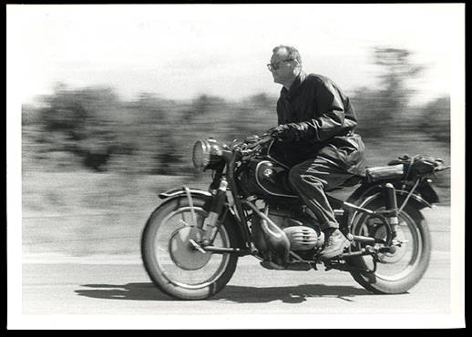
Radical sociologist C. Wright Mills
The second half of the twentieth century was a relatively peaceful era of economic development and the golden age of U.S. hegemony. The Cold War between the U.S. and the Soviet Union provided a justification for the U.S. to extend credits to other societies for national development and for the Soviet Union to sponsor urbanization, education and industrialization in its Eastern European satellites. Another wave of national liberation movements in the remaining colonies brought independence and the trappings of national sovereignty to Africa and Asia. The demographic transition to lower birth rates continued to spread, but so did the transition to greater longevity and lower mortality rates, so the world population continued to rapidly increase, becoming more than 6 million by the end of the century. Cities continued to grow and in some areas this produced city-regions – dense concentrations of large cities with suburbs in between them. Country-folk in non-core countries increasingly moved to dwell in large urban areas and so by the end of the century over half of the human population of the Earth lived in large cities. Another great wave of globalization and the falling costs of communication and transportation brought the peoples of the world into much greater contact with one another, and two more world revolutions (1968 and 1989) once again challenged and restructured the institutions of global and national governance.
America’s Half Century
Those enlightened conservatives who wanted to take the rough edges off of capitalism in order to preserve it invented the New Deal and a global development project based on Keynesian economic policies. The intent was to overcome the perceived dangers of speculative capitalism and state communism that ran wild in the 1920s and the beggar-thy-neighbor economic nationalism that took hold during the deglobalization of the 1930s. The New Deal addressed the problems of overproduction and underconsumption by supporting the rights of workers to organize unions to collectively bargain with employers over wages and working conditions. In the U.S. the Wagner Act of 1935 provided legal protections to union organizers. Henry J. Kaiser, a progressive industrialist based in California, encouraged the workers at his steel and shipbuilding plants to organize their own independent labor unions. Corporate businessmen and wealthy families in the older Eastern industries and politicians from the U.S. south opposed this enlightened conservatism. In order to get New Deal legislation passed President Franklin Delano Roosevelt had to make compromises. Southern Dixiecrats (conservative Democrats) demanded that agriculture not be included in the New Deal labor legislation. The rising potential military challenge from Japan in the Pacific was a powerful argument for industrializing the U.S. West. Eastern steel companies acquiesced in allowing new steel production in the West, but only under certain conditions. The Fontana steel mill in Southern California, built by Kaiser, had to be located far enough from water transportation to make its products too expensive to survive during peacetime (Davis 1994). Thus did the New Deal contain important aspects of the old deal.
The Congress of Industrial Organizations (C.I.O), with strong leadership provided by the American Communist Party, organized less skilled workers and the unemployed, and tried to overcome white racism in the labor movement by encouraging cooperation between black and white workers. In 1934 the American Communist Party had over a million members. That was the year of the San Francisco general strike, in which longshoremen and sailors led a successful organizing effort that resulted in radical unions taking control of hiring at all the west coast ports of the United States. This victory and other important struggles signaled the growing power of the C.I.O.
World War II was a replay of World War I. But now the Japanese challenge and the German challenge came together in time, and on the same side. This required the U.S. to fight wars in Europe and in the Pacific at the same time. Only a supersized superpower could bring this off. The war also ushered in the nuclear age. The “Manhattan Project” succeeded at detonating a plutonium implosion bomb near Alamagordo, New Mexico in 1945, that physicist J. Robert Oppenheimer described as “brighter than a thousand suns.” In August of the same year the U.S. dropped two bombs that obliterated the Japanese cities of Hiroshima and Nagasaki, ostensibly to save lives by ending the fighting more quickly. But the U.S. monopoly on nuclear weapons of mass destruction was short-lived. The U.S. and the Soviet Union had become allies in the fight against Nazi Germany in the war, but this evolved rapidly into the Cold War and a “balance of terror” arms race after the Soviet Union acquired nuclear weapons.
After World War II the United States actively took up the mantle of global multilateral hegemony. The establishment of the United Nations and the Bretton Woods institutions – the International Monetary Fund and the World Bank -- was a further move toward political globalization. The Marshall Plan facilitated the rebuilding of the Western European national economies by means of massive U.S. lending. A similar approach was employed in East Asia, where developmental states were supported in Japan and later in Korea, and U.S. corporations were prevented from buying up key domestic sectors of the Japanese and Korean economies. Getting support from conservatives in the U.S. for all these far-reaching global initiatives was not easy. And President Roosevelt, the great architect of the New Deal, died in April of 1945. His Vice President was Harry Truman, and Truman was elected President in a very close race with Henry Wallace, the candidate of the Progressive Party, in 1948. Truman was able to get the acquiescence of the heartland conservatives for the Marshal Plan and other international programs because he painted these as part of the effort to contain Communism and to protect and develop “the Free World.” Thus did the Cold War, a global confrontion between different visions of the human future, serve as a powerful political justification for U.S. hegemony and an important contributor to the further expansion of capitalist globalization.
The C.I.O. and the Communist Party (CP) emerged as powerful in certain unions and sectors in the U.S. after World War II. Many sympathizers with the radical labor movement had been badly put off by the U.S. Communist Party’s support for the Hitler-Stalin pact before World War II. But the CP played an important role in organizing workers in the steel and auto industries before and during World War II. Julius and Ethel Rosenberg were accused of passing the secret of the atomic bomb to the Soviet Union and were tried and executed for treason. Senator Joseph McCarthy from Wisconsin led a crusade to expose Communists and “fellow-travelers” in the federal government and higher education. And a battle took place within the labor movement between those radicals who wanted to fundamentally challenge the rule of capital and those other labor leaders who only wanted the workers that they represented to get a larger share of the pie.
Joe McCarthy’s methods were unscrupulous and many innocents suffered until those who supported civil rights were able to prevail over the witch-hunt. But the “business unionists” prevailed over the reds in most of the struggles within the labor movement in the U.S. The prospect of an expanding U.S-led hegemonic project with a growing economy and an expanding middle class tilted in favor of class harmony rather than class struggle, at least within the core of the world-system. The business unionists won out in most of the labor movement because capitalism was able to incorporate a broad sector of the core working class into its developmental project as national citizens and consumers.
The wave of decolonization after World War II produced another spate of “new nations” in Asia and Africa. American leadership needed a development ideology that could compete with Soviet and Chinese Communism. The experiences of the Age of Extremes and the demands of the Cold War produced a consensus on Keynesian national development as the main project of the American hegemony and the reformist alternative to communism. All these factors reduced the salience of world parties and transnational social movements, and further increased the legitimacy of national societies as the totemic unit of world political and social organization. By constituting the world order as a set of separate national societies, each with its own allegedly unique history and culture, nationalism became an even stronger dimension of the institutional structure of the world-system than it had been in the nineteenth century. Transnational political organizations and non-national forms of solidarity based on class, religion and ethnicity, continued to operate, but they were upstaged by national states and international organizations such as the United Nations and the Bretton Woods international financial institutions (the World Bank and the International Monetary Fund) in which national states were the main constituent members. The “new nations” of the periphery had a strong motive to support this institutional structure because they had only recently gained at least formal national sovereignty, and they had high hopes of using this new autonomy to modernize and develop their societies without the obstacles posed by colonialism.
The Bandung Conference (Asian-African Conference) of 1955 was organized by non-core (so-called Third World) states, mainly former colonies, that wished to pursue policies that were non-aligned with either the Soviet Union or the West. This non-aligned movement was an important development in the political representation of the non-core, and recent efforts to organize solidarity among peoples of the global south owe a great debt to the legacy of the Bandung Conference. But even the non-aligned states did not encourage their citizens to directly participate in transnational political decision-making. Global governance became increasingly defined as the representation of national societies.
Figure 19.1 (below) shows changes in the distribution of shares of world Gross Domestic Product (GDP) among countries from 1820 to 2000 based on the estimates of national GDP produced by Angus Maddison (1995, 2001). Shares of world GDP are not an ideal indicator of hegemony because they include simple economic size, which is an important but insufficient aspect of relative power among states. A large country with a lot of people will have a large GDP. But if we look at changes in the world shares over time we can see the trajectories of hegemony that we have been discussing. In Chapter 14, Figure 14.4 we showed the Dutch, British and U.S. hegemonies in a graph of the last 500 years. Geopolitical hegemony is a relative, not an absolute, concept. The Dutch are no longer the fore-reachers of the capitalist world economy that they were in the 17th century, but the Queen of the Netherlands still owns many of the stately mansions on embassy row (Massachusetts Avenue) in Washington, DC, renting them to the countries that can afford this prestigious location. And Amsterdam is still an important center of world financial services nearly four centuries after the peak of Dutch hegemony in 1630. Figure 19.1 shows the trajectories of individual European countries, the U.S., Japan, and lumps together those European Countries who had joined the European Union by 1992.
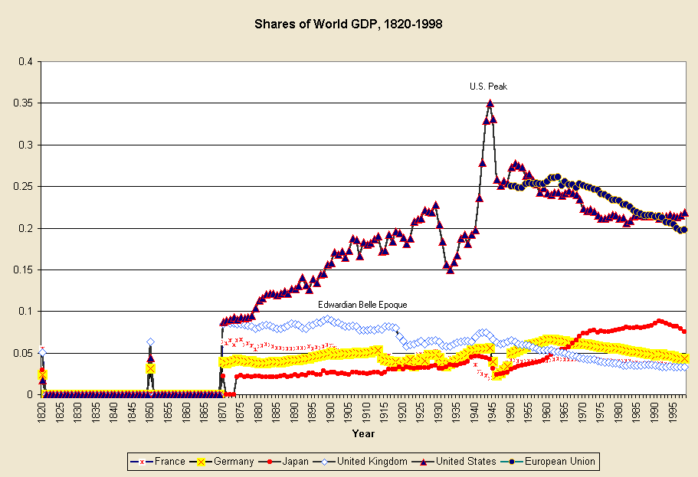
Figure 19.1: Shares of World GDP, 1820-1998 Sources: Maddison 1995, 2001.
The most striking feature of Figure 19.1 is the rapid ascent of the U.S. economy in its size relationship with the world economy as a whole – from less than 2% in 1820 to a peak of 35% in 1944. The U.S. share slumped precipitously from 1929 to 1933, and then rapidly ascended again to its highest point in 1944. A rapid post-World War II decline was followed by a slight recovery that began in 1949 and then, beginning in 1951, a decline until 1958, then a plateau until 1968, then another decline until 1982, followed by another plateau until 1998 at between 21 and 22%. The U.S. GDP trajectory shown in Figure 18.3 strongly supports the contention that U.S. economic hegemony rose and then declined in the twentieth century. But some of the details of the timing contradict certain accounts of the U.S. trajectory. By the measure of shares of world GDP the U.S. decline began in 1944, not in the late 1960s as some world-systems analysts have claimed. There were three steps of U.S. decline, the first beginning in 1944, the second in 1951 and the third in 1968.
As mentioned above, the U.S. share of world GDP had become larger than that of Britain by 1880. The stair-step nature of both hegemonic rise and hegemonic decline can be seen in the U.S. trajectory in Figure 19.1. Economic hegemony is a matter of staying ahead of the game relative to competitors. New lead industries are the key, and each modern hegemon has tended to move from consumer goods to capital goods and then to financial services (Wallerstein 1984). As discussed in Chapter 16, Britain’s first wave of industrial leadership was in the production of cotton textiles, which then spread to other countries. Then Britain became the leading producer of machines, steam engines, railroads and steam ships, both for its own home market and for markets across the globe. As competition in these sectors increased, and profits declined, British capital shifted into financial services and making money on money. This, and a continuing predominance in global telecommunications, were the economic bases of the belle epoque.
For the U.S. the sequence was similar, though the particular industries were different, and the whole trajectory was somewhat modified because of the much greater size of the U.S economy relative to the sizes of other core powers and to the world economy as a whole. While Britain’s home market was that of an island nation, the U.S. came to encompass a continent-sized home market, which was a big advantage in international competition.
U.S. industrial hegemony emerged with the development of the oil industry and the production of automobiles. These were the new lead industries and generative sectors (Bunker and Ciccantell 2205) that further transformed the built environment of the North American continent and then the world.
As cotton textile manufacturing had in the British hegemonic rise, the automobile industry spread abroad and profits went down because of increased competition. The U.S. managed to stay ahead of the curve by developing electronic technology (the telephone, vacuum tubes, the transistor and the computer chip) and information technology (Hugill 1999). But these also moved abroad and became more competitive, and new possible high tech industries (e.g. biotechnology and nanotechnology) have been slow to move out of the research and development phase. So U.S. investors, like the British in the belle époque, have increasingly moved into financial services with the huge advantage that the U.S. economy is such a large portion of the whole world economy that making money on the U.S. dollar and financial services is much less of a challenge than making money on the pound Sterling had been.
After World War II U.S. military expenditures had returned to peacetime levels, but they went back up during the Korean War, and after that military spending remained a very large proportion (nearly half) of the U.S. federal expenditures. Thus the economic boom of the 1950s was stimulated in part by government spending – so-called “military Keynesianism.” U.S. federal expenditures in the name of “defense” were used to subsidize key industries in the United States and to stimulate the development of new lead technologies, especially the transistor. And the government also acted to prevent the phone company, American Telegraph and Telephone (AT&T), whose Bell Labs had invented the transistor with federal grant support, from monopolizing and sitting on the new technology. As the world’s biggest owner of traditional switching devices and vacuum tube amplifiers, AT&T had a lot of investment in the old technologies that solid-state electronics made obsolete. Despite the vaunted fecundity of private entrepreneurs, many of the techno-miracles of advanced capitalism were first developed with heavy financial support and organizational intervention from the U.S. federal government -- e.g. nuclear energy, the transistor, and the Internet.
The most recent phase of financialization of the world economy has expanded the realm of virtual capital (based on securities that ostensibly represent future income streams) to a far greater extent than earlier financial expansions did. New instruments of financial property have multiplied and information technology has facilitated the expansion of trading of securities in new venues located in the older financial cities and in the so-called “emerging markets” of the less developed countries (Arrighi 1994; Henwood 1997).
The post-World War II expansionary boom was based on new lead manufacturing industries in the United States, some of which spread to Japan and to Europe, especially Germany. In the 1970s Japan and Germany caught up with the United States in manufacturing and the profit rate declined (Brenner 2002). This profit squeeze in core manufacturing encouraged an expansion of investment in financial services that was the beginning of the huge wave of financialization that has ballooned since the 1970s. Lending to non-core countries expanded rapidly and there was a large debt crisis in the 1980s in which many non-core countries in Asia, Africa and Latin America were unable to make the payments on external debt that they had committed to make (Suter 1992).
This development was not unusual. The capitalist world economy has experienced waves of debt crises since at least the 1830s when many states within the United States, as well as countries in Latin America, defaulted on foreign loans. Usually the house of cards collapses. The symbolic claims on future income are devalued, and the real economy of goods production, trade and services starts up again with a reduced set of property claims and symbols of value. But this did not happen in the 1980s debt crisis. There was no collapse. Rather the bankers of the core cooperated with one another and engineered a renegotiation of the terms of indebtedness of the non-core countries. This an important indicator of the relatively high degree of cooperation achieved by the world’s bankers by the time of the 1980s and it supports the contentions of those who see the emergence of an increasingly integrated transnational capitalist class (Sklair 2001; Robinson 2004).
But one result of this new level of cooperation is that the huge mountain of “securities” -- claims on future income streams -- has continued to grow larger and larger such that it now dwarfs the real world economy of production, trade and services. In the past financial collapses periodically brought the domains of purely symbolic and material values back into balance with one another. The continuous rapid expansion of what some call “fictitious capital” since the 1970s appears to have altered some of the basic rules of the capitalist economy and has led many observers to claim that the old rules have been transcended by the new information economy. Whether that turns out to be the case in the long run remains to be seen.
The economy of the United States regained some of its lost share of world GDP in the 1990s. This was mainly due to financialization and a real estate investment boom based on a large inflow of capital investment from abroad. Though other national currencies have not been pegged to the U.S. dollar since the 1970s, the United States continues to enjoy what historical sociologist Michael Mann (2006) calls “dollar seignoriage.”
The only use for surplus U.S. dollars held abroad was now to invest them in the US. Since most were held by central banks, they bought U.S. Treasury notes in bulk, which lowered their interest rate. U.S. adventures abroad could now be financed by foreigners, despite American current account deficits, and at a very low interest rate. The alternative, the foreigners felt, was worse: disruption of the world’s monetary system, weakening U.S. resolve to defend them, and a fall in the value of the dollar, making U.S. exports cheaper than their own. Hudson (2003: 20) concludes “This unique ability of the U.S. government to borrow from foreign central banks rather than from its own citizens is one of the economic miracles of modern times.” This miracle of economic imperialism meant that U.S. governments were now free of the balance of payments constraints faced by other states (Mann 2006).
The European Union is shown in Figure 19.1 as if it already existed in 1950, though in reality it was not formally constituted until 1992. This is so we can see that those twelve European core countries that joined together in 1992 had a downward trajectory in terms of shares of world GDP that was similar to that of the United States. What was happening in this period was the rise of Japan (see Figure 19.1) and the rise of the newly industrializing countries in the semiperiphery (e.g. China, India, Korea, Taiwan, Brazil, etc.). These rises partly account for the relative downward trend in shares of both the U.S. and the E.U.
The Global Settlement System
The ancient volcano form of the city that had emerged with the first cities in Mesopotamia 5000 years ago, had survived the industrial revolution and railroads, but it succumbed to the car-based multicentric suburban and edge-city settlement structure when residences and work became organized around mass individual motorcar transportation (see Figures 19.2 and 19.3).
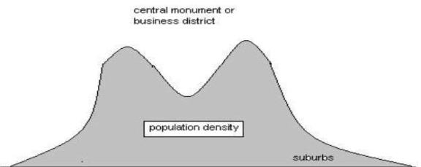
Figure 19.2: The volcano model of urban structure
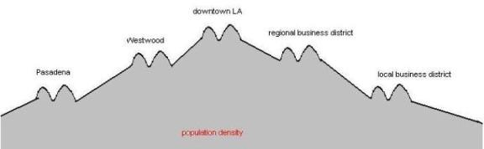
Figure 19.3: The multicentric pattern of automobile-based urban structure
As mentioned in Chapter 18, the global population continued to move into cities in the twentieth century, so that the proportion of the total population living in rural areas continued to fall and the sizes of cities continued to rise. But the world city size distribution flattened out after 1950. New York had been both the largest city and the biggest center of business in the world since it grew larger than London in 1925, but after World War II other cities began to catch up with New York in terms of population size. Tokyo-Yokohama became as large as greater metropolitan New York City by 19xx, and then other cities such as Sao Paolo, Mexico City and Shanghai began to catch up (Chase-Dunn and Willard 199x). It seems that there is a contemporary growth ceiling on the population size of the largest cities that is around 20 million, and that cities in both the core and the semiperiphery are catching up to this ceiling. Some of the megacities of the non-core have become among the largest settlements on Earth.
The other thing that is happening to the global settlement system is the formation of large city-regions. The whole eastern half of the United States is an urbanized region in which nearly contiguous suburbs connect formerly cities with one another. Europe is another city region of this kind. The structure of the world settlement system can be seen in Figure 19.4, which shows city lights at night as recorded from satellites and in photographs taken by shuttle astronauts.
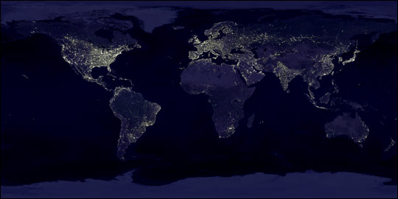
Figure 19.4: City lights from satellite and shuttle images
The Final Wave of Decolonization
Core countries mobilized soldiers from their colonies to fight in World War II, and when these soldiers returned home they demanded citizenship rights and sovereignty for their homelands. Movements for decolonization and sovereignty had been emerging since the earlier wave of late eighteenth century and early nineteenth century decolonizations (See Figure 16.4 in Chapter 16).
After World War II the U.S. was able to quickly build a global network of military bases by providing political and financial support to European powers to help them continue to control their colonial empires. Thus did the U. S. accomplish in a few years what it had taken the British Empire centuries to achieve – an intercontinental system of military power. This was made possible because the U.S. utilized the colonial structures that had been erected by the other European powers (Go 2007). In return for financial support the U.S. gained locations for military bases as well as agreements to allow trade and investment.
But the post-war decolonization movements became increasingly militant and in many cases they received encouragement from the Soviet Union. The principle of national self-determination had long been an important pillar of European civilization, and now the colonized peoples asserted that they too were citizens, not subjects. And in this they found support from the Soviet Union, but also from the UN. Declaration of Human Rights. Eventually the U.S. also became a supporter of decolonization. Just as Britain had claimed the moral high ground by stopping the slave trade and supporting Latin American independence in the early 19th century, the United States proclaimed itself the leader of “Free World” and began to support (or did not oppose) most non-communist independence movements in the colonies of the other core powers. The U.S. intervened covertly or overtly in countries in Latin America, Asia and Africa where emerging nationalist or leftist movements appeared to be likely to align with the Soviet Union or to threaten the property rights of U.S. companies (e.g. Nicaragua, Guatemala, the Dominican Republic, the Congo, and eventually Vietnam, etc.). But the wave of decolonization that began in the years after World War II was eventually successful in extending at least the formal trappings of national sovereignty to nearly the entire periphery, creating a global system of national states for the first time.
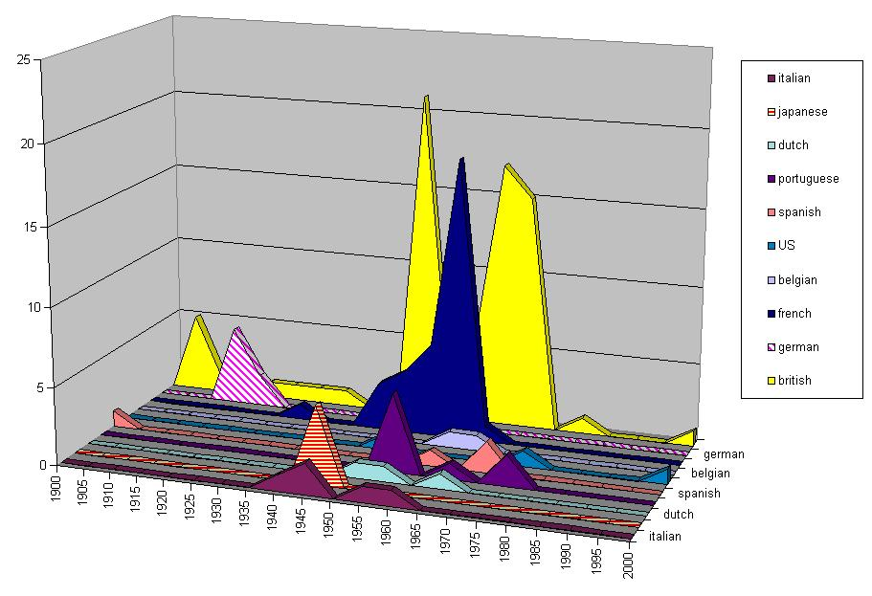
Figure 19.5:Twentieth Century Decolonization- Last Year of Colonial Governors (Source: Henige 1970)
Figure 19.5 shows the last year in which a territory had a colonial governor. The main reason why colonial governors were sent home in this period was the great wave of decolonization after World War II in which former colonies became sovereign states. Exceptions were the African colonies taken from Germany at the end of World War I (note the diagonally-lined pyramid in Figure 18.7 in 1915. These became French and British “protectorates” that eventually gained formal sovereignty only after World War II. By the time Japan’s colonies were taken from it at the end of World War II it had become acceptable to go quickly to formal sovereignty, as did Korea and Taiwan, rather than having to pass through a long period in the status of protectorate. The horizontally-lined triangle in Figure 19.5 represents Japan’s former colonies – Korea, Manchuria and Taiwan.
Another thing that Figure 19.5 shows is that the timing of the dismantling of the French and British Empires was somewhat different. The British experienced two big waves, while the French had a single wave. But from a world-historical point of view these were minor variations, parts of an overall global phenomenon in which formal colonialism had ceased to be an acceptable practice of global governance. The enshrinement of the Universal Declaration of Human Rights as a foundational document of the United Nations, and the abolition of formal colonialism was as big a step toward global democracy as the abolition of large-scale slavery and serfdom had been in the nineteenth century. The very idea of empire in the formal sense was thrown into the dustbin of history, but huge global inequalities yet remained, and they were socially structured by the legacies of colonialism and by the continuing operation of the political and economic institutions of global governance.

Rise and Demise of the Welfare State
Political incorporation generally meant gaining the right to vote in the election of representatives in governments that increasingly became legitimated from below rather than from above. Monarchies are usually based on the idea that the king represents a divinely sanctioned moral order – the so-called divine right of kings. This was an extension of the notion of the sacred chiefs, that some people – the elites-- are closer to god or the ancestors or have great influence or control over the powers of the universe. Democracy is the idea that governance is legitimated from below. Polities have increasingly tended to be legitimated as existing to serve the people. It has become commonly asserted that government is based on a social contract in which the purpose of law is to serve the needs of the whole population of citizens, and in some states policies have increasingly been shaped by the will of average citizens (Tilly 2007).
Core states incorporated workers, and eventually women and students, by extending political, civil and welfare rights. The capitalist welfare state emerged in somewhat different ways in each country and with different political configurations that depended on the nature of the economy and the kind of class structures that existed.
The shift from divine to demographic legitimacy enhanced the claims of “men of no property” to be allowed to participate as equals in political decision-making. Democratic participation had formerly been constituted as the political rights of aristocrats, and this had usually restricted voting rights to those who owned significant amounts of property. In the nineteenth century many states extended the franchise to most adult males regardless of property qualifications, and eventually to adult females as well. In the twentieth century the capitalist welfare state expanded further to take responsibility for the provision of mass public education, public health regulations (clean water, etc.), publicly provided health care and retirement security. These expansions of the welfare state became strongly institutionalized in most of the European core states, especially after World War II, and a somewhat narrower version emerged in the United States as well.
The differences have to do with the ways in which welfare rights were constructed. In some states, especially those with ethnically homogenous populations, rights became construed as applying to all citizens. In other states the legal institutionalization of welfare rights was tied to the status of soldier or was connected with particular types of employment rather than being universal citizen rights.
In the U.S. the development of citizenship and welfare rights was complicated by the federal system and the way in which the party system was related to regional differences. The Democratic Party claimed to represent workers and urban populations in the north, but in the south it was the creature of conservative whites (Dixiecrats) who had opposed the extension of citizenship to blacks and who managed to get agriculture excluded from the protections of the New Deal labor and welfare legislation. The rights of citizenship and federal welfare programs in the U.S. had been tied to service in the armed forces since the Civil War (Skocpol 1992). Even the post-World War II expansion of the welfare state in the U.S. was importantly tied to the soldier status – the GI Bill of Rights that extended housing and education credits to veterans. Thus was national patriotism again linked to global order as the expansion of the U.S. welfare state became an important source of support for the world-wide military network that was charged with protecting the “free world.” This was the form that social imperialism took in the last half of the twentieth century.
The militarized welfare state in the U.S. was also linked to race relations. White racism stood in the way of universal welfare programs that would benefit all citizens equally because white working class people could be mobilized against programs that would benefit the non-white poor. Racism was also an important factor when welfare programs were attacked and dismantled in the 1980s and 1990s (Reese 2005). Before and during World War II the armed services were racially segregated, and platoons of black soldiers and sailors were used to do unusually dangerous and dirty jobs. In 1948 President Truman ordered the desegregation of the armed forces. The actual desegregation of the U.S armed forces took quite awhile to accomplish beyond the formal declaration but its eventual success shows that racial inequalities can indeed be eliminated by strongly supported policies. Racial segregation was a huge embarrassment to the U.S. federal government as it took up the mantle of leadership of the free world. Critics of the U.S. hegemony and foreign policy both at home and abroad pointed to the public racism that was especially visible in the U.S. South. And so federal policies began to turn against the most visible and formal aspects of institutional racism, adding a new twist to the racialized and militarized shape of the welfare state in the United States (Winant 2001).
Bretton Woods and Keynesian National Development
In 1944 representatives of the 45 countries that had been Allies against the Axis powers in World War II met in Bretton Woods, New Hampshire to found a new set of international economic institutions that were designed to try to prevent the kinds of dysfunctional economic problems that had emerged in the 1920s and the 1930s. The International Monetary Fund was set up to help countries maintain stable currencies by creating a fund to make short-term loans. International currency speculation was curtailed by pegging currencies to the U.S. dollar. The World Bank was set up as the International Bank for Reconstruction and Development to help countries recover from the disruption and destruction of the war and to help less developed countries industrialize.
These institutions, and the policies they were designed to support, were greatly shaped by the writings of the British economist John Maynard Keynes (1936). Keynes’s studies of what had happened in the international economy in the 1920s and 1930s had strong implications for the ways in which national government policies should intervene in the economy in order to take the rough edges off of the boom and bust cycles of capitalist development and to encourage full employment. Keynesian economics enjoins governments to use monetary adjustments in interest rates to even out the boom and bust cycles of capitalist development. In order to do this states need to be able to control their money supplies by printing more money to keep interest rates low or to tighten the money supply to increase interest rates in order to slow inflation. The Bretton Woods institutions were originally designed to help each country to develop industrial production that was owned by businessmen within the country. International investments were not discouraged, but global accounting systems were put in place in the International Monetary Fund’s Balance of Payments Yearbook that allowed international investments and profit repatriations to be tracked.
Keynes also proposed the creation of an international clearing union that would help to even out international inequalities by creating incentives for countries with trade surpluses to invest in countries with trade deficits. This proposal was opposed by the leader of the U.S. delegation at the Bretton Woods conference, Harry Dexter White, and the clearing union did not come to pass (Monbiot 2003:159-169).
This was the international face of the New Deal. It was a global order that was designed to produce national development by expanding mass education and raising labor productivity in the non-core countries. The Roosevelt administration strongly supported both the founding of the Bretton Woods institutions and the United Nations.
The main purpose of the United Nations was to implement “collective security” by creating a mechanism that would allow countries to resolve their conflicts without resort to warfare. This was also a reaction to the Age of Extremes, in which two devastating world wars had occurred. The founding conference of the United Nations was held in San Francisco in 1945. Franklin Delano Roosevelt seriously considered proposing that the headquarters of the U.N. should be located on Niihau, a small island off the coast of Kauai in the Hawaiian archipelago. Roosevelt wanted the new proto world government to strongly symbolize the incorporation of Asia into the new institutions of global governance. China, one of the Allied Powers in World War II, became a founding member of the U.N. Security Council.
Roosevelt’s global New Deal also involved a massive funding of reconstruction in Europe that became known as the Marshall Plan. And Roosevelt acted to prevent U.S. corporations from gaining control of the conquered Japanese economy after World War II. Both Japan and Korea were protected from “Latin Americanization” by the U.S. federal government’s policies, thereby laying the foundation for the developmental states that emerged in these two countries (Arrighi 1994). The complicated deal allowed Japanese zaibatsu (family-based business conglomerates) to control the major industries of the Japanese economy, but proscribed them from competing in the aircraft industry. The purposes of these policies were to stimulate trade partners for American businesses, but also to produce strong developmental states friendly to the United States that could help contain Communism within the borders of China and the Soviet Union. Thus did semiperipheral state communism help to induce the expansion of core capitalism (Boswell and Chase-Dunn 2000).
This incorporation of Asia, and especially Japan, into the circle of core countries required confronting racism toward Asians within the United States. In California, where fears of the “yellow peril” had been inculcated since the Gold Rush, the requirement that the locals should be polite to the Japanese was a hard sell, but a group of internationalists among the regional elites stepped forward to insist on equal treatment for Asians. This did not eliminate racism, but it did set a standard in which tolerance was expected and overt racist behavior was disapproved.
The Boom and the Bubble
The post-war boom was a further expansion of core capitalism that incorporated formal-sector workers in the core and expanded the size of the middle class in some of the non-core countries as well. In the U.S. it was a period of interstate highway construction, suburbanization and the expansion of higher education. More families could afford to own their own homes, and this was supported by government-sponsored housing credits. Increasing sales buoyed the automobile industry and automobile workers, now members of the United Auto Workers union, were earning good wages and working full-time. The lunch buckets were full.
Mass production of standardized goods that were affordable to the working class became known as Fordism because this model was touted and implemented by Henry Ford in the early decades of the twentieth century. Ford opposed labor unions, but the Fordist model of industrial organization came to incorporate a more positive attitude toward unions that sought better wages and working conditions for their members in the period after World War II. This was part of the Keynesian effort to encourage full employment and to pay workers enough so that they could purchase the products produced by large capitalist firms. Manufacturing was also growing in Europe and Japan, and the U.S. naval forces protected the seas so that oil from distant ports could be globally delivered in larger and larger tanker ships mentioned above.
Developmental states under the sponsorship of the United States emerged in Japan and in Korea (Evans 1995). Japan’s reemergence as a strong and competitive economic power after World War II is shown in Figure 19.1 above. The Japanese developmental state combined a highly professional planning bureaucracy with strong links to large family-owned business conglomerates called Zaibatsu and nationally coordinated higher education and research and development capabilities. The Japanese model developed business practices that were later adopted all over the world with the shift from Fordism to flexible specialization. Japan built the biggest ports, the biggest ships, and gained access to cheap energy and raw materials imported from distant continents. Korea, a Japanese colony from 1910 to the end of World War II, emulated the Japanese model with the help of both the U.S. and Japan. And Taiwan, another former Japanese colony, also joined the club of newly industrializing societies. The Chinese diaspora of the 19th century had spread migrants from China to Thailand, Singapore, and Indonesia as well as to the United States and the Caribbean. Giovanni Arrighi (2008) has contended that the East Asian regional system after World War II retained aspects of the earlier trade-tribute system that had existed before the Western states surrounded China in the 19th century. The U.S. took over the role that China had played in the earlier system, a somewhat paternalistic power that acted to facilitate development by sustaining developmental states in Japan, Korea and Taiwan. This stance by the U.S. was justified to the American public and European as containing Russian and Chinese communism (Cumings 1984,1990). It also provided a context which allowed Japan to become an important economic center in East Asia despite having been defeated in World War II and which subsequently allowed China to re-emerge as large and strong economy and a regional power after the Maoist era.
The World Revolution of 1968
But all was not happy, even during the great post-war boom. The middle class expanded, more people went further in school and had decent jobs, more owned their own homes and had cars, and the homes had labor-saving appliances, making housework less onerous. The Frankfurt school had come to the conclusion that Marx had made a mistake in not analyzing more deeply the cultural processes of capitalism. Political scientists and sociologists wrote about the emergence of mass society in which middle-class consumers came under the sway of mass media that promoted social consensus and depolarized class struggle.
But not everyone was pleased. In the U.S. South black people were still kept from voting and were insulted every day by public segregation practices. The Civil Rights movement emerged to challenge racist institutions, and college students, now an expanded group that had not yet been fully incorporated into political life as citizens, brought the Civil Rights movement to the north. Radical sociologist C.Wright Mills wrote about the power elite, a governing class that manipulated the political process in order to have its way (Mills 1959; Hayden 2006). Mills and an important group of other U.S. intellectuals, especially those associated with the independent Marxist journal, Monthly Review, were inspired by the Cuban Revolution that overthrew the rule of General Fulgencia Batista in 1959, and hoped that serious challenges to the rule of capital would re-emerge within the U.S.
The Vietnam War was a failed attempt by the U.S. to prevent the emergence of a Communist regime in Southeast Asia. Perceived by radical students and some black leaders as a return to imperialism, the anti-war and civil rights movements brought forth the World Revolution of 1968. In 1962 students who had been involved in the civil rights movement in the South returned to campuses in the north and came together to form the Students for a Democratic Society (SDS). Tom Hayden wrote “the Port Huron Statement” for a founding conference of SDS in 1962 (Hayden 2006). In 1964 students at the University of California in Berkeley found their political activities on campus restricted by a policy of “in loco parentis” that treated them as if they were children despite that they had the right to vote and were seasoned political activists, some of whom had been on the front lines of the civil rights movement in the south. The Free Speech Movement at Berkeley mobilized students around their own interests and radicalized large numbers.
In 1966 Mao Zedong launched the Great Proletarian Cultural Revolution in China by mobilizing young “Red Guards” for the purpose of revitalizing the Chinese revolution. The news from China and Mao’s philosophy spread widely across the globe as radicalized young people looked for critical alternatives to the mainstream mass media pablum and circus. The People’s Republic of China flooded the world with inexpensive translations of Mao’s “Little Red Book” as well as other essays by Mao and classical Marxist texts. Radical students joined with militant workers in France and Italy in huge demonstrations. There were also important manifestations and violent government crackdowns in Argentina and Mexico and the populist “liberation theology” of radical Latin American Catholic priests spread to both the core and the non-core.
In the U.S. “the New Left” attacked electoral politics and the welfare state as counter-revolutionary and undemocratic fig leaves hiding the power of capital. As had happened in the past, radical social movements spun out of one another. Feminists criticized the macho Marxists leading the student movement and went on to form their own groups, thus revitalizing the movement for the equality of women that had emerged out of the abolitionist movement in the 19th century. The environmental movement was reborn as more people became aware of the massive ecological degradation produced by industrial capitalism. The youth movement produced a critique of the sexual mores of middle class society, and proponents of alternative forms of sexual expression mobilized to assert their rights. Hallucinogenic drugs became popular as a way of protesting middle class norms, and added to the stew of resistance and revolution in the years around 1968.
The Neoliberal Counter-revolution
In the 1970s the Organization of Petroleum Exporting Countries (OPEC) organized a cartel and raised the price of crude oil. At the same time Japanese and European manufacturing caught up with the United States and the increasing competition caused a profit squeeze. The international monetary system erected at Bretton Woods had pegged national currencies to the U.S. dollar and the dollar was denominated at a low “official” gold price that became more and more deviant from the market price of gold as time passed. In the 1970s the rise of other currencies in value relative to the dollar put financial pressures on the U.S., and the Nixon administration unilaterally rescinded the Bretton Woods monetary agreement, allowing national currencies to trade against one another in a global market for money.
The profit squeeze and other pressures led to reneging on the New Deal social contract that had been established after World War II. In California a state referendum called Proposition 14 greatly constrained the use of property taxes for public education. Wealthier homeowners, most of whom no longer had children in school, were not willing to pay the educational costs of the children of renters, a group that was increasingly made up of non-white immigrants. The New Deal institutions were attacked as inefficient government interference in the market economy. Welfare programs were discredited as unfair taxation of workers to pay for “welfare queens” who were portrayed as fat and promiscuous black women (Reese 2005). Labor unions were attacked as “special interest groups” that obtained undeserved rents for their members by means of political muscle.
Politicians arose in the U.S. and Great Britain who championed the ability of markets to provide optimal production and distribution and vilified state interference. This set of political ideas has become known as “neoliberalism.” It championed the operation of free markets, justified attacks on organized labor, advocated the privatization of publically-owned or controlled resources, and supported “streamlining” business operations by replacing workers with technology. Governmental regulations were portrayed as inefficient relative to the private sector, which was alleged to be much more entrepreneurial, productive and efficient. In the United States California Governor Ronald Reagan, who was later elected President of the U.S, promulgated this neoliberal political ideology. In Britain Prime Minister Margaret Thatcher championed a very similar approach.
The ideas were not new. They are basically some of the same moral and philosophical concepts that can be found in Adam Smith’s The Wealth of Nations, published in 1776. What was new was the vigorous promulgation of these concepts and policies by certain think-tanks and politicians as replacements for the Keynesian policies that had been predominant in the West since World War II. The neoliberal political notions spread widely. Politicians in nearly all countries adapted neoliberalism to their local situations. Communist Parties in Europe, Social Democrats in New Zealand and the Chinese Communist Party all moved in the direction of market-based justifications for policy.
Neoliberalism was also adopted by international agencies, especially the International Monetary Fund, under the banner of what came to be known as “the Washington Consensus.” The International Monetary Fund (IMF) took it upon itself to try to enforce neoliberal policies by making them the condition for further loans – so-called Structural Adjustment Programs that required governments to reduce or abolish subsidies for food, transportation, etc. These policies were not popular, especially in poor countries in the Global South, and a large number of “anti-IMF” demonstrations and riots occurred in the 1980s (Walton and Seddon 1994). These and the Zapatista rebellion in 1994 in Southern Mexico were precursors of the so-called antiglobalization protests that gained greater attention in the late 1990s (Podobnik 2003).
In 1971 the World Economic Forum was founded by Swiss business professor Klaus Schwab. Annual invitation-only January meetings in Davos, Switzerland are attended by leading global corporate executives, politicians, entertainers and other celebrities. This institution is perhaps the most visible face of what Leslie Sklair (2001) and Bill Robinson (2004) have called the transnational capitalist class.
1989: Another World Revolution
The rise of information technology facilitated a shift in the organization of business away from mass production of standardized goods toward more flexible production of smaller customized batches. Businesses throughout the world adopted techniques that had been developed in Japan such as “just in time” inventory deliveries from subcontracted firms. These changes in the organization of business practices also undermined the power of labor unions that had developed during the Fordist regime of mass production. And these changes were also incompatible with the “command economies” that had emerged in the Soviet Union and its satellites and in the Peoples Republic of China. Nationalist rebellion against Soviet dominance in Eastern Europe had been occurring since the Hungarian revolt of 1956. The clunky state-owned economy in the Soviet Union was also under great pressure because it was trying to keep up with the U.S. in a new arms race. President Ronald Reagan had undertaken another wave of huge military expenditures – the so-called “Star Wars” program -- that was to provide a shield against intercontinental ballistic missiles. These pressures led to a political crisis in the Soviet Union in which Mikhail Gorbachev proposed to dismantle party controls over communications and to open up political life. The resulting political upheaval led to the fall of the Soviet State, and a series of major regime changes in Eastern Europe as well. This was the World Revolution of 1989.
Gorbachev and the Solidarity Movement that emerged in Poland wanted individual political rights such as the freedom of speech, freedom of the press, and more democratic political institutions, but they also wanted to preserve some of the progressive features of social life that had been achieved under state communism, such as protections for the rights of women, socialized health care and public education. The transitions that ensued often did provide more political rights and individual freedoms, but the arrival of neoliberal consultants from the West advocating market-based “shock therapy,” deregulation and privatization dismantled most of the kinds of social equality that had been the legacy of the Soviet era.
The Great U-Turn of Inequality in the Core
In most premodern state-based world-systems urbanized core societies in which a small elite ruled over a mass of urban poor and rural peasants had more internal inequality than non-core societies, where less social stratification was the norm. In the modern world-system this pattern became reversed. In the modern system non-core societies have a pyramid-shaped distribution of income and wealth (∆) with a small elite and a much larger number of poor urban and rural residents. Core societies, on the other hand, tend to have diamond-shaped distributions of income and wealth (♦) in which a large proportion of middle-class people compose a bulge in the middle of the distribution, with elites above and a smaller proportion of poorer people below. This simple fact about the modern world-system both reflects and causes other features of the system. Core countries have larger middle classes because their economies are more developed and they require larger numbers of educated and skilled workers (Lenski, 1966). Representative democracy is more prevalent in the core because it is easier to establish and maintain the institutional prerequisites of electoral democracy when there is less inequality.
This situation has changed somewhat since the emergence of neoliberalism and the globalization project in the 1970s and 1980s. As we have described above, a number of things came together to produce the rise of neoliberalism. The profit squeeze produced by Japanese and German manufacturing catching up with U.S. manufacturing combined with availability of new mass transportation technologies, communications technologies and information processing. There was also a conservative reaction to the world revolution of 1968 especially in the U.S. where evangelical Christians adapted some of the musical styles of the 60s (folk, rock and roll) to support a renewal of family and church-based community values. This development allowed neoliberal politicians to gain popular support while attacking the welfare state protections of the working class. And neoliberal businessmen also perceived threats to profit-making from the emergent solidarities in the global south such as the Organization of Petroleum Exporting Countries (OPEC) and the initiative for the New International Economic Order (NIEO) that was pushed by non-core countries at the U.N.
The shift to flexible specialization, the deindustrialization of the core produced by manufacturing businesses investing in the non-core, the attack on labor unions and the welfare state, deregulation and privatzation led to the phenomenon in some core countries that has been called “the shrinking middle class” (Rose 2007). Rose’s research has shown that the size of the bulging middle of the U.S. income distribution shrank as some households move up while a much larger number moved down. A similar trend toward greater income inequality has also been demonstrated in many of the other core nations since the 1980s (Bornschier 2008).
Some analysts have overstated the significance of this trend by using terms such as “the peripheralization of the core” and others have declared that the world is flat (Friedman 2005), meaning that the earlier core/periphery hierarchy based on colonialism is a thing of the past. But these breathless celebrations (or condemnations) of the new global age are undoubtedly overstated. The U.S., while its hegemony is obviously in decline, remains the most powerful national society on Earth. Inequalities at the global level have not diminished (Bornschier 2008). The core/periphery hierarchy is alive and well. It has always been a complicated and messy structure composed of nested local, regional and international spatial inequalies, and that situation continues. But it has certainly not evaporated to produce a level playing field in the context of the latest wave of globalization. The economic rise of China and India are an important instance of the recurrent pattern of semiperipheral development, but the overall level of international inequality has not been reduced, at least so far (Bornschier 2008).
Nevertheless, the shrinking middle class in core societies is an important structural fact that has had huge consequences for social, political and economic change in recent world history. In the U.S. a new generation of extremely wealthy people seem to be replaying the conspicuous consumption of the “robber barons” of the late 19th century, while the large majority of citizens work harder for less income and hope to hit the Lotto so that they too can live the life of the rich and famous.
Neoliberals and Neoconservatives
Neoliberalism was made possible in part by new transportation, communications and information-processing technologies, but it was also spurred by a profit squeeze in core manufacturing and by conservative reactions to the world revolution of 1968. Another important motivating force was reaction to perceived threats to core profits posed by organized non-core resistance. The Organization of Petroleum Exporting Countries (OPEC) formed in the 1970s was a cartel of non-core fossil fuel producers that demonstrated that states in the global south could form powerful coalitions that could be major players in the global political economy. Research on the negative economic and inequality effects of dependence on foreign capital investment (Bornschier and Chase-Dunn 1985) and organized efforts to produce a New International Economic Order (NIEO) that would reduce core/periphery inequalties also created a climate that provoked the neoliberal counter-revolution.
The neoliberal ideologues seized upon the fall of the Soviet Union and the world revolution of 1989 to proclaim the “end of history” and the final triumph of capitalism and parliamentary democracy (e.g. Fukayama 1992). These developments helped to spread and support the emerging ideological hegemony of neoliberal policies. British Prime Minister Margaret Thatcher declared that there was no alternative to capitalist globalization.
But by the 1990s some of the neoliberals seemed to have lost their nerve. Some swung away from the radical notions of dismantling states and privatizing everything. Jeffrey Sachs, one of the most militant proponents of “shock therapy” – rapid marketization, deregulation and privatization—in Eastern Europe and the Soviet Union, has joined with Mary Robinson, former Irish Prime Minister and U.N. Secretary of Human Rights, in a campaign to ameliorate the suffering of the poorest people in the periphery that have been left out of the wonders of capitalist globalization (Sachs 2005).
Others have embraced a different approach that sought to prop up the declining U.S. economic hegemony by means of the unilateral use of U.S. military supremacy in a bid to obtain greater control over the global supply of fossil fuels. These “neoconservatives” proposed a plan for “A New American Century” in which strong military interventions by the U.S. would confront the growing disorder of the world-system. This proposed approach made little headway until the terrorist attacks of September 11, 2001 propelled the administration of President George W. Bush to mount a “war on terrorism” by invading Afghanistan and Iraq.
Samir Amin (1997) suggested that the neoliberal policies were “crisis management” in the sense that they were motivated by the perception that the previous Keynesian policies were unlikely to be able to succeed in prolonging the hegemony of the U.S. and the stability of the global political economy. Crisis management is also an apt characterization of the rise of the neoconservatives who saw that neoliberalism could not succeed for long.
The recent neoconservative project is similar in important ways to the policies developed and pursued by an important element within the British ruling class during the decline of British hegemony at the end of the 19th century. The Boer Wars, discussed in Chapter 18, were the most obvious example. Unilateral military power was employed in an effort to sustain a world order under the sway of English-speaking peoples. This phenomenon has been called “imperial over-reach” by Paul Kennedy (1988) and “the imperial turn” by George Modelski (2005). Declining hegemonic core powers tend to try to shore up their global position by employing unilateral military coercion, playing the last card in which they still have a comparative advantage. These actions usually only exacerbate the problems of global disorder and help to usher in a period of hegemonic rivalry, resource wars and rebellions.
The twentieth century ended and the new millennium began with a situation among humans that was similar in many ways to the end of the nineteenth century, except that the declining hegemon was far larger and even more tightly wound with the whole global political economy . The institutions of global governance beyond the interstate system and governance by hegemony were far more developed, but perhaps still not sufficiently evolved to be able to effectively deal with the new problems that our species had created for itself. Notably the hugely enlarged human population, globalized industrial production and the massive burning of fossil fuels had begun to degrade the biosphere on a global scale. Global warming would pose a huge problem, especially to the large numbers of very poor people living in areas that are particularly susceptible to disruption by rising sea levels, droughts and violent storms. To this we can add the inevitable arrival of important resources shortages as non-renewable fossil fuels bring about the end of cheap energy, and even renewable resources such as sources of fresh water become short because of the massive scale of human usage. Peak oil and peak water posed large challenges to the increasingly integrated single world society of humans, and these combine with the older challenges of huge inequalities and violent conflict to create the potential for a perfect storm of Malthusian corrections. But this is not the only possibility. The next chapter discusses several possible human futures for the 21st century.
Further Reading:
Arrighi, Giovanni 1994 The Long Twentieth Century. London: Verso
______________ 2008 Adam Smith in Beijing. London: Verso.
Bornschier, Volker and Christopher Chase-Dunn 1985 Transnational Corporations and
Underdevelopment. New York: Praeger.
Brenner, Robert 2002 The Boom and the Bubble: the U.S. in the World Economy. London: Verso.
Bunker, Stephen and Paul Ciccantell 2005 Globalization and the Race for Resources. Baltimore: Johns Hopkins University Press.
Cumings, Bruce 1990 The Origins of the Korean War. Princeton, N.J.: Princeton University
Press.
Glenn, Evelyn Nakano 2002 Unequal freedom : how race and gender shaped American citizenship and labor. Cambridge, MA: Harvard University Press.
Harvey, David 2003 The New Imperialism, New York: Oxford University Press
___________ 2005 A Brief History of Neoliberalism. New York; Oxford University Press
Hayden, Tom 2006 Radical Nomad: C. Wright Mills and His Times. Boulder: Paradigm.
Kennedy, Paul. 1988. The Rise and Fall of the Great Powers: Economic Change and Military Conflict from 1500-2000. New York: Random House.
McCormick, Thomas J. 1989 America’s Half Century: United States foreign policy in the Cold War.
Baltimore: Johns Hopkins University Press
Lenski, Gerhard 1966 Power and Privilege. New York: McGraw-Hill.
Reese, Ellen 2005 The Backlash Against Welfare Mothers. Berkeley: University of California
Press.
Robinson, William I. 2004 A Theory of Global Capitalism. Baltimore,MD: Johns Hopkins
University Press.
Rose, Stephen J. 2007 The American Profile Poster. New York: The New Press.
Winant, Howard 2001 The World Is A Ghetto: Race and Democracy Since World War II. New
York: Basic Books.

Chapter 20:
The 21st Century: The Next Three Futures
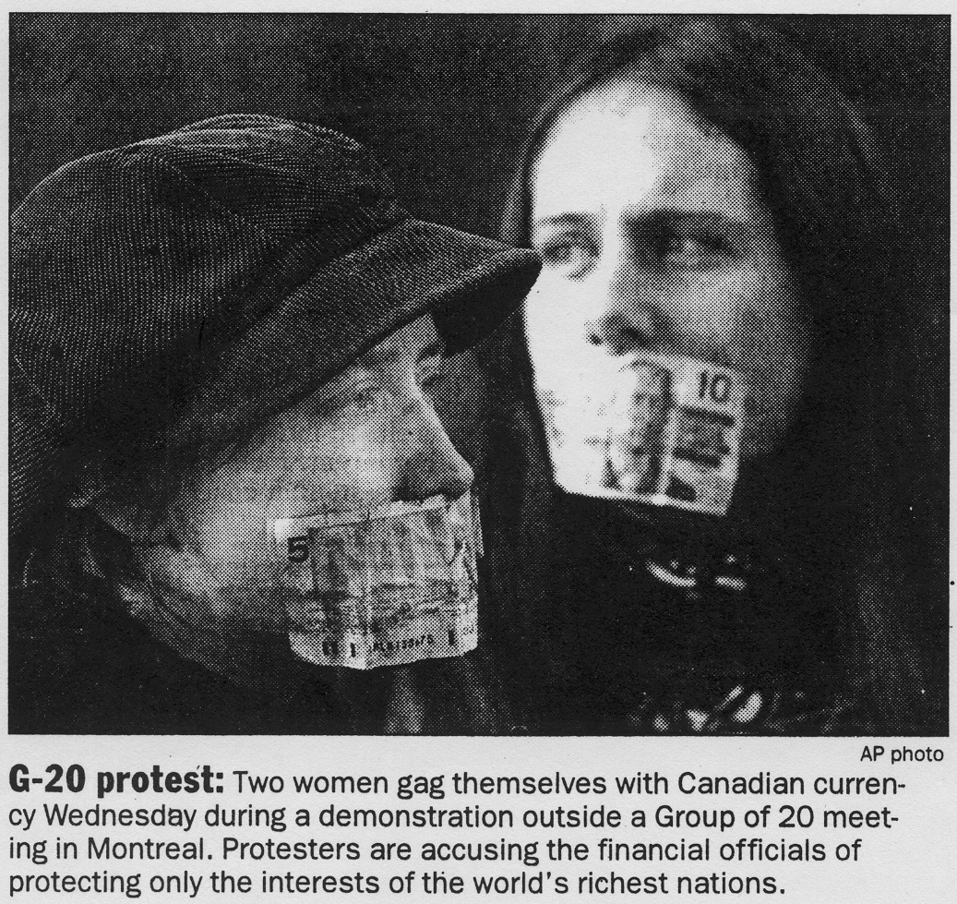

v. 12-6-08 11072 words

techno fix not in time, cold fusion, clean nukes . use internet but beware that big grid could come down, semip devel, use review of patomaki. Probability of future war among core states diagram from c-d and podob. Transnational capitalist class?(diagram).

This final chapter discusses developments in the first decade of the 21st century and uses the comparative world-systems perspective to consider possible scenarios for the next several decades. Prediction is always a risky business, but some things are actually quite predictable, while others are less so. Natural cycles such as the seasons will continue, although human-caused global warming may be changing them to some extent. Human demographic processes are fairly predictable as well. Because of the spread of the demographic transition to lower birth rates to the Global South, demographers predict that the total population of the Earth will continue to rise until about 2075. The steepness and duration of this continuing rise will determine how many people there will eventually be on Earth. The estimates vary from 8 to 12 billion. The timing and height will be affected by the usual factors: birth and death rates are influenced by the food supply, diseases and natural and human caused disasters. The education of women and their employment in jobs outside the home are the main things that affect the demographic transition. The rapidity or slowness of the demographic transition and the consequent size of the global population will have a huge impact on the effort to move toward a more sustainable global economy. The fewer humans that need to be accommodated, the easier the required adjustments will be.
This chapter considers the likely trends of the 21st century as well as the major challenges that humanity will face. Like the birth rate and the total population, the timing and strength of these challenges and their interactions with each other will greatly influence how well we are able to cope with them and how much disruption and tragedy they will cause. As in the past, large challenges are also opportunities for innovation and for reorganizing human institutions.
Cosmologists and astrophysicists contend that the sun is burning out, like a match. Eventually our solar system will turn very cold, and life will no longer be possible. But that will take another 4 billion years (Christian 2004:487). On the scale that most humans reckon time this is not very worrisome. Some observers think that the biosphere of the Earth is seriously at risk as a result of human activities. John Bellamy Foster’s powerful book about the ecological consequences of industrial capitalism is entitled The Vulnerable Planet (Foster 1994). But the biosphere is probably not seriously at risk. There have already been huge megafauna die-offs from natural causes, but the processes of biological evolution have always resumed along new paths and toward higher levels of complexity. Thus the biosphere would probably eventually recover in a few million years despite the possibility that humans might wreak unbelievable havoc. It is rather us, the humans, that are primarily at risk. Because we are a large animal that require a lot of food and energy, and because there are so many of us, unlike other populations of megafauna, both our civilizations and our very existence could conceivably be brought to an end by some human-caused cataclysm.
The point of this chapter is not to be scary. Nor will we simply assume that all problems can be easily resolved. Our world-systems perspective leads us to see some disturbing similarities, but also some important differences, between what happened during the late 19th century and the first half of the 20th century and what seems to be happening in the early 21st century.

Major Challenges of the 21st Century
There are three major crises that loom in the early decades of the 21st century:
- global inequalities,
- ecological degradation, and
- a failed system of global governance in the wake of U.S. hegemonic decline.

Global Inequalities
Careful studies of trends in income inequality show that a huge global gap emerged during the 19th century between the average incomes of people living in the core countries and the average incomes of people in the non-core. That gap has not decreased despite all the efforts to develop the non-core societies (Bornschier 2008). The global income gap has not gotten worse during the period of neo-liberal policies, but neither has it gotten better. There is a huge, yawning chasm between the rich and the poor of the world that is not going away. Those who are concerned about inequality should be aware of, and focus upon, this huge global gap. It is far larger than the inequalities that exist within most national societies.
This said, there has not been absolute immiseration, except in a few small regions, over the last century. Average incomes in the most of the core and most of the non-core have both increased, but at rates that have reproduced the huge gap. Trends within particular countries have varied. Some have increased and others have decreased.
The causes of the global income gap include the uneven development of technologies and labor productivity, but also the operation of political and financial institutions. Wages went up in the core as industrialization increased the productivity of labor. But the core/non-core differences in income are much greater than the differences in labor productivity. Colonialism contributed to global inequality by allowing core countries to use the law as an instrument of exploitation and domination. Since decolonization most countries of the non-core have experienced relative underdevelopment because of dependence on foreign investment and the operation international financial institutions such as the International Monetary Fund and the World Trade Organization.
Dependence on foreign investment means that foreigners own and control a relatively large part of a national economy. Crossnational comparative research has shown that investment dependence slows economic growth and increases within-country income inequality (Bornschier and Chase-Dunn 1985). The operations of the International Monetary Fund and the World Trade Organization have greatly favored core countries, especially since the rise of the neoliberal “Washington Consensus” in the 1980s. Structural adjustment programs (SAPs) imposed by the International Monetary Fund have increased inequality in many countries. The World Trade Organization, despite its free trade ideology, has presided over a situation in which free trade has been imposed on non-core countries while core countries have been allowed to maintain protective tariffs and trade quotas, especially on agricultural goods. This is protectionism for the core and free trade for the non-core. Thus global inequalities are partly a matter of uneven development and partly due to what Andre Gunder Frank (1966) called “the development of underdevelopment” -- global institutions that favor the core countries and reproduce low levels of economic development in most of the non-core.
Relative Deprivation
But why is this a problem? Despite the continuation of the huge global gap in incomes, most non-core countries have experienced some growth of average incomes. Life expectancy has gone up, and most countries are beginning the demographic transition to lower birth rates. Should not these things make people happy?
Political scientists and sociologists have long understood that people’s perceptions of a fair distribution of rewards -- distributive justice -- is largely a function of “relative deprivation.” Whether people are happy or not, and whether or not they feel exploited, is highly dependent on with what they compare their circumstances. If people in the non-core compared their levels of consumption with those of their parents most would perceive an improvement because life expectancies and average levels of living have increase, and so they should be content. But mass media and nearly instantaneous global communications have produced a situation in which people in poor countries increasingly compare their lives with those in rich countries. They see on television how people in core countries live. And they aspire to live that way. Most people would like to own their own car and to live in a large house with modern conveniences. They see these things on television and they want them.
Another contextual factor that makes continuing huge global inequalities a problem is the broad institutionalization of beliefs in the sanctity of equality. Equality is a value that is based in all the world religions and that was given powerful support by the European Enlightenment and the spread of secular humanism. The Universal Declaration of Human Rights is a foundational charter of global culture that is widely supported by the peoples of the world. Most local cultures have shifted toward individualized and merit-based ideologies of distributive justice and away from ideologies such as the caste system that justify inequalities based on categories that are inherited at birth (so-called ascriptive characteristics). Racism and gender inequality are held to be illegitimate nearly everywhere despite that strong currents of these old inequalities are still operating. In this cultural and political context the existence of huge global inequalities appears to be unjust to broad segments of humanity in both the core and the non-core, and the frustrations of those who have unsuccessfully tried to better their condition has led to unhappiness with the existing systems of governance. International inequalities were masked when national societies were thought to be largely unconnected systems, each with its own unique history. But the increasing realization that national societies exist within, and are strongly connected to, a larger global system encourages people to compare themselves to those in other societies and to see the whole world as a system of distributive justice.
Peter Taylor (1996) points to the important fact, which he calls “world impasse,” that it is an ecological impossibility for the global poor to catch up with the global rich. If the Chinese people eat as many eggs per person and drive as many cars as the Americans do the biosphere will cease to function. Thus global equalization will require that the rich go down to meet the poor who are coming up. This is a huge problem that no one wants to hear about, especially in the core countries. Mentioning this in polite conversation is usually considered to be in poor taste.
The United States is declining in terms of hegemony in economic production, just as Britain did in the late 19th century. The great post-World War II wave of globalization and financialization is faltering, and some analysts predict another trough of deglobalization. The declining economic and political hegemony of the U.S. poses huge challenges for global governance. Newly emergent national economies such as India and China need to be fitted in to the global structure of power. The unilateral use of military force by a declining hegemon further delegitimates the institutions of global governance and provokes resistance and challenges. In the 19th century this led to a period of hegemonic rivalry and world war. Such an outcome is less likely now, but not impossible, as we shall see.
These developments parallel to some extent what happened a century ago, but the likelihood of another “Age of Extremes” or a Malthusian correction may also be exacerbated by some new twists. The number of people on Earth was only 1.65 billion when the 20th century began, whereas at the beginning of the 21st century there were 6 billion. Fossil fuels were becoming less expensive as oil was replacing coal as the major source of energy (Podobnik 2006). It was this use of inexpensive fossil energy that made the geometric expansion and industrialization of humanity possible. Coal and oil are composed of solar energy that was harnessed by plants over a period of millions of years and then compressed beneath the surface of the Earth. Such stores of fossil fuel are called non-renewable because they cannot be naturally produced on a human time scale.
Now we are facing global warming as a consequence of the spread and rapid expansion of industrial production and energy-intensive consumption, and energy is once again becoming more expensive. The low hanging “ancient sunlight” has been picked. “Peak oil” is rapidly approaching, and the price of energy will go up no matter how much we invest in new kinds of energy production (Heinberg 2004). None of the existing alternative technologies offer low-priced energy of the kind that has made the huge expansion possible. Many believe that overshoot has already occurred in terms of how many humans are alive, and how much energy is being used by some of them, especially those in the core. Adjusting to rising energy costs and dealing with the environmental degradation caused by industrial society will be difficult, and the longer it takes the harder it will be. Ecological problems are not new, but this time they are on a global scale. Peak oil and rising costs of other resources are likely to cause resource wars that can exacerbate the problems of global governance. The war in Iraq is both an instance of imperial over-reach (which also occurred during the British hegemonic decline) and also a resource war because the U.S. neoconservatives thought that they could prolong U.S. hegemony by controlling the global oil supply.
The first decade of the 21th century has seen a continuation of many large-scale processes that were under way in the last half of the 20th. Urbanization of the Global South continued as the policies of neoliberalism gave powerful support to the “Live Stock Revolution” in which animal husbandry on the family ranch was replaced by large-scale production of eggs, milk and meat. This, and industrialized farming, were encouraged by the export expansion policies of the IMF-imposed Structural Adjustment Programs (SAPs). One consequence was the ejection of millions of small farmers from the land.
For most of these former rural residents migration to the megacities meant moving to huge slums and gaining a precarious living in the “informal sector” of services and small-scale production. These huge slums lack adequate water or sewage infrastructure. The budget cuts mandated by the SAPs, required by the International Monetary Fund as a condition for further loans, have often decimated public health systems. And so the slums have become breeding grounds for new forms of communicable diseases, including new strains of avian flu that pose huge health risks to the peoples of both the core and the non-core. These diseases are rapidly transmitted by intercontinental air travel. Many public health experts believe that a flu pandemic similar in scope and lethality to that of the infamous 1918 disaster is highly likely to occur in the near future. Most of the national governments have failed to adequately prepare for such an eventuality, and so a massive die-off is a likely outcome. Like most disasters, the lethality will be much greater among the poor, especially in the megacities of the Global South (Davis 2005).

The Democratic Deficit
Institutions of global governance have been evolving for centuries, as discussed in earlier chapters. The system of sovereign states was extended to the non-core in waves of decolonization. International organizations have emerged, grown in number and size, and taken on increasingly specialized and differentiated functions since the Napoleonic Wars. Democracy is still a contested concept. There are large and important disagreements about what constitutes democracy, despite the triumphalism on the part of neoliberals after the demise of the Soviet Union. The old debates about economic and participatory democracy have been raised anew in the global justice movement, and there are new debates about non-
Western forms of political participation. This said, the different notions of democracy are related to one another. Nearly all the forms involve legitimation from below, in which the human population rather than transcendent deities are understood to be the main constituency whose interests are to be represented and served by government. In this broad sense democracy has become the predominant justification for governmental institutions across the world. The Universal Declaration of Human Rights states that “the will of the people shall be the basis of authority of government.”
The existing institutions of global governance exhibit what many observers have called a “democratic deficit.” This means that, by even the weakest standards, the institutions of power in the global system are not democratic. The world polity, despite the emergence and growth of international organizations, is still mainly operating according to the logic of the system of sovereign states and global governance continues to take the form of hegemonic power exercised by a single national state.
The United States is the world’s only superpower. It controls a massive global military apparatus that is formally under the control of the U.S. Commander-in-Chief – the President. But the U.S. President is not elected by the peoples of the world, but by the voting citizens of the United States. Thus the global system of military force is not democratically controlled or legitimated. It remains a system of “might makes right.” The United States claims to act in the interest of the majority of the Earth’s peoples, but many do not believe these claims and dissenters outside the U.S. have no legitimate way to “throw the bums out.” There has been growing popular sentiment against the policies of the U.S. government in most countries of the world since 2001 (PEW Global Attitudes Project). This constitutes a crisis in global governance in which the old mechanism of hegemonic leadership is being brought into question because of the decline of U.S. hegemony and the broad awareness that the whole world now constitute a single global economy and a global polity.
The main international organizations with general responsibilities for international and global governance are:
- the regional military apparatuses such as NATO (the North Atlantic Treaty Organization), SEATO (the South East Asian Treaty Organization), etc.
- the United Nations and
- the international financial institutions (IFIs) such as
the World Bank,
the International Monetary Fund (IMF)and
the World Trade Organization (WTO).
The regional treaty organizations are key institutions in the global system that are intended to provide security and military cooperation. They, and the other international institutions of global governance lack what Jackie Smith (2008: 11) calls “external” legitimacy, meaning that they are not at all subject to popular consent. The also lack what Smith calls “internal legitimacy” – because their policies and actions do not represent the consensus of all the world’s national governments. This is not just because they are regional organizations. They are primarily controlled by the grat powers that are their members, mainly the United States.
The United Nations and the international financial institutions (IFIs) are increasingly seen as both incapable of dealing with challenges such as global warming, and as primarily controlled by the United States or by the core powers and thus the democratic deficit is a perception that applies to both the system of hegemony and to the structure of global governance by international organizations.
The IFIs have been targeted by large social movement protests since the anti-IMF riots in the 1980s because of the unpopularity of the structural adjustment programs that they began imposing on non-core countries after the rise of the neoliberal Washington consensus.
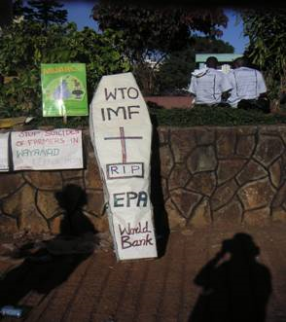
The transnational “Twenty-five Years is Enough” coalition advocates the abolition of the World Bank. The World Trade Organization’s meeting in Seattle in 1999 became the occasion for a huge protest demonstration by labor unions, environmentalists, and others that has become known as the “Battle of Seattle,” a totemic event in the growing global justice movement of movements.
The United Nations, though survey research shows that it is far less unpopular than the IFIs, is widely believed to be undemocratic even though the General Assembly of the U.N. makes decisions based on the principle of “one nation, one vote”. Both China and Honduras have a single vote in the General Assembly,and thus the General Assembly displays what Smith (2008:11) calls internal legitimacy – representing the voices of all the world’s governments.

Figure 20:10: World Social Forum, Nairobi, January 2007
But the U.N. General Assembly has little real power. It is known as a debating society. The important decisions about “collective security” – when to deploy U.N. peace-keeping forces – are the responsibility of the Security Council. The Security Council has five permanent members – the countries that won World War II. Germany and Japan are not permanent members. Proposals to restructure the Security Council so that it is not monopolized by the winners of World War II have been advanced for decades. But the Security Council cannot legally be restructured except by a vote of the permanent members, and they have continued to obstruct reforms.
Neither the U.N. nor any other major international institution tries to directly represent the wishes the world’s peoples. There is no global popular assembly or parliament. George Monbiot (2003) and others have proposed the formation of a global parliament, but such an institution is as yet only an idea.
The IFIs are even less democratic than the U.N. The Director of the World Bank is always from the United States. The Director of the International Monetary Fund (IMF) is always a European. The formal structure of control of the World Trade Organization is more representative of the world’s nations, but all the important decisions are reportedly made in the informal “Green Room” by the most powerful countries before they are brought to a formal vote. The IMF and the World Bank both have their headquarters offices near one another in Washington, DC.

The World Revolution of 20xx

As we have gotten closer to the present the world-system has become more integrated. The current high degree of economic integration is already higher than the peak in the 19th century, but we should also remember that waves of globalization have always been followed by periods of deglobalization in which long-distance interaction decreases, and this is likely to also be true of the future. As political globalization – the formation of a single global polity, the extension of the interstate system to the whole periphery, the growing size of the hegemon compared to earlier hegemonies and the growth and elaboration of international political and financial organizations—has become denser, world revolutions have become more frequent and have started to overlap one another. There is another world revolution occurring now and it is too soon to pick a symbolic year of a key event or development that connotes its character. Thus we shall call it the world revolution of 20xx.
As with earlier world revolutions, it is a constellation of local, national and transnational rebellions and protest movements that cluster in time. These challenge the powers that be simply because they all occur in the same period. The institutions of global governance have to contend with rebellion on many fronts. This is analogous to a single national state getting into more than one war at the same time. But the world revolution of 20xx includes more transnational rebellions and movements than any of the earlier world revolutions have had. This is a consequence of the saturation of the modern societies by mass media forms of communication, the low cost of long-distance transportation and communications, and the Internet, which allows nearly instant communication among peoples and organizations all over the planet.
The phenomenon of transnational social movements and global political parties that we have observed in the 19th and 20th centuries has grown to the point that there is now a vibrant global civil society of world citizens who consciously act in the arena of world politics. No one knows how large this group of cosmopolitan world citizens is at present. Obviously the people who consciously think of themselves as acting in world politics remain a small minority of the global population. Most people continue to participate mainly at local or national levels. But this cosmopolitan minority of world citizens is undoubtedly larger than ever before, and it includes substantial numbers of farmers, workers and students as well as the usual collection of scientists and intellectuals, journalists, statesmen , and religious leaders that have acted in world politics for centuries.
Figure 20.2 depicts the class structure of the world-system as a whole, and implies that there are transnational segments of all the classes. William I. Robinson’s (2004) theorization of the structure of global capitalism suggests that each country has a segment of elites who are members of what he calls the transnational capitalist class. Figure 20.2 portrays the existence of transnational segments of the other classes as well. No one knows the real numbers of those who are consciously participating in a global arena of politics, but it is obvious that the numbers have grown in recent decades as social movements have discovered that local and national political activities often cannot resolve problems that appear to have been created by forces abroad. Local and national social movements have also been able to gain additional leverage by accessing resources from abroad or by appealing to international institutions. This process, called “scale-shift” by scholars studying social movements, has produced a vibrant and diverse global civil society.
The world revolution of 20xx has primarily been a reaction against what we have called the neoliberal globalization project. Arguably it began with the anti-IMF riots that broke out in the 1980s when the Structural Adjustment Programs caused prices of food and transportation to rise in many of the cities of the global south.
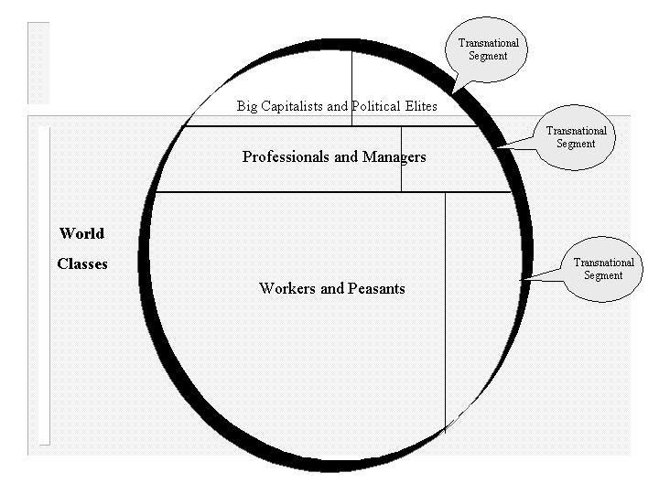
Figure 110.2: The global class structure with transnational segments
The World Social Forum (WSF) was established in 2001 as a counter-hegemonic popular project focusing on issues of global justice and democracy. Initially organized by European and Latin American NGOs who were miffed at not being able to participate in the World Economic Forum (WEF) that has met in Davos, Switzerland, usually annually in January, since 1971. The WSF was organized as the popular alternative to the WEF. It was designed to be a forum for the participants in, and supporters of, grass roots movements from all over the world rather than a conference of representatives of political parties or governments. The WSF has been supported by the Brazilian Workers Party, and has been most frequently held in Porto Alegre, Brazil, a traditional stronghold of that party. Whereas the first meeting of the WSF in 2001 reportedly drew 5,000 registered participants from 117 countries, the 2005 meeting WSF drew 155,000 registered participants from 135 countries. In opposition to Margaret Thatcher who declared that, “there is no alternative” to neoliberal globalization, WSF participants proclaim that “another world is possible.” The WSF is both an institution—with its own leadership, mission, and structure—and an “open space” where a variety of social actors--activists, policy experts, students, intellectuals, journalists, and artists—from around the world can meet, exchange ideas, participate in multi-cultural events, and coordinate actions. The WSF is open to all those opposed to neoliberal globalization, but excludes groups advocating armed resistance. Participants vary in terms of their affiliations with particular movements and different types of organizations. Both participants in unconnected local and national campaigns come together with long-time veterans of transnational organizations and internationally coordinated groups (Smith 2008). The WSF has inspired the spread of hundreds of local, national, regional, and thematic social forums.
The Multicentric Network of Movements
Just as world revolutions in the past have restructured world orders, the current one may also do this. But do the activists themselves agree on the nature of the most important problems, visions of a desirable future or notions of appropriate tactics and forms of movement organization? The Transnational Social Movements Research Working Group at the University of California-Riverside has performed a network analysis of movement ties based on the responses to as survey that was carried out at the 2005 WSF meeting in Porto Alegre, Brazil. This study examines the structure of overlapping links among social movements by asking attendees whether or not they were actively involved in a list of eighteen movements. The results show that the structure of movement links, based on those who reported involvement in more than one movement, forms a multicentric network.
Figure 20.3 shows a multicentric network organized around the five main movements that serve as bridges connecting the other movements to one another: peace, anti-globalization, global justice, human rights and environmentalism. While no single movement is so central that it could call the shots, neither is the network structure characterized by separate cliques of movements that might be easily separated from one another. This structure means that the transnational activists who participate in the World Social Forum process share goals and support the general global justice framework asserted in the World Social Forum Charter. It also means that this group is relatively integrated and is not prone to splits. A global cosmopolitan united front approach that pays attention to the nature of this network structure and is sensitive to Global North/South issues may be able to mobilize a strong force for collective action in world politics, especially in alliance with progressive regimes that seem to be emerging in the non-core.
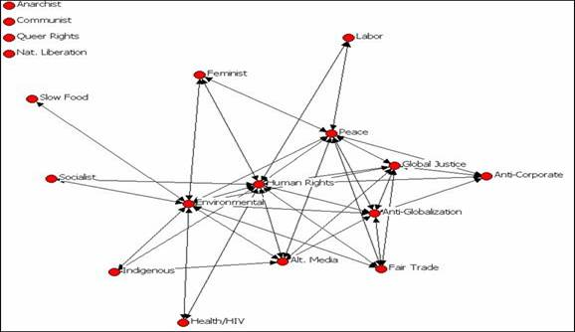
Figure 20.3: The Network of Social Movements at the World Social Forum in 2005
Similarities and Differences Between the 19th and 20th Century Waves of Globalization
There are both important similarities and important differences between the 19th and 20th century waves of globalization that need to be taken into account in order that we can understand the contemporary world historical situation. Both were periods of increasing integration based on long-distance trade, increasing foreign investment, as well as the expansion and cheapening of global transportation and communications. In both periods markets were deregulated and disembedded from political and socio-cultural controls, as Karl Polanyi emphasized in his important world historical analysis, The Great Transformation (1944). In both waves of globalization a hegemonic core power rose to centrality in the global political economy and then declined, losing first its comparative advantages in the production of consumer goods, then capital goods and then it used its centrality in global networks to make money on financial services. Indeed, much of the whole world economy became financially organized around the hegemon, whose currency served as world money (see Figure 20.1). The size of the symbolic economy of “securities” – financial instruments representing alleged future income streams—grew far larger than the economy that was based on transactions of material goods and services. In both waves of globalization capitalist industrialization spread to new areas and came to involve a far larger number of the world’s people in global networks of production and exchange.
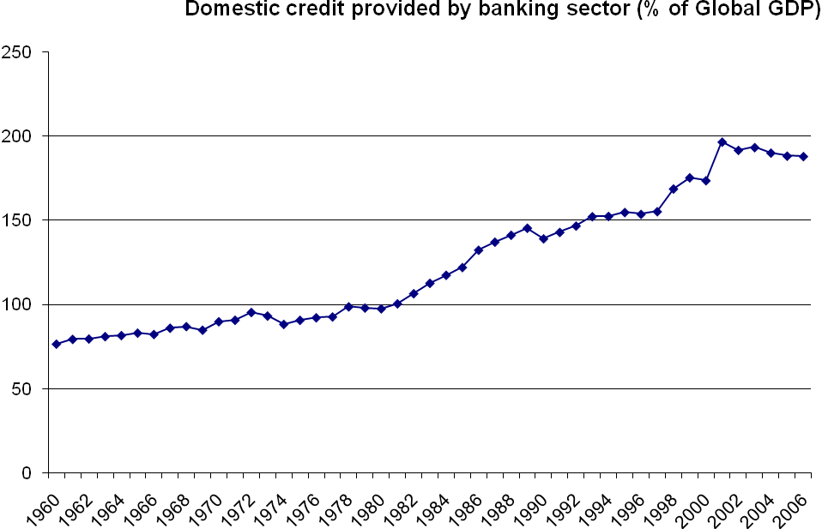
Figure 20.12: The expansion of credit as a percentage of global GDP, 1960-2006
Figure 20.2 shows the trajectory of an indicator of global financialization from 1960 to 2006. The indicator is global domestic credit provided by the banking sector as a percentage of the global GDP. This indicator of financialization, which does not include credit that banks offered to borrowers abroad, rose dramatically over the last 4 ½ decades, indicating that the relationship between real goods and services and symbolic forms that may be used to pay a debt has changed. Financialization means that the symbolic economy and the activities of financial services have come to be larger than the “real” economy of the production and exchange of goods and other services. It also indicates that finance capital has become a predominant player in the whole world economy. Though we do not have comparable quantitative indicators to produce the kind of graph shown in Figure 20.2 for the later decades of the nineteenth century, it is well-known that there was a somewhat similar expansion of finance capital during the period of British hegemonic decline in industrial production.
There were also important structural differences between the two waves of globalization. Formal colonialism was abolished from the global polity by the last great wave of globalization. The interstate system of legally sovereign states was extended to the non-core, and so core states could no longer extract taxes from their colonial empires. In the late 19th century and early 20th century the British were able to use their empire, especially its direct control over India, to finance the operations of the British state. And Britain also was able to mobilize large numbers of soldiers from its colonies to fight in the Boer Wars and in World War I. Both colonial revenue and cannon fodder were available to the hegemon as well as to the other contending core powers. That is a source of support that no longer exists because of the evolution of global governance. When the U.S., like Britain, began to use its centrality in global military power to try to shore up its declining hegemony, it had to rely primarily on U.S. citizens to perform soldierly duties. And it could not, as did the British, directly tax a colonial empire to financially support its adventures.
Of course, there have been functional substitutes. The U.S. has tried to get its allies to pay more of the costs of the Gulf Wars and the War in Afghanistan by sending troops. Soldiers have been recruited disproportionately from non-citizen immigrants within the United States by holding out the promise of gaining formal citizenship. And the U.S. government has increasingly privatized security by hiring companies of mercenaries to provide services in war zones. There have been huge efforts to rely on “smart warfare technologies” as a substitute for troops on the ground. None of these new factors have made the U.S. foray into “imperial over-reach” any more successful than was the British effort. The transition from hegemonic leadership to a policy that employs military supremacy unilaterally generates too much resistance from both the targets of coercion and from erstwhile allies.
Too Large To Fail
The functional substitute for colonial control over India has been what Michael Mann (200x) has called “dollar seignorage,” which we discussed in Chapter 19. U.S. federal government spending has been made possible without increasing taxes because governments and investors abroad have been willing to buy U.S. government bonds. This massive influx of money has also allowed the U.S. to sustain a huge trade deficit in which imports of foreign goods have come to vastly exceed the amount of U.S. goods that are exported (see Figure 20.3).
Probably the most important structural difference between the 19th and 20th century waves of globalization is the far great relative size of the hegemon. Figure 19.1 in Chapter 19 shows the proportions that the U.S. and British home markets constituted in the total world Gross Domestic Product. At its peak in about 1900 Britain’s share was less than 10%. At its peak in 1945 the U.S. share was 35% and, though it has declined in a series of steps down since then, it is still about 21%. This is twice as large as the British economy was at its peak. Thus the relative size of the hegemon in the larger world economy has more than doubled. This simple fact has allowed the U.S. to play the financialization card much more effectively than the British were able to do. The British were capital investors in the rest of the world economy, and returning profits on foreign investment were an important factor sustaining the “belle époque” of the Edwardian era before World War I.
The U.S. has obtained great returns on investment abroad, but it has also been sustained by huge flows of investment from abroad into the U.S. This is a big difference between British and U.S. hegemonic decline. The British mainly exported capital and got returns from investments abroad. The U.S. has done that too. The investments abroad of U.S. multinational corporations grew rapidly in the decades after World War II. U.S. companies established subsidiaries in many countries, branch offices and manufacturing operations as well as resource-extracting firms (mines, logging companies, fruit companies, etc). This is called “direct” investment because the headquarters firm owns and controls the subsidiary. Other core countries and some non-core countries also greatly expanded the operations of their own multinational corporations. The core countries also expanded their purchases of bonds from foreign national and local governments, and eventually core capital flowed in to newly emerging stock markets in noncore countries. This is called “portfolio” investment because the owner does not have control over the day-to-day operations of the entities whose securities are purchased. All this was similar to the export of capital by the British and other core countries in the great wave of 19th century globalization.

But then something different emerged -- huge inflows of foreign investment into the United States, first from other core countries, especially Japan and Britain, but later from non-core countries as well, especially China. It is these flows, which have taken the form of buying bonds as well as investment in real estate and stocks, that sustained the long U.S. expansion during the 1990s and the first years of the 21st century. Because of its ability to sell bonds the U.S. government was able to keep interest rates low and so developers built new housing, and homeowners were able to sell their old houses and move into larger houses because the prices of housing tended to go up. Residential mortgages were also subsidized as they had been since the G.I Bill of Rights after World War II, but the mortgage industry kept expanding credit and lowering the requirements for obtaining a housing loan. Mortgages from the residential and commercial real estate markets were also repackaged by Wall Street financial entrepreneurs as global commodities and sold to institutional investors all over the world. Thus did the wave of financialization during the U.S. hegemonic decline take on new dimensions that differentiate it from what happened at the end of the 19th century.
The U.S. government was also able to finance overseas wars in Afghanistan and Iraq by selling bonds to foreign investors, including the Chinese, who came to have such a stake in the U.S.-led financial bubble that they have become important supporters rather than challengers.
The dollar sector of the world economy is so large that there are no alternatives large enough to replace it even when foreign investors have become disenchanted about the prospects of future returns on their investments. The Euro would seem a possibility, but the sheer size of the mountain of securities in dollar-denominated investments makes the Euro sector look like a dwarf.
The difference in relative size between Britain in the 19th century wave and the U.S. in the 20th century wave means that the rest of the world is much more dependent on the economy of the hegemon and would-be competitors come to have a huge stake in the ability of the U.S. to buy their products. As is sometimes said about gigantic corporations such as General Motors, the U.S. economy is “too large to fail.”
Another and related difference between British and U.S. hegemonic decline is the huge U.S. balance of trade deficit that has emerged in conjunction with financialization and the export of manufacturing (see Figure 20.1). The balance of trade is the ratio of exports to imports of goods and services. Figure 20.1 shows this ratio as a percentage of the U.S. GDP. U.S. companies have relocated production and jobs overseas where labor and other expenses are cheaper, and the Bush regime encouraged this “outsourcing.” The expansion of financial services, the real estate boom and new lead technologies such as information technology (IT), biotechnology and nanotechnology were supposed to provide employment for those who lost jobs due to the export of manufacturing and some services (call centers, etc.)

Figure 20.13: U.S Trade Balance (Exports/Imports), 1970-2006
The Global Policeman
The U.S. is also far more supreme in military terms than Britain ever was. The United States currently maintains 737 military bases abroad. By comparison, at the peak of its global power in 1898 Britain had 36 bases (Johnson 2006: 138-39).
Another important difference between the two waves of globalization is that alliances among core countries are much stronger now than they were at the end of the 19th century. Recall that during the Second Boer War there was great fear in both Britain and France that war might break out between them. After World War II the U.S. and the core countries of Europe organized a strong coalition based on international organizations and an international multilateral military command structure, the North Atlantic Treaty Organization (NATO). The strongest economic challenges to U.S. hegemony in manufacturing during the decades after World War II came from Germany and Japan, the countries that lost the war. During long Cold War between the U.S. and the Soviet Union, the other core countries were content to let the U.S. be the superpower in military terms and so they did not develop their own military capabilities to any significant extent. After World War II both Germany and Japan renounced the use of military power, and kept only small capabilities, relying on the U.S. for protection. The consequence, after the demise of the Soviet Union, is that serious global military power is a near monopoly of the hegemon. This is a very stable military structure compared with what existed in the world-system before World War I. No single country, and not even a coalition of countries, could militarily challenge the United States. But this structure had been legitimized by the Cold War and by a relatively multilateral approach to policy decisions employed by the United States in which major decisions were taken in consultation with the other core powers.

The Democratic Peace and Global Capitalism
International relations theorists have argued that conflict within the core is quite unlikely because all the major core powers have democratic regimes. The “democratic peace” idea is that sharing a set of political values makes conflict less likely, and that democratic regimes should be less likely than non-democratic ones to initiate warfare. Democratic peace theory contends that wars between democratic and undemocratic regimes are more likely than wars between democracies. The relevance of this hypothesis for the future of the probability of war among powerful states is based on the assumption that the great powers remain democratic. This seems plausible enough if we could assume stable economic development, well-legitimized institutions of global governance and fair access to a growing supply of natural resources. Environmental crises, population pressure, financial crises and hegemonic decline might well provide challenges that the “democratic peace” factor is not strong enough to mitigate.
A similar argument applies in the case of those who contend that a global stage of capitalism has emerged or is emerging in which there is a single integrated transnational capitalist class and an emerging transnational capitalist state (Sklair 20xx; Robinson 2004). Globalization has indeed increased the degree of global coordination and integration, but will the institutions that have emerged be strong enough to prevent the reemergence of conflict among the great powers during a new period of deglobalization, hegemonic decline, peak oil, resource wars and strong challenges from social movements and counter-hegemonic regimes in the non-core? That is the question.
Since September 11, 2001 the United States has increasingly adopted a unilateral approach in which actions have been taken despite the opposition of some of its most powerful allies. Germany and the U.N. Security Council did not support the invasion of Iraq in 2003. This new unilateral approach is reminiscent of Britain’s actions at the turn of the century, but the context is different. Despite the continuation of uneven economic development and the emergence of new challenges to the economic pre-eminence of the hegemon, there are no serious military challenges by contending states. Armed resistance is confined to those who employ “weapons of the weak” (e.g. suicide bombers) and a few low-intensity guerrilla forces in non-core countries. The U.S. has been encouraging Germany and Japan to expand their military capabilities in order to take up some of the burden of policing the world. But the U.S. concentration of power is so great that it is hard to imagine a situation any time soon in which the structure of military power among core states would become similar to the more even balance of capabilities that existed before World War I.
The U.S. would have to greatly reduce its military capability, and potential challengers would have to greatly increase theirs. Since military capability is greatly dependent on economic wealth, the decline of U.S. economic hegemony could eventually have such a result, a point that was made by Barack Obama during the presidential campaign of 2008. But it takes time to build up military capability. This could happen quickly if an arms race situation were to emerge such as the one that existed before World War I between Germany and Britain. But in the current situation who would play the role that Germany played before World War I, an economic challenger that morphs into a military challenger? No single country could do this because the U.S. supremacy is so great. But a coalition of countries (Japan and China, China and Russia, Germany and Russia, or the European Union) could conceivably do it at some point in the future.

The Next Three Futures
In world historian and futurist W. Warren Wagar’s science fiction novel A Short History of the Future (2nd edition) the U.S. hegemonic decline eventually leads to a political shift to the left within the U.S. and the election of a Latina woman to the presidency. The U.S. armed forces have become composed of the “internal Third World” of U.S. immigrants and former minorities, mainly people of color. When the Latina is elected disgruntled whites in the Midwestern heartland attempt a military coup, but the newly elected regime puts down the rebellion quickly with the strong support of the military. The new U.S. regime makes alliances with “rogue states” in the semiperiphery, so the proto-world government, now firmly in the hands of the largest capitalist corporations, decides that a military first-strike is necessary to take out the wayward U.S. regime. This launches a 3-year global nuclear war in which two thirds of the world’s population, mainly in the northern hemisphere, is killed. This catastrophe allows the “World Party” to form a democratic socialist world government that cleans up the environment and greatly reduces global inequalities and inequalities within regions.
This is fiction. But is Wagar’s scenario or something like it entirely impossible? It proposes the return of a military power configuration within the core in which world war among core states could happen, especially if U.S. hegemony continues to decline. Maintaining a global network of military bases is expensive.
We are going to discuss the major structural alternatives for the trajectory of the world-system during the twenty-first century by positing three basic scenarios (and then discussing possible combinations and changing sequences):
- Another round of U. S. economic hegemony based on comparative advantage in new lead industries and another round of U.S. political hegemony (instead of supremacy).
- Collapse: further U.S. hegemonic decline and the emergence of hegemonic rivalry among core states and with rising semiperipheral states. Deglobalization, financial collapse, economic collapse, ecological disaster, resource wars and deadly epidemic diseases.
- Capable, democratic, multilateral and legitimate global governance strongly supported by progressive transnational social movements and global parties, semiperipheral democratic socialist regimes, and important movements and parties in the core and the periphery. This new global polity accomplishes environmental restoration and the reduction of global inequalities.

A Second U. S. Hegemony
Modelski and Thompson (1994) contend that there were two British hegemonies, one in the 18th century and another one in 19th century. They contend that under some circumstances a hegemon can succeed itself. The logic of sclerosis can be overcome if a new internal interest group who are partisans of new industries can overcome the power of the vested interests of the old industries. Normally this is not possible within the confines of a single national polity and this explains why hegemony usually moves on and why uneven development is geographically mobile. If this were typical regions with a comparative advantage would last for millennia rather than centuries and Mesopotamia (Iraq) might still be at the leading edge of human socio-cultural evolution. But even if something is atypical, it might happen under unusual circumstances.
The most explicit argument for the likelihood of another round of U.S. hegemony is made by Joachim Rennstich (200x). Rennstich contends that the U.S. has developed a powerful capability by which newly rising industries can escape the clutches of old vested interests and flourish. He notes that high tech firms who felt that they were being sidelined at the New York Stock Exchange were able to form their own stock market, the NASDAQ. Part of this is due to the culture of the U.S., which genuinely supports innovation and independence, and an anti-monopoly tradition in the U.S. federal government that occasionally gets trotted out by political entrepreneurs who go after firms that appear to be too greedy at the expense of the consuming public.
Rennstich also notes that U.S. culture is somewhat unusually open to social and economic change relative to other national cultures in both the core and the non-core. Europeans worry about genetically modified foods, whereas consumers in the U.S. apparently do not care enough to even require notification when they are having “frankenfoods” for breakfast. Rennstich’s point is that this is a very flexible culture that is open to change, and that this characteristic is probably an advantage in future competition over new lead industries (especially biotechnology).
It is well-known that the U.S. has a comparative advantage in higher education, especially in research universities that develop advances in both pure and applied sciences. This advantage should lead to an advantage in the commercialization of new technological advances and, in principal, could be the basis of a restoration of U.S. economic hegemony that is profitable enough to continue to support those aspects of hegemony that are less profitable. Information technology has probably already run the course of the product cycle from technological rents to competition over production costs. There will undoubtedly be a few new gadgets and profitable Internet services that will redound to U.S. firms such as Apple and Google, but this is not likely to be the basis of a new growth industry in which returns are concentrated within the U.S.
Biotechnology and nanotechnology have greater possibilities. And green technology that allows more efficient use of natural resources is also a possibility. A new political regime with a strong industrial policy of renewal that was willing to husband resources and invest in education and product development, and that could overcome the internal resistance to new taxes by mobilizing a popular constituency to support these projects might have a chance of success.
A restoration of U.S. economic hegemony would provide the resources for a potential restoration of U.S. political hegemony. Of course the new regime would have to distance itself from the kind of unilateral adventurism displayed in the second Iraq war, and would have to respect the existing institutions of multilateral global governance that the U.S. championed after World War II. A new respect for global equality and effort to understand peoples who are culturally different could go a long way toward undoing the damage done by the neoconservatives during the Bush administration from 2000 to 2008.
One advantage of such a development that might find support from abroad is that the current unipolar structure of the global military apparatus could be maintained, thus obviating any likelihood of future war among powerful national states. This should relieve those who fear that another round of hegemonic rivalry might descend into world war, as it always has in the past. Such a unipolar structure of military power could also be made more legitimate by bringing it under the auspices of the United Nations or of the North Atlantic Treaty Organization. And if this were combined with a larger disarmament of national forces, the size and expense of the global military apparatus could be reduced.

Collapse: Rivalry, Ecocatastrophe and Deglobalization
The second structural scenario is that of continued U.S. hegemonic decline and resultant economic and political/military restructuring of the world-system. Here the scenario bears a strong likeness to what happened during the decline of British hegemony at the end of the 19th century, but with a few important differences. We have already seen some developments that are strongly reminiscent of the British hegemonic decline. The neoliberal “globalization project” was mainly a crisis-management response to a profit squeeze in manufacturing when Japan and Germany caught up with the U.S. after recovering from World War II. The rise of the neoconservatives and unilateral “imperial over-reach” was again crisis management in response to the obviously untenable position of the U.S. balance of trade that emerged after 1990. These and the rise of new economic competitors such as China and India are strong similarities to the earlier period of hegemonic decline. We have also mentioned the expansion of finance capital that was an important characteristic of the last phase of both British hegemony and of U.S. hegemony.
Regarding differences, we have already mentioned that British decline and the inter-regnum between the British and U.S. hegemonies occurred during a period of transition from the coal to the oil energy regime in which the cost of energy was falling. This time around hegemony is declining during a period of generally rising costs of non-renewable resources. Another difference already mentioned is the much greater size of the U.S. economy and military supremacy compared with that of the British.
This energy cost differences probably slants the system toward chaos. It is well-known that the rise of greater centralization and state-formation in the long run is tied to the ability of complex systems to capture free energy. Hierarchies and further differentiation are expensive in energy terms. Reductions in the availability of free energy have often been associated with the collapse of hierarchies and of complex divisions of labor (Tainter 19xx ). The peaks of renewable resources probably also raise the probability of future resource wars, especially in the absence of a strong and legitimate hegemon or a legitimate global state.
The size difference probably slants against a fast collapse. Even the economic challengers have a vested interested in the current U.S.-centered financial system and are unlikely to do anything that will undermine it. They own too many U.S. bonds and they depend too much on the ability of buyers in the U.S. to purchase their products.
And though U.S. military capability will undoubtedly decline as the ability of the U.S. economy to support it wanes, this could take a long time, just as it will take time for new economic centers to develop their military capabilities. The military and economic size factors do not preclude hegemonic decline but they do slow it down and also put off the onset of strong hegemonic rivalries.
Global environmental catastrophes are likely due to industrialization and population growth overshoots and overconsumption in the core. Global warming may be slown by reducing the production of greenhouse gases now that the new U.S. administration has signaled strong support, though getting universal adoption and implementation should not be taken for granted even now. The pressures to use coal as oil prices rise may overcome the all the good intentions and international treaties. Environmental catastrophe will destabilize both the economy and the existing political arrangements. Fragile states will be challenged by internal resource wars (such as the “blood diamond” wars in Africa) and whole countries will be increasingly tempted to use armed force to protect or gain access to natural resources. The collapse of fisheries, the arrival of peak water, deforestation, and pollution of the streams, ground water and seas, will add to economic problems and exacerbate population pressures. The environmental dimension of the current situation could conceivably make a positive contribution to global governance if the response encourages the formation of international institutions that can organize a cooperative approach to solving the problems. But they could also make such a solution less likely be increasing competition over increasingly scarce natural resources. In the collapse scenario competition and conflict overwhelm cooperation and institution-building.
Deglobalization means less international trade, less international investment and the reemergence of greater local and national self-reliance for the production of goods and services. The rise of transportation costs because of rising energy prices is one factor that should reduce international trade. Efforts to carbon emissions may will also involve greater regulation of long distance transportation by air, ship and truck and this will encourage a return to more local and regional circuits of production and consumption. International investment will decline if there is greater international conflict because the risks associated with investments in distant locations will increase.
Greater local self-reliance will be good for manufacturing and for farmers in places where imports have been driving locals out of business. But the cost of some goods will go up. Services may continue to be supplied internationally if the global communications grid is maintained. It is expensive to maintain the satellites and cables, but this may be a good investment because long-distance communication can increasingly substitute for long-distance transportation. International business and political meetings can be held in cyberspace rather than by flying people from continent to continent. The carbon footprint of transoceanic communication is considerably smaller than the carbon footprint of transportation because information is lighter than people. But the infrastructure of global communication also relies on international cooperation, and so the rise of conflict might make communications less reliable or the big grid might even come down.

A Global Democratic and Sustainable Commonwealth
Eventually the human species will probably escape from the spiral of population pressure and ecological degradation that has driven human socio-cultural evolution since the Stone Age. If the demographic transition continues its march through the Global South this is likely to occur by the year 2100 or so. After the total human population ceases to rise it will still take time to become adjusted to the economic, environmental and political problems that will result from a global population of 8, 10 or 12 million people. And even then history will not end because human institutional structures will continue to evolve and to generate new challenges.
But the focus of this chapter is the next several decades. Many observers of human socio-cultural evolution predict the emergence of a single Earth-wide state based on the long term trend of polities to get larger. Projecting from historical trends, Raoul Narroll forecasts the probability of a world state emerging by 2125 of .40, and .95 by 2750; his student, Louis Marano, predicted a world empire around 3500 C.E. Robert Carneiro (2004) projects the decline in autonomous political units from 600,000 in 1500 B.C.E. to a single global government in 2300 C.E.
The problem raised by the analysis above is that the existing institutions of global governance are in crisis and that a new structure that is both legitimate and capable needs to emerge to enable the humans to deal with the problems that we have created for ourselves. But what could speed global state formation up such that an effective and democratic global government could be formed by the middle of the 21st century? This is the third scenario that we will imagine as a possible middle-run future.
First recall that in our understanding of the evolution of global governance world state formation has been emerging since the end of the Napoleonic Wars in 1815. The Concert of Europe was a multilateral international organization with explicit political intent – the prevention of future revolutions of the type that emerged in France in 1789 and the prevention of future Napoleonic projects. The Concert of Europe was fragile and eventually foundered on the differences between the rigid conservatism of the Austro-Hungarian Empire led by Prince Metternich, and the somewhat more enlightened conservatism of the British, led by Lord Castlereigh. But the emergence of a proto-world state was tried again in the guise of the League of Nations and once again as the United Nations Organization. We can notice that the big efforts have followed world wars. And we should also mention that the United Nations is a very long way from being a true world state in Weberian sense of a monopoly of legitimate violence.
All the previous advances in global state formation have taken place after a hegemon has declined and challengers have been defeated in a world war among hegemonic rivals. Recall that in Warren Wagar’s (1999) future scenario discussed above a global socialist state is able to emerge only after a huge war among core states in which two thirds of the world’s population are killed. The idea here is that major organizational changes emerge after huge catastrophes when the existing global governance institutions are in disarray and need to be rebuilt. But while using a global war as a kind of deus ex machina in a science fiction novel is quite different from planning and implementing a real strategy that relies on a huge disaster in order to bring about change. Obviously political actors who seek to promote the emergence of an effective and democratic global state must also do all that they can to try to prevent another war among the great powers. Humanistic morality must trump the possibility of strategic advantage.
This said, it is very likely that major calamities will occur in the coming decades regardless of the efforts of far-sighted citizens and social movements. That is why we have imagined the collapse scenario above. And it would make both tactical and strategic sense to have plans for how to move forward if indeed the perfect storm of calamities were to come about.
But let us imagine how an effective and democratic global government might emerge in the absence of a huge calamity. Instead we will suppose that a series of moderate-sized ecological, economic and political calamities that are somewhat spaced out in time can suffice to provide sufficient disruption of the existing world order and motivation for its reconstruction along more cooperative, effective and democratic lines.
The scenario we have in mind involves a network of alliances among progressive social movements and political regimes of countries in the Global South along with some allies in the Global North. We are especially sanguine about the possibility of relatively powerful semiperipheral states coming to be controlled by democratic socialist regimes that can provide resources to progressive global parties and movements. The long-term pattern of semiperipheral development that we have seen operating in the socio-cultural evolution of world-systems since the rise of paramount chiefdoms suggests that the “advantages of backwardness” may again play an important role in the coming world revolution.
One scenario would involve a coalescent global party-network of the Left that would emerge from the existing “movement of movements” participating in the World Social Forum process.

Rank the probabilities.
Ranks the degree of dangerousness in human terms. Core war is the largest danger. Wagar uses it as a dues ex machine for the entrada of the world party. But would-be world parties must do all they can to prevent another core war.

See what patamaki says. I think he has 8 futures.

Similarities and Differences

- democracy: waves of, left and right enlightenement. Bollen and paxton., polyarchy, direct domecracy, respresentatives vs delegates. Use global democracy paper. Economic democracy.global governance- US. Decine. sims and diffs from Britain and 19th. Sims. Diffs.. the size of Britain and the size of US in fig 19.x. investment flow out vs. investment flow in. absence of formal empire for U.S. , home citizens need to die in war. The Vietnam syndrome. Core states don’t fight anymore. The democratic peace. Core condominium. But what about semip challengers. Russia, India, china, iran. Not just rogue states. US unilateralism and decline. Pouring gasoline on the fire.
Global governance illegitimacy. Nuclear weapons. Democracy. Who elects the U.S. president. The UN security council. A monopoly of the winners of world war II. The democratic deficit. Civilization clash.
- ecological degradation: avian flu, rising sea levels, violent storms, peak oil. Peak water. Power down. Tokyo temperatures.
Solutions: 1,2,3 power down, green business, globdemo
Low-power global state.
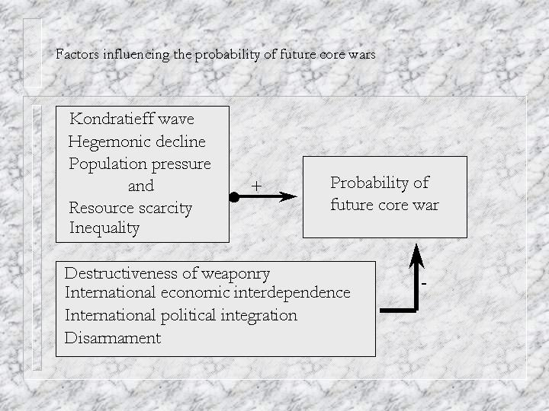

Further Reading
Bornschier, Volker 2008 “Income inequality in the world – looking back and ahead” Presented at the conference on “Inequality Beyond Globalization” organized by the World Society Foundation and the RC02 of the International Sociological Association, University of Neuchatel, June 28, 2008.
Christian, David 2006 Maps of Time. Berkeley; University of California Press.
Danaher, Kevin, Shannon Biggs and Jason Mark 2007 Building the Green Economy. Sausalito, CA: Polipoint Press.
Davis, Mike 2005 Monster At Our Door: The Global Threat of Avian Flu. New York: New Press.
Florini, Ann 2005 The Coming Democracy: New Rules for Running A New World Order.
Washington, DC: Brookings
Heinberg, Richard 2004 Powerdown. Gabriola Island, BC: Island Press.
Johnson, Chalmers A. 2006 Nemesis : the last days of the American Republic. New York: Metropolitan Books.
Markoff, John 1996 Waves of Democracy. Thousand Oaks, CA: Pine Forge Press.
Monbiot, George 2003 Manifesto for a New World Order. New York: New Press
Patomaki, Heikki 2008 The Political Economy of Global Security. London: Routledge
Podobnik, Bruce 2006 Global Energy Shifts. Philadelphia, PA: Temple University Press.
Smith, Jackie 2008 Social Movements for Global Democracy. Baltimore, MD: Johns Hopkins University Press.
Stiglitz, Joseph E. 2002 Globalization and its Discontents. New York: Norton
Wagar, W. Warren 1999. A Short History of the Future, 3rd ed. Chicago: University of Chicago Press.
Ad ref Chalmers Johnson, 2006

The definition we employ is explained and discussed in Chapter 2. “Capitalism is based on the accumulation of profits by the owners of major means of the production of commodities in a context in which labor and the other main elements of production are commodified.”
Karl Marx’s theory of expanded reproduction presented in Volume 1 of Capital proposes such an understanding. Marx defines capitalism as commodity production using wage labor, and so fully developed capitalism only emerges with the English industrial revolution. He sees modern colonialism as precapitalist because coercion is often directly used in the mobilization of labor power (e.g. slavery). World-system theorists have contended that what happened in the periphery was and continues to be essential for what occurs in the core, and peripheral capitalism must be understood as a constitutive and necessary institution that is part and parcel of the structural logic of capitalism. This said, Marx’s pithy portrayal (as translated from the German by Moore and Aveling) of the run-up to industrial capitalism remains one of the most powerful brief renditions of the roots of modernity. The discovery of gold and silver in America, the extirpation, enslavement and entombment in mines of the aboriginal population, the beginning of the conquest and looting of the East Indies, the turning of Africa into a warren for the commercial hunting of black skins, signalised the rosy dawn of the era of capitalist production. These idyllic proceedings are the chief momenta of primitive accumulation. On their heels treads the commercial war of the European nations, with the globe for a theatre. It begins with the revolt of the Netherlands from Spain, assumes giant dimensions in England’s Anti-Jacobin War, and is still going on in the opium wars against China, &c. (Marx 1967: 751). Karl Marx, Capital, Vol. 1, Chapter 21, “Genesis of Industrial Capital” [1887 (1967:751)] Frederic Engels (ed.), translated from the 3rd German edition by Samuel Moore and Edward Aveling. New York: International Publishers
This is likely to be true of future world-system as well, though the form of the power cycle may change.
A core-wide empire has sometimes been called a "universal empire" by world historians such as Arnold Toynbee (1947). Immanuel Wallerstein’s (1974b) distinction between a “world-empire” and a “world-economy” points to this same difference in the degree of centralization of a state system. The term world-empire has sometimes been used to refer to single tributary states such as Sassanid Iran (e.g., Foran 1993), but this is a mistaken usage because all tributary states are involved in trade of basic goods with other regions. Thus they are not whole world-systems but are rather parts of systems.
Earlier examples of colonial empires were the sea-borne imperial enterprises of those maritime semiperipheral capitalist city-states who captured distant political and economic vantage points in order to carry out long distance trade.
. The increased inequality of wealth and income in the United States since the 1980s are in the direction of a Third World-like stratification system, but the remaining differences are still very large.
The contemporary focus on transnational corporate sourcing and the single interdependent global economy is the heightened awareness produced by a trending cycle long in operation.
Immanuel Wallerstein (200x) refers to this phenomenon as “geoculture” and Philip Curtin’s (1984) study of cross-cultural trade and trade diasporas used the term “trade ecumene” for the emergence consensual understandings that allow different cultures to trade directly with one another without the services of an intermediary group (see Chapter 12).
Coded from Henige (1970). Ottoman and Manchu conquests were not included because they were not included in Henige and are not understood to have been products of modern colonialism. Also not included were new colonies created from old colonies, redivisions of existing colonies, and colonial transfers (colonies taken from other powers). The criteria we used to determine when a colony should be included were: it had to be both claimed and settled and it could not have been settled and claimed by another country previously. Territorial expansions were also documented in the data sets. Double counting was avoided. So territories taken from other modern colonial powers were not counted. Temporary settlements of short duration (e.g. Roanoke) were not counted. The idea was to capture the territorial expansion of European colonial sovereignty. ? The definition we employ is explained and discussed in Chapter 2. “Capitalism is based on the accumulation of profits by the owners of major means of the production of commodities in a context in which labor and the other main elements of production are commodified.” ? Karl Marx’s theory of expanded reproduction presented in Volume 1 of Capital proposes such an understanding. Marx defines capitalism as commodity production using wage labor, and so fully developed capitalism only emerges with the English industrial revolution. He sees modern colonialism as precapitalist because coercion is often directly used in the mobilization of labor power (e.g. slavery). World-system theorists have contended that what happened in the periphery was and continues to be essential for what occurs in the core, and peripheral capitalism must be understood as a constitutive and necessary institution that is part and parcel of the structural logic of capitalism. This said, Marx’s pithy portrayal (as translated from the German by Moore and Aveling) of the run-up to industrial capitalism remains one of the most powerful brief renditions of the roots of modernity. The discovery of gold and silver in America, the extirpation, enslavement and entombment in mines of the aboriginal population, the beginning of the conquest and looting of the East Indies, the turning of Africa into a warren for the commercial hunting of black skins, signalised the rosy dawn of the era of capitalist production. These idyllic proceedings are the chief momenta of primitive accumulation. On their heels treads the commercial war of the European nations, with the globe for a theatre. It begins with the revolt of the Netherlands from Spain, assumes giant dimensions in England’s Anti-Jacobin War, and is still going on in the opium wars against China, &c. (Marx 1967: 751). Karl Marx, Capital, Vol. 1, Chapter 21, “Genesis of Industrial Capital” [1887 (1967:751)] Frederic Engels (ed.), translated from the 3rd German edition by Samuel Moore and Edward Aveling. New York: International Publishers ? This is likely to be true of future world-system as well, though the form of the power cycle may change. ? A core-wide empire has sometimes been called a "universal empire" by world historians such as Arnold Toynbee (1947). Immanuel Wallerstein’s (1974b) distinction between a “world-empire” and a “world-economy” points to this same difference in the degree of centralization of a state system. The term world-empire has sometimes been used to refer to single tributary states such as Sassanid Iran (e.g., Foran 1993), but this is a mistaken usage because all tributary states are involved in trade of basic goods with other regions. Thus they are not whole world-systems but are rather parts of systems. ? Earlier examples of colonial empires were the sea-borne imperial enterprises of those maritime semiperipheral capitalist city-states who captured distant political and economic vantage points in order to carry out long distance trade. ?. The increased inequality of wealth and income in the United States since the 1980s are in the direction of a Third World-like stratification system, but the remaining differences are still very large. ? The contemporary focus on transnational corporate sourcing and the single interdependent global economy is the heightened awareness produced by a trending cycle long in operation. ? Coded from Henige (1970). Ottoman and Manchu conquests were not included because they were not included in Henige and are not understood to have been products of modern colonialism. Also not included were new colonies created from old colonies, redivisions of existing colonies, and colonial transfers (colonies taken from other powers). The criteria we used to determine when a colony should be included were: it had to be both claimed and settled and it could not have been settled and claimed by another country previously. Territorial expansions were also documented in the data sets. Double counting was avoided. So territories taken from other modern colonial powers were not counted. Temporary settlements of short duration (e.g. Roanoke) were not counted. The idea was to capture the territorial expansion of European colonial sovereignty.
Queen Victoria (reign =1837-1901) presided over the classical years of the British hegemony.
After Queen Victoria’s death in 1901, King Edward served as the British monarch during the belle époque of the declining years of British hegemony.
In Chapter 2 we defined states, nations and ethnic groups. A nation is simply a group of people who speak the same language and who identify with one another and see themselves as sharing a common history. “The First New Nation” is the title of a book by Seymour Martin Lipset (1963) in which he considers the history and character of the United States in comparative perspective. Lipset wrote the book in 1963 during the last wave of decolonization in which the former colonies of European core powers were becoming sovereign states and were termed “new nations.” Lipset alludes to the fact that the U.S. was the first of the new nations. The term “first nations” is now being used to designate indigenous peoples who have been subjected to colonialism or neo-colonial domination.
Though we shall occasionally use the term “American” to refer to the residents of the U.S.A. we are mindful that all the peoples of the Americas should be included in that term. The alternative, “United Statesian,” is clumsy and so we go along with common usage. The successful often see themselves as the center of the universe.
The establishment of shipbuilding firms and textile factories in New England did not inexorably lead to the rise and triumph of core capitalism, but rather the forces of peripheral capitalism and competing interests in England constantly challenged the very survival of these core producers until the issue was finally settled in the U.S. Civil War.
Hamilton was killed in a duel with Aaron Burr. Dueling remained part of the code of male honor throughout the nineteenth century in all of the countries that were held to be “most civilized.”
As Lord Brougham explained to Parliament in 1816, it was "well worth while to incur a loss upon the first exportation, in order, by the glut, to stifle in the cradle those rising manufactures in the United States, which war had forced into existence, contrary to the natural course of things." (Forsythe, 1977: 69).
14 A clue that led me to Laura Bornholdt’s (1949) article on early Pan-Americanism was a seemingly incongruous statue of Simon Bolivar encountered on walk up Baltimore’s North Charles Street.
15 Part of the Jacksonian coalition involved an agreement to expand at the expense of the American Indians. Jackson's fame as an Indian fighter and his toleration of the abrogation of treaties and removal of Indians from the lands of the South was an early example of the dark side of American democracy.
17 Northern sympathizers called it the Civil War. Southerners called it the War for Southern Independence.
18 This injury and the emerging British superiority in ocean steamships caused the American maritime industry to go into a decline from which it did not recover until the end of the century.
U.S. Department of the Census, Historical Estimates of World Population, http://www.census.gov/ipc/www/worldhis.html
King Edward VII came to the thrown following the death of his mother, Queen Victoria on January 22, 1901.
Rosa Luxemburg’s (1951) theory of capitalist imperialism focused on the “realization problem” – the necessity of selling the produced commodities in order to realize profits. Capitalists try to cut labor costs and substitute machines for human labor, but they must eventually sell their products to workers who increasingly do not have the money to buy the goods. So overproduction and underconsumption crises are a major contradiction that drives capitalism to expand into external systems to find new markets. Lenin and others put more emphasis on the competitive search for cheap raw materials.
Quigley (1981:49) says of Milner and Rhodes “Both sought to unite the world, and above all the English-speaking world, in a federal structure around Britain.” Rhodes’s first will, written in 1877, says “The extension of British rule throughout the world,…the ultimate recovery of the United States of America as an integral part of a British Empire, the consolidation of the whole Empire, the inauguration of a system of Colonial Representation in the Imperial Parliament which may tend to weld together the disjointed members of the Empire, and finally the foundation of so great a power as to hereafter render wars impossible and promote the best interests of humanity” (Quigley 1981:33).
The 1979 movie, Breaker Morant, tells the true story of a Australian Lieutenant serving with the British Army who was tried, convicted and executed before a British firing squad for killing Boer prisoners.
The Spanish flu pandemic that broke out in 1918 and spread world-wide until 1920 is thought to have killed somewhere between 20 million and 100 million people. The rapid spread of this pandemic and many of the deaths were brought about by the squalid conditions of trench warfare on the Western Front.
At one point Rhodes proposed that Britain should become a state within the federal structure of the United States (Quigley 1981:38).
One of the most dramatic illustrations of this is a famous picture of South African trade unionists standing under a banner that proclaims “Workers of the world unite for an all-white South Africa.”
In the Hollywood movie “Reds” (1981) the role of John Reed is played by Warren Beatty.
Marlon Brando starred as the revolutionary leader in the fictionalized 1952 movie, Viva Zapata.
A large part of What Is To Be Done, written in 1901, is devoted to finding a middle path between, on the one hand, the trade unionists who focused on narrowly defined issues of wages and working conditions, and on the other hand, those who advocated acts of terrorism as a revolutionary tactic for bringing down the Czarist regime. Lenin stressed the importance of developing an organized group of professional political agitators who were to serve as the revolutionary leadership of the workers’ movement. This approach has come to be known as vanguardism.
It was easy to organize company towns because the power structure was composed of single hierarchy. See the classic study by Kerr and Siegel (1954) “The interindustry propensity to strike.”
The story of reporter Edward R. Murrow, who stood up to McCarthy, is dramatized in the 2005 movie entitled “Good Night, and Good Luck.”
A communist resistance movement led by Marshal Tito came to state power in Yugoslavia without much help from the Soviet Union. Tito championed the notion that non-Soviet aligned leftist regimes should support one another and resist becoming agents of either the United States or Russia.
The Gross Domestic Product (GDP) of a country estimates the monetary value of all the goods and services that are sold within that country in a single year. The world GDP is the sum of all the country GDPs.
GNP per capita measures also show a similar pattern (Chase-Dunn, Reifer, Jorgenson and Lio 2005).
Recall that we define settlements as a contiguously built-up area. This definition allows for cross-cultural comparisons of settlement sizes because it does not rely on political boundaries or socio-cultural attributes.
Recall the discussion of neocolonialism in Chapter 14
But see Arrighi (2008) for a different view of Adam Smith.
Some population ecologists think that the 6 ½ billion humans that are alive now are already too many for a sustainable relationship with the biosphere.
The U.S. and some other core countries have experienced an increase in within-country inequality since the 1970s, the “great U-turn” and shrinking middle class discussed in Chapter 19.
Russia, in response to the U.S. proposal to build a missile site in Poland, has repeatedly proposed the expansion of NATO (the North Atlantic Treaty Organization) into a Eurasian-wide treaty organization. If this were to happen it would constitute global state formation from a Weberian point of view (the state as the monopoly of legitimate violence).
World Social Forum Charter http://wsf2007.org/process/wsf-charter
The survey and other results are available at http://www.irows.ucr.edu/research/tsmstudy.htm .
In the first edition, published in 1989, the Soviet Union played an important role until 2044. Wagar rewrote the first third of the book after the demise of the Soviet Union, changing the nature of the scenario of the events and structures leading up to the World War, which acts as the deus ex machina that makes the ascendance of the World Party and a global democratic socialist government possible. Writing the future is always a dicey business.

