Appendix:
Evidence for the Classification of 22 Polity Upsweeps with regard to status as non-Core marcher states
v. 3-27-2015
http://irows.ucr.edu/cd/appendices/semipmarchers/semipmarchersapp.htm
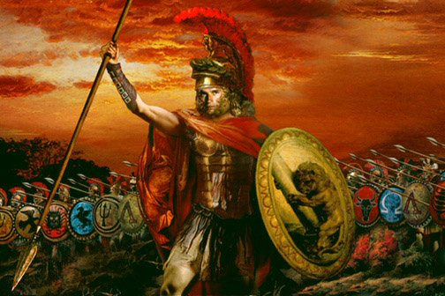
Table of Contents
- Introduction
- List of Polity Upsweeps
- Mesopotamia
- Lagash
- Akkadia
- Mitani
- Egypt
- 5th dynasty
- 12th dynasty
- Hyksos
- Central System
- 18th dynasty
- Assyria
- Achaemenid Persia
- Rome
- Islamic empires
- Mongol/Yuan
- Britain
- East Asia
- Shang/Western Zhou
    - Shang
    - Western Zhou
  - Qin, Xiongnu, and Western Han
    - Qin
    - Xiangnu
    - Western Han
- Eastern Han
- Eastern Turk
- Sui-Tang
- Mongol/Yuan
- Qing
- South Asia
- Mauryan
Introduction
For each of the territorial upsweeps in the five political-military networks we are studying we include a description of the evidence that is relevant regarding whether or not the polity or polities that carried out the upsweep were semiperipheral or peripheral marcher states. This involves determining the world-system position of the polity in the centuries before it carried out the territorial upsweep. Our definition of non-core marcher states and of empirical indicators of world-system position are contained in the main paper. Here we summarize the relevant scholarly literature to determine what kinds of evidence might exist that is relevant to the determination we are trying to make
One problem we encounter is that, because semiperipherality is a relational concept, the determination of whether or not a particular polity was semiperipheral or not depends on the nature of institutionalized power in the core/periphery structures that existed in the particular world-systems of which that polity is a part. Matters are also complicated by the fact that polities often exist in a context in which they are interacting with more than one core region and so their position relative to these two core regions may be different. We try to address these issues in the summaries that follow.
List of Polity Upsweeps
Mesopotamia 2800 BCE to 1500 BCE
Year | Size | Polity name
-2400 | 0.05 | Lagash
-2250 | 0.8 | Akkadia
-1450 | 0.3 | Mitanni

Egypt 2850 BCE to 1500 BCE
Year | Size | Polity name
-2400 | 0.4 | 5th Dynasty
-1850 | 0.5 | 12th Dynasty
-1650 | 0.65 | Hyksos

Central PMN 1500 BCE to 1991AD
Year | Size | Polity name(s)
-1450 | 1 | 18th Dynasty
-670 | 1.4 | Neo-Assyrian
-480 | 5.4 | Achaemenid Persia
117 | ‘5 | Rome
750 | 11.1 | Islamic Empires
1294 | 29.4 | Mongol-Yuan
1936 | 34.5 | Britain

East Asia 1300 BCE to 1830 AD
Year | Size | Polity name(s)
-1050 | 1.25 | Shang/Western Zhou (Chou)*
-176 | 4.03 | Qin/Western Han/Xiongnu *
-50 | 6 | Western Han
100 | 6.5 | Eastern (Later) Han
624 | 4 | E. Turks
660 | 4.9 | Sui-Tang
1294 | 29.4 | Mongol-Yuan
1790 | 14.7 | Qing

South Asia 420 BCE to 1008 AD
Year | Size | Polity name
-260 | 3.72 | Mauryan
* If there is more than one polity name and the names are separated by a / this means that the upsweep in territorial size is a composite upsweep involving more than one polity. In order to be counted as a part of an upsweep a polity must attain a size that is larger than the earlier peak size of polities.
Mesopotamia: 2800 BCE to 1500 BCE

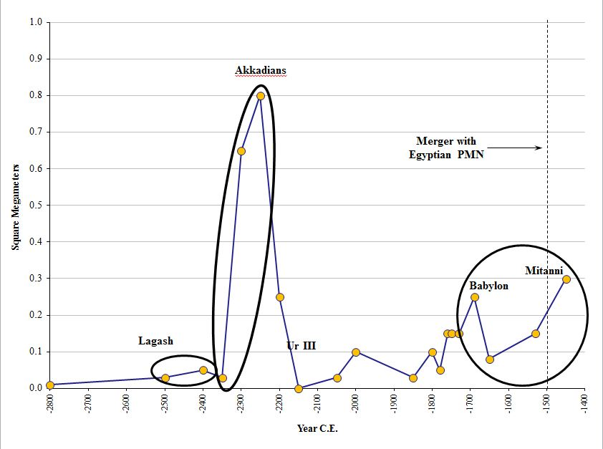

Lagash
Lagash was in southern Mesopotamia west of Uruk, south of Kish, and east of Susa. The city-state of Lagash was made up of two towns, Lagash (Tell al-Hiba) and Girsu (Tellow) (Yoffee 2006:57). The main language of Lagash was Sumerian. Lagash dates from somewhere in the third millennium BCE, about a millennium after Susa and Uruk. Lagash was involved in a struggle for control of the region with other city-states. Flannery calls it “subordinate” to Kish before the area was unified (see below).
Table: Estimated Lagash Polity Sizes
Polity | Date | Location | Approximate Size | Estimated  Population | Type | Source
Lagash  (al-Hiba) | Third mill. | Eastern alluvium, S. Mesopotamia | Around 600 hectares |  |  | Algaze (2005:143)
Lagash | 2500 BCE | Southern Mesopotamia | 3200 sq kilometers | 105,000 | Third generation regional state | Wright (2006: 15-16)
Lagash  includes:  Tell al Hiba  Tello (Girsu) | 2500-2000 | Southern Mesopotamia | 3000 sq km  4 sq km  80 hectares | 120,000  75,000  15,000 | City-State | Table in Yoffee (2006:43)
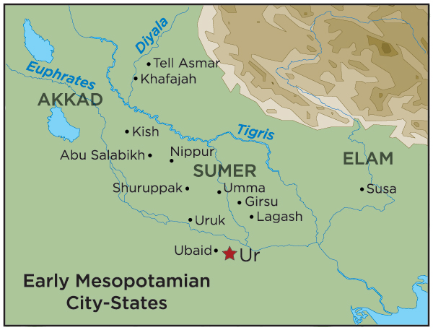

The city of Lagash (Tell al-Hiba) was the largest city in the region in the mid-third millennium. It’s areal size is estimated at 400 hectares, with a population estimated at 75,000 (Yoffee 2006: 43, 57). With regard to polity size, the city-state of Lagash became the largest in the region once it had unified the area in the mid-third millennium. Its territorial size has been estimated at more than 3000 km², with 120,000 estimated population (Yoffee 2006: 43, 57; see also Marcus 1998: 80-81).
The consensus of several scholars is that Lagash was part of a number of city-states that were going through periods of unification and independence from each other during the period before and after the Akkadian empire. Marcus (1998:86) states that "Strong rulers fought incessantly to incorporate their neighbors into a larger polity; weak rulers did whatever they could to retain their autonomy. It might be more accurate to describe such periods as consisting of relentless attempts to create larger polities by alliance or conquest..."
A ruler named Eanatum became King of both Lagash and Kish. Eanatum [elsewhere spelled Eannatum] was the grandson of the first king of Lagash, Ur-Nanshe. Eanatum conquered all of southern Mesopotamia, including Uruk, made Umma pay tribute, and also conquered Elam. Flannery (1998:20) states that Lagash “shows a cyclic ‘rise and fall’ and uses the word "subordinate" to describe Lagash in relation to the pre-Sargon city-state of Kish: “Lagash was for a time subordinate to Mesalim of Kish,” and then it "rose to prominence under a ruler named Eanatum, who assumed the kingship of both Lagash and Kish.”
It would appear that Lagash was in the core region of Mesopotamian city-states. in about -2400. Eannatum, grandson of Ur-Nanshe, was a king of Lagash who conquered all of Sumer, including Ur, Nippur, Akshak (controlled by Zuzu), Larsa, and Uruk (controlled by Enshakushanna, who is on the King List). He also annexed the kingdom of Kish, which regained its independence after his death. He made Umma a tributary, where every person had to pay a certain amount of grain into the treasury of the goddess Nina and the god Ingurisa after personally commanding an army to subjugate the city. Eannatum expanded his influence beyond the boundaries of Sumer. He conquered parts of Elam, including the city Az on the Persian Gulf, allegedly smote Shubur, and demanded tribute as far as Mari. However, often parts of his empire were revolting.
In c.2450 BC, Lagash and the neighboring city of Umma fell out with each other after a border dispute. As described in Stele of the Vultures the current king of Lagash, Eannatum, inspired by the patron god of his city, Ningirsu, set out with his army to defeat the nearby city. Initial details of the battle are unclear, but the Stele is able to portray a few vague details about the event. According the Stele's engravings, when the two sides met each other in the field, Eannatum dismounted from his chariot and proceeded to lead his men on foot. After lowering their spears, the Lagash army advanced upon the army from Umma in a dense Phalanx. After a brief clash, Eannatum and his army had gained victory over the army of Umma. Despite having been struck in the eye by an arrow, the king of Lagash lived on to enjoy his army's victory.
From 2600-2400 BCE Lagash was a city-state of major importance in the Sumerian confederation even though its priest-kings were not mentioned in Sumerian king lists. It is known for major artworks and the construction of a significant irrigation system. It was on a major trade route. When it was later sacked by Sargon during the Akkadian upswing, it survived and later revived. Its commercial and military reach included Syria, Arabia, and Fars. It was probably not a SMS because it was not a border state, but a part of the Sumerian core. It was able to revive after conquest and had staying power due to its success as a trade and information hub. Except under King Gudea in the post-Akkadian revival when Anshan (in Fars) was conquered, Lagash did not consistently try to expand its territory. Before its upsweep that peaked in 2400 BCE it is best characterized as a provincial commercial city-state that was interdependent with the other Sumerian core states. It was long able to survive through commercial activity and defensive protection within the greater Mesopotamian PMN, despite being conquered by Akkadian, Seleucid and Parthian empires. The important point about Lagash is that it thrived after conquest when other Sumerian city-states did not. This implies that it was successfully following a method of sustainability based on commercial trade, agricultural economy and religion, and this may also have been the basis of its early upsweep.
Eanatum’s grandfather was Ur-Nanshe, the first king of the First Dynasty of Lagash in the Sumerian Early Dynastic Period III. Ur-Nanshe was probably not of royal lineage, since in his inscriptions he refers to his father as one Gunidu without an accompanying royal title. The fact that the name does appear in offering lists from the time of the later kings Lugalanda and Uruinimgina suggests that Gunidu nevertheless held an important, possibly religious, office in Lagash. The notion that Lagash was subordinate to Kish before the rise of Eanatum, and the possibility that
Eanatum’s family was not a royal lineage before the rise of his grandfather Ur-Nanshe to kingship might suggest the possibility that Lagash was semiperipheral vis-à-vis the other polities in Mesopotamia before Eanatum’s conquest. But these are slender reeds, and we prefer to conclude that there is not enough evidence in the case of Lagash one way or the other.

References:
Algaze, Guillermo. 2005. The Uruk World System: The Dynamics of Expansion of Early Mesopotamian Civilization, 2nd Ed. Chicago, IL: University of Chicago Press.
Beaujard, Philippe. 2012. Les mondes de l’Océan Indean, tome 1: De la formation de l’état au premier système-
monde afro-eurasien. Paris: Armand Colin.
Cuneiform Digital Library Initiative, Faculty of Oriental Studies, University of Oxford,
http://cdli.ox.ac.uk/wiki/doku.php?id=ur-nanshe
Cooper, Jerrold S. 1983 “Reconstructing history from ancient inscriptions: the Lagash-Umma
border conflict” Sources from the Ancient Near East 2,1; Malibu, CA: Undena Publications.
Flannery, Kent V. 1998. “The Ground Plans of Archaic States.” Pp. 15-57 in Archaic States, Gary M. Feinman and Joyce Marcus, eds. Santa Fe, NM: School of American Research Press.
Frayne, Douglas R. 2008 “Presargonic period : 2700-2350 BC” Toronto : University of Toronto
Press
Marcus, Joyce. 1988. “The Peaks and Valleys of Ancient States: An Extension of the Dynamic Model.” Pp. 59-94 in Archaic States, Gary M. Feinman and Joyce Marcus, eds. Santa Fe, NM: School of American Research Press.
Wright, Henry T. 2006. “Atlas of Chiefdoms and Early States.” Structure and Dynamics: eJournal of Anthropological and Related Sciences 1(4): 1-17 Avail: http://repositories.cdlib.org/imbs/socdyn/sdeas/vol1/iss4/art1
Yoffee, Norman. 2006. Myths of the Archaic State: Evolution of the Earliest Cities, States, and Civilizations. New York: Cambridge University Press.
Akkadian Empire
Recent scholarship on the origins of the Akkadian Empire in Mesopotamia (ca 2350 BCE) has not differed much from the earlier, and in part, speculative positions held by the preeminent authors (e.g., Algaze, Liverani, Weiss, and Yoffee). There are two major reasons for this relative stasis: 1) the decades-long U.S. and Iraq conflict limited archaeological research, and may have destroyed unknown artifacts; and 2) the limited amount of written documentation from the period, and the difficulty in separating historical fact from myth and/or propaganda.
It is therefore not necessary to revise the position taken by Chase-Dunn et al in 2006 – the Akkadian upward sweep may have been initiated and/or facilitated by an ethnic revolt of the Semitic-speaking people against the Sumerian-speakers. The scholars essentially agree that the Akkadians had been pastoralists from the Arabian desert who migrated into the Mesopotamian region in waves, probably climate-induced or influenced (Weiss et al , around the 3rd millennium. They settled in central Mesopotamia (around the city of Kish) and in northern Mesopotamia (present day Syria) but they also inhabited the southern section where the Sumerians were the majority. Liverani (2006) describes an ethnocentrism held by the “urban” Sumerians against the “nomadic” peoples, enflamed by fear of attack and migration from the latter. Yoffee (2005), taking a more sanguine view, asserting that the ethno-linguistic differences were not sources of serious conflict. The historical record is unclear on how much conflict, if any, existed between the two groups at the time of the Akkadian upward sweep, and it must be noted that over half a millennium had passed since the major Semitic migration into the region.
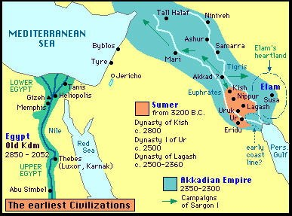
Map Source: https://dianabuja.wordpress.com/2011/11/04/climate-change-and-the-origins-of-agriculture-and-complex-societies/
The Semitic pastoralists had probably been peripheral in the Mesopotamian world-system prior to their settlement in the 3rd Millennium. The area they settled in, centered around the city of Kish, was semi-peripheral to the Uruk-based southern regional core, although that hegemony was largely replaced by internecine city-state conflict and then a measure of unification under Lugalzagesi in the south just prior to Sargon’s conquest of the area. Kish was an important trade node between the southern and northern areas (Steinkeller 1993) and was also one of the sites that was granted divine kinship after the mythical flood. So it is not incorrect to say that the Akkadian Empire was an example of the rise of a semiperipheral marcher state. But the Semitic people didn’t simply ride into the area and vanquish the core. Instead, they settled in the area in waves over centuries and likely seized the opportunity to take control of a major, but semiperipheral city-state when the advantage became theirs. It seems possible that Sargon may have become King of Kish by coup d’etat. The story of his ascent to power in the city is shrouded in a legend in which Sargon, of meager beginnings and then a cupbearer to the king Ur-Zababa, was a usurper to the throne amidst a power struggle and possibly an assassination attempt on his life by the king (Chevalas 2006: 84, 167; Cooper 1993: 18; Levin 2002). Powerlessness/subordination against the temple ruling elite may have been a factor as “a kind of revenge of those kin-based elites that had been set aside by the impersonal administration of the temple institution” (Liverani 2006: 75). Yoffee, by contrast, states that “Sargon forged the first pan-Mesopotamian state…having begun his ascent to power from the venerable city of Kish (which he had conquered)…[italics are mine] (Yoffee 2006: 142).
There is general agreement that the Akkadian Empire was more militant and territorially expansive than the city-states they conquered had been. Mann’s (1986) contention that advanced military technology was an important factor in the Akkadian rise was also mentioned by the Russian Assyriologist, Igor Diakonoff (1973).
Mesopotamia was an unbounded geographic area, but is in the Tigris and Euphrates alluvium, and can be divided into northern, central, and southern regions, or upper and lower. The north consisted of the area in the Habur Plains in what is now Syria, the center was in central Iraq, the south near the Persian Gulf (Figure 1). Southern Mesopotamia in the latter part of the Early Dynastic period, ca. 2500-2350 BCE, was composed of multiple independent city-states each with their own capital and a hinterland of smaller population centers. Central Mesopotamia, by contrast, “formed a single territorial state or, perhaps more accurately, a single political configuration” (Steinkeller 1993: 117). The largest cities in each area were Tell Leilan in the north, Kish in the center, and Uruk in the south (Table 1). Kish was the center of a commercial network linking Upper and Lower Mesopotamia and was the defacto capital of central Mesopotamia (Steinkeller 1993). The central and southern city-states were engaged in regular internecine conflict over access to arable land and trade routes. While a degree of cultural unity existed across Mesopotamia, there was not a single unified political system under central control until the Akkadian Empire was formed in the late third millennium BCE (Yoffee 2006: 56-57).
According to Algaze (2005), prior to the Akkadian system, Mesopotamia had a world-system, a “complex, albeit loosely integrated, supraregional interaction system” (p. 5) broken into competing regions, centered in southern Mesopotamia (the largest settlements, population density, complexity), in the Tigris and Euphrates alluvium, in the Uruk period (4th millennium BCE). The Sumerian speaking people of the southern system colonized the Susiana plain in SW Iran and the SW Syrian plateau, to take advantage of abundant resources. Uruk enclaves and outposts were established at key points in the periphery of the S. Mespotamia Uruk system. Evidence exists for interaction/integration from similar pottery and other artifacts. The Susiana plain had some large settlements, Susa (25 ha) and Chogha Mish (18 ha), that “developed in ways that were increasingly analogous to those of the alluvial lowlands of southern Iraq (p. 11). But the Susiana plain seems to have been politically independent of the SW Iraq system, and Susa and Chogha Mish politically independent of each other. By the end of the Uruk period, Chogha Mish had collapsed and Susa had a significant population reduction (p.18). In Syro-Mesopotamia, Tell Brak was very large in the Late Chalcolithic period, at least 65 hectares, up to 160 if you include the surrounding settlements (p. 138). Algaze (p.142) notes that the Late Chalcolithic period system was only a second-order level of complexity – large center surrounded by small village/hamlets. Tell al-Hawa is similar, both with less complexity than the southern Mesopotamia system in the same period (Middle Uruk in south). Three-tier settlement systems appear in the north only after contact with Uruk societies. Algaze notes that Warka, what I think must also called Warku, was four times larger than the second-tier of settlements, violating “Zipf’s Law” that states urban populations are ranked in tiers with each one double the size of the next (2005:141). Umma, and a site nearby called Umm al-Aqarib, both in S. Mesopotamia alluvium, are still being excavated, but Algaze thinks they will be the “missing” second-tier of settlements adhering to Zipf’s Law (see #14 above). The estimate of 120 hectares is based on that formula, not on excavations. Tablets found in the sites proclaim the economic importance of Umma in the Late Uruk period, generating Algaze’s belief it may be second only to Warka in importance to the southern system (p.141).
But the competing city-states that emerged across S. Mesopotamia in the mid-to late 4th millennium “was the first time that the southern polities, both singly and in the aggregate, surpassed contemporary societies elsewhere in southwest Asia in terms of their scale and degree of internal differentiation, both social and economic” (Algaze 2005: ix). The fertility of the soil, water transport, technology of accounting and writing systems were all advantages the southern alluvium held over the peripheral areas (pp.147-149). It was during this time that societies in the alluvium engaged in “an intense process of expansion…[that] may be considered to represent the earliest well-attested example of the cyclical ‘momentum toward empire’” (Algaze 2005: 6). Algaze states that the Uruk Expansion in the 4th millennium could be the “Mesopotamia’s—and the world’s—first imperial venture” and “whether or not the Uruk phenomenon as Mespotamia’s first empire, it certainly was the world’s earliest ‘world system’(p. 145). Stein disagrees, providing a “distance-parity” model that argues that premodern control over socities drops off with distance due to transportation (p.146) The Uruk sites in the periphery were “gateways” located at nodes along exchange networks between core and periphery, raw materials or semiprocessed commodities from the periphery in exchange for fully processed goods from the core, to the benefit of the core (145). By world system, he means an assymetrical economic interaction across societies of varying complexity, DOL, technology, social control, administration (defn 145). The southern system also had settlements that were close enough in distance to facilitate daily contact, and cultural sharing, unlike the settlements on the Syro-Mesopotamian Plains (p.142). As the southern system rose, the northern fell, by the transition from the 4th to 3rd millennium the northern settlements had effectively disappeared and would not reappear until the second quarter of the third millennium. Warka reached 600 hectares at this time, and Al-Hiba in the eastern edge of the alluvium almost as large (p. 143).
The Akkadian Empire originated in the city of Kish in central Mesopotamia in the late 24th century BCE. It was created by Semitic-speaking people, growing through conquest to include Sumerian-speaking areas. There were differences between the social organization of the Semitic-speaking people that formed the Akkadian Empire in the center of the region and the Sumerian-speakers in the south. The Semites came from the Arabian desert, and were distinguished by their pastoral mode of production, kinship-based property structure, and tribal political organization, and settled mostly in the valley. The Sumerians, in contrast, lived in the delta, practiced irrigated agriculture, had a collective structure for labor and property, in a temple-guided system (Liverani 1993; Steinkeller 1993).
But the Semites did not migrate to the area and immediately conquer the existing system; instead, they had settled in Mesopotamia “well before Sargon [the first leader of the Akkadian Empire], since the beginning of the onomastic and linguistic documentation (Liverani 1993: 2-3). Steinkeller contends that around the beginning of the 3rd millennium BCE, the end of Uruk IV and through the Uruk III period [3300-2900 BCE], “there occurred, probably in several waves and over an extended period of time, a major intrusion of Semitic peoples into Syria and Upper Mesopotamia. One of these peoples, probably the ancestors of the Akkadians, migrated into the Diyala Region and northern Babylonia, eventually settling there and adopting the urban mode of life.” This immigration of Semitic people effectively ended the Uruk presence in the area as Semitic institutions were dominant during the Early Dynastic period [29th century BCE] (1993: 115-116).
The reason for the migration of the Semitic pastoralists from the desert is unclear, but follows a pattern of urbanization that occurred in the region during the 3rd millennium. It could have been caused by a changing climate as the region experienced severe aridity and century-long droughts that accelerating beginning around 3500 BCE, with a minimum of rainfall from 3200-2900 BCE and desertification of the Habur plains between 2200 and 1900 BCE. (Algaze 2001; Brooks 2006: 38; Fagan 2004; Weiss et al. 1993).
There is some evidence to suggest that the possibility that Semitic people were part of the Mesopotamian world-system prior to the beginning of the third millennium BCE. There was extensive Uruk colonization during the Late Uruk period throughout the area, including the area near to where the Semitic people migrated from, established at least in part to facilitate material exchange, particularly as a means to acquire prestige goods for elites (Algaze 2001; Liverani 2006; Weiss and Courty 1993: 132). For Algaze (2001), the Uruk informal empire was large and asymmetrical, but this seems to be a minority viewpoint (Rothman 2001). Steinkeller (1993) disagrees with the intensity and reach of Uruk control, but he does contend that control over some areas was likely. Steinkeller also speculates that the Diyala area in which the Semitic people had settled was included in the Kish-based kingdom during the Early Dynastic period (1993: 119-120). But there is little evidence documenting the type of relationship that involved the Semitic pastoralists prior to their movement into the region, and it is unclear what resources they controlled, beyond sheep, that were valued by the core of the Mesopotamian system. Once they settled in the region, however, they were most likely in a semi-peripheral or peripheral position. Although Steinkeller’s assertion that “we have convincing evidence that the institutions of chattel slavery and villeinage had been known in northern Babylonia” during this period, there is no indication that Semitic people were involved (1993: 121).
There is also little documentation regarding their ascent to power once they arrived, beyond the story of Sargon, the originator and first leader of the Akkadian Empire, that is. Sargon’s tale is shrouded in legend and myth, some of which was created by his own administration or written centuries later. Scholars generally agree that Sargon came from the area around the city of Kish in central Mesopotamia. Kish was a city-state that formed upon the “merger” of independent villages, with an approximate size of 5.5km² and a population of 60,000 during the second half of the 3rd millennium (Yoffee 2006: 43, 57). Sargon was of relatively meager beginnings and rose through the administration in the city of Kish. (Legend has Sargon as cupbearer to the king of Kish, Ur-Zababa) (Chevalas 2006: 84, 167, Levin 2002). Not being part of the royal family whose authority was divine, Sargon became king of Kish as a usurper to the throne, but how he took power is unspecified, although legend reveals a struggle for power between the king and the aspirant, and possibly an assassination attempt on Sargon by the Ur-Zababa, as told in the legend “Curse of Akkad” (Cooper 1993: 18; Levin 2002). (Liverani (2004: 96) notes that most protagonists in tales from this time period were usurpers, rising to power outside of the normal route and coming from modest backgrounds). Powerlessness against the temple ruling elite may have been a factor as “a kind of revenge of those kin-based elites that had been set aside by the impersonal administration of the temple institution” (Liverani 2006: 75). Yoffee, by contrast, states that “Sargon forged the first pan-Mesopotamian state…having begun his ascent to power from the venerable city of Kish (which he had conquered)…[italics are mine] (Yoffee 2006: 142).
Having taken the city of Kish, Sargon—his taken name, meaning “True King”—conquered the southern Mesopotamian region that had been unified under Lugal-zagesi, the king of Umma who, around 2300 BCE, had gained hegemony by force or coalition building over the cities of Uruk, Ur, Umma, and Lagash (Steinkeller 1993). Sargon then went north, conquering Mari, Ebla, Ashur, and Nineveh, and pushing into Anatolia and the Mediterranean (Levin 2002). He may have had a standing army of around 5400 people (Van De Mieroop 2007: 64).
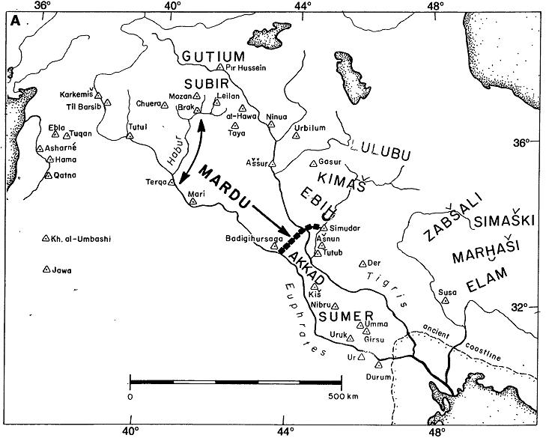
Figure 1: Syro-Mesopotamia, 2600 to 2000 BCE. (Arrows indicate tribal pastoralist Amorite seasonal north-south transhumance before their movement down the Euphrates and the Tigris. The Repeller of the Amorites wall of fortresses was constructed from about 2054 to 2030 BCE from Badigihursaga to Simudar to control Amorite infiltration.) Source: Weiss et al. 1993b
Sargon moved his capital from the city of Kish to Akkad (also Agade) (location unknown) and proclaimed himself “King of Sumer and Akkad,” adding this to his previous title “King of Kish.” (King of Kish meant a divinely authorized ruler over all of Sumer and was distinct from the kingship of the city of Kish, although the city of Kish was one of the cities where kingship was lowered from heaven after the flood, according to the Sumerian King List). This title came to mean “king of everything,” changing to “King of the Four Corners of the Universe” during Sargon’s grandson Naram-Sin (Michalowski 1993: 88). Sargon was Semitic and adapted the Sumerian cuneiform script to his language, which became known as Akkadian (Levin 2002). Steinkeller (1993) contends that the central Mesopotamian region was a distinct cultural entity, Akkadian, differing from the south that was Sumerian, but Yoffee (1998, 2001) disagrees, seeing much integration of people as well as Akkadian being the official administrative language of the entire region. Liverani (1993) attributes the claims of ethno-linguistic conflicts to an earlier historical tradition, and minimizes their impact, stating that “the ethnic factor had a limited and indirect relevance on the organization of states, on their politics and mutual relationships” (p. 2).
But there was clearly ethnic disdain in the region between the people of the core and periphery. Liverani (2006) is worth quoting at length:
The most recurrent [mental maps] are those that contrast nomads to the sedentary people and the alluvium to the mountains. The pastoral people of the steppe (the Martu) and of the mountains (the Guti) are characterized by the very absence of the most basic traits of urban culture. They have no houses, they have not tombs, they do not know agriculture, and they do not know the rites of the cult. It is an ethnocentric vision that aims to strengthen the self-esteem of those living in a world that is culturally superior, but that is potentially threatened by the insistent and violent pressures of foreign peoples. (P. 65)
The core also clearly desired resources from the periphery, such as wood, metal, and stone, that were not available in the alluvium (ibid, 65-66).
Liverani points out that recent scholars contend that the Akkadian empire was not the first empire, that distinction could be applied to Uruk or Ebla in the Sumerian south prior to the Akkadian emergence. But “the originality of Akkad would consist in a “heroic” and warring kingship, quite different from the Sumerian idea of the ensi who administered in the god’s name the large farm that was the city-state” (1993: 4, see also Nissen 1993). Indeed, “for the first time, the power basis was created for large military actions against neighboring areas” (Nissen 1993: 97).

Table 1: Estimated Mesopotamia City Sizes
City Name | Period | Area | Land | Population | Source
Tell Leilan | mid 6th-2nd Millennium | North | 75-100 hectares max |  | Weiss et al. 1993
Uruk | 3200 BCE | South | 250 ha | 20,000 | Yoffee 2006
Kish | 2500-2000 BCE | Central | 550 ha | 60,000 | Yoffee 2006
Lagash (Tell al-Hiba) | 2500-2000 BCE | South | 400 ha | 75,000 | Yoffee  2006

References:
Algaze, Guillermo. 2001. “The Prehistory of Imperialism: The Case of Uruk Period Mesopotamia.” Pp. 27-83 in Uruk Mesopotamia & Its Neighbors: Cross-Cultural Interactions in the Era of State Formation, edited by M. S. Rothman. Santa Fe, NM: School of American Research Press.
______. 2005. The Uruk World System: The Dynamics of Expansion of Early Mesopotamian Civilization, 2nd Ed. Chicago, IL: University of Chicago Press.
Brooks, Nick. 2006. “Cultural Responses to Aridity in the Middle Holocene and Increased Social Complexity.” Quaternary International 151: 29-49.
Chavalas, ed. 2006. The Ancient Near East: Historical Sources in Translation.
Cooper, Jerrold S. 1993. “Paradigm and Propoganda: The Dynasty of Akkade in the 21st Century.” Pp. 11-23 in in Akkad, The First World Empire: Structure, Ideology, Traditions, edited by M. Liverani. Padova, Italy: Tipografia Poligrafica Moderna.
Diakonoff, Igor M. 1973. "The Rise of the Despotic State in Ancient Mesopotamia." Pp. 173-203 in I. M. Diakonoff (ed.) Ancient Mesopotamia, edited by I. M. Diakonoff, trans by G. M. Sergheyev Walluf bei Weisbaden: Dr. Martin Sandig.
Fagan, Brian. 2004. The Long Summer: How Climate Changed Civilization. New York: Basic Books.
Liverani, Mario. 1993. “Introduction.” Pp. 1-10 in Akkad, The First World Empire: Structure, Ideology, Traditions, edited by M. Liverani. Padova, Italy: Tipografia Poligrafica Moderna.
______. 2004. Myths and Politics in Ancient Near Eastern Historiography, edited and introduced by Zainab Bahrani and Marc Van De Mieroop. Ithaca, NY: Cornell University Press.
______. 2006. Uruk: The First City, edited and translated by Z. Bahrani and M. Van De Mieroop. London: Equinox.
Michalowski, Piotr. “Memory and Deed: The Historiography of the Political Expansion of the Akkad State.” Pp. 69-90 in Akkad, The First World Empire: Structure, Ideology, Traditions, edited by M. Liverani. Padova, Italy: Tipografia Poligrafica Moderna.
Nissen, Hans J. 1993. “Settlement Patterns and Material Culture of the Akkadian Period: Continuity and Discontinuity.” Pp. 91-106 in Akkad, The First World Empire: Structure, Ideology, Traditions, edited by M. Liverani. Padova, Italy: Tipografia Poligrafica Moderna.
Rothman, Mitchell S. 2001. “The Local and the Regional: An Introduction.” Pp. 3-26 in Uruk Mesopotamia & Its Neighbors: Cross-Cultural Interactions in the Era of State Formation, edited by M. S. Rothman. Santa Fe, NM: School of American Research Press.
Steinkeller, Piotr. 1993. “Early Political Developments in Mesopotamia and the Origins of the Sargonic Empire.” Pp. 107-129 in Akkad, The First World Empire: Structure, Ideology, Traditions, edited by M. Liverani. Padova, Italy: Tipografia Poligrafica Moderna.
Van De Mieroop. 2007. A History of the Ancient Near East, ca. 3000-323 BC. 2nd Edition. Blackwell.
Yoffee, Norman. 1979. “The Decline and Rise of Mesopotamian Civilization: An Ethnoarchaeological Perspective on the Evolution of Social Complexity.” American Antiquity 44(1): 5-35.
______. 1998. The Collapse of Ancient Mesopotamian States and Civilization. Pp. 44-68 in The Collapse of Ancient States and Civilizations, edited by Norman Yoffee and George L. Cowgill. Tucson, AZ: University of Arizona Press.
______. 2006. Myths of the Archaic State: Evolution of the Earliest Cities, States, and Civilizations. New York: Cambridge University Press.
Weiss, Harvey and Marie-Agnès Courty. 1993a. “The Genesis and Collapse of the Akkadian Empire: The Accidental Refraction of Historical Law.” Pp. 131-155 in Akkad, The First World Empire: Structure, Ideology, Traditions, edited by M. Liverani. Padova, Italy: Tipografia Poligrafica Moderna.
Weiss, H., M.-A Courty, W. Wetterstrom, F. Guichard, L. Senior, R. Meadow, and A. Curnow. 1993b. “The Genesis and Collapse of Third Millennium North Mesopotamian Civilization.” Science 261(5124): 995-1004.
Mitanni
The Mitanni occupied the area of the northern Euphrates steppe between the Euphrates and Tigris, an area the Assyrians called Hanigalbar. Its capital, Washukkanni, lay at the head of the Khabur River. The origins of the Mitanni are uncertain but seem closely related to the history of the Hurrians. The Hurrians appear to have been a people given to migration or clan travel. The archaeological records suggest that the Hurrians formed in Sumer small groups of immigrants comparable to Armenians in modern Iraq. There is evidence that colonies of Hurrians had been extant in various parts of Mesopotamia for millennia. The Hurrians inflated their numbers in the Syrian town of Alalah and formed the majority of population in 1800 B.C. It was probably around this time that a warrior caste of Aryan (Indo-Iranian) dynasts came to impose themselves on the Hurrian people and become a new aristocracy in command of war and government. We do not know when and how the Indo-Aryans came to be mixed with the Hurrians and took control over them, but there is little doubt that, at least during the fifteenth and fourteenth centuries B.C., they were settled among them as a leading aristocracy. The names of several Mitannian kings, such as Mattiwaza and Tushratta, and the term mariannu, which is applied to a category of warriors, are most probably of Indo-European origin. Moreover, in a treaty between Mitannians and Hittites, the gods Mitrasil, Arunasil, Indar and Nasattyana – which are, of course, the well-known Aryan gods Mithra, Varuna, Indra and the Nasatyas – are invoked side by side with Theshup (Hurrian god of sky and storm) and Hepa (mother goddess).
The Hurrians became dominant in northern Syria. By 1550 B.C.E. Hittite texts report a major Hurrian-based kingdom, known as the Mitanni, having come into being east of the Euphrates and having become a major competitor to Hittite and Egyptian influence in Syria.
The kingdom of Mitanni had formulated when the Hittite king Mursili conquered the Kingdom of Aleppo in approximately 1530 B.C.E. and left a power vacuum in the northern Syria. Because Assyrian kings were weak and Mursili of the Hittite was assassinated by Hantili who took the throne after he returned to his kingdom, Mitanni had an opportunity to fill the vacuum which these successes had created. The Hurrian kingdom was powerful enough to hold in check the Assyrians in the east, the Hittites and Egyptians in the west.
Starting from the king Parattarna, Mitanni expanded the kingdom west to Aleppo, north-east to Carchemish and south-west to Nuzi.. The political structure of the Mitanni was probably a Mitanni innovation superimposed on the old Hurrian social order and seems to have been imposed on Mitanni’s vassal states as well, turning them into provinces whose governance and military administration were directed from the center.
There are two assumptions about Mitanni’s success and its character as a semi-peripheral marcher state. First, they seem to have imposed themselves peacefully and to have adopted the culture of the land into which they entered. Their main contribution seems to have been the introduction of a new form of political and social organization that was more effective at mobilizing and employing resources for war. The pattern was a familiar one among Indo-Aryans, namely strong king drawn from a “great family” tied by blood to his vassals, who acted as a council of advisors. The Mitanni system was similar to the Hittite whose origins are also obscure and who superimposed a new caste on the then extant Hattian society.
Second, the Mitanni were the first to use the military technology of horse with the spoked-wheel chariot as a primary combat vehicle. The spoked-wheel war chariot made its first appearance among the Mitanni sometime soon after their arrival in the Hurrian land circa 1600 B.C.E. The validity of this claim can be deduced from the Hittite texts of this time that recount the story of Kikkui of the Land of the Mitanni, who was hired by the Hittite king to instruct his army in the breeding and use of the horses.
References:
Bromiley, Geoffrey W. 1995. International Standard Bible Encyclopedia: E-J. Grand Rapids, MI: William B. Eerdmans Publishing Co.
Bryce, Trevor. 1998. The Kingdom of the Hittites. New York: Oxford University Press.
Garbriel, Richard A. 2007. The Ancient World. Westport, Connecticut: Greenwood Press
Novak, Mirko. 2007 “Mitani Empire and the Qeustion of Absolute Chronology: Some Archaelogical Considerations” in M. Bietak - E. Czerny (eds.), The Synchronisation of Civilisations in the Eastern Mediterranean in the Second Millennium B.C. III. Proceedings of the SCIEM 2000 – 2 ndEuro Conference (Wien 2007), Pp. 389–401
Roux, Georges. 1992. Ancient Iraq. Third Edition (First publish in 1966). New York:
Penguin Books
Sagona, Antonio G. and Paul Zimansky. 2009. Ancient Turkey. New York: Routledge.
Egypt:2850 BCE to 1500 BCE
5th Dynasty
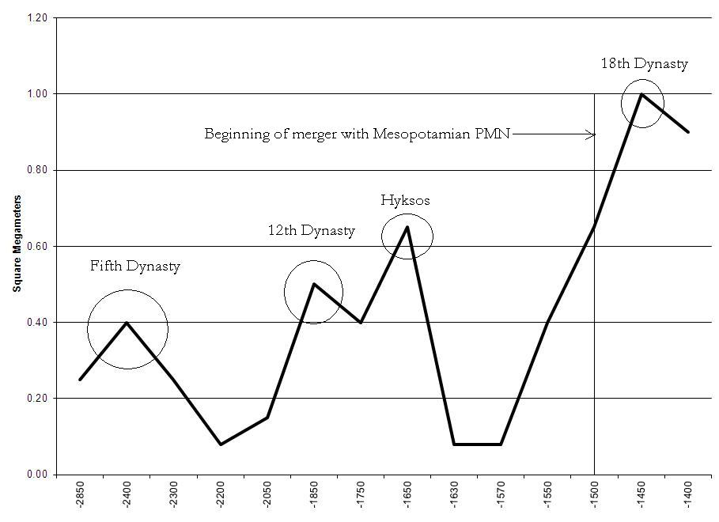
Largest states and empires in the Egyptian PMN, 2850 BCE-1500 BCE
The upsweep shown in the figure above started with the 2nd Egyptian dynasty so in order to understand its causes we need to consider what was going on in the 2nd through 5th dynasties.
The 2nd dynasty capital was the city of Memphis. It is poorly known from archaeological and documentary evidence. But Kathryn Bard (2000:85 says “There is much less evidence for the kings of the 2nd Dynasty than those of the 1st Dynasty until the last two reigns (Peribsen and Khasekhemwy). Given what is known about the early Old Kingdom in the 3rd Dynasty, the 2nd Dynasty must have been a time when the economic and political foundations were put in place for the strongly centralized state, which developed with truly vast resources. Such a major transition, however, cannot be demonstrated from the archaeological evidence for the 2nd Dynasty.”
The origins of the Old Kingdom 5th Dynasty--as those of the 1st--are shrouded in legend. Manetho wrote that the Dynasty V kings ruled from Elephantine, but archaeologists have found evidence clearly showing that their palaces were still located at Ineb-hedj ("White Walls") in the city of Memphis. There is evidence of significant changes in religious structure, such as the writing of the "Pyramid Texts" (funerary prayers inscribed on royal tombs), the rise of Ra as the prominent deity (and his cult's prominence), followed at the end of the dynasty by the succession of the cult of Osiris, and the "solar cult" (which would centuries later be solidified under the Sun God Pharoah, Akhenaten) and its obelisks and other "solar temples." Beaujard (2112:176) interprets the rise of the cult of Osiris during the 5th dynasty as an indication of the internal consolidation of power of the Egyptian hegemon.
Regarding original Egyptian state formation Van de Mieroop says:
This still did not explain why territorial unification occurred. Theories that the concept was inspired from abroad - Babylonia and Nubia have both been suggested - are mostly rejected now (cf. Midant - Reynes 2003 : 275 -307), and scholars prefer to focus on indigenous forces. Many think that centers of production and exchange developed along the Nile Valley and that elites in them sought increased territorial powers to gain access to trade items and agricultural areas. When the zones of influence of neighboring centers started to intersect, conflict arose, which was settled through either war or alliances (Bard 1994 : 116 - 18). But Egypt was rich in resources and had a small population in late prehistoric times, so why would people have competed over them? Non - materialist motives may have driven expansion. People who settled down became territorial and like players in a Monopoly game tried to expand their holdings. Thousands of such games took place along the Nile and increasingly fewer players became more powerful until one triumphed (Kemp 2006 : 73 - 8). Conquest was not necessarily the main force of unification; peaceful arrangements (marriages, etc.) may have been more important (Midant - Reynes 2003 : 377 - 80). In recent years the view that the valley was the primary locus of change has been under attack. Remains in the desert, which was more fertile in the fourth millennium bc than it is now, show that pastoralists flourished more than the early farmers of the valley. Part of the evidence on them derives from rock art in the eastern desert (T. Wilkinson 2003 : 162 - 95), other evidence comes from the western desert oases (Riemer 2008 ). For centuries the people who moved around outside the valley were more active and wealthier than those who farmed. They developed a greater social hierarchy and an elite that controlled resources and they ultimately unified the whole of Egypt - valley, Delta, and desert regions - into a vast territory with a bureaucracy to administer it (Wengrow 2006 ).
Archaeological finds at Byblos attest to diplomatic expeditions sent to that Phoenician city. For this dynasty, we rule out the rise of a semiperipheral marcher state and inter-core conflicts, and for now assume this dynastic shift was the result of an internal succession.
References
Bard, Kathryn A. 2000 "Chapter 4 — The Emergence of the Egyptian State". In Shaw, Ian. The Oxford History of Ancient Egypt(paperback) (1st ed.). Oxford: Oxford University Press.
Beaujard, Philippe 2012 Les mondes de l’océan Indien Tome II: L’océan Indien, au coeur des globalisations de l’ancien Monde du 7e au 15e siècle. Paris: Armand Colin
Hassan, Fekri A.1988 “The predynastic of Egypt” Journal of World Prehistory Vol. 2, Number 2.: 135-185
_____________ 1997 “Holocene paleoclimates of Africa” African Archaeological Review 14,4: 213-230 http://link.springer.com/article/10.1023/A:1022255800388
Romer, John 2013 A History of Ancient Egypt. Volume 1. London: Penguin Books.
Shaw, Ian, ed. (2000). The Oxford History of Ancient Egypt. Oxford University Press.
Smith, W. Stephenson 1962 The Old Kingdom in Egypt and the beginning of the First Intermediate Period. London: Cambridge University Press
___________ 2014 “The Circumscription Model of the Egyptian State” Social Evolution Forum November 19 https://evolution-institute.org/blog/the-circumscription-model-of-the-egyptian-state/?source=sef
Van De Mieroop, Marc 2011 A History of Ancient Egypt. Malden, MA: Wiley-Blackwell
Warburton, David 2001. Egypt and the Near East: Politics in the Bronze Age. Recherches et Publications, Neuchâtel, Paris.
Wengrow, David 2006 The Archaeology of Early Egypt: Social Transformations in North-East Africa, 10,000 to 2650 BC. Cambridge University Press, New York
Wilkinson. Toby A. H 1996 State Formation in Egypt: chronology and society Oxford: Tempus Repartum
12th dynasty
The territorial upsweep that peaked during the 12th dynasty in 1850 BCE began during the 6th dynasty during the First Intermediate period. And the peak was followed by the beginning of a decline that began during the 12th dynasty (see Egypt data).
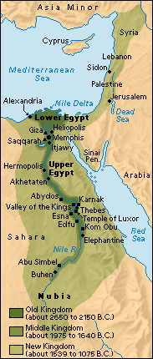
The 12th Dynasty—according to Manetho—emerges not from a nomadic or semiperipheral rise within the region, but from an internal succession of viziers over established pharaohs. The scope of their power eventually came to encompass semiperipheral peoples along the Upper Nile (Shaw 2000.)
References

Arnold, Dorothea 1991 “Amenemhat I and the Early Twelfth Dynasty at Thebes” Metropolitan Museum Journal, 26 :5-48 Chicago: University of Chicago Press http://www.jstor.org/stable/1512902 .
Grajetzki, Wolfram 2006 The Middle Kingdom of ancient Egypt, London: Duckworth
Shaw, Ian, ed. 2000. The Oxford History of Ancient Egypt. Oxford University Press
Van De Mieroop, Marc 2011 A History of Ancient Egypt. Malden, MA: Wiley-Blackwell

Hyksos
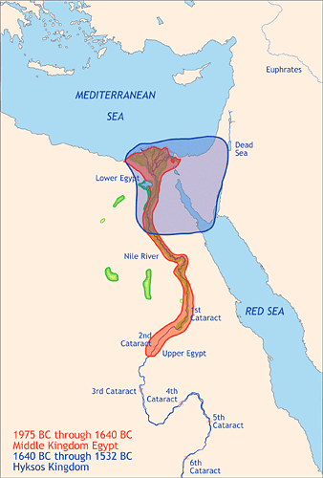
Archaeologists such as McGovern (2000) and Bietak (1996) regret that they have little to work with in order to reconstruct an unbiased account of the Hyksos’ rule in Egypt. Given that the Hyksos were not indigenous to the region, and were never fully accepted by the native Egyptians, their brief rule ends with the destruction of the bulk of their contributions to the region (primarily infrastructure, pottery, and writing), which, if not destroyed, would allow contemporary Egyptologists to better piece together the actual events of that time.
As such, we are left with the retrospective accounts of Manetho, whose work is produced during the 3rd-century BCE, over a millennium after the expulsion of the Hyksos from the Nile region. This view—which paints the Hyksos as ubiquitously militant conquerors who entered the Nile valley and easily crushed the fragmented Egyptian empires from as early as the 13th Dynasty to the last Egyptian dynasty to be subjugated by Hyksos rulers: the 17th—has until recently been the primary source of the Hyksos’ chronology for most modern historians (Redford 1992, 1997; Redmount 1995).
This epoch—ranging from the 18th century BCE to the rise of Tao I around 1560 BCE, and typically classified as the 2nd Intermediate Period—is described in Manetho’s writings as militarily driven, though not necessarily strewn with warfare. Though sparsely chronicled, the Hyksos are reputed to have participated in uprisings against the established Egyptian cities, burning them down with little resistance from the local elites (Bietak 1975: 102). It would not be until after these initial conflicts that the Hyksos would be in a position to exact tribute from the indigenous dynasties in both Upper and Lower Egypt.
Beaujard (2012: 183) states that Egypt maintained trade/diplomatic relations with Kush to the south, even during the momentous incursions from Canaan by the Hyksos.

A new school of Egyptologists has recently gained momentum on the nature of the Hyksos as they enter Egypt from the northeast. Booth (2005) states that they did not enter by primarily military means, but as merchants and immigrant laborers. Due to internal logistical problems—brought on by famine and plague—the 13th Dynasty was powerless to stop or effectively regulate the influx of these Asiatic (Canaanite) immigrants. She suspects that the extensive mining and architectural aspirations of Amanemhat III may have even encouraged the advent of these laborers.
Bourriau’s (1997) account of the transition to Hyksos rule is similar to Booth’s. Her excavation of Memphis does not point to a military campaign or a forced entry into Egypt by the Hyksos, but rather debunks Manetho’s depictions of the Hyksos as roving bands of marauders to be nationalistically motivated, as has been the norm for most historians until our own times. For Bourriau, there is no evidence that points to the sacking of Memphis or any other major urban center by the hands of the Hyksos.
These reconstructed histories, relying on archaeology rather than classical and ancient historians’ allegations, paint a drastically different picture of the Hyksos as certainly peripheral or semiperipheral, but not necessarily as an exemplary case of a marcher state. Having never found any chariots at Avaris, the capital of the Hyksos, these contemporary archaeologists assert there to be no clear evidence of the use of the chariot by the Hyksos as a significant contribution to their rise to prevalence in Egypt. In short, their findings do not point to a war of incursion by Canaanite foreigners. They do, however, note some of the Hyksos’ contributions to Egyptian civilization: bureaucracy. Insofar as the formalization of an already existing bureaucracy can be taken as an indicator of an upward sweep, or an intensification of previous modes of government, we can conclude with some certainty that the Hyksos were far from a peripheral people by the time they entered Egypt, though there is similarly no conclusive data that would support the notion that they were an established core power in Canaan and the Levant.
References:
Beaujard, Philippe 2012 Les mondes de l’océan Indien Tome II: L’océan Indien, au coeur des globalisations de l’ancien Monde du 7e au 15e siècle. Paris: Armand Colin
Bietak, Manfred 1975 Tell el-Dab’a II. Vienna: Osterreichishcen Akademie der Wissenschaften
_____________ 1981 Avaris and Piramesse: archaeological exploration in the Eastern Nile delta. Oxford: Oxford University Press.

______________ 1996 Avaris, the Capital of the Hyksos. Recent Excavations at Tell el-Dab’a,
Booth, Charlotte 2005 The Hyksos Period in Egypt. p.10. Shire Egyptology,
Bourriau, Janine. 1997 The Hyksos: New Historical and Archaeological Perspectives, ed. Eliezer Oren, University of Pennsylvania Pp. 159-182.
McGovern, Patrick E.2000 The Foreign Relations of the “Hyksos”: A neutron activation study of Middle Bronze Age pottery from the Eastern Mediterranean. Oxford: Archaeopress
Redford, Donald B. 1992 Egypt, Canaan and Israel in Ancient Times. Princeton, N.J. : Princeton University Press
________________, 1997 “The Hyksos in history and tradition” Orientalia, 39:, 1-52.
Redmount, Carol A. 1995 “Ethnicity, Pottery, and the Hyksos at Tell El-Maskhuta in the Egyptian Delta”, The Biblical Archaeologist, 58:182 – 190 American Schools of Oriental Research.
Van De Mieroop, Marc 2011 A History of Ancient Egypt. Malden, MA: Wiley-Blackwell
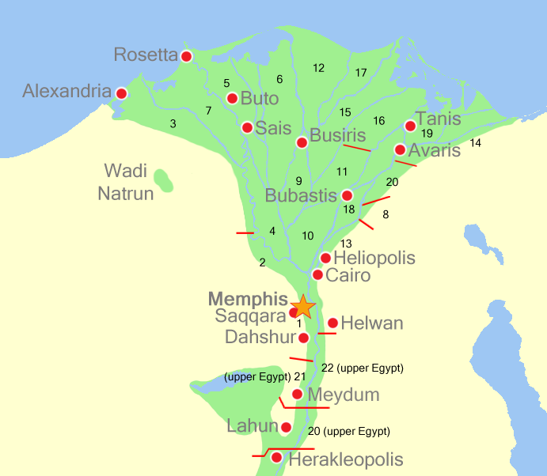
The Central PMN: 1500 BCE to 1991AD
18th Egyptian Dynasty
The accounts of Reeves (2001: 31 - 32), Aldred (1988), Wilkinson (1999) and Redford (1984) ubiquitously point to Akhenaten's 18th dynasty as a core polity when they drove the Hyksos out of Egypt. They not only are an established power sharing continuity with the pre-Amorite rulers of Egypt, but their levels of bureaucracy and sophistication allow these indigenous rulers to resurrect the power structure of the Middle Kingdom and bring the Nile region back into prominence after the 2nd Intermediate Period.
References:
Aldred, Cyril 1988 Akhenaten: King of Egypt London: Thames & Hudson
Redford, Donald B. 1984 Akhenaten: The Heretic King Princeton, NJ: Princeton University Press
Reeves, Nicholas 2001 Akhenaten: Egypt's False Prophet London: Thames & Hudson Wilkinson,
Toby A. H. 1999 Early Dynastic Egypt London: Routledge, Taylor & Francis
Neo-Assyrian Empire
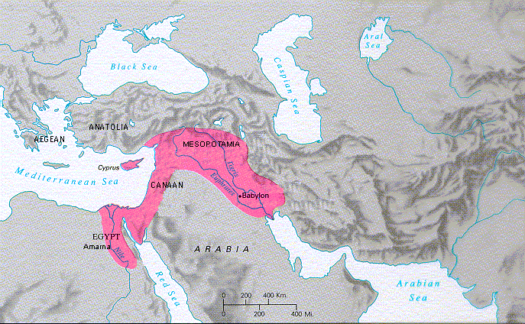
The Neo-Assyrian Empire at its peak size in 670 BCE

Assyria originally was one of a number of Akkadian city states in Mesopotamia. In the late 24th century BC, Assyrian kings were regional leaders only, and subject to Sargon of Akkad who united all the Akkadian, Semites, and Sumerian speaking peoples of Mesopotamia under the Akkadian Empire which lasted from 2,334 BC to 2,154 BC. Assyria gradually expanded its control over a vast area from western Iran to the Mediterranean and from Anatolia to Egypt, dominating political and economic life. The development of the empire was accomplished by a series of powerful rulers who led their army on campaigns almost every year. Progress was neither smooth nor linear. Two phases can be distinguished: the first in the ninth century BC and a second phase starting in the mid-eighth century BC (Van De Mieroop 2004:216). In the period of empire building, it is referred to as the Neo-Assyrian period. The Neo-Assyrian Empire began in 934 BC and ended in 609 BC.
The rise of Neo-Assyrian Empire was explained by many factors. First, towards the end of the tenth century BC, Assyria began to escape its long dark ages. The lack of unity among enemies had saved it from rapid destruction. Babylonia was partly occupied and plundered by the Aramaeans; Elam had disappeared from the political stage; Egypt, ruled by Libyan princes, was almost powerless; the Phrygians in Anatolia, the Medes and Persians in Iran were still remote and harmless competitors; and Urartu was not yet fully grown. These situations gave Assyria the best opportunities to expand (Roux 1992:300).
Assyria had a very strong military. All men could be called up for military service and all state officers were designated as military ones. The king was at the top of the structure and his primary role was to conduct war for the benefit of the state. Thus, there was an ideology that the king must lead his army into battle annually (Van De Mieroop 2004:217).
Second, Assyria was a multi-ethnic state composed of many peoples and tribes of different origins. Historical documents mention numerous Assyrian citizens identified or identifiable as Egyptians, Israelites, Arabs, Anatolians and Iranians on the basis of their names or the ethnic labels attached to them (Parpola 2004: 5-7). Despite comprising of many ethnicities, Aramaic was also made an official language of the empire, alongside the Akkadian language (Frye 1992). The reasons for the spread of the Aramic language were not only the expansion of the Aramaeans themselves into the Fertile Crescent since 2,000 B.C., but also the policies of deportation of populations by the Assyrian state under Sargon II (722 – 705 BC) and Tiglath-Pileser III (745-727 BC). Large numbers of peoples, including Aramaens, were deported and settled all over the Fertile Crescent (Frye 1992). The mass deportations served many purposes. It provided labor and people to inhabit its new cities, reduced opposition in peripheral territories as rebellious populations were resettle in foreign environments where they needed imperial protection against local hostility. They would not escape as they were unfamiliar with the country (Van De Mieroop 2004:219). Also, a multiethnic population base in each region would have curbed nationalist sentiment, making the running of the Empire smoother.
The first peak is dominated by the two long and successful reigns of Ashurasirpal II (883-859 BC) and Shalmaneser III (859-824 BC) (Liverani 2004:213). Soon after Assyria initiated its first phase of expansion, Ashurasirpal II moved the capital to Kalhu and rebuilt many palaces and temples inside an 8-kilometer-long city-wall (Van De Mieroop 2004:220).
Focusing on military technology, Nefadov 2008 notes that the Neo-Assyrians adopted iron swords, helmets and armor from Urartu after 735 BC while their Urartan rivals were subsequently smashed by the Cimmerians, who had cavalry. The Neo-Assyrians invented a new three-line battle tactic using shielded warriors (1st line) covered shooting bowmen (2nd line), and then heavy infantry with iron armor and weaponry (3rd line).). By 729 BC they had captured lands from Mediterranean Sea to the Persian Gulf. Later, in 7th century BC they conquered Egypt and Elam as well. Tiglapatalasar III came to power through an anti-elite revolt that was supported by commoners, and introduced the principle of meritocratic promotion in the army and widened the state economy sector. War captives were settled on new land (distant from their original homes), paid state taxes and could be drafted. All this stimulated the expansion of a centralized bureaucracy. The Neo-Assyrians lost their military edge to the Scythians, who had cavalry, and from 623 BC were conquered by them. So semiperipheral marcher Urartu fostered reactive and adaptive Neo-Assyrian technological and military innovations and organizational transformations. The Neo-Assyrian upswing was stimulated by pressure from a semiperipheral marcher state. This is a variant of Turchin’s “mirror empires” model discussed above.
References:
Allen, Mitchell. 1997 Contested Peripheries: Philistia in the Neo-Assyrian World-System. Unpublished Ph.D.
dissertation, Interdepartmental archaeology program, UCLA.
_____. 2005. “Power is in the Details: Administrative Technology and the Growth of Ancient Near Eastern Cores.” Pp. 75-91 in The Historical Evolution of World-Systems, edited by Christopher Chase-Dunn and E. N. Anderson. New York and London: Palgrave.
Frye, Richard Nelson. 1992. “Assyria and Syria: Synonyms.” Journal of Assyrian Academic
Studies, 51(4): 281-285.
Harper, Prudence O. et al, ed. 1995. Discoveries at Ashur on the Tigris: Assyrian Origins.
Worcester, MA: Mercantile Printing
Joannès, Francis. 2004. The Age of Empires: Mesopotamia in the First Millennium BC.
Edinburgh: Edinburgh University Press.
Liverani, Mario. 2004. “Assyria in the Ninth Century: Continuity or Change in From the Upper Sea
to the Lower Sea: Studies on the History of Assyria and Babylonia in honour of A.K. Grayson, ?” pp.213-226, edited by G. Frame, Leiden : Nederlands Instituut voor het Nabije Oosten
Nefedov, S.A. 2008 Faktornyy analiz istoricheskoho processa. Istoriya Vostoka (Factor analysis of historical
process. The History of the East) Moscow: Publishing house
Parpola, Simo. 2004. "National and Ethnic Identity in the Neo-Assyrian Empire and Assyrian
Identity in Post-Empire Times." Journal of Assyrian Academic Studies, 18(2): 5-22.
Radner, Karen 2014 “The Neo-Assyrian Empire” Pp. 101-119 in Michael Gehler and Robert Rollinger (eds.) Imperien und Reiche in der Weltgeschichte, Teil 1. Wiesbaden: Harrassowitz Verlag

Rollinger, Robert. 2006. "THE TERMS "ASSYRIA" AND "SYRIA" AGAIN." Journal of
Near Eastern Studies, 65(4):283-287.
Roux, Georges. 1992. Ancient Iraq. 3rd ed, New York: Penguin Books
Van De Mieroop, Marc. 2004. A History of the Ancient Near East, ca. 3000-323 BC. Malden, MA:
Blackwell.
Achaemenid Persia
At its height the Achaemenid Empire, around 550 BCE, stretched from Greece and the Black Sea, over all of Turkey and as far east as the Indus River (Gershevitch 1985). Originating in the Anshan or Parsuwah region of what is now south central Iran, a collection of tribes originating from central Asia unified under a central king in the mid 670 BCE. Caught in between several stronger empires, the new unified Persians under the rule of the Achaemenid dynasty continued expanding, conquering and incorporating a number of Iranian cities and empires until reaching a peak under Darius the Great and Xerxes. However, following defeats by Alexander the Great during a long series of Greek wars and internal instability in the mid-300 BCE, the Achaemenid Dynasty fell and the vast empire was broken up into several smaller polities or was conquered by invading Greeks (Venetis 2012).
Around the 8th century BC, a group of agriculturalists and pastoralists (Garthwaite 2005) migrated to the Iranian plateau, from central Asia (Brosius 2006). The migration of several different groups to the same region, melding together and eventually becoming known as Persians. Most likely, the first Persians migrants from central Asia appeared through gradual the infiltration of mounted and armed pastoral nomads (Garthwaite 2005). Nevertheless, their migration route was influenced by the already settled powers west of the plateau. The Assyrian empire was dominant in western Iran. Because of this, Persians avoided conflict and moved south between the Zargos Mountains and the desert until they reached the plains of Fars. To the southwest were the Elemaites and Medes. These neighboring people were of material importance both to the evolution of the Persian Empire and urban life in the ancient east (Irving, 1979).
Cyrus I of Paruwash, Ruler of Anshan
By the first millennium BC, Ashan had become the homeland of Achaemenian Persians. This area is in what is today south central Iran. Anshan (an ancient Persian city), as a result of diplomacy, was part of the Akkadian empire (Gershevitch 1985). However, there is strong evidence that Anshan was political center of the Elamites (Gershevitch 1985). Assyrian texts record the land of Parsua first in the 9th century BC when they invaded the land several times. Inscriptions of Sargon II (721-705 BC) identify the same area was invaded previously, but known as Parsuash, and show it under the reign of Assyrian provincial rule. This suggests Persians were originally under the control of the Assyrian empire (Gershevitch 1985). The Assyrian record claims that the Achaemenids were immigrants that did not settle into the region until Cyrus I consolidated different tribes. However, there is evidence that settlements date back as far as 675 BCE. It is obvious that there were several separate tribes and settlements in the Persian homeland before 675 BCE (Gershevitch 1985).
Cyrus I, the grandfather of Cyrus the Great (Cyrus II), was credited with the formation of the first Persian Empire. Before the naming of East Asian immigrants as Persians they were known as Achaemenid dynasty, of whom Cyrus I was the ancestor of the founder, Achaemenes (Frye 2010). They thrived independently as rulers of the Anshan and Parsuwah region before an invasion by Ashurbanipal, an Assyrian King in 627 BCE. However, it is difficult to determine when exactly these tribes arrived in this area and when they joined together to form the Persian Empire. Also, many of these tribes could have remained separate from the establish Persian empire and slowly joined the Achaemenians to eventually form the larger Persian Empire. Their assimilation and integration into other, dominant societies, eventually allowed for their domination of the entire Zargos mountain region.(Gershevitch 1985).
Vassals of the Medes and Adoption of Elamite Codes
Before the rise of the Persian Empire, the Medes ruled much of what is modern-day Iran and controlled all pastoral tribes (Irving 1979). Around 675 BC, the Medes gained control over the Persians, which would eventually lead to a joint semi-peripheral marcher state that would dominate the region (Briant 2002). In addition to being control by the Medes, the newly arrived Persians also adopted the codes and scripts of Elamite administration to be used in their own bureaucratic structures. Persian kings and royalty also adopted Elamite art and culture and the line between Persian and Elamite became convoluted (Brosius 2006).
Thus, the Achaemenid Persians, who would soon dominate modern-day Iran, where definitely the combination of several different groups, Medes, Elamites, and other central Asian immigrants. Nevertheless, the Persian migration to the region should not be seen in terms of a peripheral marcher state as they were soon dominated by the Medes and attempted to integrate themselves into Elamite culture and tradition. This domination reversed course as the Achaemenid Persians soon sought to force assimilation and incorporate previous established cultures (Gershevitch 1985).
Internal Revolt and the Beginnings of Empire
The rise of the Persian Empire was the result of an internal revolt led by Cyrus II, against his Median overlords (Olmstead 1948; Briant 2002). There is no clear birthdate for Cyrus II, or Cyrus the Great. Estimation ranges from 600 BCE to 575 BCE. Cyrus first united all Persians who were vassals of the Medes and under his control he sought an ally against the Medians. Eventually the Persians were joined by the Babylonians to challenge Median rule. Through the conquest of the Median Empire, Cyrus II gained large amounts of land and power, which was originally gained during the Median’s conquest of Assyria. These large gains were soon seen as a direct challenge to Babylonian rule and all alliances disappeared. The destruction of the Medes upset a delicate balance that had existed in the region and the Persians and the Babylonians soon came into direct conflict (Olmstead 1948; Briant 2002; Chadwick 2005).
With the two major power being Persia and Babylon, the Persians soon began the conquering of other powers in the region, beginning with the Lydians (Briant, 2002). They soon subjugated the Greeks and the Lycians while also conquering much of the region to the east of the empire. Finally, by 539 BC the Persians conquered Babylon and gained complete power within the region. The empire would continue to rule and challenge all others until 330 BC when it began to decline (Olmstead 1948; Briant 2002; Chadwick, 2005). It was Cyrus II who first fought in Egypt, and conquered the northern section for the Achaemenid Empire (Gershevitch 1985).
During the expansion period of Cyrus the Great, the capital Pasargadae was founded. Politically, the control of the nascent empire was continually consolidated in this city in the southern central part of Iran. However, it was still under construction when Cyrus II was killed in battle, sometime around 540 BCE, warring with other Persian tribes during the Achaemenid expansion. His tomb was crafted in Pasargadae (Holland 2005).
Darius I
Darius the Great (Darius I) consolidated the power and expanded the rule of the Achaemenid Empire after the chaotic period immediately following the death of Cyrus the Great. A politically ruthless man, doubts still linger if he had inherited the throne legitimately or through murder. Regardless, the young king was born in 550 BCE in a small city in the far eastern limits of the Persian Empire, what is now Afghanistan. After cementing his power from inside the Achaemenid Empire, Darius set out to systematically conquer a series of weaker neighbors through a combination of brilliant military victories, expert diplomacy, and a relatively humanistic style of governance. Darius first put down a revolt from within Babylon before moving on to conquer the Indus valley and incorporate what is now western India into his empire. Next, Darius the Great finished the conquest of northern Iran, thus uniting all of modern Iran under a single Persian empire. Darius later invaded eastern Greece and incorporated Trace into the Persian Empire (Abbot 2009).
Darius, however, was finally stopped at the battle of Marathon. Greek kings had been involving themselves in the internal affairs of the Persian Empire. In response, Darius launched the invasion of Greece which reached its apex with the conquest of Thrace. However, Darius continued to launch military campaigns into southern Greece until his defeat at Marathon. However, this would only be the first in a long series of Greek and Persian wars, which would only end with Alexander the Great's victory over the Persians and the decline of the empire (Stoneman 2012).
Although Darius died before the completion of the empire, he left an indelible mark on the Achaemenid Empire. The central city of his empire, Persepolis, was unfinished at the time of his death. It would grow to become the principle government and commercial hub of the Persian Empire. Darius died of illness after putting down a revolt in Egypt and was buried in central Iran (Holland 2005).
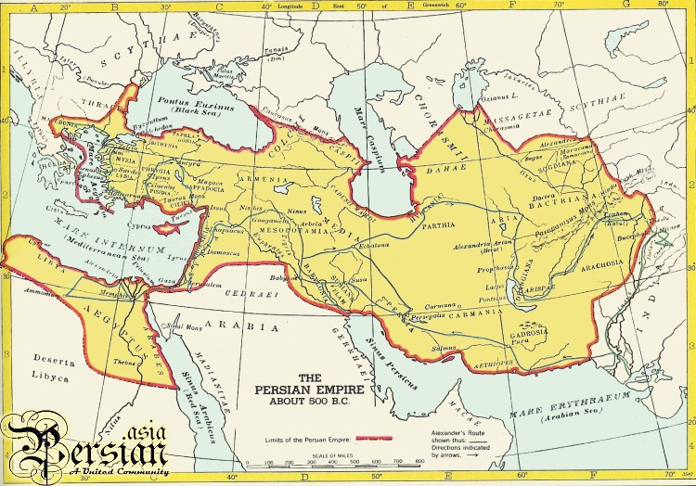
References:
Bausani, Alessandro 1971 The Persians: From the Earliest Days to the Twentieth Century. London: Elek
Briant, Pierre 2002 From Cyrus to Alexander: A History of the Persian Empire. Winona Lake, Indiana: Eisenbrauns
Brosius, Maria 2006 The Persians: An Introduction New York: Routledge.
Frye, Richard Nelson. 2010. “Cyrus the Mede and Darius the Achaemenid.” Pg 17-20 in the World of Achaemenid Persia: History, Art and Society in Iran and the Ancient Near East. Edited by John Curtis and St. John Simpson. New York : I.B. Tauris
Garthwaite, Gene R. 2005 The Persians. Oxford: Blackwell Publishing.
Gershevitch, Ilya. 1985. The Cambridge History of Iran: Volume Two The Median and Achaemenian Periods. New York: Cambridge University Press.
Irving, Clive 1979 Crossroads of Civilization: 3000 Years of Persian History. London, Weidenfield and Nicolson.
Katouzian, Homa. 2009. The Persians, Ancient, Mediaeval, and Modern Iran. New Haven, CT: Yale University Press
Kuhrt, Amelie 2007 The Persian Empire: A Corpus of Sources of the Achaemenid Period, Volume 1. New York: Routledge.
The origins of the Roman Empire
The question of the origins of the Romans and their world-system position during their early rise requires us to know about the linguistic, cultural and subsistence history of the Italian peninsula.
The emergence of Neolithic farming in Europe has been a controversial topic for a long time (e.g. Child 1957). There are two contending views about the origins of farming in Europe: cultural diffusion and parallel independent innovation (Whittle and Cummings 2007); or the migration of farming peoples (Cavalli-Sforza 1996; Haak et al 2005; Renfrew 1992). The cultural diffusion/parallel independent innovation hypothesis contends that the Neolithic transition in Europe was due to a combination of local adaptation and learning of farming techniques by the peoples who were already living in Europe who were participating in information networks with farmers from the older core regions of early horticulture and agriculture in Mesopotamia and Egypt. It could have been the diffusion of the ideas about farming of agriculture combined with parallel and independent innovation by the indigenous Europeans. The other hypothesis is that that farming was brought to Europe by migrants from the older Western Asian regions where it had emerged earlier. Recent scholars have argued that the reality may have been a combination of both processes (Fort 2012, Pinhasi et al. 2012; Pinhasi and Noreen 2012). Rising population density put pressure on resources, encouraging indigenous foragers to expend more labor increasing the productivity of nature, and there were also migrations of farmers into Europe from the older original regions of horticulture. In southern Europe, –including the western coasts of Greece, Albania, Dalmatia, the southern Italian peninsula and Sicily—farming was first practiced in the late 7th millennium BCE (Pinhasi and Noreen 2012; Skeates, 2003:171).
Italic (a language that includes Latin) is a sub-family of the Indo-european language family. It is not known when Indo-european speaking peoples arrived on the Italian peninsula. The first evidence of written Italic languages dates from the 7th century BCE.
The origins of Etruscans
The Etruscan language is not well understood. The alphabet shows Greek influence and some Etruscan words were borrowed into Latin, but the corpus of known documents is not large, and the relationship of Etruscan with larger language families is not well understood. Herodotus argued that the Etruscans migrated from Lydia in Asia Minor (now Turkey). Another Greek historian, Dionysius of Halicarnassus, claimed that the Etruscans were indigenous to Italy (Cornell 1995: 46). Archaeological evidence suggests that the migration of the Etruscans from Asia Minor to the Italian peninsula occurred before the eighth century BCE. The Etruscans are thought to have invaded Iron Age Villanovan settlements on the northern Italian peninsula and built their characteristic hill-top cities (Cornell 1995:47). Recent DNA studies of both humans and cattle support the notion of migration from Asia Minor (Achilli et al 2007;Wade 2007; Guimares et al 2009; Ghirotto et al 2013; Pellechia et al 2007). In the 7th century BCE the great necropoli (i.e. extensive burial places with tomb monuments) began to be developed with elaborate chamber tombs for aristocratic burials. Etruscan civilization thrived in the period from 800 to 500 BCE, and in this period, powerful city-states developed (Cornell 1995:45).
The Romans were a small tribe of Latin-speaking farmers that inhabited the central Italian peninsula. In 800 BC, there were Italic (an Indo-European family of languages) speakers in the Italian peninsula— Latins (a small section in the west), Sabines (in the upper valley of the Tiber), Umbrians (in the north-east), Samnites (in the South), Oscans and others (see figure 1 below). They shared the peninsula with two other major ethnic groups: the Etruscans in the North, and the Greeks in the south, both of which spoke non-Indo European languages. Indo-European languages of Italy were brought from outside by migration of peoples, thus it results in the patchwork of languages due to the movements of populations into the Italian peninsula. (Cornell 1995:44) (see figure 1). The language of the Etruscans was different from that of Romans and may not be related to the Indo-european language family (Bonfante and Bonfante 2002; Bonfante 2011).
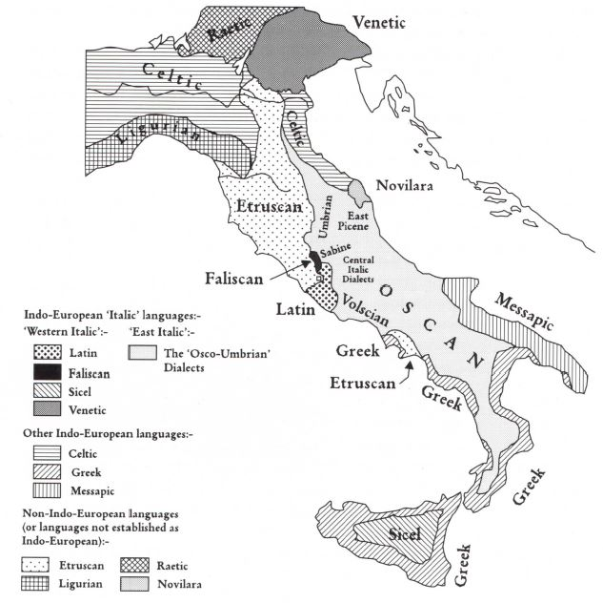
Figure 1: Languages of pre-Roman Italy, c. 450-400BCE [Cornell 1995:41]
The first known Roman settlement was at the Palatine Hill (see figure 2). There are ongoing debates regarding the origin of Roman city-state. Some claim that Rome grew from settlements on the Palestine Hill and the Quirinal Hill, forming a joint community. (Cornell, 1995:.80) (see Figure 2)
This view of joint origin supports the legendary story of Romulus and Remus that suggests the fusion of two peoples, Romans (in the Paletine Hill) and Sabines (in the Quirinal Hill), in the fourth century BC.
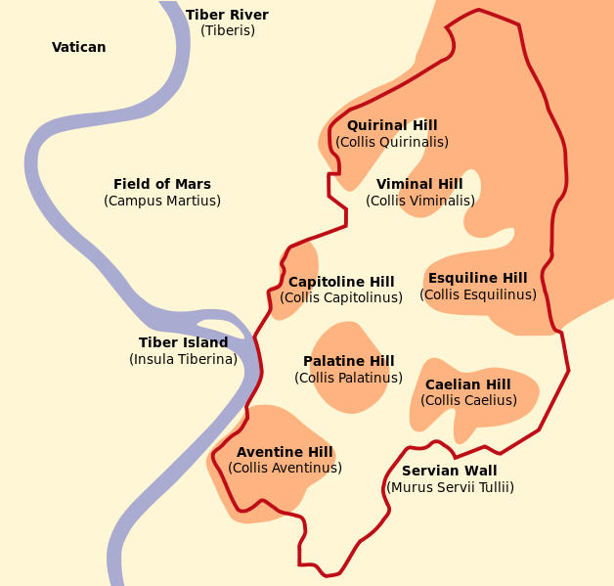
Figure 2. Seven Hills of Rome
http://en.wikipedia.org/wiki/Seven_Hills_of_Rome
From archaeological evidence, material finds indicate that the Sabine district is culturally very close to the Latins and Faliscans, and so it is difficult to differentiate archaeologically between Romans and Sabines. The joint formation of the Roman city-state by Sabines and Romans is consistent with linguistic evidence but is not completely be proven or disproved by archaeological evidence.
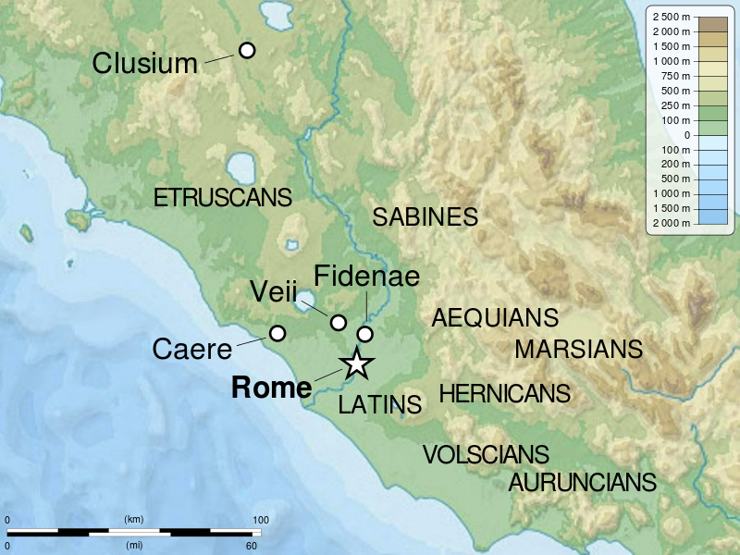
Figure 3: Latium, 5th Century BCE
http://en.wikipedia.org/wiki/File:Latium_-5th_Century_map-en.svg
The relationship with the Etruscans
In Latium, there were multiple ethnic groups that co-existed in 800 BCE. There were Italic-speaking communities, such as Latins, Sabines, Umbrians, Samnites, and Oscans. There were also other ethnic groups, such as the Etruscans in the north and the Greeks, who resided in the south.
Between 750 and 550 BC, the Greeks founded colonies in Southern Italy, including Cumae, Naples, and Taranto, and also colonized a part of Sicily. The Etruscans were in Etruria (north of Rome—see the Figure 3) and became the originators of art, literature, philosophy and science, becoming the founders of civilizations (Cornell 1995:151). The Etruscans had a large impact on the formation of Roman culture, which is shown by the Etruscan origin of some of the mythical Roman kings. The Etruscans in Etruria had the largest cities and were the core polities of the region, while the Italic-speakers, including the Romans, were peripheral or semiperipheral in their relationship with the Etruscans.
Archaic inscriptions imply that Rome was not conquered by the Etruscans. The archaic inscriptions of Rome reveal only a partial influence by Etruscan text forms. In Rome, most of archaic inscriptions are in Latin. The epigraphic material confirms the understanding of a predominantly Latin-speaking population in Rome. This is contrasted with the non-Greek cities in Campania. Campania was considered as totally dominated by the Etruscans, which was evidenced in the epigraphic (evidence) and literary texts that indicate that the non-Greek cities of Campania were colonized by the Etruscans.
From both archaeological and epigraphic evidence, it is suggested that Rome was not militarily dominated by the Etruscans, rather, it was culturally influenced. Roman culture was transformed through the contacts with Etruria, and the Etruscans influenced the development of Rome as a city, institutions, arts, and religion (Cornel 1995).
The peak of Etruscan influence over Latium and Rome occurred about 600BCE. Yet, the city of Rome became powerful and large in size. In the 8th and 7th centuries there were a series of wars between the Romans and several Etruscan city-states. The Annalistic tradition discusses that “it was a specifically Roman uprising that drove the Etruscans from Rome in 509.” In 509BC, the Roman monarchy—the king Lucius Tarcuinius Superbus whose family was originally from Etruria (Tarquinii)—was overthrown, and the first consuls of the republic were elected. According to Livy, the Etruscans were defeated by the Roman army at the Battle of Silva Arsia in the same year. A coalition of Latins and Greeks forced the Etruscans to withdraw from Latium in 475BCE.
In conclusion, the rise of Rome is considered as a case of semiperipheral marcher state formation. The formation of a large-scale polity of Rome was made possible by the conquering of the Etruscan core city-states by the Roman monarchy and the Roman republic.
References:
Achilli, Alessandro , Anna Olivieri, Maria Pala, Ene Metspalu, Simona Fornarino, Vincenza Battaglia, Matteo Accetturo, Ildus Kutuev, Elsa Khusnutdinova, Erwan Pennarun, Nicoletta Cerutti, Cornelia Di Gaetano, Francesca Crobu, Domenico Palli, Giuseppe Matullo, A. Silvana Santachiara-Benerecetti, L. Luca Cavalli-Sforza, Ornella Semino, Richard Villems, Hans-Ju¨rgen Bandelt, Alberto Piazza, and Antonio Torroni. 2007. "Mitochondrial DNA Variation of Modern Tuscans Supports the Near Eastern Origin of Etruscans" The American Journal of Human Genetics. 80: 759-768.
Astin, A. E., F. W. Walbank F.B.A., M. W. Frederkisen and R. M. Ogilvie (eds.). 2006. The Cambridge Ancient History Vol 8. Rome and the Mediterranean to 133 B.C. Cambridge, UK: Cambridge University Press.
Bloch, Raymond. 1960. The origins of Rome. Series: Ancient peoples and places (Praeger), v. 15. New York: Praeger.
Bonfante, Giuliano and Larissa Bonfante 2002. The Etruscan Language: an Introduction. Manchester: University of Manchester Press.
Bonfante, Larissa (ed.) 2011. “The Etruscans: Mediators between northern Barbarians and Classical Civilization” in pp. 233- The Barbarians of Ancient Europe: Realities and Interactions. Cambridge University Press.
Bonfante, Larissa. 1990. Etruscan. Berkeley: University of California Press.
Childe VG. 1957. The Dawn of European Civilisation. Bungay, Suffolk: Chaucer Press.
Cornell, Timothy. J. 1995. The Beginnings of Rome: Italy and Rome from the Bronze Age to the Punic Wars (c.1000-264BC). New York: Routledge.
Crook, J. A., Andrew Lintott, Elizabeth Rawson (eds.) 2006. The Cambridge Ancient History 2nd ed. Vol 9. The Last Age of the Roman Republic, 146-43 B.C. Cambridge, UK: Cambridge University Press.
Encyclopædia Britannica 15th Ed (1995): Micropædia: "Latium" http://www.britannica.com/EBchecked/topic/332009/Latium
Fort, Joaquim.2012. "Synthesis between demic and cultural diffusion in the Neolithic transition in Europe" Proceedings of the National Academy of Sciences of the United States of America (PNAS) 109 (46): 18669-18673.
Graves-Brown, Paul, Siân Jones, Clive Gamble (eds) 1996. Cultural identity and archaeology: the construction of European communities. London; New York: Routledge.
Ghirotto, Silvia, Francesca Tassi, Erica Fumagalli, Vincenza Colonna, Anna Sandionigi, Martina Lari, Stefania Vai, Emmanuele Petiti, Giorgio Corti, Ermanno Rizzi, Gianluca De Bellis, David Caramelli, Guido Barbujani. 2013. "Origins and Evolution of the Etruscans’ mtDNA. PLOS ONE, 8 (2): e55519
Guimaraes, Silvia, Silvia Ghirotto, Andrea Benazzo, Lucio Milani, Martina Lari, Elena Pilli, Elena Pecchioli, Francesco Mallegni, Barbara Lippi, Francesca Bertoldi,k Sauro Gelichi,k Antonella Casoli, Elise M.S. Belle, David Caramelli, and Guido Barbujani. 2009. "Genealogical Discontinuities among Etruscan, Medieval, and Contemporary Tuscans" Molecular Biology and Evolution. 26(9):2157–2166
Haak,Wolfgang, Peter Forster, Barbara Bramanti, Shuichi Matsumura, Guido Brandt, Marc Ta¨nzer, Richard Villems, Colin Renfrew, Detlef Gronenborn, Kurt Werner Alt, and Joachim Burger. 2005. "Ancient DNA from the First European Farmers in 7500-Year-Old Neolithic Sites" Science 310: 1016-1018.
Heiken, Grant, Renato Funiciello, and Donatella De Rita.2005. The seven hills of Rome: a geological tour of the eternal city. Princeton: Princeton University Press.
Nicolet, Claude. 1991. Inventaire du monde. Space, geography, and politics in the early Roman empire / Claude Nicolet. Ann Arbor: University of Michigan Press.
Paolo Ajmone-Marsan. 2007. "The mystery of Etruscan origins: novel clues from Bos taurus mitochondrial DNA" Proceedings of the Royal Society B. 274: 1175–1179.
Pellecchia, Marco, Riccardo Negrini, Licia Colli, Massimiliano Patrini, Elisabetta Milanesi, Alessandro Achilli, Giorgio Bertorelle, Luigi L. Cavalli-Sforza4, Alberto Piazza5, Antonio Torroni, and Paolo Ajmone-Marsan. 2007. "The mystery of Etruscan origins: novel clues from Bos taurus mitochondrial DNA" Proceedings of the Royal Society B. 274: 1175–1179.
Pinhasi, Ron, Fort Joaquim, and Albert J Ammerman. "Tracing the Origin and Spread of Agriculture in Europe" PLOS. available at: http://www.plosbiology.org/article/info%3Adoi%2F10.1371%2Fjournal.pbio.0030410
Pinhasi, Ron and Von Cramon-Taubadel, Noreen. 2012. "A Craniometric Perspective on the Transition to Agriculture in Europe," Human Biology: 84 (1) Article 10. Available at: http://digitalcommons.wayne.edu/humbiol_preprints/11
Renfrew, Colin. 1987. Archaeology and language: the puzzle of Indo-European origins. London: Cape.
Renfrew Collin. 1992. Archaeology, genetics and linguistic diversity. Man (NS) 27:445-478.
Sabin, Philip, Hans Van Wees, and Michael Whitby (eds.) 2007. The Cambridge History of Greek and Roman Warfare Vol 1. Greece, the Hellenistic world and the rise of Rome. Cambridge, UK: Cambridge University Press.
Skeates, R. 2003” Radiocarbon dating and interpretations of the Mesolithic-Neolithic transition in Italy. In The Widening Harvest. The Neolithic Transition in Europe: Looking Back, Looking Forward. Ammerman, A. J. & Biagi, P. Boston: Archaeological Institute of America. 157-187.
Storey, Glenn R. 1999 “Archaeology and Roman society: Integrating textual and archaeological data”. Journal of Archaeological Research 7(3):203-248.
Wade, Nicholas 2007 “Origins of the Etruscans: Was Herodotus right?” New York Times, April 3
http://www.nytimes.com/2007/04/03/health/03iht-snetrus.1.5127788.html?_r=1&
Walbank F.B.A., F.W., A. E. Astin, M.W. Fredriksen, R.M. Ogilvie, and A. Drummond (eds.) 2006. The Cambridge Ancient History Vol 2. The Rise of Rome to 220 B.C. Cambridge, UK: Cambridge University Press.
Whittle, Alasdair and Vicki Cummings (eds.) 2007 Going Over the Mesolithic-Neolithic Transition in North West Europe. Oxford: Oxford University Press.
Origins of the Islamic Empires:
The Islamic empires originated from the Bedouin tribes of the Arabian Peninsula. At the edges of the Persian-Sassinid Empire, on the Arabian Peninsula, the nomadic Bedouin developed a distinct culture from the usual agrarian societies that dotted the Arabian landscape. The Arabian Peninsula had had few large cities or polities during the millennia in which cities and polities were emerging in Mesopotamia, Egypt and the Mediterranean.
The pastoral Bedouins had domesticated the camel, which served as a superior beast of burden compared to the other available pack animals. The domesticated camel was the tool that gave the Bedouins the capability of controlling a large portion of long-distance trade while raiding rival trading caravans. Eventually groups of Bedouins developed sedentary societies that depended on a merchant-warrior class that overtook the power of local nomadic polities. This occurred along with the growth of cities on the Arabian Peninsula.
As the large Sassanid Empire and Eastern Roman (Byzantine) Empires fought with each other, the Bedouin tribal kingdoms gained much power and profit. Because of the important trade routes the Bedouin controlled, they were able to broker trade treaties with both the Sassanids and the Byzantines. They were able to trade with the warring empires, as well as with the lands beyond. In addition to the trading, both the Byzantines and Persians occasionally hired Bedouin mercenaries.
Both the still-nomadic and the sedentary Bedouins began referring to themselves as Arabs and at the center of the Arab trade kingdoms' networks was the city of Mecca. This settlement had potential as both a military and an economic stronghold. It connected the major trade routes from Africa and Europe to Asia and the Red Sea while being protected by a flank of mountains. The Bedouin Quraysh (قريش‎) tribe, consolidated their power in Mecca by monopolizing the revenue generated by the pilgrimage to the central religious temple known as the Kaabah. At this temple all the Bedouin tribes were supposed to bring their tribal totems, and a rule designating a season in which the raiding of caravans was proscribed by the temple.
It was in this context of proto-state formation among the Arab tribes that a new world religion emerged (Islam) that combined elements of Judaism and Christianity. The Prophet was a merchant from Mecca who became a military leader in his struggle with the tribes that opposed him. This was an instance of theocratic state formation that occurred in a region that was rising in the context of network of older core regions. So the Islamic Empire upsweep was a case of semiperipheral marcher conquest.
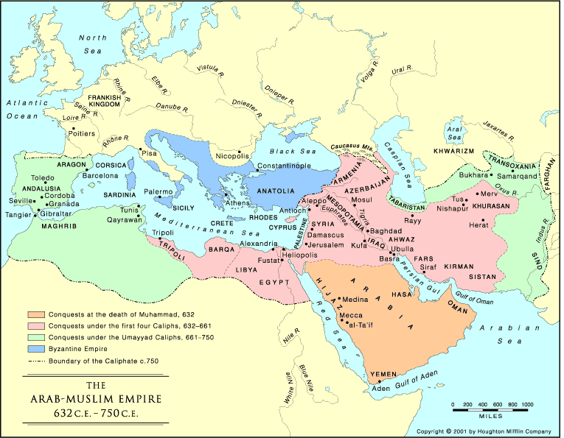
Reference:
Berkey, Jonathan P. 2003 The Formation of Islam. Cambridge: Cambirdge University
Crone, Patricia 1987 Meccan Trade and the Rise of Islam. Princeton, NJ: Princeton University Press.
Press.
Hodgson, Marshall G. S. The Venture of Islam: Conscience and History in a World Civilization.
Vol. 1. Chicago: University of Chicago, 1974.
Mongol-Yuan
Several indicators point to the peripheral status of the Mongolian confederation prior to the formation of the Mongolian Empire. One of the main indicators of peripherial status was the weak inter-tribal political structure of the Inner Steppes clans and tribes. Proto-state formation began with the emergence of the Khamag Confederation after the fall of the Liao Dynasty in Mongolia (Cleave 1982). After the death of the khan Yesugei in 1171, the Khamag tribal confederation began to disintegrate because of its inability to elect a new khan. Over the next 30 years, a series of skirmishes and battles between tribes spread over the Inner Steppe region (Ibid). The unification of tribal groups came with the ascension of Temujin, who was able to obtain the title of khan within the Khamag confederation and defeat other Inner Steppe tribes in order to consolidate the Inner Steppe region into one confederated unit.
The ascension of Temujin into a Mongolian khan (Chinggis), and the early state formation of the Mongolian confederation, signified a fundamental transformation of the supratribal polity system in the Central Asian steppes. According to Kradin (2007), however, through exploring the Secrets History of the Mongolia, from the perspective of Claessen (1978), the early Mongolian confederation (during the reign of Chinggis Khan) exhibited only two of the five indicators of state formation (P. 119). Specifically, the early political institutions of the Mongolian confederation had only the state forms “out-of-clan administration and judges” (P. 119). Further, returning to a previous point, the lack of class segmentation in Mongolian societies reduced the likelihood of state formation (P. 121). One primary indicator of semiperipherality is the presence of class and state institutional forms (see Chase-Dunn and Hall 1997, Ch. 5). During the rule of Chinggis Khan’s son, Ögedei, state development accelerated with the formation of elites and a complex hierarchy of administration (Kradin 2007; c.f. Rodgers 2012). However, these developments were primarily inspired by Chinese bureacracy after the Mongolian Empire spread across most of Central Asia.
During the early years of Temujin’s life, the majority of social life for his people was directed to basic subsistence (Barfield 1989, P. 189). The multi-resource pastoral nomads of the Central Asian steppes were primarily dependent on the bulk and prestige goods of the Northern Chinese agricultural societies because of the instability of pastoral economic production in the sparse ecologies of the Inner Steppe region (Hall 2005; Krader 1978; Barfield 1989; c.f. Rodgers 2012). The nomadic tribes of the Central Asian steppes were reliant on the agriculturalist societies of Northern China for grain and cloth as well as metals (Di Cosmo 1994). Even though the varying nomadic tribes in the Inner Steppes practiced limited forms of agricultural production (Di Cosmo 1994), the inability to generate large surpluses limited the process of class formation and other complex sociopolitical institutions while instilling a recurrent economic crisis in Mongolian society (Di Cosmo 1999). This perpetual economic instability of the Inner Steppe nomadic tribes propelled them to develop an effective military organization, which became a central mechanism for maintaining major flows of goods from the Chinese core (Hall 2005).
The complete unification of the Mongolian tribes under the leadership of Chinggis Khan in 1206, represented the early moments of semiperipherality through the consolidation of Inner Steppes region. As a peripheral marcher ‘state’, utilizing an over-extended ‘outer frontier strategy’ (see: Chase-Dunn et al 2006 and Barfield 1989), in an attempt to extract surplus from the Jurchin dynasty, the Mongol confederation expanded into Northern China by conquering the Jurchin dynasty. According to Hall (2005), steppe confederations should be understood as semi-peripheral because steppe confederations extracted surplus from the core, prevent the formation of other confederations, but are dependent on the core for resources. The conquering of the Jurchin dynasty represents a true moment of systemic mobilization and consolidation of regional power because the Mongols subjugated the Jurchin as a tributary source for its territorial expansion and conquest.
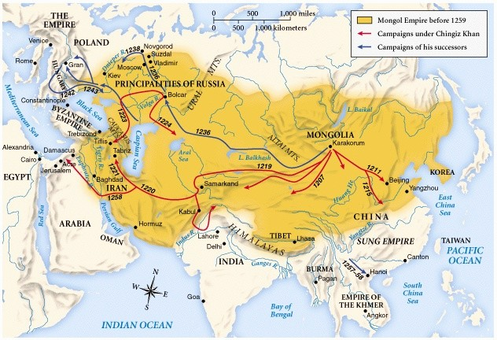
References:
Barfield, Thomas 1989 The Perilous Frontier: Nomadic Empires and China, 221 BC to AD 1757.
Cambridge: Blackwell.
Chase-Dunn, Christopher, Thomas D. Hall, Richard Niemeyer, Alexis Alvarez, Hiroko Inoue, Kirk
Lawrence, and Anders Carlson. 2010 “Middlemen and Marcher States in Central Asia and
East/West Empire Synchrony.” Social Evolution and History 9:1(March):1-29.
Claessen, Henry 1978 “The Early State: A Structural Approach.” Pp. 533–596 In The Early
State, edited by Henry Claessen and Peter Skalník. The Hague: Mouton.
Cleave, Francis 1982 The Secret History of the Mongols. Harvard University Press, Cambridge, MA.
Di Cosmo, Nicola 1994. “The Economic Basis of the Ancient Inner Asian Nomads and Its
Relationship to China.” Journal of Asian Studies (53): 1092–1126.
Di Cosmo, Nicola 1999 “State Formation and Periodization in Inner Asian History.” Journal of
World History (10): 1-40.
Hall, Thomas 2005 “Mongols in World-Systems History.” Social Evolution and History (4): 89
118.
Kradin, Nikolay 2008 “Early State Theory and the Evolution of Pastoral Nomads.” Social
Evolution and History (7): 107-130.
Rodgers, J.D. 2012 "Inner Asian States and Empires: Theories and Synthesis." Journal of Archaeology Research 20: 205-256.
British Empire
Territorial Size of the British Empire (Taagepera, 1997: 502)

From the 15th to the 19th century England had made itself into a vast colonial empire (see Figure above). From England to India to the Americas, the British Empire became the largest in history. It was said that the “Sun never set on the British Empire.” What was the position of England in the core/periphery hierarchy of the Europe-centered world-system when it began its empire upsweep?
The British Isles had been a peripheral region colonized by the Roman Empire during its expansion. After the decline of the Western Roman Empire, parts of the British Isles were again conquered by the Normans, themselves a semiperipheral marcher state of Viking conquerors who had absorbed some French institutions and culture. These conquests had brought core-like political, religious and economic institutions to the British Isles, leading to English state-formation. By the fourteenth century England was winning wars with the French. The Europe-centered system of which the British Isles were a part was already experiencing the transformation to a capitalist world-system. The Italian city-states were competing with one another and making alliances with rising tributary states. The Genoese alliance with the Portuguese was an early version of the alliance between finance capital and state power that later become incorporated into a single polity, the Dutch nation-state. Spain was a powerful tributary state contender within the European system that helped expand European domination into the Americas. The Dutch revolution against Spain was aided at a crucial moment by the English Navy, leading to the defeat of the Spanish Armada in 1588. The alliance with the Dutch devolved into a competition that the English eventually won, setting the stage for the further expansion of the empire.
It was in 1578 that Queen Elizabeth gave a patent to Humphrey Gilbert to further explore the West Indies. This was the start of British exploration. Spain, France, and the Netherlands had already established colonies overseas. In 1581, the Turkey Company was formed, and in 1592 it merged with the Venice Company to become the Levant Company. The company was able to obtain a patent from Queen Elizabeth to trade currants. In 1585, Queen Elizabeth granted a monopoly to the Barbary Company that was the main source of sugar for the English market. Most significantly, in 1600 the East India Company was founded.
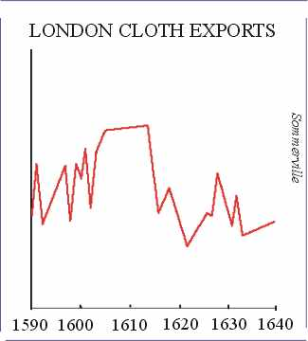
By 1614 a trade recession hit Britain, but one of King James’ trusted officials, Sir William Cockayne, came up with a solution to increase profits in England’s main export, woolen cloth. The purpose was to cut out the Dutch as the middle man and to directly export finished cloth in order to avoid Dutch customs duties and to increase profits. This plan backfired when the Dutch refused to accept the finished cloth. Sales exponentially decreased and the English cloth sales slumped. The English eventually reversed this monopoly but they did not recover from this slump for years. Although Cockayne left Britain’s textile industry in shambles, he sparked a wave of economic nationalism in the country.
This however caused an upheaval in both England and the Netherlands that led to the Anglo-Dutch wars and the English Revolution. The “Glorious Revolution” of 1688 made it possible for William of Orange to take the British throne. This brought peace but the Netherlands had a more advanced financial system than did England. After the Glorious Revolution, England introduced bank notes, joint-stock banking, the Bank of England, clearinghouses, stock exchanges, savings banks, token coins and discount houses. Most of these institutions had already been developed in Amsterdam. The new system improved upon the prior English banking system by allowing for greater liquidity, enabling the English investors to compete with the Dutch. England was well on the way to moving from the semiperiphery to the core, and eventual hegemony within the expanding Europe-centered system. It was a semiperipheral marcher state of a new kind, combining military power with economic power based on the making of profits.
It was during the age of exploration that the economic concept of Mercantilism took place, which played a huge impact in the polity upsweep of Britain. Mercantilism is the economic doctrine that government control of foreign trade is of great importance for ensuring the military security of the state. It is this philosophy that dominated Western European economic discourse from 16th- to 18th century. It is also because of Mercantilism, that European wars were fought at the time (wars for power and control) and ultimately, motivated colonial expansion and hegemony and resulted for Britain’s polity upsweep (from semi-peripheral to core).
Mercantilism dominated Western Europe and Britain’s economic policy from 16th to 18th centuries. At the same time, protectionist policies came into practice in Britain. Protectionism is the economic policy of restraining trade between states through methods such as tariffs on imported good. In other words, protectionist policies involved governmental regulations to harbor fair competition between imports, and goods and services produced domestically. More simply, protectionism was the policy of protecting local businesses from foreign competition. This theory was designed to protect infant industries during their developmental stage, and this had been practiced in the U.K in the 14th century from the days of protecting the wool industry.
During the Dutch hegemony that peaked in 1630 a free trade doctrine was prescribed by Johan DeWitt, the Statholder (mayor) of Amsterdam. This was also the period in which Hugo Grotius proclaimed the Law of the Sea which designated the ocean as a global commons for use by all nations for purposes of transportation. The British would eventually promulgate similar policies, but not until the height of their own hegemony in the 19th century.
The Corn Laws were repealed in 1846, and this marked the abandonment of mercantilism, and symbolized liberal free trade. It was during a famine in Britain, (the Corn Laws forbade importing corn in this time of need) that Corn Laws were finally repealed. Free trade is the policy of a hegemonic core power with a comparative advantage in the most profitable commodities (the Dutch in the 17th century, the British in the 19th century and the United States in the 20th century, but also of raw material exporters in the periphery. It is semiperipheral powers that can benefit most from protectionism that is used as an instrument for moving up the food chain toward the production of high wage goods.
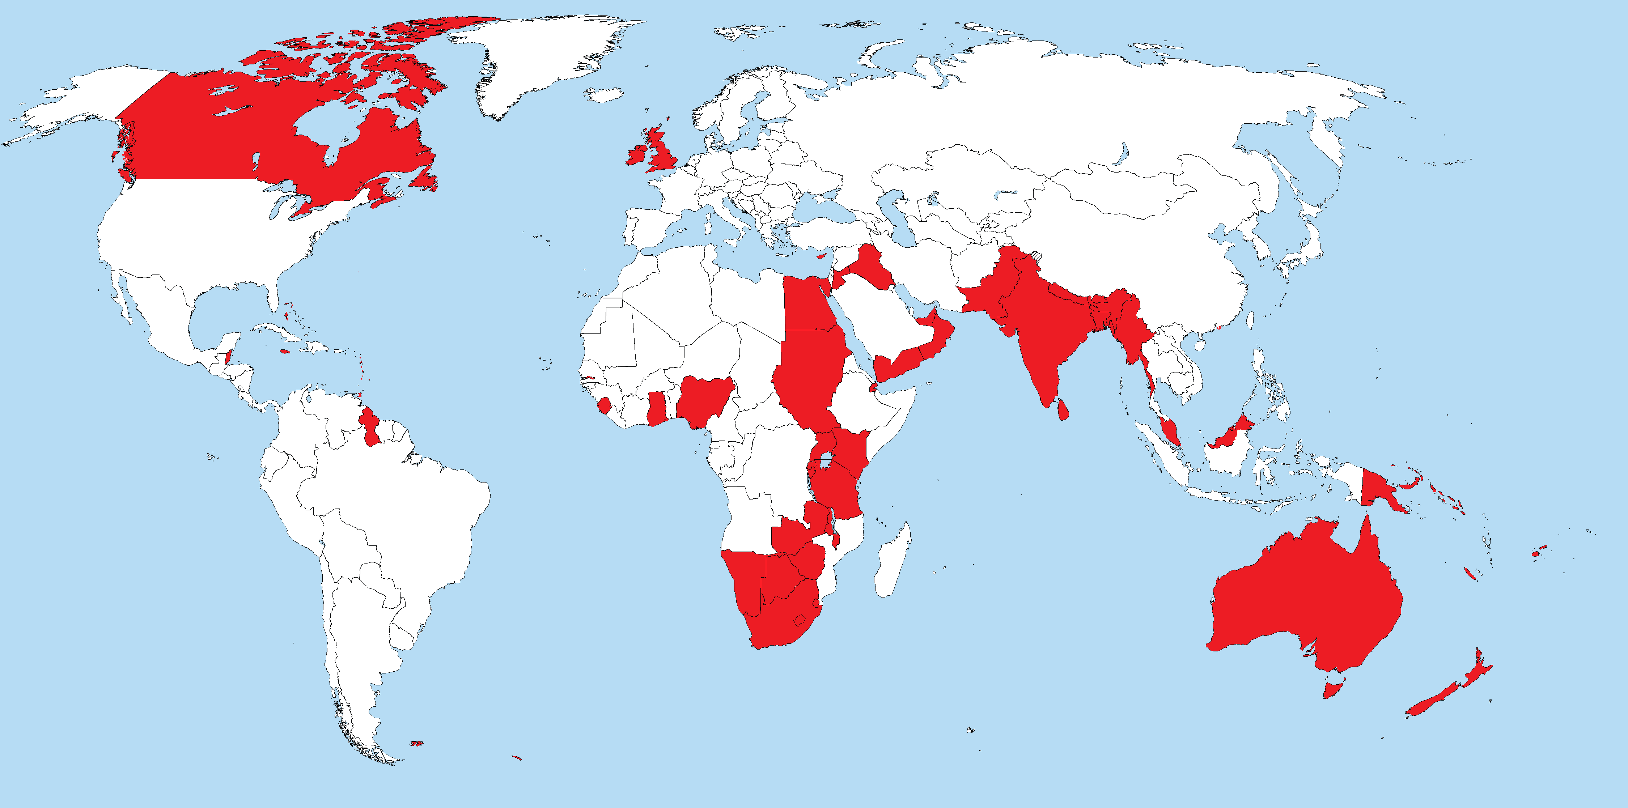
The British Empire
References:
Albernethly, David 2000 The Dynamics of Global Dominance, European Overseas Empire 1415-1980. Yale University Press.
Bromley, J.S. (ed.) 1971 The Rise of Great Britain and Russia, 1688-1715/25. Volume 6 of the New Cambridge Modern History. London: Cambridge University Press.
Hobsbawm, Eric J. 1968 Industry and Empire Baltimore, MD: Penguin.
Mann, Michael 1993 The Sources of Social Power, Volume 2: the rise of classes and nation-states 1760-1914. Cambridge, Cambridge University Press.
O’Brien, Patrick K 2000 “Mercantilism and imperialism in the rise and decline of the Dutch and British economies, 1585-1815” De Economist 148: 469-501.

O' Brien, Patrick K. and Philip A. Hunt (1993) “The rise of a fiscal state in England: 1485-1815” Historical Research Volume 66, Issue 160, pages 129-176 (June) http://onlinelibrary.wiley.com/doi/10.1111/j.1468-2281.1993.tb01806.x/abstract
Thomas, P. J. 1926 Mercantilism and the East India Trade. London: P.S. King and Son.
East Asia: 1300 BCE to 1830 AD
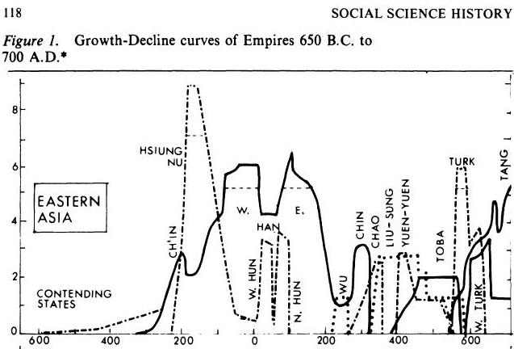

Rein Taagepera’s East Asia Graph 600 BCE to 700 CE
Shang/Western Zhou
In our numerical data analysis of upsweeps, the scale-up of polity size to form upsweep for the Shang and Zhou dynasty occurred in a sequence (see Figure 1). Combining the two, we counted the growth of the Shang and Zhou dynasty as a single upsweep. In the figure below, it is shown as “Western Zhou,” but this upsweep includes the growth of the Shang polity. Qualitatively, the Shang and Zhou make a distinct rise, and they are both considered to be formed by semiperipheral marcher state conquest.

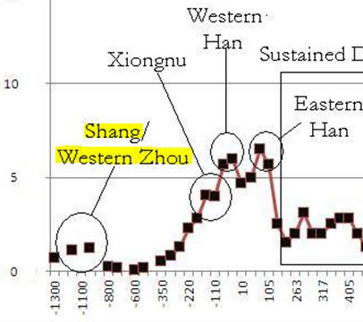
Figure : Territorial sizes of largest East Asian States from 1300 BCE to 400 BCE
Shang Dynasty (1600-1046 BCE)
The origins of the Shang Dynasty
The origin of the Shang dynasty and the dynamics of three dynasties including Shang—Xia, Shang, and Zhou—have been controversial among archaeologists and historians due to the lack of data and difference in analytical approach (Liu 2003; Thorp 2006; Wilkinson 1999). Chang (1983), for example, argues that the three dynasties succeed one another: the Shang overthrew Xia, and the Zhou began by conquering Shang. Yet, he also points out that these dynasties were not merely three chronological segments—Xia and Shang were two chronologically parallel, or at least overlapping political groups, for a while, and so were Shang and Zhou (Chang 1983: 349) until Zhou finally conquered Shang. They interacted one another, and in particular, the late Shang dynasty developed hegemonic relationship over other multicultural systems in Yellow River basin (Wilkinson 1999). Reviewing Chao Lin, Wilkinson (1999: 507) suggests that the late Shang moved from a state confederacy toward an empire by conquering small states, establishing overlordship, and transforming vassal states into Shang administrative districts. Liu (2003) also contends that each of several multiple political entities existing in Shang had autonomous political unity and those political entities interacted one another, having core-periphery relationships. It is argued that there were non-Shang political entities on the periphery which were not as backward as has been considered in ancient texts. Many polities which are contemporary with the Shang dynasty may have been autonomous states. Among these states, the Shang dynasty was the strongest (Liu 2003:22).
Based on newly developing archaeological evidence, Liu (2003, 2004) indicates that the old center of the Erlitou culture and its city (ca. 1900 B.C.E -1500 B.C.) was replaced by the newly emerged Erligang culture and its largest city, Zhengzhou (ca. 1600 -1415 B.C.). The period of the expansion and contraction of Erligang culture and the cities of Zhengzhou, Yinxu, and others correspond to Shang. Following Liu, we consider the old core of Erlitou was taken over by a rapidly enlarged semiperipheral Erligang culture. Erligang culture was initially diffused with the expansion of the city of Zhengzhou , and later Anyang /Yinxu. The Shang dynasty changed its name to Yin around -1401 (really ca. -1300) with move of capital from Zhengzhou to Anyang around then. It presumably indicates a crisis of the dynasty. For the reasons above, we consider the Shang was most likely a semiperipheral marcher state (or a semiperipheral marcher chiefdom.)
References:
Chang Kwang-chih 1983 Art, Myth, and Ritual. Cambridge, Mass, Harvard University Press.
Chang Kwang-chih 1999 “China on the Eve of the Historical Period” In The Cambiridge History of Ancient China: From the Origins of civilization to 221 BC, edited by Michael Loewe and Edward Shaughnessy.pp 37-73. Cambridge: Cambridge University Press.
Jing, Zhichun and George Rapp 1995 “Holocene Landscape Evolution and Its Impact on the Neolithic and Bronze Age Sites in the Shangqiu Area, Northern China.” Geoarchaeology: An International Journal. 10: 481-513.
Liu, Li and Xingcan Chen 2003 State Formation in Early China. London: Duckworth.
Liu, Li, Xingcan Chen, Yun Kuen Lee, Henry Wright, and Arlene Rosen 2004 “Settlement Patterns and Development of Social Complexity in the Yiluo Region, North China” Journal of Field Archaeology, 29 (1/2): 75- 100.
Keightley, D. N. 2000 The Ancestral Landscape: Time, Space, and Community in Late Shang China (ca. 1200-1045 B.C.). Berkeley, Institute of East Asian Studies.
Thorp, Robert L. 2006 China in the Early Bronze Age: Shang Civilization. Philadelphia: University of Pennsylvania Press.
Wilkinson, David 1999 “Power Polarity in the Far Eastern World System 1025BC –AD 1850: Narrative and 25-Year Interval Data.” Journal of World-Systems Research. 5 (3): 501-617.
Xia Shang Zhou chronology project: summary of results from 1996-2001. 2000. “Zia Shang Zhou duandi gongcheng 1996-2000 nian jieduan chengguo gaiyao” Wenwu 12: 49-62.
Yoffee, Norman 2006 Myths of the Archaic State: Evolution of the Earliest Cities, States, and Civilizations. Cambridge.
Western Zhou Dynasty:1050 to 221BCE
Rise
The ruling family of the Zhou arose near the Feng River in Shaanxi (Shaughnessy 1999:307, 2003). Later this location became the capital of the Zhou. The Zhou royal family founded the Zhou state and then conquered the Wei valley area. In 1045BCE, the Zhou troops and their western allies marched from the Wei River valley and defeated the Shang army at Muye (near the Shang capital in northern Henan (Li 2006: 2, 27) on the Yellow River). Later they occupied the Shang capital, Anyang. After the conquest of Shang, the Western Zhou peaked insize around 1050 BCE (Shaughnessy 1999: 307).
Crisis
In 771 BCE, Zhou’s king was killed and the capital was captured by the Quanrong people. The capital was moved from near Xi’an to Luoyang . From this shift, the later Zhou is categorized as the Eastern Zhou until 221BCE. Fragmentation of Zhou continued, and it experienced another crisis in 481 BCE (the end of Spring Autumn period) and lost its control over north China, ending with a tiny territory.
The rise of the Western Zhou was the conquest of the preceding core, the Shang, from the semiperipheral location. This would support the idea of the Western Zhou as an instance of a semiperipheral marcher state.
References:
Fang, Hui, Gary M. Feinman and Linda M. Nicholas 2015 “Imperial expansion, public investment and the long path of history: China’s initial political unification and its aftermath” PNAS 2015 : 1419157112v1-201419157. http://www.pnas.org/content/early/2015/03/12/1419157112
Feng, Li. 2006 Landscape and Power in Early China: The Crisis and Fall of the Western Zhou, 1045-771BC. Cambridge: Cambridge University Press.
Feng Li 2000 The Decline and Fall of the Western Zhou Dynasty: A Historical, Archaeological, and Geographical Study of China from the Tenth to the Eighth Centuries B.C. (Ph.D. diss., University of Chicago, ),
Hui, Victoria Tin-bor. 2005. War and State Formation in Ancient China and Early Modern Europe. New York: Cambridge University Press.
Huang, Chun Chang, Shichhao Zhao, Jiangli Pang, Qunying Zhou, Shue Chen, Ping Li, Longjiang Mao and Min Ding. 2003. “Climatic aridity and the relocations of the Zhou culture in the Southern Loess Plateau of China.” Climatic Change. 61:361-378.
Nivison, David 1995 “An Interpretation of the Shao Gao”, Early China 20 (1995), 177–193.
Shaughnessy, Edward L. 1988 "Historical Perspectives on the Introduction of the Chariot into China." Harvard Journal of Asiatic Studies. 48 (1): 189–237.
Shaughnessy, Edward L. 1992 Sources of Western Zhou History.CA: University of California Press
Shaughnessy, Edward L. 1999 "Western Zhou History", in pp. 292-351. Michael Loewe and Edward L. Shaughnessy (eds.) The Cambridge History of Ancient China.
Shaughnessy, Edward L. 2001-2 "New Sources of Western Zhou History: Recent Discoveries of Inscribed Bronze Vessels," Early China, pp. 26-27.
Shaughnessy, Edward L. 2003. "Toward a Social Geography of the Zhouyuan during the Western Zhou Dynasty: the Jing and Zhong lineages of Fufeng county" in pp. 16-34. Nicola Di Cosmo & Don J. Wyatt (eds.) Political Frontiers, Ethnic Boundaries, and Human Geographies of Chinese History. New York: Routledge Cuzon.
Wu, K. C. 1982 The Chinese Heritage. New York: Crown Publishers.
Qin, Xiongnu, and Western Han
In this analysis, Qin, Xiongnu, and Western Han together form a composite upsweep which reached unprecedented territorial size in Western Han (6 sq. mega meters in 50BCE [Taagepera 1976]; see table 1). We counted this as one upsweep, though it comprises three different polities. Qin’s territorial size peaked in 230 BCE (size 2.3) (Taagepera 1976). This formed the initial expansion to form the upsweep of the three dynasties.

polity sq.m yr
Qin 2.3 230 BC
Xiongnu 9 176 BC
Western Han 6 50 BC
Table 1 (Taagepera 1976)
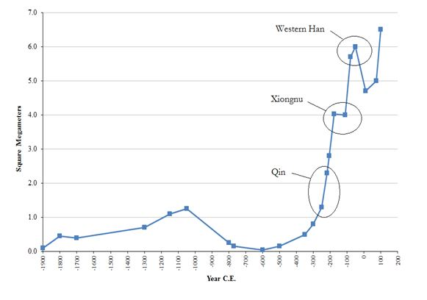
Figure 1: Largest East Asian polities, 1900 BCE to 200 CE
Qin dynasty: 221BCE ~ 206BCE
Ethnic origin
Feng (2006) notes that there are two archaeological views on the ethnic origin of the Qin people: the western China and eastern China positions (p.264).
Western origin
Some archeologists consider the Qin’s origin as the Rong (Xirong) people (or the closely related Quanrong people) in the west. The Rong people lived to the west of Longshan (Long mountain) since the end of Shang period. The Rong (or Xirong) people were a collection of nomadic tribal people inhabited in the extremities of ancient Huaxia, to the west of the Gansu and Ningxia. (Feng 2006: 264).
Following Sima Qian, von Falkenhausen (1999, 2004) also contends that the ancestors of the rulers of Qin were nomadic tribal people in the Upper Wei valley. According the Shi ji, these nomadic tribal people raised horses for the Zhou kings. Qin was only a landholding patrilineal kin-group in the Western Zhou period. It was after 770 BCE, when Qin moved to the former Western Zhou metropolitan area, that Qin was raised to the rank of a full-fledged polity, subordinate to the Zhou royal house. The Shi ji also reports that the Qin capital was moved several times, reflecting the polity’s gradual expansion towards the east (von Falkenhausen, 1999, 2004). The shift are the evidenced by the considerable archaeological sites located at Young sp?? in Fengxiang (Xhaanxi) –the Qin capital between 667 and 384BCE. There are also large sites in the Lower Wei valley, e.g., Yueyang (present Lintong county (Shaanxi))—Qin capital between 385 and 351 BCE, Xianyang—Qin capital between 350-270BCE (Falkenhousen 2004).
Eastern origin
The theory of eastern origin asserts that the Qin people were related to the Dongyi communities in the Shandong region. (see figure 2) (Feng 2006:264).

Both western and eastern origin views lack specific evidence to support their assertion. In particular, the origin of eastern China is less likely, which is indicated by the vast amount of archaeological evidence that the Qin polity evolved in situ. It is most likely that Qin originated from Rong and ancestral Chinese (Hua, Huaxia), and any other groups living in the area probably contributed also.
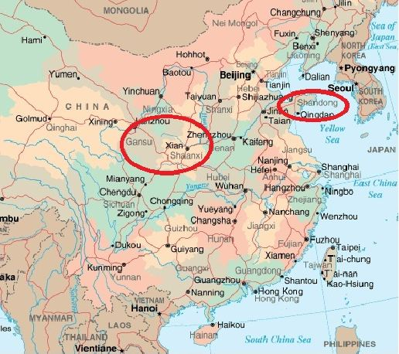
Figure 2 Qin’s possible homeland
http://www.personal.psu.edu/faculty/d/g/dga11/HS10_05_Anc_China_map.htm
Rise
Qin enlarged its power and territory rapidly in the Warring States period. Geographically, Qin was located at the margin (see figure 3). Being located to the far west of the Chinese system, Qin did not have enemies in the east. The polity was not located in the center of competing states, and this geographical location provided an advantageous position for Qin to expand (Collins 1978; Hui 2005).
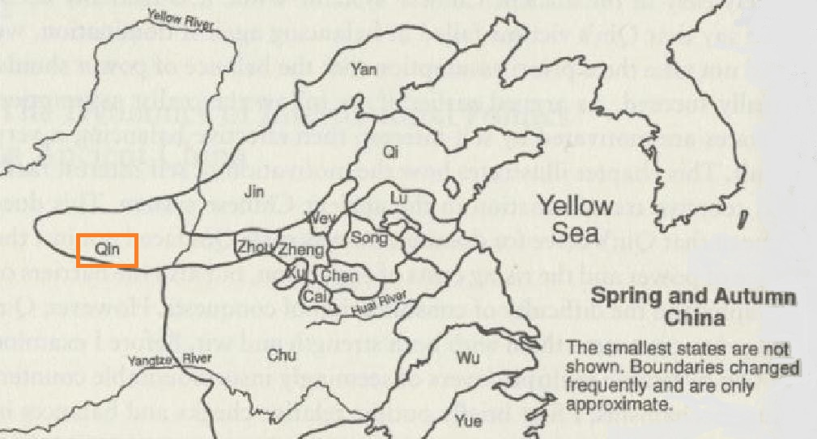
Figure 3 Qin’s location in the Spring and Autumn period
Source: Hui, Victoria Tin-bor. 2005. War and State Formation in Ancient China and Early Modern Europe. New York: Cambridge University Press p.56; Creel, Herrlee. 1970. The Origins of Statecraft in China. Chicago: University of Chicago Press.
The unification
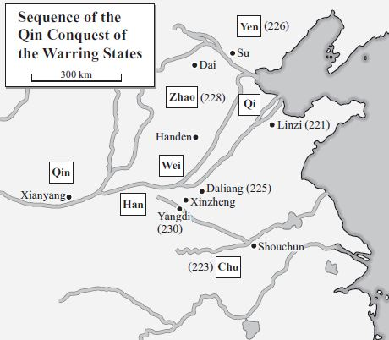
Figure 4 Source: Lewis (2007, p.15)
Qin extinguished the Zhou court in 256 BCE. By 241BCE, Qin had taken a large territory in the central plain, and shared borders with Qi. In 236, Qin started the final wars of unification, and it established the Qin dynasty in 221 BCE (Hui 2005:66).
Besides the geopolitical advantage, Lewis (2007) contends two major internal factors that contributed to Qin’s dominance and success in creating a unified empire. One is the systematic reforms which included the registration and mobilization of all adult males for military service and the payment of taxes. By so doing, Qin administration was devoted to mobilizing forces for conquest. The other is the success in concentrating power in the person of the ruler. Unlike the surrounding states, Qin was able to make the ruler the single locus of undivided authority (Lewis 2007:39).
After the unification, Qin Shihuangdi continued to extend the empire throughout his rule, eventually reaching as far south as Vietnam. Qin reached its peak of territorial size around 230 BCE (see figure 4). The uniqueness of Qin’s case is that the process of taking over the core was not rapid; rather it was a gradual process. It does not show the sudden jump to the largest core power. “Qin seized territory in bits and pieces over the course of 135 years” (Hui 2005: 76).

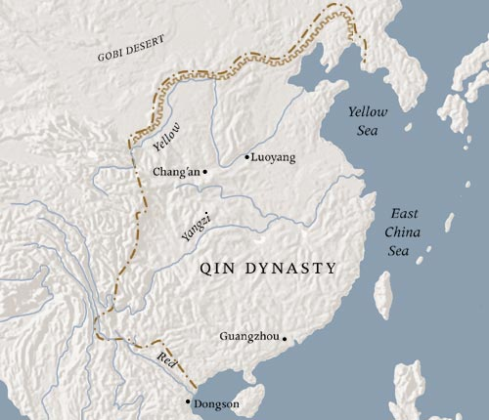
Figure 4 source: Metropolitan Museum of Art
http://www.metmuseum.org/toah/hd/qind/hd_qind.htm
Centuries of battle among six states over military supremacy in the Warring States period was ended in 221BCE with the Qin dynasty’s defeat of Chu and unification of the country. Qin attained unification starting from geographically peripheral area. Qin is a typical example of a semiperipheral development, and it clearly forms a case of semiperiphery marcher state formation.
References:
Bodde, Derk 1986 "The State and Empire of Ch'in," in The Cambridge History of China: Volume I: the Ch'in and Han Empires, 221 B.C. – A.D. 220. ed. by Denis Twitchett and Michael Loewe. Cambridge: Cambridge University Press.
Behnke, Anne and Grant Hardy 2005 The Establishment of the Han Empire and Imperial China. Westport, Connecticut: Greenwood Press.
Collins, Randall 1978 “Some Principles of Long-Term Social Change: The Territorial Power of States.” In Research in Social Movements, Conflicts, and Change, vol. 1, edited by ouis F. Krisberg, 1-34. Greenwich, CT: JAI Press.
Fang, Hui, Gary M. Feinman and Linda M. Nicholas 2015 “Imperial expansion, public investment and the long path of history: China’s initial political unification and its aftermath” PNAS 2015 : 1419157112v1-201419157. http://www.pnas.org/content/early/2015/03/12/1419157112
Feng, Li. 2006 Landscape and Power in Early China: The Crisis and Fall of the Western Zhou, 1045-771BC. Cambridge: Cambridge University Press.
Falkenhausen, Lothar von1999 “The Waning of the Bronze Age: Material Culture and Social Developments, 770-481 B.C. 450” in eds. Michael Loewe and Edward L. Shaughnessy. The Cambridge History of Ancient China: from the Origins of Civilization to 221 B.C. Cambridge University Press.
Falkenhousen, Lothar von 2004/2006. "Mortuary Behavior in pre-Imperial Qin: A religious Interpretation" in pp. 109-172. John Lagerway (ed). Religion and Chinese Society vol 1.ancient and Medieval China. Hong Kong: The Chinese Univeristy Press and Ecole francaise d'Extreme-Orient.
Hui, Victoria Tin-bor 2005 War and State Formation in Ancient China and Early Modern Europe. New York: Cambridge University Press.
Lewis, Mark Edward 2007 The Early Chinese Empires: Qin and Han. London: Belknap Press.

Map sources:
Figure 1: David Atwill, Pennsylvania State University
http://www.personal.psu.edu/faculty/d/g/dga11/
http://www.personal.psu.edu/faculty/d/g/dga11/HS10_05_Anc_China_map.htm
Figure 2: Qin’s location in the Spring and Autumn period
Source: Hui, Victoria Tin-bor. 2005. War and State Formation in Ancient China and Early Modern Europe. New York: Cambridge University Press p.56; Creel, Herrlee. 1970. The Origins of Statecraft in China. Chicago: University of Chicago Press.
Figure 3: Sequence of Qin conquest of Warring States
Source: Lewis, Mark Edward. 2007. The Early Chinese Empires: Qin and Han. London: Belknap Press. P. 15
Figure 4: The Metropolitan Museum of Art
Heilbunn Timeline of Art History, Qin Dynasty (221-206 B.C.) http://www.metmuseum.org/toah/hd/qind/hd_qind.htm
Xiongnu
The Xiongnu is the first recognized centralized polity in the steppe regions bordering China. Initially, the Xiongnu was a gathering of small tribes residing in Mongolian highlands. The new ruler, Maodun, organized the Xiongnu into a confederacy that eventually extended from the Aral Sea in the west to eastern Mongolia and the Yellow Sea (Bentley 1993:360). The Xiongnu retained a political power on the Chinese border for more than 500 years, and during the first 250 years they completely dominated the steppe (Barfield 1981: 47). The Xiongnu’s territorial size peaked around -176 (Taagepera 1978). In 201-200BCE, the Xiongnu came into conflict with the Han dynasty (--newly established in 202BCE) in China (Bentley 1993: 37). In the war, the Xiongnu defeated and almost captured the first Han emperor.
Barfield (1989) called the steppe polities as shadow empires and explained that the rise of the steppe polities occurred with the political centralization in China; while the decline of the steppe polities followed the political anarchy of China. Having economic interdependent relationship with China, the rise of the Xiongnu was affected by the sequence of integration and disintegration of China.
The Xiongnu’s economy was relatively complex, relaying on trade, gifts / subsidies from China, taxes from conquered areas, and their own pastoral production (Barfield 1981: 47). The steppe regions were not engaged exclusively in herding; they also practiced some level of complementary agriculture (Rogers 2007: 253). Given various forms of economy they had taken, it is difficult to fit the Xiongnu into the dichotomy, either nomadic herding or settled agriculture.
Summary
The Xiongnu had expanded its territory by conquering the steppe, and its war with the Han dynasty is the case of external invasion to the core. However, the Xiongnu never conquered the core, the Han dynasty. The Xiongnu had too few people, and the Han was a strong empire. The Xiongnu’s case was not one of a semipeipheral marcher state conquering the core.
When the Xiongnu warred with the Han, the Xiongnu had developed a complex and semi-settled polity, or semiperipheral polity. It has been recognized in the last 20 years that the Xiongnu held Central Asian oases that were very fertile and productive in those days. They later became major agricultural bases for Han. The Xiongnu held a large area of good agricultural land in what is now northern Shaanxi and neighboring provinces. They were by no means a strictly nomadic pastoral steppe empire; they had a mixed, diversified economy. Archaeology has disclosed quite rich tombs with Chinese-type but Central Asian influenced culture. The Xiongnu’s empire formation was thus semiperipheral development, rather than peripheral development.
In this sense, the case of Xiongnu Empire was not formed through simple semiperipheral marcher conquest but was a case of a semiperipheral marcher formation of a large-scale empire through unique interrelationship with the core.
References:
Adas, Michael 2001 Agricultural and Pastoral Societies in Ancient and Classical History, American Historical Association./Temple University Press.
Bailey, Harold W. 1985 Indo-Scythian Studies: being Khotanese Texts, VII, Cambridge UP, pp. 25-41.
http://www.archive.org/details/EtymologyOfXiongnuNamesByTheLateH.w.Bailey
Barfield, Thomas. J. 1989 The Perilous Frontier. Basil Blackwell.
Barfiedl, Thomas J. 1981 "The Hsiung-nu Imperial Confederacy: Organization and Foreign Policy" The Journal of Asian Studies. 41(1): 45-61.
Devor, Eric J., Ibrokhim Abdurakhmonov, Mark Zlojutro, Meredith P. Mills, Jessica J. Galbraith, Michael H. Crawford, Shukhrat Shermatov, Zabardast Buriev, and Abdusattor Abdukarimov. 2009 “Gene Flow at the Crossroads of Humanity: mtDNA Sequence Diversity and Alu Insertion Polymorphism Friquencies in Uzbekistan.” The Open Genomics Journal. 2: 1-11.
Beckwith, Christopher I. 2009 Empires of the Silk Road: A History of Central Eurasia from the Bronze Age to the Present. Princeton University Press
Bentley, Jerry 1993 Old World Encounters: Cross-Cultural Contacts and Exchanges in Pre-Modern Times. New York: Oxford University Press.
Di Cosmo, Nicola 1999The Northern Frontier in Pre-Imperial China. In: The Cambridge History of Ancient China, edited by Michael Loewe and Edward Shaughnessy. Cambridge University Press.
Di Cosmo, Nicola 2004 Ancient China and its Enemies: The Rise of Nomadic Power in East Asian History. Cambridge University Press. (First paperback edition; original edition 2002)
Hill, John E. 2009 Through the Jade Gate to Rome: A Study of the Silk Routes during the Later Han Dynasty, 1st to 2nd Centuries CE. Book Surge, Charleston, South Carolina.
Park, Jang-Sik, William Honeychurch and Amartuvshin Chunag 2011 Ancient bronze technology and nomadic communities of the Middle Gobi Desert, Mongolia Journal of Archaeological Science 38: 805-817.
Taagepera, Rein 1978 "Size and Duration of Empires: systematics of size" Social Science Research 7: 108-127.
Han Dynasty: 6BCE to 221AD
(interruptions by the Xin dynasty 9 to 25AD)
Western Han (Former Han): 206BCE to 9AD
The Han culture spread into the southern region of China where the southern natives were already inhabited by various groups speaking several different languages (Wen et al. 2004). Not only was there diffusion of Han culture, but also there were substantive movements of population to the south at the same time (“demic diffusion”) (Wen et al. 2004). The Han people were largely Chinese, in more or less the modern sense, but with various (unknown) numbers of non-Chinese people.
Rise
The Qin Dynasty (221-207 BCE) became unstable after the death of the first emperor Qin Shi Huangdi. Popular revolt by Chu (206BCE) broke out after the death of the second Qin emperor. A Qin general, Liu Bang, founded the Han Dynasty (206 BCE). Liu Bang engaged in a war with Xiang Yu, defeating him at the Battle of Gaixia.
Liu Bang established an imperial state that largely adopted Qin institutions. After briefly establishing his capital at Luoyang, he recognized the geographic advantage of the Qin state and shifted his capital to Chang'an (Lewis 2007: 19; Loewe 1986). The capital of Han was initially at Chang’an (modern Xi’an), thus, it is called “Western Han.”
After the death of Liu Bang in 195 BCE, his empress, Lu Zhi, took over the empire for her own family and started an abortive dynasty (188 - 180 BCE). The Liu clan regained control with a surviving son of Liu Bang, Emperor Wen. The Lius wiped out the empress’ entire kin (180 BCE), and the empress and her kin were thus displaced by countercoup.
The territorial size increase following the Xiongnu’s upsweep
Having established firm imperial control, the Emperor Wu (reigned140 -87 BCE) reinvented the dynasty as expansionist. The main wars were against the Xiongnu from 134 to 119BCE. The Xiongnu was a powerful nomadic empire located in the north of Han. The Xiongnu expanded their territorial size and attained its peak in -176 ( Taagepera (1976), also see Xiongnu section of the appendix). Our data on territorial size (see figure1) indicates that the upsweep of the Xiongnu forms a part of the following Western Han’s upsweep. The rise of the West Han following the Xiongnu is due to the expansionist policy of the emperor Wu against the northern nomadic empire and states. After the long years of confrontation, the Xiongnu was defeated by the Western Han right before the death of the emperor Wu (Lewis 2007).
The Western Han’s expansion
In addition to the expansion toward the north and northwest of the Western Han, the empire expanded to the south, south west, Korea, and Eastern Central Asia, attaining its greatest size (Lewis 2007). This expansion formed the largest upsweep of the territorial size of the West Han around 50 BCE (see table 1, Taagepera (1976)). However, Han’s expansionist policy under Emperor Wu created one of the causes of financial difficulty, ending in the retraction of the empire.
Despite of the fact that it took a huge civil war, Liu Bang's defeat of Xiang Yu was in fact an internal coup within Qin. It was simply a takeover by a general during a period of Qin breakdown. Thus, the establishment of the Western Han dynasty was not a semiperipheral marcher state formation.

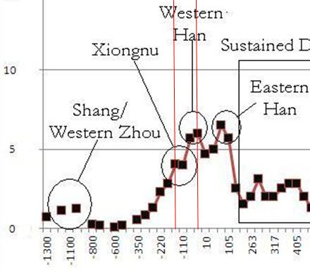
Figure 1 Western Han’s upsweep
Size of the largest polity
year | Sq.megameters | Polity name
-206 | 2.80 | Western Han
-176 | 4.03 | Xiongnu
-110 | 4.00 | Xiongnu
-80 | 5.70 | Western Han
-50 | 6.00 | Western Han
10 | 4.70 | Western Han
Source: Taagepera 1976
Table 1
References:
Hansen, Valerie 2000The Open Empire: A History of China to 1600. New York & London: W.W. Norton & Company.
Bielenstein, Hans 2008 “Wang Mang, the restoration of the Han dynasty, and Later Han.” in pp. 223-290 (eds.) Twitchett, Denis and John K. Fairbank. The Cambridge History of China, Vol. 1: The Ch'in and Han Empires, 221 BC-AD 220. Cambridge University Press.
Lewis, Mark Edward 2007 The Early Chinese Empires: Qin and Han. Cambridge: Harvard University Press
Loewe, Michael 1986 “The Former Han dynasty.” in pp. 103-198. eds. Twitchett, Denis and John K. Fairbank. The Cambridge History of China, Vol. 1: The Ch'in and Han Empires, 221 BC-AD 220. Cambridge University Press.
Twitchett, Denis and John K. Fairbank (eds) 1986/2008 The Cambridge History of China, Vol. 1: The Ch'in and Han Empires, 221 BC-AD 220. Cambridge University Press.
Wen, Bo, Hui Li, Daru Lu, Xiufeng Song, Feng Zhang, Yungang he, Feng Li, Yang Gao, Xianyun Mao, Liang Zhang, Ji Qian, Jingze Tan, Jianzhong Jin, Ranjan Deka, Bing Su, Ranajit Chakraborty and Li Jin 2004 "Genetic evidence supports demic diffusion of Han culture" Nature. 16: 302-305.
Eastern Han (Later Han): 25AD – 220AD
The crisis of Western Han began in 6 BCE, with the rise and coup by the Wang family. The Xin dynasty was established under Wang Mang and lasted for 17 years from 9AD to 25AD. After Xin’s brief control, the countercoup and restoration of Han occurred. Wang Mang’s authority was challenged by peasant rebellion; the leading families of east China joined the rebellion (Bielenstein 1986a; Lewis 2007: 24; Nishijima 1986: 588). The Xin dynasty was overthrown.
A distant relative of the Liu lineage, Liu Xiu, became the first emperor of a restored Han (Emperor Guangwu of Han) (Knechtges 2010; Lewis 2007; Nishijima 1986). The capital was transferred from Chang’an (in the west) to Luoyang (in the center of China), thus the term “Eastern Han.” Lewis (2007) points out that the transfer of the capital showed a “shift from an area that had dominated thought position and military force to one that claimed supremacy in the sphere of literary and economic production” (p.24).
Eastern Han was characterized by a history of lineages and factions with regional power bases. The increasing separation and isolation of the court from local society became prominent from Emperor He’s r.89-106) time onward (Lewis 2007:24).
In addition to the increasing isolation of the court, the dynasty had threats from tribesmen and states at the frontiers—e.g., the Xiongnu, the Xianbei (at north frontier), and the Qiang (at western frontier). By 168 AD, the western four provinces were abandoned, due to conflicts with tribesmen, and the former capital had been lost (Lewis 2007:27). The progressive breakdown of Eastern Han started from 169 AD. The split between the central government and local society became critical.
The control of the court was de facto lost to General Cao Cao around 200AD. One of the warlords, Cao Cao took charge of the emperor by holding the emperor as virtual prisoner for more than 20 years, and he declared himself the title of the imperial line which was previously reserved for the Liu lineage (216AD). Cao Cao thus successfully staged a coup, and the Han dynasty ended in 221 AD.
Much like the case of the Western Han, the establishment of the Eastern Han was through internal coup. The rise of Eastern Han was not a semiperipheral marcher state formation.
References:
Hansen, Valerie 2000The Open Empire: A History of China to 1600. New York & London: W.W. Norton & Company.
Beck, Mansvelt B.J. 1986 "The fall of Han” in pp. 317-376. eds. Twitchett, Denis and Michael Loewe (eds). The Cambridge History of China, Vol. 1: The Ch'in and Han Empires, 221 BC-AD 220. Cambridge University Press.
Bielenstein, Hans 1986 a. "Wang Mang, the restoration of the Han dynasty, and Later Han" in pp. 223-290. Eds. Twitchett, Denis and Michael Loewe (eds). The Cambridge History of China, Vol. 1: The Ch'in and Han Empires, 221 BC-AD 220. Cambridge University Press.
___________ 1986 b. "The institutions of Later Han" in pp. 491-519. (eds.) Twitchett, Denis and Michael Loewe (eds). The Cambridge History of China, Vol. 1: The Ch'in and Han Empires, 221 BC-AD 220. Cambridge University Press.
Knechtges, David R. 2010 "From the Eastern Han through the Western Jin (AD 25–317)” in The Cambridge History of Chinese Literature, eds. Kang-i Sun Chang and Stephen Owen. Cambridge: Cambridge University Press.
Lewis, Mark Edward 2007 The Early Chinese Empires: Qin and Han. Cambridge: Harvard University Press
Nishijima, Sadao 1986 " The economic and social history of Former Han " in pp. 545-607. eds. Twitchett, Denis and Michael Loewe (eds). The Cambridge History of China, Vol. 1: The Ch'in and Han Empires, 221 BC-AD 220. Cambridge University Press.
Twitchett, Denis and Michael Loewe (eds) 1986 The Cambridge History of China, Vol. 1: The Ch'in and Han Empires, 221 BC-AD 220. Cambridge University Press.
Yü, Ying-shih 1967. Trade and Expansion in Han China: A Study in the Structure of Sino-Barbarian Economic Relations. Berkeley: University of California Press.
_____________ 1986 "Han Foreign Relations," in The Cambridge History of China: Volume I: the Ch'in and Han Empires, 221 B.C. – A.D. 220, 377–462. edited by Denis Twitchett and Michael Loewe. Cambridge: Cambridge University Press.
Eastern Turks
“In the middle of the 6th century A.D., a tribal grouping calling itself Türk burst suddenly upon the stage of world history” (Golden 2006:83). They were speakers of an Altaic language; Golden sees the Altaic languages (Tukic, Mongol, Tungus) as differentiating by “4000-3000 B.C. if not earlier” (ibid). The languages appeared in south-central Siberia, with standard or common Turkic breaking up not many centuries before the sixth century appearance. The Türks emerged (supposedly as specialists in mining and metals) within the Xiongnu tribal confederation and its successor the Xianbei and Rouran confederations. By the 6th century there were apparently four Turkic-led tribal confederations: the little-known Tiele in Mongolia and the steppes; the Qirgiz in Yenisei area (ancestral, partly, to the modern Kirghiz); the Qipchaqs (again, partly ancestral to later Qipchaks, but all little known); and the Türks who formed the empires on the Chinese fringe. The Türks considered themselves descended from “a she-wolf impregnated by the sole survivor of a tribe destroyed by a neighboring state. The wolf fled and bore ten sons, one of whom was Ashina (possibly a loanword from Tokharian, an Indo-European language family) (Golden 2006:88 and Findley 2005). The Türks may have settled in the Altai Mountains (at the head of the Yenisei River, in south Siberia) in the 5th century, and there become a major grouping under their current name (ibid).
Meanwhile, the Tabghach or Toba Türks, with allies from the old Xianbei confederacy, conquered north China in 338 and held it till 557 (parts of it till 577). They established the Wei Dynasty, or rather three or four different Wei kingdoms), and were the major rulers within the Chinese world from about 400 to 550; China was disunited and fragmented, but the Wei were the largest and most powerful polity (or polities). Wei was thus the first major kingdom to be Turkic-led. The importance of Central Asian rulers and leaders in Chinese history, especially during this time, has been greatly underemphasized in the past (Mair 2005).
“The Chinese accounts place the Ashina [Türks] in Gansu and Xinjiang, areas associated with Iranian and Tokhharian peoples... from this region they migrated in the fifth century to the Altai Mountains, with its Turkic-speaking inhabitants, where they became subject ironsmiths of the Avars,” a Mongolian tribe known as Juan-Juan to the Chinese who were eventually conquered and forced to the west by the Türks (Golden 2011:38). The Altai steppe regions were not home to fertile agricultural lands but rather unproductive grasslands, deserts and wastelands (Golden 1998:7) which served as a precursor to Turkic success. As a result, minerals and metals were extracted for weaponry production and horses were domesticated, both served as bargaining and trading power for silk and agricultural goods (Findley 2005). These commodities provided much more than trading power alone, they were the foundation of their pronounced military success as all tribe members were trained in weaponry and were vastly mobile. In 546 A.D., Bumin, the leader of the Turks, helped the Avars contain a Tiele revolt and requested a royal princess bride from them in 551 A.D. (Golden 2011:37). Their insolent refusal led Bumin to join with the western Wei, accepting a bride and conquering the Avar Empire in 552 A.D. (Golden 2011:37), which was the start of the first Turkish empire, The Gӧk Türk Empire, which stretched from Manchuria to the Black Sea with the help of Bumin’s brother and successor, Ishtemi (Golden: 2011:37). The Gӧk Türks formed a symbiotic relationship with the Sogdians, town-dwellers, farmers and merchants who spoke an East Iranic language (Golden 2006:89) who were the “principal middlemen in moving the cargoes of the Silk Road from Central Asia to the Mediterranean world” (Golden 2011:38). Trained by their Sogdian vassals, the Turks emerged as major silk traffickers (Golden 2011:38); in fact, the flourishing economy of the Eurasian Silk Road can be credited to the “Türks’ eagerness to trade”, along with their military strength that swayed others to trade with them and their dominance over central Asia (Beckwith 2009:112)
The Turkic qaghanate divided into east and west - with Ishtemi and his successor in the west and political seniority in the east - and rivalry for total power was produced among them, causing strife and instability. The eastern qaghanate exploited rivalries of China’s divided northern Qi and Zhou dynasties until the Sui dynasty assumed power and reunited China (Golden 1998:31). The Sui dynasty was aware of the Turkic threat and strengthened their northern defenses while the Tiele (possibly encouraged by the Sui dynasty) successfully revolted against the Türks in 603 A.D. The Tang Dynasty succeeded the Sui in 618 A.D. and welcomed one of “China’s most brilliant periods” (Golden 2011:41) during which time they “bought off” the eastern Türks while instigating strife and turmoil within. In 630 A.D., the eastern Türks suffered famine and many fled their harsh ruler, Xieli, who was captured by the Tang and died in captivity ending the first Turkic Empire. The remaining nomads of the qaghanate surrendered and settled among the Chinese northern frontier, while the chieftains and higher aristocracy were appointed successful military positions in the Tang courїt (Golden 2011:42). By 682 A.D., a small but strong band of Türk people turned on the Tang and restored their power, bringing rise to the second Turkish Empire (682-745 A.D.)
A Turkic tribe, the Basmїl, conquered the Türks in 741 A.D. and were subsequently conquered by the Uighurs in 744 A.D., who succeeded as the most powerful Turkic group in eastern Asia, holding the balance of power in what is now Xinjiang (Golden 2006:94). The Uighurs “led a tribal confederation called Toquz Oghuz, meaning ‘the nine related groups’ of eastern Tiele origin” (Golden 2011:44). They aided the Tang in their defeat over rebels and continued to support the Tang Dynasty as an avenue to exploit China in trade of silk for unhealthy horses. The Uighur dynasty remained in power until 840 A.D.
References
Beckwith, Christopher, I. 2009 Empires of the Silk Road. A History of Central Eurasia from
the Bronze Age to the Present. Princeton, NY: Princeton University Press.
De la Vaissière, Étienne 2005 Sogdian Traders: A History. Trans. James Ward. Leiden: Brill.
Golden, Peter. 2010 Central Asia in World History. New York: Oxford University Press
___________ 1998 Nomads and Sedentary Societies in Medieval Eurasia. American
Historical Association
____________ 2006 “The Turkic Nomads of the Pre-Islamic Eurasian Steppes.” in The Turkic-
Speaking Peoples, Ergun Çağatay and Doğan Kuban, eds. Munich:Prestel. Pp.82-106
Findley, Carter V. 2005 The Turks in World History. New York: Oxford University Press
Sui-Tang 618AD-907AD
The Tang Dynasty began 618 (holding full power only from 620), declined rapidly after 880, and finally fell in 907 (Lewis 2009b; Twitchett 1979). The Tang was founded by a general of the preceding Sui Dynasty who won the civil wars at the breakdown of Sui (a brief dynasty, 589-618; its powerful first ruler had a weak successor who lost control). Significantly, both Sui and Tang were started by generals from the northwest frontier, known to have some Turkic blood (apparently from Wei Dynasty rulers; the Wei was a Turkic dynasty). There is even some suspicion that one or both of them was pure Wei by descent, but the early histories regard them as partly Han Chinese. Thus, these were both empires founded by internal processes, but with some steppe ancestry and background and extremely heavy steppe cultural influences (Chen 2012). Both the Sue and Tang marcher lords were very conscious of their roots and had apparentlyTurkic names. Certainly Li's mother and mother's mother did. "Barbarian" both overtranslates and undertranslates the situation. The Chinese terms refer to specific ethnic groups, or groups of ethnic groups according to geography, and do not have as pejorative a connotation as English "barbarian" or the later Chinese "fan." In the BC era you hear about the Rong (northerners of different language), Yue (southerners of different language), etc. In the Sui-Tang period they referred to the ethnic group names: Xianbei, Tuoba, Uighur, etc.
References:
Chen, Sanping 2012 Multicultural China in the Early Middle Ages. Philadelphia: University of Pennsylvania Press.
Lewis, Mark Edward. 2009 China’s Cosmopolitan Empire: The Tang Dynasty. Cambridge, MA: Harvard University Press.
Mote, Frederick W. 1999 Imperial China 900-1800. Cambridge, MA: Harvard University Press.
Twitchett, Denis (ed.) 1979 The Cambridge History of China. Vol. 3. Sui and T’ang China, 589-906. Cambridge: Cambridge University Press.
Mongol-Yuan (see above under Central System)
Qing: 1644-1911 CE
The Qing Dynasty (1644-1911) is a clear case of semiperipheral marcher state takeover. The Manchus, heirs of the Jin Dynasty, developed in the 17th century a state in Manchuria that rapidly became powerful. When the Ming Dynasty collapsed between 1630 and 1644 (Brook 1988, 2010), the Manchus were lured in by Chinese factions seeking military aid. The Chinese factions weakened each other; the Manchus saw an amazing opportunity, and quickly took advantage of it (Mote 1999). So a state of a very few million people took over an empire with a hundred million or more.
The Chinese soon realized they were getting the short end of a deal, and the former allies of the Manchus staged a rebellion in the 1680s, the War of the Three Feudatories. This was successfully put down, with considerable loss of life (Mote 1999; Mote and Twitchett 1988; Rowe 2009).
After this, the Qing went on a burst of expansion unequalled since the beginning of the Chinese Empire. It took over Mongolia, Tibet, and the former Han and Tang territories in Central Asia (Perdue 2005). It brought Manchuria (now Dongbei) into the empire. It took or held millions of square kilometers in what is now Russia (Mote and Twitchett 1988). By the early 18th century, China was the biggest it had ever been (Rowe 2009). In the late 18th and early to mid 19th century, Russia took over the Siberian properties by a mix of threat and guile (Mote and Twitchett 1988); in the 1920s, the rising USSR forcibly “liberated” Outer Mongolia as an independent state, actually a puppet of the USSR till the latter collapsed in1989. Even after that, China remained the second largest country in the world, and has held its territory since, in spite of several breakaway efforts.
However, from the 1830 on, rebellions occurred; the Taiping Rebellion, 1850-64, almost brought down the dynasty. In 1862, the Tongzhi Restoration begins; the Tongzhi Emperor reinvented Qing, trying to follow Japan in modernizing and westernizing, but real power became more and more concentrated in the hands of Empress Dowager Cixi, who held much power till her death in 1908 (Mote and Twitchett 1988; Rowe 2009). The empire then collapsed, officially ending in 1911 when a leading general, Yuan Shikai, followed China’s historic pattern of staging an internal military coup and starting a new empire (Mote 1999). His empire lasted till 1915 before being ended by democratic rebellions.
References:
Brook, Timothy 1988 Geographical Sources of Ming-Qing History. Center for Chinese Studies, University of Michigan.
Brook, Timothy 2010 The Troubled Empire: China in the Yuan and Ming dynasties. Cambridge, Mass. : Belknap Press of Harvard University Press.
Mote, Frederick W. 1999 Imperial China 900-1800. Cambridge, MA: Harvard University Press.
Mote, Frederick, and Denis Twitchett (eds.) 1988 The Cambridge History of China: The Ming Dynasty. 2 v. Cambridge: Cambridge University Press.
Perdue, Peter 2005 China Marches West: The Qing Conquest of Central Eurasia. Cambridge, MA: Harvard University Press.
Rowe, William T. 2009 China's Last Empire: the Great Qing. Cambridge, Mass: Belknap Press of Harvard University Press.
South Asia: 420 BCE to 1008 AD
Mauryan
The Mauryas seem to have first originated in the Kosala Kingdom, which was a polity contemporaneous with the Maghada Empire. Kosala stood in Awadh, in the northern part of modern-day Uttar Pradesh. The Mauryas were first known as Moriyas, a clan who ruled a small republic in Northern India called Pipphilivana, so named because it supposedly stood deep in a forest of Peepal trees. The Mauryas seem to be independent of Kosala as they earned their name (Maurya or Moriya) after being driven off by the Kosalan prince Virudhaka. They then setteled in a region that abounded in moras or peacocks. The exact location of Pipphalivana remains unknown, but it was likely right outside Gorakhpur City, which is some 130 kilometers away from Avodyha, which was the capital of Kosala.
The Kosala Kingdom was a powerful polity at the time, but fell into a war with the Maghada Empire, another large polity in the region. Kosala subsequently fell into decline, ultimately being absorbed by the Maghada Empire during the time of the Nandas. Mauryan Pipphilavana apparently suffered the same fate, as it is told in the Mahavamsatika that Chandragupta Maurya’s father was the leader of the Mauryas, and was killed by a powerful raja, presumably the Nanda king. Chandragupta Maurya’s mother then fled, living in the Maghada capital of Pataliputra in disguise, where she lived and worked as a peacock tamer. This story is corroborated by Jain and Buddhist texts.
Chandragupta attempted a revolt with the help of a chieftain named Parvataka and his Brahman adviser Kautilya. Chandragupta apparently failed in a first attempt to usurp the Nandas, as both the Jain and Buddhist traditions tell of his early defeats against the Nandas. He subsequently fled north of the Maghada Empire where, according to Plutarch, he met Alexander the Great at the tail end of Alexander’s campaign in India. Chandragupta supposedly remarked that Alexander would have no trouble conquering the whole of the Maghada Empire because of the unhappiness of the people with the base-born rulers.
Chandragupta restarted his revolutionary conquest after the death of Alexander. He first attacked and freed the Punjab and Sindh from foreign Macedonian rule. After collecting and augmenting his forces after his northern conquests, Chandragupta moved with lightning rapidity through Maghada, taking province after province and finally exterminating all of the Nanda line.
Chandragupta’s ascent to power seems to follow the trajectory of a semi-peripheral marcher state. His people ruled independently on the marches of a more powerful kingdom (Kosala) before being uprooted into the expanding Nanda kingdom. From there, it took only one generation for the Mauryan line to collect power, first conquering marginal territories and then overthrowing the Sudra-born Nanda rulers and replacing them with Ksatriya Mauryas.
References:
Bhargava, P.L. 2007 Chandgragupta Maurya. Delhi: D.K. Printworld.
Habib, Irfan and Vivekanand Jha 2004 Mauryan India. New Delhi: Tulika Books.
Mookerji, Radhakumud 1960 Chandragupta Maurya and his times. Delhi: Motilal Banarsidass.
Pathak, Vishnuddhanand 1963 History of Kosala up to the rise of the Mauryas. Delhi: Motilal Banarsidass.
Sastri, K.A. Nilakanta 1967 Age of the Nandas and Mauryas. Delhi: Motilal Banarsidass.
Schwartzberg, Joseph E. 1992 A Historical Atlas of South Asia. Oxford : Oxford University Press, 1992.

According to the legend of Romulus and Remus, the Romans abducted Sabine women to populate the newly built Rome. The resultant war ended only by the women throwing themselves and their children between the armies of their fathers and their husbands. The story became a common motif in Roman art.
Upon being elected khan of the Mongols, Temujin only had a fraction of the tribes unified (Barfield 1989, P. 190). Around 1204, with the defeat of Kereyid confederation, full unification was complete. At this stage in Mongol imperial development, we could classify the Mongol confederation as weak semi-peripheral, since the Mongols defeated, arguably, the strongest Inner Steppe confederation and started developing complex political organization (Rodgers 2012). Around 1206, Temujin earned the title Chinggis Khan (Barfield 1989, P. 191).
Even though sociopolitical hierarchy in Inner Steppe polities were not based on class divisions, stratification was primarily embedded in kinship systems, where leaders would claim lineage from an aristocratic clan or family (Rodgers 2012).
The period is adapted from Liu (2003) and Yoffee (2006), and it is commonly shared definition of Shang period.
There are multiple contending views on the origin of the Xiongnu. See Di Cosmo (2004)
Modu became a new chayu, Xiongnu Chanyu, (Channyu: the title used by the nomadic supreme rulers)
There are different views on the rise of Xiongnu in the relationship with China. Di Cosmo (1999) describes the unification and rise of the Xiongnu took place due to compounded factors of steppe nomad polities’ economic crisis derived from the loss of pasturelands and political and military emergency incurred by Chinese campaign against the Xiongnu (Di Cosmo 1999: 964-966). The rise of the Xiongnu, according to Di Cosmo, was not much related with the unification of China (Di Cosmo 2004).
We currently know that there were Thai, Miao/Hmong, Yao/Mian, Austronesian, and Mon-Khmer peoples.
The Han dynasty really started, and consolidated hold over China, in 206 BCE, but it was not in full official control of the empire till 202BCE.

